|  |  |  |  |
| --- | --- | --- | --- |
| 1 | | 24,504 | |
| **NUMERO DE FRONTERAS** | | **ENERGIA AGREGADA** | |
|  | | | |
| 104,908,178 | 164 | | 3,756,815 |
| INGRESO 2020 | DÍAS CERTIFICADOS 2020 | | ENERGIA RESPALDADA 2020 |
|  | | | |
| 97,712,934 | 175 | | 4,263,582 |
| INGRESO 2021 | DÍAS CERTIFICADOS 2021 | | ENERGIA RESPALDADA 2021 |

**HISTORICO REINTEGRO DDV**

|  |  |  |
| --- | --- | --- |
|  | **2020** | **2021** |
| **ENE** | 14.02 | 11.85 |
| **FEB** | 20.59 | 14.73 |
| **MAR** | 24.2 | 8.01 |
| **ABR** | - | 4.16 |
| **MAY** | 1.86 | 10.18 |
| **JUN** | 8.5 | 2.17 |
| **JUL** | 12.34 | 11.74 |
| **AGO** | 6.9 | 13.54 |
| **SEP** | - | 11.91 |
| **OCT** | 9.86 | 9.44 |
| **NOV** | 5.31 | - |
| **DIC** | 1.33 | - |

**Los valores de la tabla están en millones de COP**

**REINTEGRO MECANISMO DDV OCTUBRE 2021**

|  |  |  |  |  |  |
| --- | --- | --- | --- | --- | --- |
| FECHA | TIPO DIA | CANTIDADES RESPALDO | PRECIO PONDERADO USD | TRM | PNETO |
| 2021-10-05 | Martes | 24,498 | 5.98 | 3,784.44 | 496,754 |
| 2021-10-06 | Miércoles | 24,502 | 5.98 | 3,784.44 | 496,835 |
| 2021-10-07 | Jueves | 24,503 | 5.98 | 3,784.44 | 496,855 |
| 2021-10-08 | Viernes | 24,503 | 5.98 | 3,784.44 | 496,855 |
| 2021-10-09 | Sábado | 24,502 | 5.98 | 3,784.44 | 496,835 |
| 2021-10-10 | Domingo - Festivo | 24,502 | 5.98 | 3,784.44 | 496,835 |
| 2021-10-11 | Lunes | 24,502 | 5.98 | 3,784.44 | 496,835 |
| 2021-10-12 | Martes | 24,502 | 5.98 | 3,784.44 | 496,835 |
| 2021-10-13 | Miércoles | 24,498 | 5.98 | 3,784.44 | 496,754 |
| 2021-10-14 | Jueves | 24,498 | 5.98 | 3,784.44 | 496,754 |
| 2021-10-15 | Viernes | 24,502 | 5.98 | 3,784.44 | 496,835 |
| 2021-10-19 | Martes | 24,503 | 5.98 | 3,784.44 | 496,855 |
| 2021-10-20 | Miércoles | 24,503 | 5.98 | 3,784.44 | 496,855 |
| 2021-10-21 | Jueves | 24,502 | 5.98 | 3,784.44 | 496,835 |
| 2021-10-22 | Viernes | 24,502 | 5.98 | 3,784.44 | 496,835 |
| 2021-10-23 | Sábado | 24,502 | 5.98 | 3,784.44 | 496,835 |
| 2021-10-24 | Domingo - Festivo | 24,502 | 5.98 | 3,784.44 | 496,835 |
| 2021-10-25 | Lunes | 24,502 | 5.98 | 3,784.44 | 496,835 |
| 2021-10-26 | Martes | 24,502 | 5.98 | 3,784.44 | 496,835 |

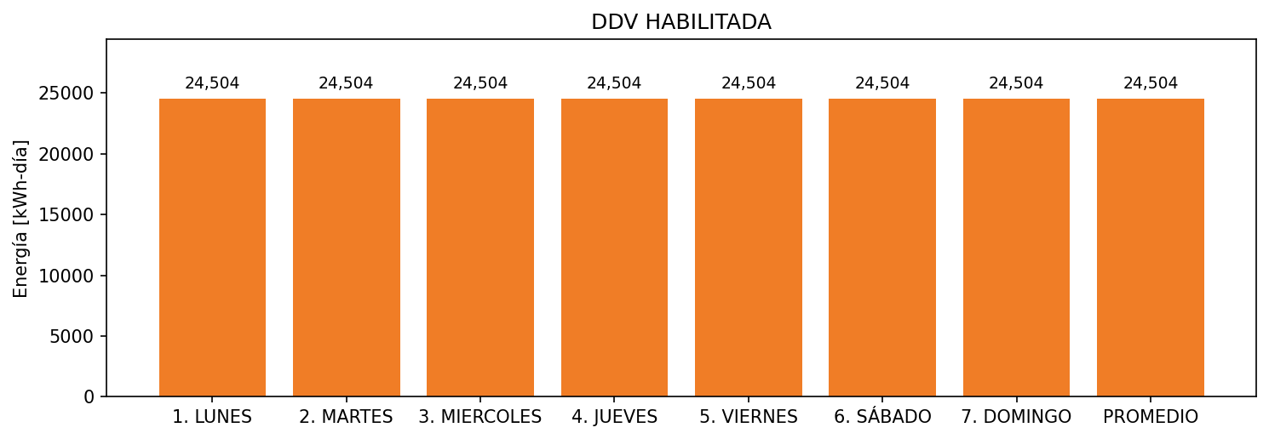

|  |  |  |  |  |  |  |  |  |  |
| --- | --- | --- | --- | --- | --- | --- | --- | --- | --- |
| **FRONTERA** | **COD SIC** | **FRT DDV** | **TIPO DDV** | **PROMEDIO** | **PRÓXIMA ACTUALIZACIÓN** | **MARGEN DE ERROR** | **ÚLTIMA PRUEBA DDV** | **DÍAS PARTICIPACIÓN** | **FECHA REFERENCIA PRÓXIMA PRUEBA DDV** |
| BAVARIA S.A. (MALTIBIT) | Frt00641 | Frt33221 | LBC | 24,504 | 2022-01-18 | 3,41 | 2021-06-04 | 89.0 | 2021-12-18 |