|  |  |  |  |
| --- | --- | --- | --- |
| 1 | | 11,736.0 | |
| NUMERO DE FRONTERAS | | ENERGIA AGREGADA | |
|  | | | |
|  | |  | |
| CONTRATO | | VENCIMIENTO CONTRATO | |
|  | | | |
| 45,445,475 | 144 | | 1,696,636 |
| INGRESO 2020 | DÍAS CERTIFICADOS 2020 | | ENERGIA RESPALDADA 2020 |
|  | | | |
| 35,634,324 | 130 | | 1,551,237 |
| INGRESO 2021 | DÍAS CERTIFICADOS 2021 | | ENERGIA RESPALDADA 2021 |

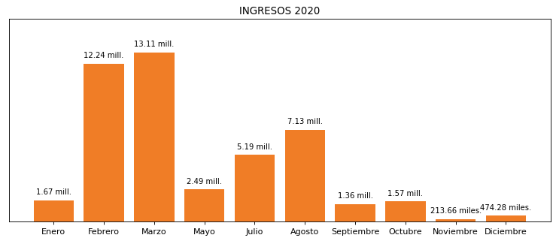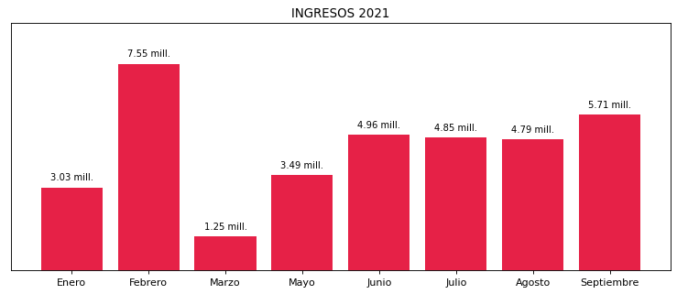

|  |
| --- |
| **MICROPLAST**  USUARIO |

|  |
| --- |
| **Camilo Bermudez**  Ejecutivo de cuenta |

|  |
| --- |
| **Duban Calle / Ingeniero de mejora continua / dcbetancur@coldeplast.com.co**  PUNTO FOCAL |

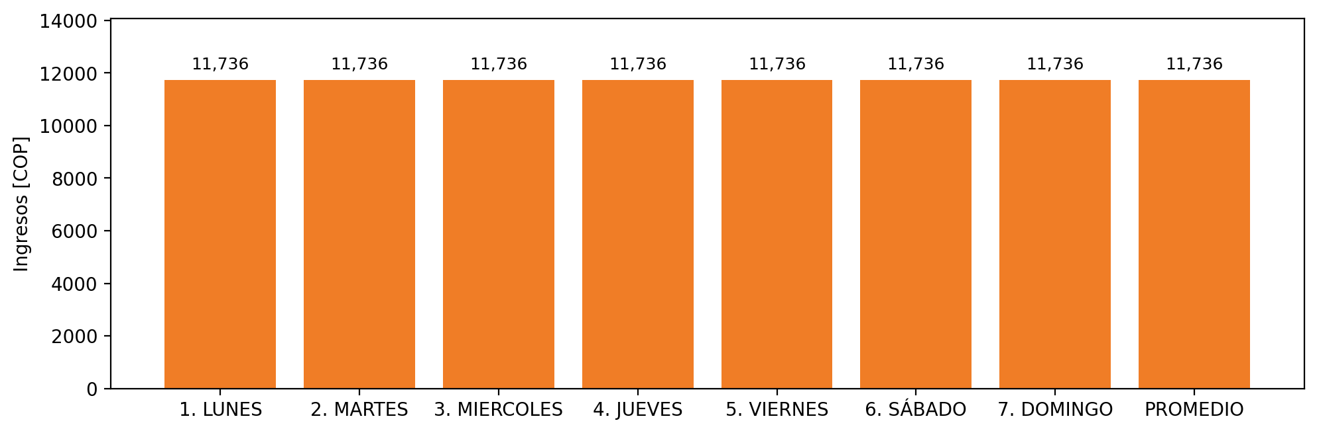

|  |  |  |  |  |  |  |  |  |  |  |
| --- | --- | --- | --- | --- | --- | --- | --- | --- | --- | --- |
| **FRONTERA** | **COD SIC** | **PREDIO** | **FRT DDV** | **TIPO DDV** | **PROMEDIO** | **PRÓXIMA ACTUALIZACIÓN** | **MARGEN DE ERROR** | **ÚLTIMA PRUEBA DDV** | **DÍAS PARTICIPACIÓN** | **FECHA REFERENCIA PRÓXIMA PRUEBA DDV** |
| MICROPLAST ANTONIO PALACIO Y CIA. S.A. - MICROPLAST S.A. | Frt00851 | Prd01577 | Frt36401 | LBC | 11,736 | 2022-03-01 | 3,13 | 2021-04-02 | 89.0 | 2021-12-05 |