|  |  |  |  |
| --- | --- | --- | --- |
| 1 | | 11,736 | |
| **NUMERO DE FRONTERAS** | | **ENERGIA AGREGADA** | |
|  | | | |
| 45,445,475 | 144 | | 1,696,636 |
| INGRESO 2020 | DÍAS CERTIFICADOS 2020 | | ENERGIA RESPALDADA 2020 |
|  | | | |
| 35,634,324 | 130 | | 1,551,237 |
| INGRESO 2021 | DÍAS CERTIFICADOS 2021 | | ENERGIA RESPALDADA 2021 |

**HISTORICO REINTEGRO DDV**

|  |  |  |
| --- | --- | --- |
|  | **2020** | **2021** |
| **ENE** | 1.67 | 3.03 |
| **FEB** | 12.24 | 7.55 |
| **MAR** | 13.11 | 1.25 |
| **ABR** | - | - |
| **MAY** | 2.49 | 3.49 |
| **JUN** | - | 4.96 |
| **JUL** | 5.19 | 4.85 |
| **AGO** | 7.13 | 4.79 |
| **SEP** | 1.36 | 5.71 |
| **OCT** | 1.57 | - |
| **NOV** | 0.21 | - |
| **DIC** | 0.47 | - |

**Los valores de la tabla están en millones de COP**



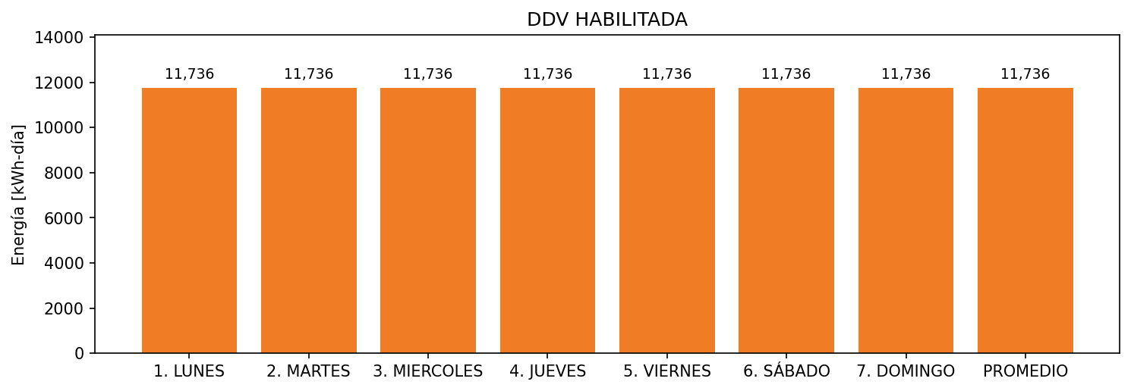

|  |  |  |  |  |  |  |  |  |  |
| --- | --- | --- | --- | --- | --- | --- | --- | --- | --- |
| **FRONTERA** | **COD SIC** | **FRT DDV** | **TIPO DDV** | **PROMEDIO** | **PRÓXIMA ACTUALIZACIÓN** | **MARGEN DE ERROR** | **ÚLTIMA PRUEBA DDV** | **DÍAS PARTICIPACIÓN** | **FECHA REFERENCIA PRÓXIMA PRUEBA DDV** |
| MICROPLAST ANTONIO PALACIO Y CIA. S.A. - MICROPLAST S.A. | Frt00851 | Frt36401 | LBC | 11,736 | 2022-03-01 | 3,13 | 2021-04-02 | 89.0 | 2021-12-17 |