|  |  |  |  |
| --- | --- | --- | --- |
| 1 | | 77,188 | |
| **NUMERO DE FRONTERAS** | | **ENERGIA AGREGADA** | |
|  | | | |
| 19,146,224 | 12 | | 923,602 |
| INGRESO 2021 | DÍAS CERTIFICADOS 2021 | | ENERGIA RESPALDADA 2021 |

**HISTORICO REINTEGRO DDV**

|  |  |
| --- | --- |
|  | **2021** |
| **ENE** | - |
| **FEB** | - |
| **MAR** | - |
| **ABR** | - |
| **MAY** | - |
| **JUN** | - |
| **JUL** | - |
| **AGO** | - |
| **SEP** | - |
| **OCT** | 19.15 |
| **NOV** | - |
| **DIC** | - |

**Los valores de la tabla están en millones de COP**

**REINTEGRO MECANISMO DDV OCTUBRE 2021**

|  |  |  |  |  |  |
| --- | --- | --- | --- | --- | --- |
| FECHA | TIPO DIA | CANTIDADES RESPALDO | PRECIO PONDERADO USD | TRM | PNETO |
| 2021-10-06 | Miércoles | 76,254 | 5.98 | 3,784.44 | 1,580,742 |
| 2021-10-07 | Jueves | 76,614 | 5.98 | 3,784.44 | 1,588,204 |
| 2021-10-08 | Viernes | 76,533 | 5.98 | 3,784.44 | 1,586,525 |
| 2021-10-09 | Sábado | 76,627 | 5.98 | 3,784.44 | 1,588,474 |
| 2021-10-10 | Domingo - Festivo | 77,058 | 5.98 | 3,784.44 | 1,597,409 |
| 2021-10-11 | Lunes | 79,410 | 5.98 | 3,784.44 | 1,646,165 |
| 2021-10-12 | Martes | 77,706 | 5.98 | 3,784.44 | 1,610,842 |
| 2021-10-13 | Miércoles | 77,706 | 5.98 | 3,784.44 | 1,610,842 |
| 2021-10-14 | Jueves | 76,266 | 5.98 | 3,784.44 | 1,580,990 |
| 2021-10-15 | Viernes | 76,626 | 5.98 | 3,784.44 | 1,588,453 |
| 2021-10-16 | Sábado | 76,533 | 5.98 | 3,784.44 | 1,586,525 |
| 2021-10-17 | Domingo - Festivo | 76,269 | 5.98 | 3,784.44 | 1,581,053 |

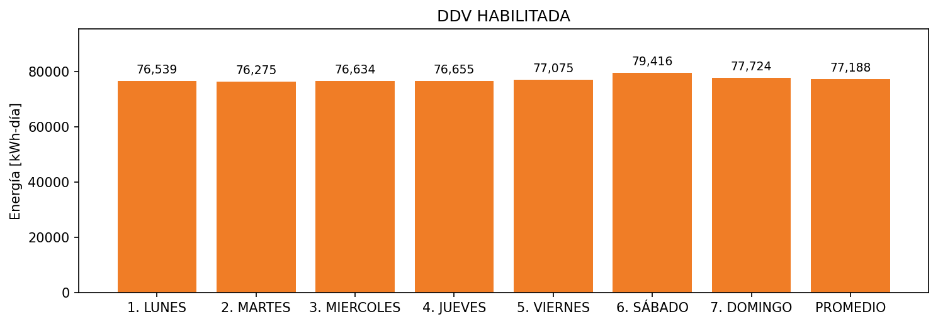

|  |  |  |  |  |  |  |  |  |  |
| --- | --- | --- | --- | --- | --- | --- | --- | --- | --- |
| **FRONTERA** | **COD SIC** | **FRT DDV** | **TIPO DDV** | **PROMEDIO** | **PRÓXIMA ACTUALIZACIÓN** | **MARGEN DE ERROR** | **ÚLTIMA PRUEBA DDV** | **DÍAS PARTICIPACIÓN** | **FECHA REFERENCIA PRÓXIMA PRUEBA DDV** |
| PETROBRAS COLOMBIA LIMITED - GUANDO | Frt06056 | Frt42735 | LBC | 77,188 | 2021-12-16 | 7,74 | 2021-09-25 | 12.0 | 2022-03-01 |