|  |  |  |  |
| --- | --- | --- | --- |
| 3 | | 36,552.0 | |
| NUMERO DE FRONTERAS | | ENERGIA AGREGADA | |
|  | | | |
| SI | | 09/01/2020 | |
| CONTRATO | | VENCIMIENTO CONTRATO | |
|  | | | |
| 76,148,044 | 108 | | 3,360,419 |
| INGRESO 2021 | DÍAS CERTIFICADOS 2021 | | ENERGIA RESPALDADA 2021 |

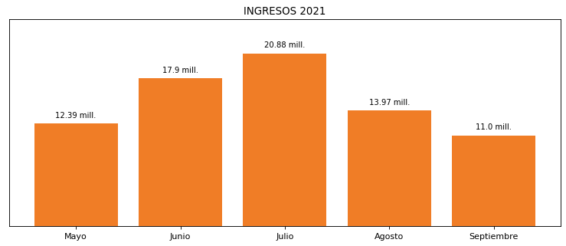

|  |
| --- |
| **ALQUERIA**  USUARIO |

|  |
| --- |
| **Mateo Porras**  Ejecutivo de cuenta |

|  |
| --- |
| **Diana Catalina Gonzalez / Gerente Compras Indirectas / dcgonzalezp@alqueria.com.co**  Primera fecha: PUNTO FOCAL |

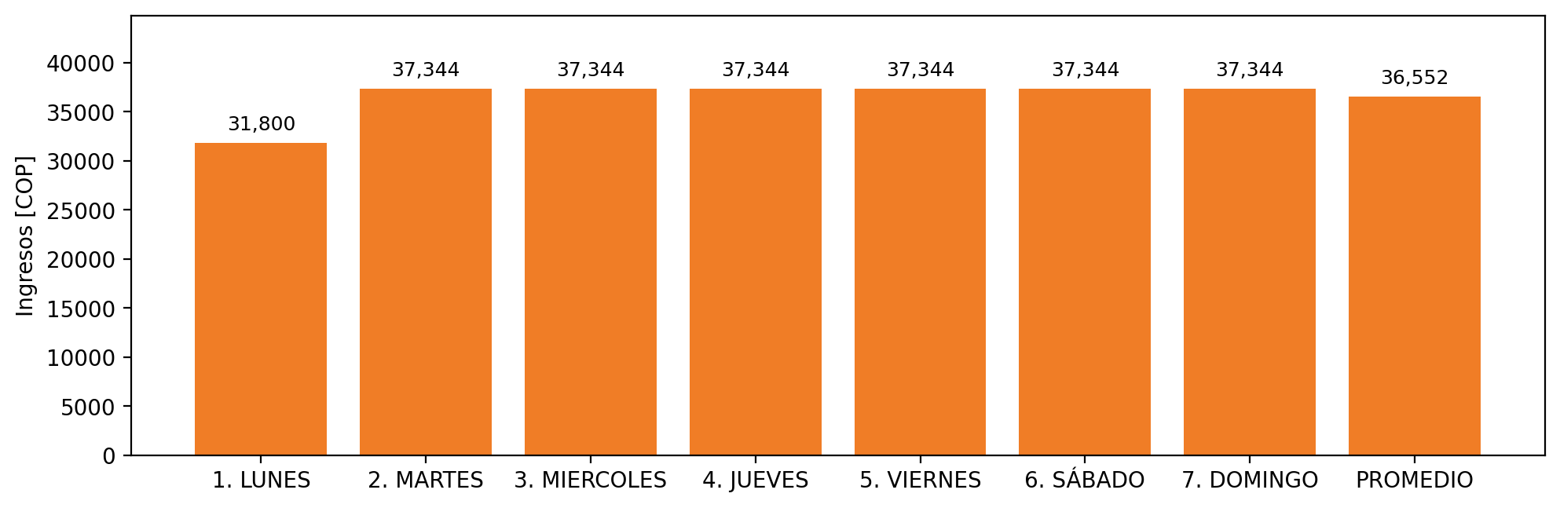

|  |  |  |  |  |  |  |  |  |  |
| --- | --- | --- | --- | --- | --- | --- | --- | --- | --- |
| **FRONTERA COMERCIAL** | **TIPO DDV** | **COD SIC** | **PREDIO** | **PROMEDIO** | **MARGEN** | **ÚLTIMA DESCONEXION** | **DÍAS CERTIFICADOS** | **ACTUALIZACION** | **PROXIMA PRUEBA DDV** |
| PRODUCTOS NATURALES DE CAJICA S.A LA ALQUERIA - 1 | Frt39977 | Frt00875 | Prd02161 | 16,800 | NO APLICA | 2021-09-06 | 13.0 | 2026-04-15 | 2022-01-24 |
| PRODUCTOS NATURALES DE CAJICA S.A LA ALQUERIA - 2 | Frt40002 | Frt00875 | Prd02161 | 16,800 | NO APLICA | 2021-09-06 | 13.0 | 2026-04-15 | 2022-01-24 |
| PRODUCTOS NATURALES DE CAJICA S.A LA ALQUERIA - 3 | Frt40003 | Frt00875 | Prd02161 | 16,800 | NO APLICA | 2021-09-06 | 13.0 | 2026-04-15 | 2022-01-24 |