|  |  |  |  |
| --- | --- | --- | --- |
| 2 | | 8,928.0 | |
| NUMERO DE FRONTERAS | | ENERGIA AGREGADA | |
|  | | | |
| SI | | 16-04-2022 | |
| CONTRATO | | VENCIMIENTO CONTRATO | |
|  | | | |
| 30,124,847 | 115 | | 1,334,141 |
| INGRESO 2021 | DÍAS CERTIFICADOS 2021 | | ENERGIA RESPALDADA 2021 |

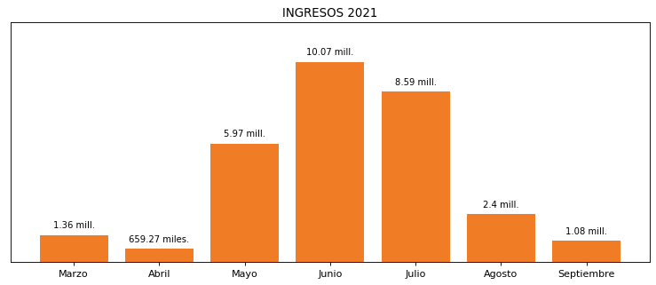

|  |
| --- |
| **APROPET**  USUARIO |

|  |
| --- |
| **Juan Marin**  Ejecutivo de cuenta |

|  |
| --- |
| **Camilo Restrepo / Coordinador de Planeamiento Financiero / crestrepo@smi.com.pe**  Primera fecha: PUNTO FOCAL |

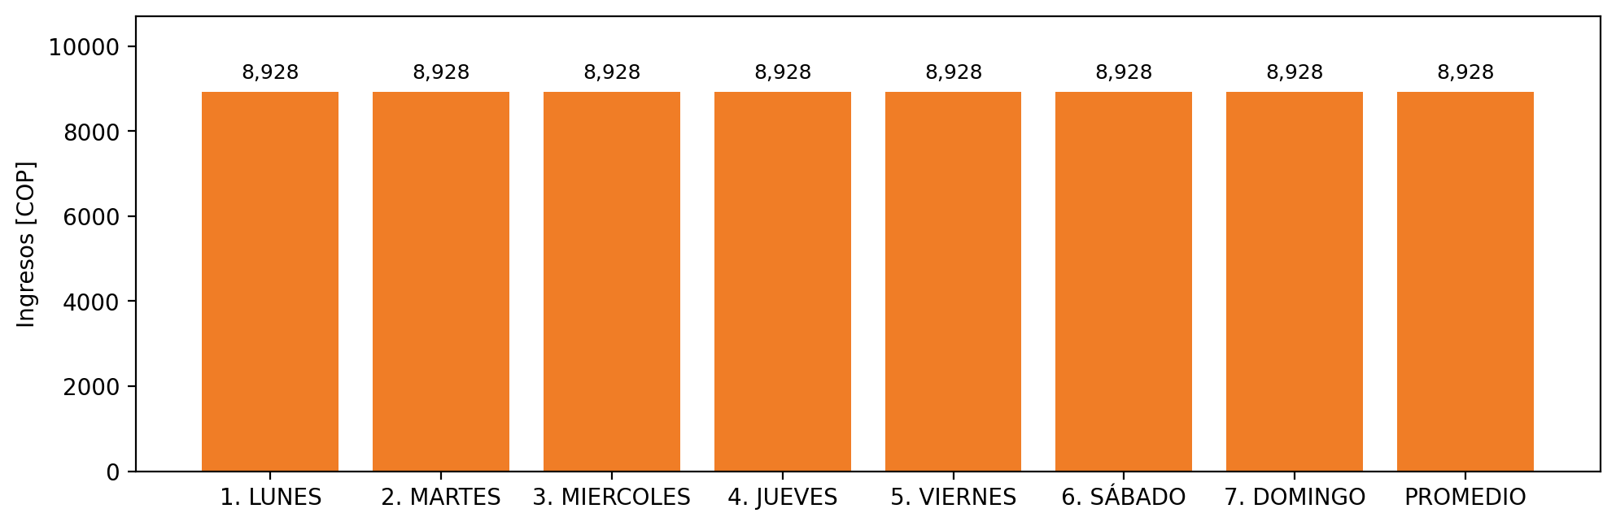

|  |  |  |  |  |  |  |  |  |  |
| --- | --- | --- | --- | --- | --- | --- | --- | --- | --- |
| **FRONTERA COMERCIAL** | **TIPO DDV** | **COD SIC** | **PREDIO** | **PROMEDIO** | **MARGEN** | **ÚLTIMA DESCONEXION** | **DÍAS CERTIFICADOS** | **ACTUALIZACION** | **PROXIMA PRUEBA DDV** |
| APROPPET REGENERADO | Frt40365 | Frt06367 | Prd02168 | 8,928 | NO APLICA | 2021-03-01 | 90.0 | 2026-04-15 | 2021-11-29 |
| APROPPET LAVADO | Frt40123 | Frt06367 | Prd02168 | 8,928 | NO APLICA | 2021-10-30 | 0.0 | 2026-04-15 | 2022-02-27 |