|  |  |  |  |
| --- | --- | --- | --- |
| 1 | | 23,075.14285714286 | |
| NUMERO DE FRONTERAS | | ENERGIA AGREGADA | |
|  | | | |
| SI | | 29/09/2022 | |
| CONTRATO | | VENCIMIENTO CONTRATO | |
|  | | | |
| 13,232,732 | 25 | | 606,000 |
| INGRESO 2020 | DÍAS CERTIFICADOS 2020 | | ENERGIA RESPALDADA 2020 |
|  | | | |
| 84,700,305 | 153 | | 3,670,871 |
| INGRESO 2021 | DÍAS CERTIFICADOS 2021 | | ENERGIA RESPALDADA 2021 |

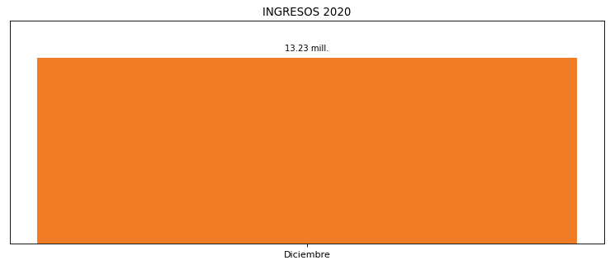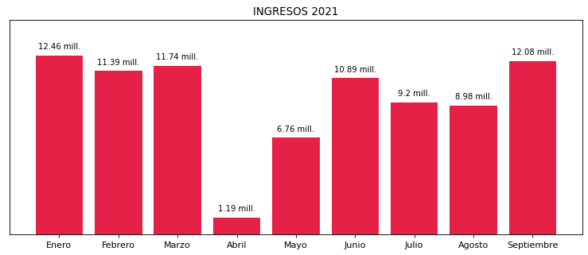

|  |
| --- |
| **BANCOLOMBIA**  USUARIO |

|  |
| --- |
| **Camilo Bermudez**  Ejecutivo de cuenta |

|  |
| --- |
| **Ruben Dario Dominguez S / Dirección Gestión del Activo e Inmobilidaria / rddoming@bancolombia.com.co**  Primera fecha: PUNTO FOCAL |

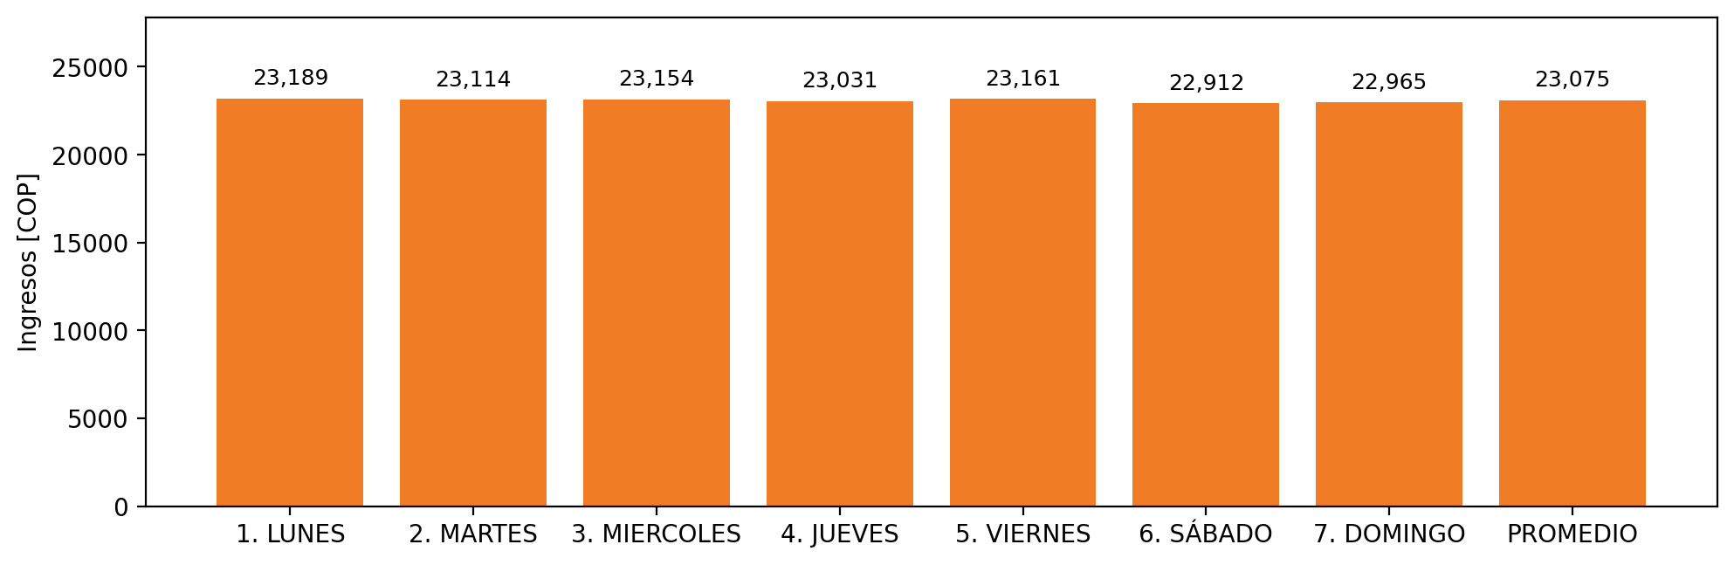

|  |  |  |  |  |  |  |  |  |  |
| --- | --- | --- | --- | --- | --- | --- | --- | --- | --- |
| **FRONTERA COMERCIAL** | **TIPO DDV** | **COD SIC** | **PREDIO** | **PROMEDIO** | **MARGEN** | **ÚLTIMA DESCONEXION** | **DÍAS CERTIFICADOS** | **ACTUALIZACION** | **PROXIMA PRUEBA DDV** |
| BANCOLOMBIA S.A. - BELLO NIVEL 3 | Frt39834 | Frt11189 | Prd02148 | 23,075 | 0,82 | 2021-09-27 | 0.0 | 2022-01-28 | 2022-02-05 |