|  |  |  |  |
| --- | --- | --- | --- |
| 1 | | 4,560.0 | |
| NUMERO DE FRONTERAS | | ENERGIA AGREGADA | |
|  | | | |
|  | |  | |
| CONTRATO | | VENCIMIENTO CONTRATO | |
|  | | | |
| 9,064,762 | 84 | | 382,561 |
| INGRESO 2021 | DÍAS CERTIFICADOS 2021 | | ENERGIA RESPALDADA 2021 |

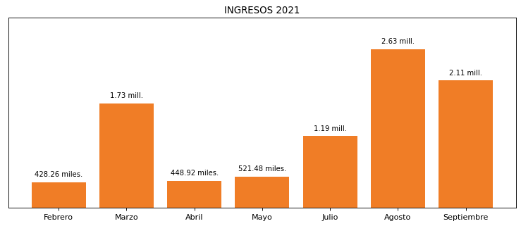

|  |
| --- |
| **BIOCOMBUSTIBLE**  USUARIO |

|  |
| --- |
| **Edwin Torres**  Ejecutivo de cuenta |

|  |
| --- |
| Primera fecha: PUNTO FOCAL |

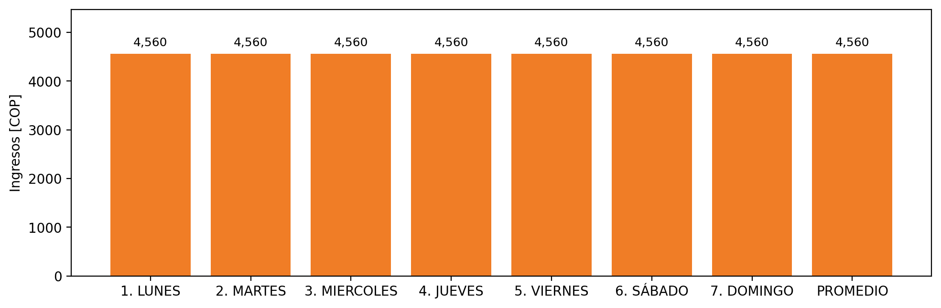

|  |  |  |  |  |  |  |  |  |  |
| --- | --- | --- | --- | --- | --- | --- | --- | --- | --- |
| **FRONTERA COMERCIAL** | **TIPO DDV** | **COD SIC** | **PREDIO** | **PROMEDIO** | **MARGEN** | **ÚLTIMA DESCONEXION** | **DÍAS CERTIFICADOS** | **ACTUALIZACION** | **PROXIMA PRUEBA DDV** |
| BIOCOMBUSTIBLE SOSTENIBLE DEL CARIBE S.A. | Frt39418 | Frt08475 | Prd02129 | 4,560 | NO APLICA | 2021-02-14 | 85.0 | 2026-04-15 | 2021-11-30 |