|  |  |  |  |
| --- | --- | --- | --- |
| 1 | | 235,244.14285714287 | |
| NUMERO DE FRONTERAS | | ENERGIA AGREGADA | |
|  | | | |
| SI | | 05/08/2020 | |
| CONTRATO | | VENCIMIENTO CONTRATO | |
|  | | | |
| 815,362,813 | 92 | | 32,503,487 |
| INGRESO 2019 | DÍAS CERTIFICADOS 2019 | | ENERGIA RESPALDADA 2019 |
|  | | | |
| 491,704,649 | 88 | | 20,190,048 |
| INGRESO 2020 | DÍAS CERTIFICADOS 2020 | | ENERGIA RESPALDADA 2020 |
|  | | | |
| 680,952,872 | 126 | | 29,647,530 |
| INGRESO 2021 | DÍAS CERTIFICADOS 2021 | | ENERGIA RESPALDADA 2021 |

|  |
| --- |
| **CARVAJAL**  USUARIO |

|  |
| --- |
| **Mateo Porras**  Ejecutivo de cuenta |

|  |
| --- |
| **Pablo Saravia / Director Compras / pablo.saravia@carvajal.com**  Primera fecha: PUNTO FOCAL |

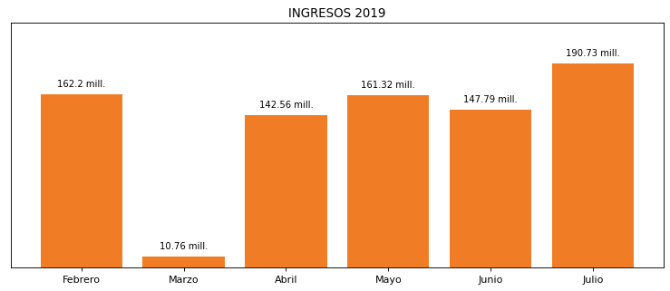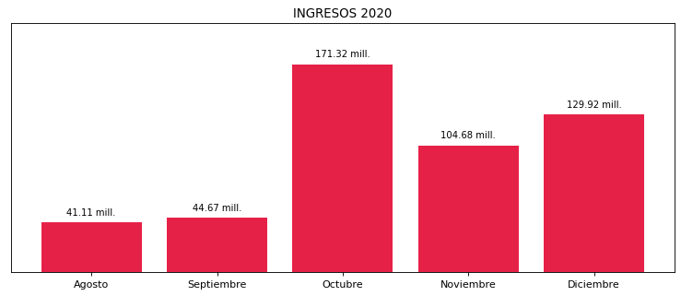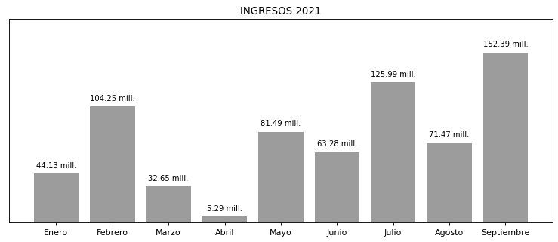

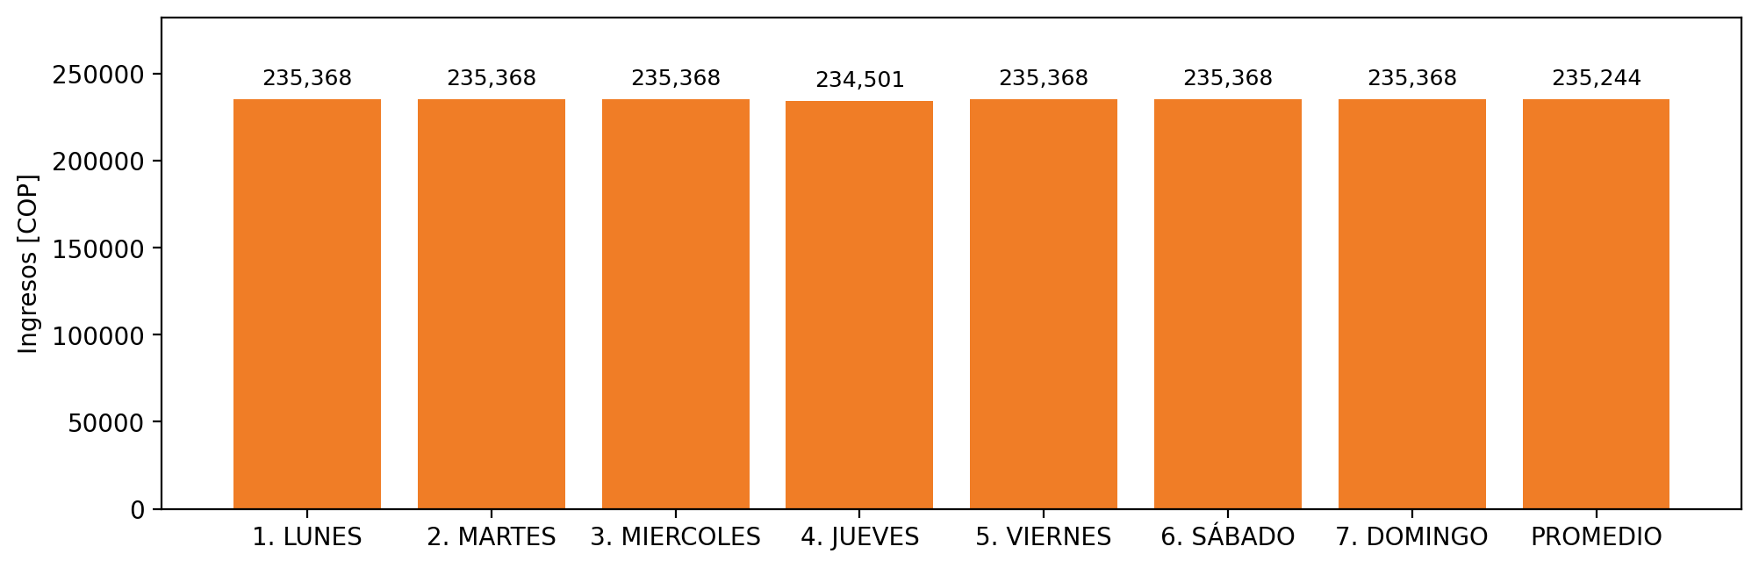

|  |  |  |  |  |  |  |  |  |  |
| --- | --- | --- | --- | --- | --- | --- | --- | --- | --- |
| **FRONTERA COMERCIAL** | **TIPO DDV** | **COD SIC** | **PREDIO** | **PROMEDIO** | **MARGEN** | **ÚLTIMA DESCONEXION** | **DÍAS CERTIFICADOS** | **ACTUALIZACION** | **PROXIMA PRUEBA DDV** |
| CARVAJAL PULPA Y PAPEL S.A. | Frt30291 | Frt11025 | Prd00789 | 235,244 | 2,59 | 2021-10-06 | 0.0 | 2022-02-25 | 2022-02-05 |