|  |  |  |  |
| --- | --- | --- | --- |
| 1 | | 68,457.14285714286 | |
| NUMERO DE FRONTERAS | | ENERGIA AGREGADA | |
|  | | | |
|  | |  | |
| CONTRATO | | VENCIMIENTO CONTRATO | |
|  | | | |
| 181,522,726 | 118 | | 7,812,488 |
| INGRESO 2021 | DÍAS CERTIFICADOS 2021 | | ENERGIA RESPALDADA 2021 |

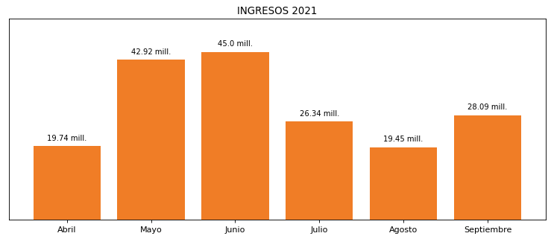

|  |
| --- |
| **EUROCERAMICA**  USUARIO |

|  |
| --- |
| **Camilo Bermudez**  Ejecutivo de cuenta |

|  |
| --- |
| Primera fecha: PUNTO FOCAL |

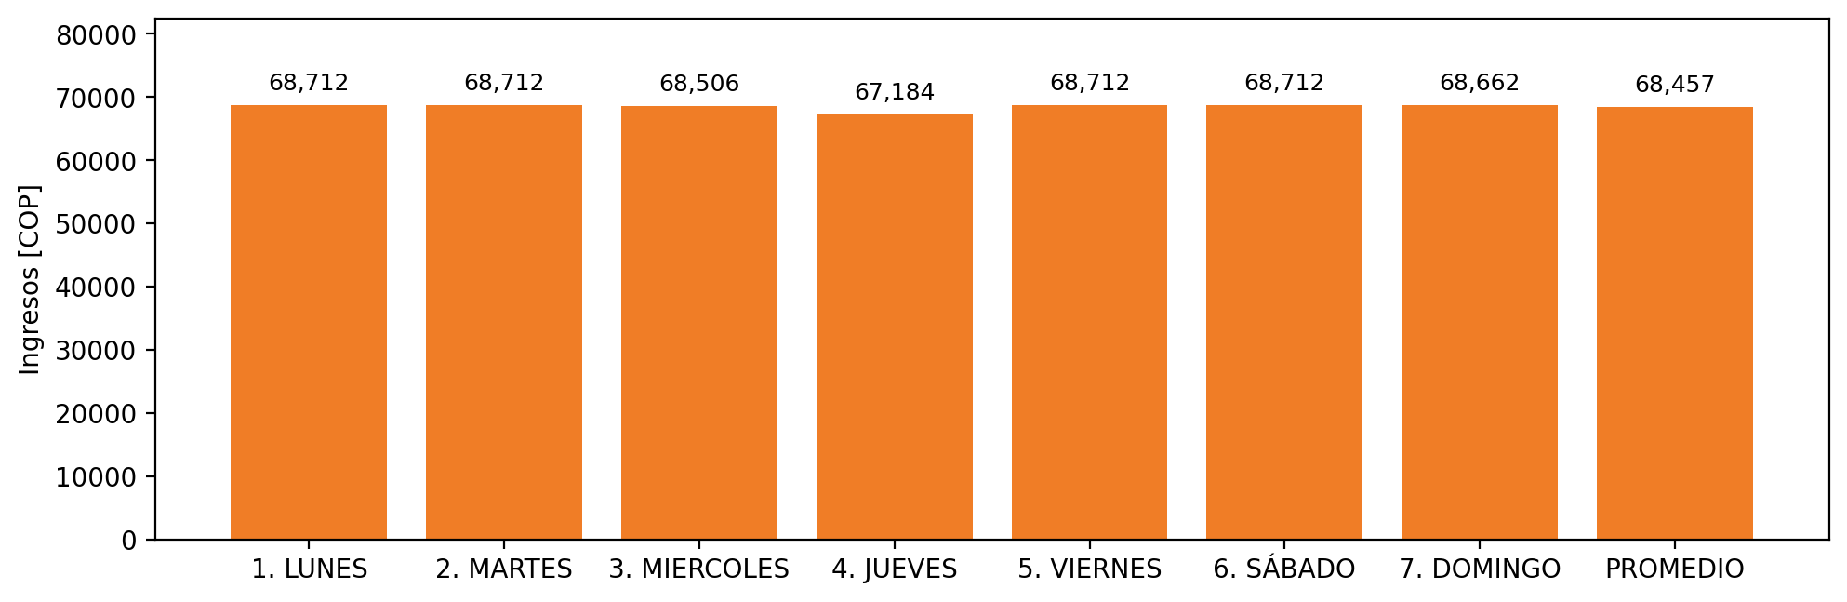

|  |  |  |  |  |  |  |  |  |  |
| --- | --- | --- | --- | --- | --- | --- | --- | --- | --- |
| **FRONTERA COMERCIAL** | **TIPO DDV** | **COD SIC** | **PREDIO** | **PROMEDIO** | **MARGEN** | **ÚLTIMA DESCONEXION** | **DÍAS CERTIFICADOS** | **ACTUALIZACION** | **PROXIMA PRUEBA DDV** |
| EUROCERAMICA S.A | Frt29409 | Frt00717 | Prd00386 | 68,457 | 2,26 | 2021-08-05 | 30.0 | 2022-01-28 | 2022-01-01 |