|  |  |  |  |
| --- | --- | --- | --- |
| 1 | | 23,156.85714285714 | |
| NUMERO DE FRONTERAS | | ENERGIA AGREGADA | |
|  | | | |
| NO | | 0 | |
| CONTRATO | | VENCIMIENTO CONTRATO | |
|  | | | |
| 32,207,994 | 83 | | 1,419,252 |
| INGRESO 2020 | DÍAS CERTIFICADOS 2020 | | ENERGIA RESPALDADA 2020 |
|  | | | |
| 46,239,351 | 89 | | 2,026,039 |
| INGRESO 2021 | DÍAS CERTIFICADOS 2021 | | ENERGIA RESPALDADA 2021 |

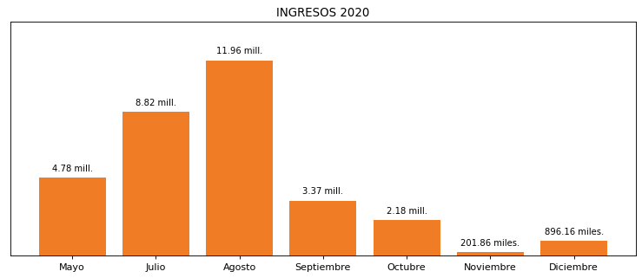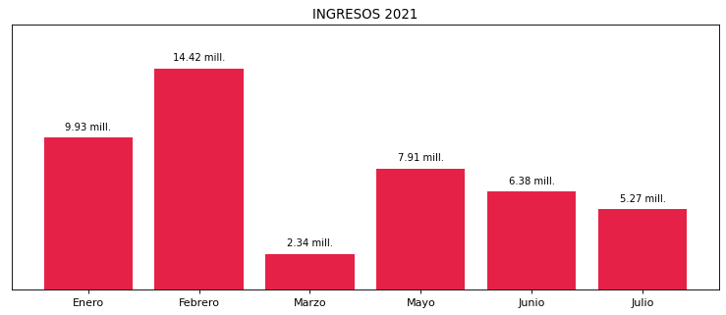

|  |
| --- |
| **FLEXOGRAFICA**  USUARIO |

|  |
| --- |
| **Camilo Bermudez**  Ejecutivo de cuenta |

|  |
| --- |
| **0**  Primera fecha: PUNTO FOCAL |

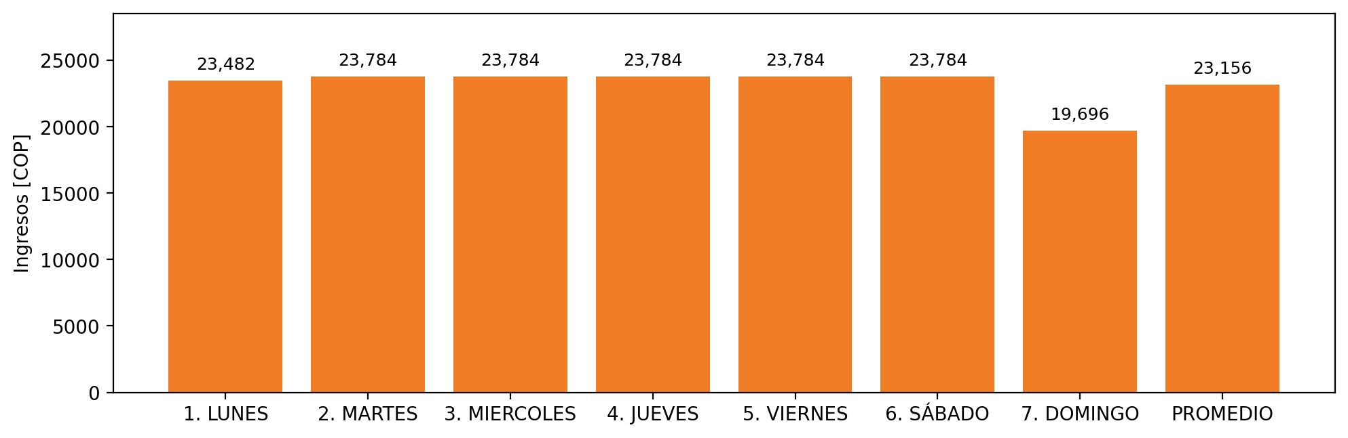

|  |  |  |  |  |  |  |  |  |  |
| --- | --- | --- | --- | --- | --- | --- | --- | --- | --- |
| **FRONTERA COMERCIAL** | **TIPO DDV** | **COD SIC** | **PREDIO** | **PROMEDIO** | **MARGEN** | **ÚLTIMA DESCONEXION** | **DÍAS CERTIFICADOS** | **ACTUALIZACION** | **PROXIMA PRUEBA DDV** |
| COLOMBIANA FLEXOGRAFICA DE PLASTICOS S.A.S. | Frt37569 | Frt02089 | Prd01977 | 23,156 | 2,97 | 2020-12-24 | 89.0 | 2022-03-02 | 2021-11-30 |