|  |  |  |  |
| --- | --- | --- | --- |
| 1 | | 10,584.0 | |
| NUMERO DE FRONTERAS | | ENERGIA AGREGADA | |
|  | | | |
| NO | | 0 | |
| CONTRATO | | VENCIMIENTO CONTRATO | |
|  | | | |
| 26,665,282 | 64 | | 974,129 |
| INGRESO 2019 | DÍAS CERTIFICADOS 2019 | | ENERGIA RESPALDADA 2019 |
|  | | | |
| 13,031,652 | 86 | | 529,675 |
| INGRESO 2020 | DÍAS CERTIFICADOS 2020 | | ENERGIA RESPALDADA 2020 |
|  | | | |
| 19,331,342 | 89 | | 834,651 |
| INGRESO 2021 | DÍAS CERTIFICADOS 2021 | | ENERGIA RESPALDADA 2021 |

|  |
| --- |
| **INDUGRAL**  USUARIO |

|  |
| --- |
| **Mateo Porras**  Ejecutivo de cuenta |

|  |
| --- |
| **Glicerio Rojas / 0 / Glicerio.Rojas2@ab-inbev.com**  Primera fecha: PUNTO FOCAL |

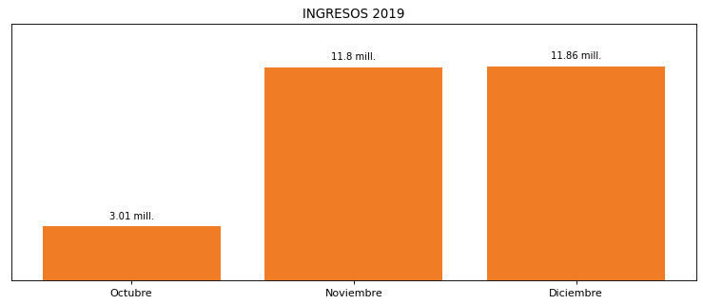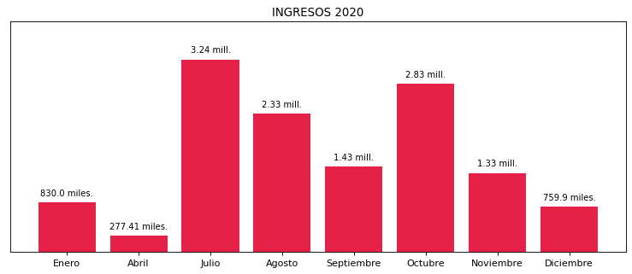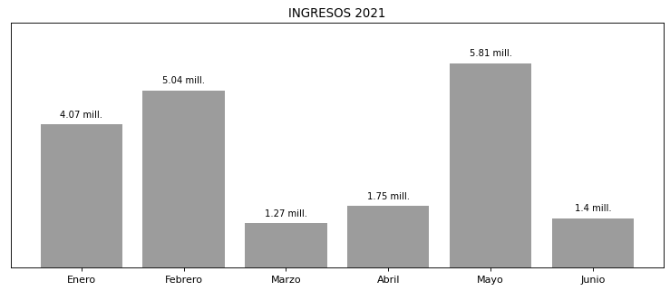

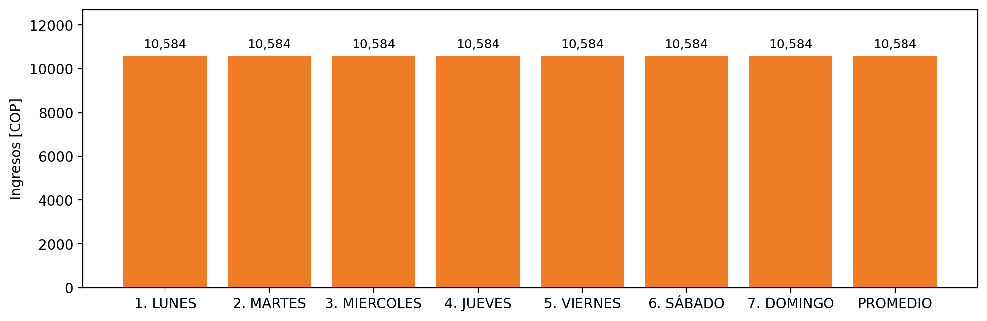

|  |  |  |  |  |  |  |  |  |  |
| --- | --- | --- | --- | --- | --- | --- | --- | --- | --- |
| **FRONTERA COMERCIAL** | **TIPO DDV** | **COD SIC** | **PREDIO** | **PROMEDIO** | **MARGEN** | **ÚLTIMA DESCONEXION** | **DÍAS CERTIFICADOS** | **ACTUALIZACION** | **PROXIMA PRUEBA DDV** |
| INDUSTRIA GRAFICA LATINOAMERICA S.A. - INDUGRAL S.A. | Frt33220 | Frt26185 | Prd01330 | 10,584 | 5,92 | 2020-12-24 | 89.0 | 2021-11-25 | 2021-11-30 |