|  |  |  |  |
| --- | --- | --- | --- |
| 156 | | 258,253.85714285716 | |
| NUMERO DE FRONTERAS | | ENERGIA AGREGADA | |
|  | | | |
| SI | | 26-11-2019 | |
| CONTRATO | | VENCIMIENTO CONTRATO | |
|  | | | |
| 814,741,725 | 211 | | 30,630,757 |
| INGRESO 2019 | DÍAS CERTIFICADOS 2019 | | ENERGIA RESPALDADA 2019 |
|  | | | |
| 943,858,281 | 204 | | 34,228,901 |
| INGRESO 2020 | DÍAS CERTIFICADOS 2020 | | ENERGIA RESPALDADA 2020 |
|  | | | |
| 542,924,489 | 204 | | 23,031,939 |
| INGRESO 2021 | DÍAS CERTIFICADOS 2021 | | ENERGIA RESPALDADA 2021 |

|  |
| --- |
| **OLIMPICA**  USUARIO |

|  |
| --- |
| **Edwin Torres**  Ejecutivo de cuenta |

|  |
| --- |
| **Jorge Orlando Vélez García / 0 / jvelez@jovega.com.co**  Primera fecha: PUNTO FOCAL |

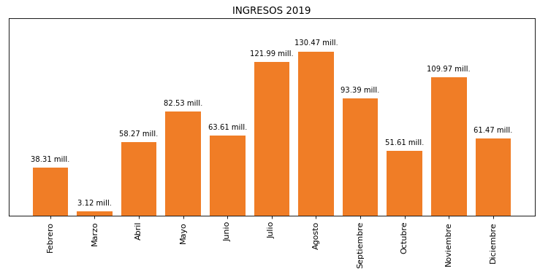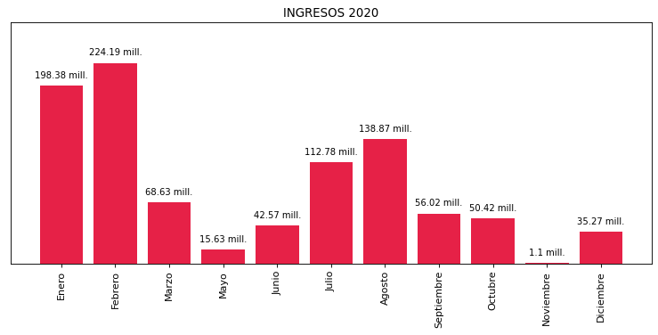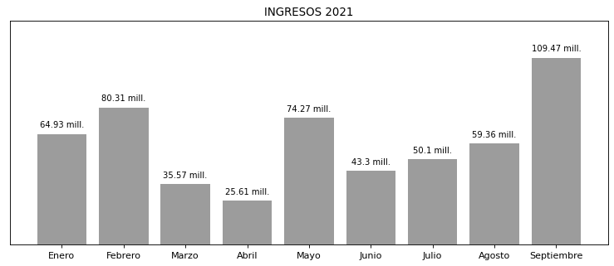

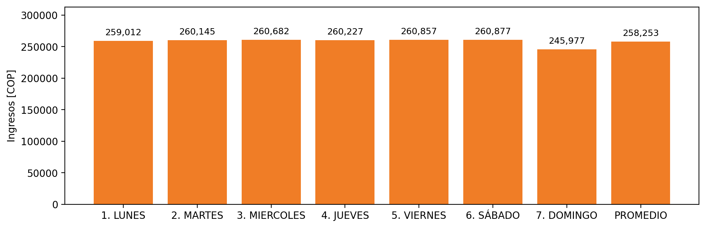

|  |  |  |  |  |  |  |  |  |  |
| --- | --- | --- | --- | --- | --- | --- | --- | --- | --- |
| **FRONTERA COMERCIAL** | **TIPO DDV** | **COD SIC** | **PREDIO** | **PROMEDIO** | **MARGEN** | **ÚLTIMA DESCONEXION** | **DÍAS CERTIFICADOS** | **ACTUALIZACION** | **PROXIMA PRUEBA DDV** |
| SUPERTIENDAS OLIMPICA BQUILLA (SAO093) | Frt31806 | Frt00594 | Prd01146 | 9,346 | 4,28 | 2021-09-28 | 0.0 | 2021-11-23 | 2022-02-06 |
| SAO HIPODROMO | Frt31804 | Frt03430 | Prd01144 | 9,346 | 4,86 | 2021-09-02 | 18.0 | 2021-11-20 | 2022-01-21 |
| OLIMPICA S.A. 5 | Frt31615 | Frt07822 | Prd01135 | 9,346 | 3,93 | 2021-08-24 | 27.0 | 2021-11-20 | 2022-01-11 |
| SUPERTIENDAS OLIMPICA FONTIBON | Frt33361 | Frt06806 | Prd01361 | 9,346 | 2,6 | 2021-07-06 | 49.0 | 2021-11-23 | 2021-12-13 |
| OLIMPICA NEIVA | Frt33360 | Frt01924 | Prd01360 | 9,346 | 2,75 | 2021-07-06 | 48.0 | 2021-11-23 | 2021-12-15 |
| OLIMPICA S.A. 12 | Frt32274 | Frt09662 | Prd01207 | 9,346 | 3,82 | 2021-05-28 | 83.0 | 2021-11-20 | 2021-11-29 |
| SUPERTIENDAS Y DROGUERIAS OLIMPICA | Frt31594 | Frt02098 | Prd01128 | 9,346 | 3,63 | 2021-07-13 | 47.0 | 2021-11-20 | 2021-12-17 |
| OLIMPICA SA | Frt32851 | Frt22335 | Prd01303 | 9,346 | 4,42 | 2021-09-03 | 15.0 | 2021-11-25 | 2022-01-25 |
| OLIMPICA SA | Frt32379 | Frt29009 | Prd01229 | 9,346 | 2,1 | 2021-09-10 | 9.0 | 2022-02-26 | 2022-01-31 |
| OLIMPICA SA | Frt32768 | Frt29231 | Prd01288 | 9,346 | 3,16 | 2021-05-28 | 81.0 | 2021-11-24 | 2021-11-29 |
| OLIMPICA SA | Frt32085 | Frt20185 | Prd01168 | 9,346 | 3,1 | 2021-06-29 | 55.0 | 2021-11-20 | 2021-12-10 |
| OLIMPICA DE LA PAJUELA | Frt32769 | Frt01642 | Prd01289 | 9,346 | 4,82 | 2021-06-29 | 58.0 | 2021-11-23 | 2021-12-06 |
| OLIMPICA SA | Frt32361 | Frt24611 | Prd01227 | 9,346 | 3,73 | 2021-06-29 | 60.0 | 2021-11-20 | 2021-12-05 |
| SUPERTIENDAS Y DROGUERIAS OLIMPICA S.A. 4 | Frt32884 | Frt01655 | Prd01308 | 9,346 | 4,73 | 2021-08-24 | 26.0 | 2021-11-23 | 2022-01-13 |
| SUPERTIENDAS Y DROGUERIAS OLIMPICA S.A. 8 | Frt32360 | Frt03963 | Prd01226 | 9,346 | 4,07 | 2021-07-19 | 40.0 | 2021-11-23 | 2021-12-28 |
| OLIMPICA S.A. (ALMACEN OMNI PLAZA) | Frt32242 | Frt02977 | Prd01204 | 9,346 | 3,98 | 2021-09-03 | 16.0 | 2021-11-23 | 2022-01-24 |
| SUPERTIENDAS Y DROGUERIA OLIMPICAS S.A. | Frt32345 | Frt01965 | Prd01222 | 9,346 | 3,2 | 2021-09-28 | 0.0 | 2022-01-01 | 2022-02-09 |
| OLIMPICA BOCAGRANDE | Frt32322 | Frt02735 | Prd01219 | 9,346 | 4,45 | 2021-09-28 | 0.0 | 2021-11-23 | 2022-02-06 |
| OLIMPICA S.A CALLE 84 | Frt31618 | Frt01110 | Prd01138 | 9,346 | 2,68 | 2021-06-29 | 60.0 | 2021-11-20 | 2021-12-04 |
| SUPERTIENDAS Y DROGUERIAS OLIMPICA S.A. | Frt32034 | Frt01657 | Prd01161 | 9,346 | 5,6 | 2021-06-29 | 61.0 | 2021-11-23 | 2021-12-05 |
| OLIMPICA S.A. 22 | Frt37959 | Frt10013 | Prd02038 | 9,346 | 6,24 | 2021-09-03 | 12.0 | 2022-02-25 | 2022-01-29 |
| OLIMPICA COLINA | Frt33296 | Frt01158 | Prd01353 | 9,346 | 2,13 | 2021-07-19 | 46.0 | 2021-11-23 | 2021-12-21 |
| OLIMPICA SA | Frt32184 | Frt18705 | Prd01198 | 9,346 | 5,13 | 2021-08-24 | 27.0 | 2021-11-25 | 2022-01-10 |
| OLIMPICA SA | Frt41704 | Frt24702 | Prd02211 | 9,346 | 4,78 | 2021-07-19 | 40.0 | 2021-11-25 | 2021-12-25 |
| OLIMPICA S.A. 8 | Frt36765 | Frt08124 | Prd01689 | 9,346 | 6,2 | 2021-09-21 | 0.0 | 2021-11-25 | 2022-02-02 |
| LA GALERIA Y CIA LTDA 2 | Frt33208 | Frt00991 | Prd01322 | 9,346 | 1,91 | 2021-07-19 | 44.0 | 2021-11-23 | 2021-12-28 |
| AL MÃXIMO S.A. | Frt36767 | Frt04385 | Prd01691 | 9,346 | 6,27 | 2021-07-06 | 55.0 | 2021-11-23 | 2021-12-11 |
| OLIMPICA S.A. | Frt33439 | Frt01934 | Prd01370 | 9,346 | 1,72 | 2021-09-10 | 7.0 | 2021-11-23 | 2022-01-30 |
| OLIMPICA S.A. 24 | Frt33365 | Frt09620 | Prd01365 | 9,346 | 1,68 | 2021-07-06 | 50.0 | 2021-11-23 | 2021-12-15 |
| OLIMPICA S.A. - ACOPIO YUMBO | Frt36768 | Frt11493 | Prd01692 | 9,346 | 4,49 | 2021-07-19 | 48.0 | 2021-11-23 | 2021-12-20 |
| OLIMPICA S.A CALLE 72 | Frt31619 | Frt01133 | Prd01139 | 9,346 | 3,01 | 2021-05-28 | 80.0 | 2021-11-20 | 2021-11-29 |
| OLIMPICA S.A. 4 | Frt31617 | Frt07821 | Prd01137 | 9,346 | 5,92 | 2021-07-13 | 52.0 | 2021-11-20 | 2021-12-16 |
| SUPERTIENDAS Y DROGUERIAS OLIMPICAS S.A. | Frt32344 | Frt01794 | Prd01221 | 9,346 | 5,62 | 2021-09-02 | 18.0 | 2021-11-25 | 2022-01-20 |
| SUPERTIENDAS Y DROGUERIA OLIMPICA S.A. ( VALLEDUPAR) | Frt32600 | Frt07273 | Prd01255 | 9,346 | 3,61 | 2021-09-03 | 15.0 | 2021-11-24 | 2022-01-24 |
| OLIMPCA 21 | Frt31805 | Frt01134 | Prd01145 | 9,346 | 5,47 | 2021-08-24 | 27.0 | 2021-11-23 | 2022-01-11 |
| SAO SUBA | Frt33295 | Frt01215 | Prd01352 | 9,346 | 1,24 | 2021-09-10 | 8.0 | 2021-11-23 | 2022-02-03 |
| LA GALERIA Y CIA S.A. (VILLACOLOMBIA) | Frt33086 | Frt05887 | Prd01319 | 9,346 | 2,28 | 2021-07-19 | 46.0 | 2021-11-23 | 2021-12-21 |
| SUPERTIENDAS Y DROGUERIAS OLIMPICA S.A. 7 | Frt33364 | Frt04960 | Prd01364 | 9,346 | 1,92 | 2021-05-28 | 85.0 | 2022-01-28 | 2021-11-29 |
| OLIMPICA SA 119 | Frt32316 | Frt26182 | Prd01214 | 9,346 | 3,47 | 2021-09-03 | 15.0 | 2022-02-25 | 2022-01-29 |
| OLIMPICA SA | Frt32317 | Frt25874 | Prd01215 | 9,346 | 4,92 | 2021-06-29 | 62.0 | 2021-11-23 | 2021-12-07 |
| OLIMPICA | Frt36090 | Frt29690 | Prd01523 | 9,346 | 10,57 | 2019-12-08 | 0.0 | 2021-11-25 | 2021-12-11 |
| OLIMPICA SA | Frt41708 | Frt36177 | Prd02213 | 9,346 | 3,71 | 2021-07-13 | 41.0 | 2021-11-25 | 2021-12-26 |
| OLIMPICA S.A. - TERMINAL | Frt32348 | Frt11895 | Prd01225 | 9,346 | 2,46 | 2021-09-28 | 0.0 | 2021-11-25 | 2022-02-04 |
| OLIMPICA SA | Frt32089 | Frt20150 | Prd01172 | 9,346 | 3,34 | 2021-09-28 | 0.0 | 2022-02-25 | 2022-02-06 |
| OLIMPICA TEQUENDAMA | Frt32396 | Frt02079 | Prd01243 | 9,346 | 2,23 | 2021-09-10 | 8.0 | 2022-02-26 | 2022-02-02 |
| OLIMPICA S.A. - TANGANAZO | Frt32091 | Frt14205 | Prd01174 | 9,346 | 3,63 | 2021-07-13 | 52.0 | 2021-11-20 | 2021-12-12 |
| OLIMPICA SA | Frt32774 | Frt24194 | Prd01294 | 9,346 | 8,49 | 2021-09-28 | 0.0 | 2022-02-25 | 2022-02-07 |
| OLIMPICA S.A. - SAHAGUN | Frt32848 | Frt11519 | Prd01300 | 9,346 | 6,64 | 2021-07-06 | 50.0 | 2021-11-25 | 2021-12-15 |
| OLIMPICA SA | Frt32176 | Frt24328 | Prd01191 | 9,346 | 3,03 | 2021-09-02 | 18.0 | 2021-11-20 | 2022-01-21 |
| OLIMPICA SA | Frt32183 | Frt25877 | Prd01197 | 9,346 | 3,73 | 2021-09-28 | 0.0 | 2021-11-25 | 2022-02-06 |
| OLIMPICA S.A. 11 | Frt32181 | Frt09649 | Prd01195 | 9,346 | 4,11 | 2021-07-27 | 36.0 | 2022-01-28 | 2022-01-08 |
| AUTO SERVICIO CAÑAVERAL | Frt33034 | Frt01373 | Prd01315 | 9,346 | 3,19 | 2021-07-19 | 47.0 | 2021-11-23 | 2021-12-15 |
| OLIMPICA SA | Frt32601 | Frt23708 | Prd01256 | 9,346 | 4,03 | 2021-09-28 | 0.0 | 2021-11-23 | 2022-02-09 |
| OLIMPICA S.A. 16 | Frt33209 | Frt09630 | Prd01323 | 9,346 | 2,21 | 2021-09-10 | 8.0 | 2021-11-23 | 2022-02-02 |
| OLIMPICA SA | Frt32392 | Frt22156 | Prd01239 | 9,346 | 2,09 | 2021-09-10 | 8.0 | 2021-11-23 | 2022-02-01 |
| OLIMPICA SA - 13 DE JUNIO | Frt32275 | Frt14426 | Prd01208 | 9,346 | 4,49 | 2021-09-03 | 15.0 | 2022-01-28 | 2022-01-27 |
| OLIMPICA SA | Frt32036 | Frt28303 | Prd01163 | 9,346 | 3,9 | 2021-08-24 | 27.0 | 2021-11-20 | 2022-01-16 |
| OLIMPICA SA | Frt32086 | Frt24296 | Prd01169 | 9,346 | 3,1 | 2021-08-24 | 27.0 | 2021-11-20 | 2022-01-11 |
| OLIMPICA SA 376 - Manizales | Frt38806 | Frt36092 | Prd02096 | 9,346 | 1,84 | 2021-09-21 | 0.0 | 2022-02-10 | 2022-02-10 |
| OLIMPICA SA | Frt32849 | Frt24295 | Prd01301 | 9,346 | 6,99 | 2021-06-29 | 62.0 | 2021-11-25 | 2021-12-04 |
| OLIMPICA SA | Frt32139 | Frt25807 | Prd01183 | 9,346 | 4,08 | 2021-06-29 | 58.0 | 2021-11-23 | 2021-12-08 |
| OLIMPICA SA - VILLACANDELA | Frt32276 | Frt14425 | Prd01209 | 9,346 | 3,64 | 2021-07-19 | 45.0 | 2022-02-25 | 2021-12-23 |
| OLIMPICA SA | Frt36818 | Frt21303 | Prd01693 | 9,346 | 7,07 | 2021-09-21 | 0.0 | 2022-03-01 | 2022-02-06 |
| OLIMPICA POPAYAN | Frt36759 | Frt02077 | Prd01683 | 9,346 | 2,3 | 2021-09-10 | 9.0 | 2021-11-23 | 2022-02-01 |
| SUPERTIENDA OLIMPICA LA COQUERA | Frt32846 | Frt06378 | Prd01298 | 9,346 | 5,33 | 2021-06-29 | 61.0 | 2021-11-23 | 2021-12-07 |
| OLIMPICA S.A. - CAMPESTRE | Frt32318 | Frt29184 | Prd01216 | 9,346 | 4,16 | 2021-09-03 | 14.0 | 2022-01-28 | 2022-01-23 |
| OLIMPICA SA | Frt32180 | Frt20184 | Prd01194 | 9,346 | 4,83 | 2021-07-13 | 45.0 | 2022-02-25 | 2021-12-25 |
| OLIMPICA SANTA ANA | Frt33289 | Frt01190 | Prd01346 | 9,346 | 1,19 | 2021-09-10 | 8.0 | 2022-01-28 | 2022-02-02 |
| LA GALERIA Y COMPAÑIA S.A. SALOMIA | Frt33035 | Frt04076 | Prd01316 | 9,346 | 3,12 | 2021-07-19 | 47.0 | 2021-11-23 | 2021-12-17 |
| OLIMPICA S.A. - VILLAVICENCIO | Frt36763 | Frt05844 | Prd01687 | 9,346 | 2,39 | 2021-07-19 | 48.0 | 2021-11-23 | 2021-12-19 |
| OLIMPICA S.A. | Frt32238 | Frt01694 | Prd01200 | 9,346 | 1,78 | 2021-04-14 | 59.0 | 2021-11-23 | 2021-12-21 |
| OLIMPICA S.A. | Frt36766 | Frt29139 | Prd01690 | 9,346 | 5,67 | 2021-09-02 | 18.0 | 2022-03-01 | 2022-01-20 |
| OLIMPICA SA | Frt32604 | Frt22273 | Prd01259 | 9,346 | 5,06 | 2021-05-28 | 82.0 | 2022-02-26 | 2021-11-29 |
| OLIMPICA SA | Frt32378 | Frt22278 | Prd01228 | 9,346 | 2,42 | 2021-09-03 | 16.0 | 2022-01-28 | 2022-01-22 |
| OLIMPICA S.A. 18 | Frt33362 | Frt08268 | Prd01362 | 9,346 | 1,66 | 2021-07-19 | 47.0 | 2021-11-23 | 2021-12-18 |
| OLIMPICA SA | Frt32132 | Frt26160 | Prd01176 | 9,346 | 3,01 | 2021-07-13 | 51.0 | 2021-11-20 | 2021-12-14 |
| OLIMPICA S.A. - PLANETA RICA | Frt32850 | Frt12071 | Prd01302 | 9,346 | 5,03 | 2021-09-03 | 16.0 | 2022-02-25 | 2022-01-24 |
| OLIMPICA CRA 14 | Frt32088 | Frt07232 | Prd01171 | 9,346 | 4,46 | 2021-08-24 | 27.0 | 2022-03-02 | 2022-01-12 |
| SUPERTIENDAS Y DROGUERIAS OLIMPICA S.A. 3 | Frt32087 | Frt01652 | Prd01170 | 9,346 | 5,02 | 2021-07-13 | 52.0 | 2021-11-20 | 2021-12-12 |
| OLIMPICA SA - BADILLO | Frt32237 | Frt14392 | Prd01199 | 9,346 | 12,65 | 2020-11-10 | 88.0 | 2021-11-20 | 2021-11-27 |
| OLIMPICA CIUDADELA | Frt32137 | Frt06250 | Prd01181 | 9,346 | 4,88 | 2021-08-24 | 27.0 | 2021-11-20 | 2022-01-16 |
| OLIMPICA LIBERTADOR | Frt32346 | Frt06400 | Prd01223 | 9,346 | 5,7 | 2021-09-02 | 18.0 | 2022-02-25 | 2022-01-27 |
| OLIMPICA S.A. - LOS ROBLES | Frt32141 | Frt14204 | Prd01185 | 9,346 | 6,68 | 2021-09-02 | 18.0 | 2022-02-25 | 2022-01-22 |
| OLIMPICA SA | Frt32393 | Frt28199 | Prd01240 | 9,346 | 4,89 | 2021-05-28 | 80.0 | 2022-02-26 | 2021-11-29 |
| OLIMPICA S.A. 10 | Frt32272 | Frt09131 | Prd01205 | 9,346 | 2,52 | 2021-07-19 | 44.0 | 2021-11-20 | 2021-12-24 |
| OLIMPICA SA | Frt32084 | Frt28779 | Prd01167 | 9,346 | 3,83 | 2021-08-24 | 27.0 | 2021-11-20 | 2022-01-13 |
| OLIMPICA S.A. 9 | Frt32321 | Frt08494 | Prd01218 | 9,346 | 4,84 | 2021-09-03 | 16.0 | 2022-01-28 | 2022-01-25 |
| OLIMPICA CRA 7 | Frt32026 | Frt07221 | Prd01157 | 9,346 | 4,68 | 2021-08-24 | 27.0 | 2022-02-26 | 2022-01-13 |
| OLIMPICA SA | Frt32767 | Frt22323 | Prd01287 | 9,346 | 4,26 | 2021-06-29 | 62.0 | 2021-11-23 | 2021-12-07 |
| OLIMPICA SA | Frt32481 | Frt28294 | Prd01251 | 9,346 | 4,64 | 2021-09-02 | 20.0 | 2022-02-27 | 2022-01-18 |
| OLIMPICA CIUDADELA SEDE2 | Frt32090 | Frt06251 | Prd01173 | 9,346 | 4,07 | 2021-08-24 | 27.0 | 2021-11-20 | 2022-01-14 |
| OLIMPICA NORMANDIA | Frt33294 | Frt01160 | Prd01351 | 9,346 | 1,97 | 2021-09-10 | 9.0 | 2021-11-23 | 2022-01-30 |
| OLIMPICA LAS ESTRELLAS | Frt32037 | Frt06412 | Prd01164 | 9,346 | 5,07 | 2021-07-13 | 46.0 | 2021-11-20 | 2021-12-24 |
| OLIMPICA SA | Frt32143 | Frt22260 | Prd01187 | 9,346 | 4,77 | 2021-07-27 | 38.0 | 2021-11-25 | 2021-12-30 |
| OLIMPICA S.A. 6 | Frt32027 | Frt07823 | Prd01158 | 9,346 | 4,45 | 2021-09-28 | 0.0 | 2021-11-20 | 2022-02-09 |
| OLIMPICA S.A. CALLE 22 | Frt32391 | Frt07203 | Prd01238 | 9,346 | 2,07 | 2021-09-10 | 9.0 | 2022-01-28 | 2022-01-31 |
| OLIMPICA S.A. - SAO PORTAL 80 | Frt33363 | Frt05756 | Prd01363 | 9,346 | 1,95 | 2020-05-08 | 79.0 | 2022-01-28 | 2021-11-30 |
| OLIMPICA SA | Frt32033 | Frt24206 | Prd01160 | 9,346 | 2,61 | 2021-05-28 | 81.0 | 2021-11-23 | 2021-11-29 |
| OLIMPICA S.A. - ARGELIA | Frt32772 | Frt29183 | Prd01292 | 9,346 | 6,06 | 2021-06-29 | 56.0 | 2022-02-25 | 2021-12-13 |
| OLIMPICA ACACIAS | Frt32398 | Frt02080 | Prd01245 | 9,346 | 4,19 | 2021-07-19 | 48.0 | 2022-02-26 | 2021-12-20 |
| OLIMPICA SA | Frt33358 | Frt22180 | Prd01358 | 9,346 | 2,75 | 2021-07-06 | 57.0 | 2022-02-10 | 2021-12-09 |
| OLIMPICA SA | Frt32482 | Frt28209 | Prd01252 | 9,346 | 6,83 | 2021-07-27 | 39.0 | 2021-11-25 | 2021-12-27 |
| OLIMPICA SA | Frt32039 | Frt28565 | Prd01166 | 9,346 | 4,97 | 2021-08-24 | 27.0 | 2022-02-25 | 2022-01-12 |
| OLIMPICA SA | Frt32142 | Frt25810 | Prd01186 | 9,346 | 3,85 | 2021-09-02 | 18.0 | 2022-02-25 | 2022-01-22 |
| OLIMPICA STO 224 | Frt36761 | Frt33469 | Prd01685 | 9,346 | 18,29 | 2021-09-03 | 16.0 | 2022-03-01 | 2022-01-22 |
| OLIMPICA QUINTA RAMOS | Frt33293 | Frt01353 | Prd01350 | 9,346 | 2,35 | 2021-09-10 | 9.0 | 2021-11-23 | 2022-01-28 |
| OLIMPICA SA | Frt37965 | Frt28310 | Prd02039 | 9,346 | 5,03 | 2021-09-03 | 19.0 | 2022-02-25 | 2022-01-21 |
| OLIMPICA S.A. 2 | Frt32032 | Frt07819 | Prd01159 | 9,346 | 3,63 | 2021-08-24 | 27.0 | 2021-11-20 | 2022-01-09 |
| OLIMPICA SA | Frt32179 | Frt21296 | Prd01193 | 9,346 | 6,68 | 2021-09-28 | 0.0 | 2022-02-25 | 2022-02-11 |
| OLIMPICA SA | Frt32320 | Frt28274 | Prd01217 | 9,346 | 3,88 | 2021-09-03 | 16.0 | 2022-02-25 | 2022-01-22 |
| OLIMPICA SA | Frt32389 | Frt28197 | Prd01236 | 9,346 | 4,01 | 2021-09-02 | 18.0 | 2022-02-26 | 2022-01-22 |
| OLIMPICA STO 080 | Frt36760 | Frt33470 | Prd01684 | 9,346 | 5,83 | 2021-06-29 | 57.0 | 2021-11-23 | 2021-12-10 |
| OLIMPICA SA | Frt32140 | Frt20137 | Prd01184 | 9,346 | 4,73 | 2021-05-04 | 89.0 | 2022-03-02 | 2021-11-30 |
| OLIMPICA SA STO 223 | Frt36764 | Frt32916 | Prd01688 | 9,346 | 7,59 | 2021-09-02 | 16.0 | 2022-03-01 | 2022-01-23 |
| OLIMPICA SA | Frt32178 | Frt25875 | Prd01192 | 9,346 | 3,23 | 2021-09-28 | 0.0 | 2021-11-25 | 2022-02-05 |
| OLIMPICA MANIZALEZ | Frt33442 | Frt03915 | Prd01373 | 9,346 | 1,52 | 2021-09-10 | 8.0 | 2021-11-23 | 2022-01-29 |
| OLIMPICA SA STO 224 | Frt36762 | Frt32911 | Prd01686 | 9,346 | 9,66 | 2021-05-28 | 85.0 | 2022-03-01 | 2021-11-30 |
| OLIMPICA SA | Frt32035 | Frt28196 | Prd01162 | 9,346 | 2,54 | 2021-08-24 | 25.0 | 2021-11-20 | 2022-01-13 |
| OLIMPICA SA | Frt32480 | Frt28264 | Prd01250 | 9,346 | 4,24 | 2021-04-14 | 59.0 | 2022-02-26 | 2021-12-24 |
| SUPERTIENDAS OLIMPICA BQUILLA (SAO001) | Frt31803 | FRT00593 | Prd01143 | 9,346 | 2,27 | 2018-10-01 | 0.0 | 2021-11-20 | 2022-02-26 |
|  |  |  |  |  |  |  |  |  |  |
| CARULLA VIVERO Y CIA S.A. | Frt33437 | Frt01152 | Prd01368 | 9,346 | 2,02 | 2018-10-01 | 0.0 | 2021-11-20 | 2022-02-27 |
| OLIMPICA CHICO | Frt33291 | Frt01159 | Prd01348 | 9,346 | 2,16 | 2020-05-19 | 84.0 | 2021-11-23 | 2021-11-29 |
| SAO PLAZA | Frt33290 | Frt01162 | Prd01347 | 9,346 | 1,53 | 2020-05-08 | 79.0 | 2022-01-28 | 2021-11-26 |
|  |  |  |  |  |  |  |  |  |  |
|  |  |  |  |  |  |  |  |  |  |
|  |  |  |  |  |  |  |  |  |  |
|  |  |  |  |  |  |  |  |  |  |
|  |  |  |  |  |  |  |  |  |  |
|  |  |  |  |  |  |  |  |  |  |