|  |  |  |  |
| --- | --- | --- | --- |
| 1 | | 77,188.28571428571 | |
| NUMERO DE FRONTERAS | | ENERGIA AGREGADA | |
|  | | | |
| SI | | 0 | |
| CONTRATO | | VENCIMIENTO CONTRATO | |

|  |
| --- |
| **PERENCO**  USUARIO |

|  |
| --- |
| **Mateo Porras**  Ejecutivo de cuenta |

|  |
| --- |
| **Sergio Segura**  Primera fecha: PUNTO FOCAL |

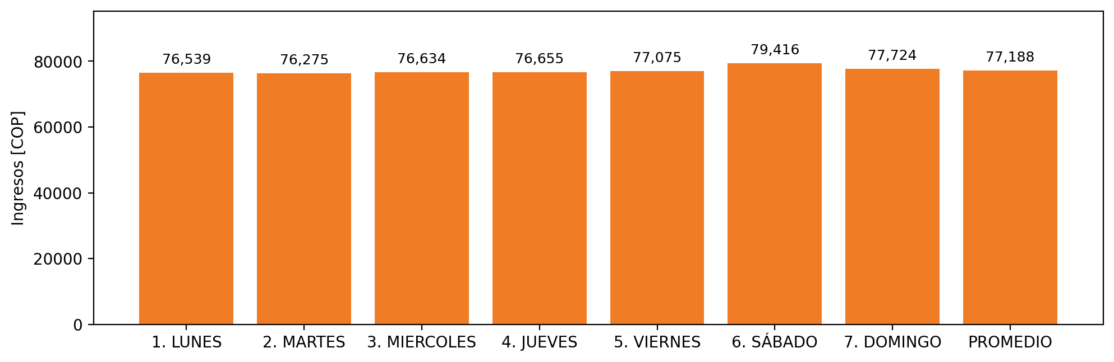

|  |  |  |  |  |  |  |  |  |  |
| --- | --- | --- | --- | --- | --- | --- | --- | --- | --- |
| **FRONTERA COMERCIAL** | **TIPO DDV** | **COD SIC** | **PREDIO** | **PROMEDIO** | **MARGEN** | **ÚLTIMA DESCONEXION** | **DÍAS CERTIFICADOS** | **ACTUALIZACION** | **PROXIMA PRUEBA DDV** |
| PETROBRAS COLOMBIA LIMITED - GUANDO | Frt42735 | Frt06056 | Prd02303 | 77,188 | 7,74 | 2021-09-25 | 0.0 | 2021-12-16 | 2022-02-14 |