|  |  |  |  |
| --- | --- | --- | --- |
| 2 | | 34,800.0 | |
| NUMERO DE FRONTERAS | | ENERGIA AGREGADA | |
|  | | | |
| NO | | 0 | |
| CONTRATO | | VENCIMIENTO CONTRATO | |
|  | | | |
| 34,386,822 | 68 | | 1,423,973 |
| INGRESO 2020 | DÍAS CERTIFICADOS 2020 | | ENERGIA RESPALDADA 2020 |
|  | | | |
| 94,193,576 | 154 | | 4,104,664 |
| INGRESO 2021 | DÍAS CERTIFICADOS 2021 | | ENERGIA RESPALDADA 2021 |

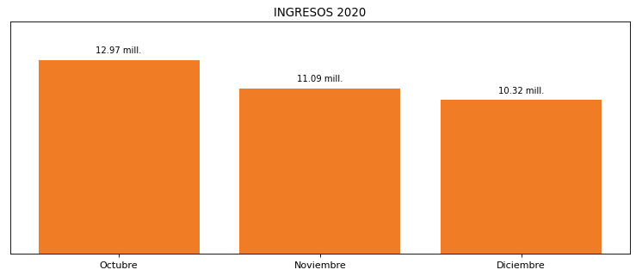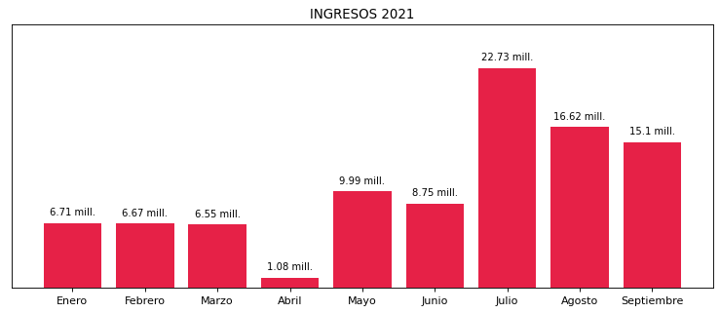

|  |
| --- |
| **ULTRACEM**  USUARIO |

|  |
| --- |
| **Edwin Torres**  Ejecutivo de cuenta |

|  |
| --- |
| **0**  Primera fecha: PUNTO FOCAL |

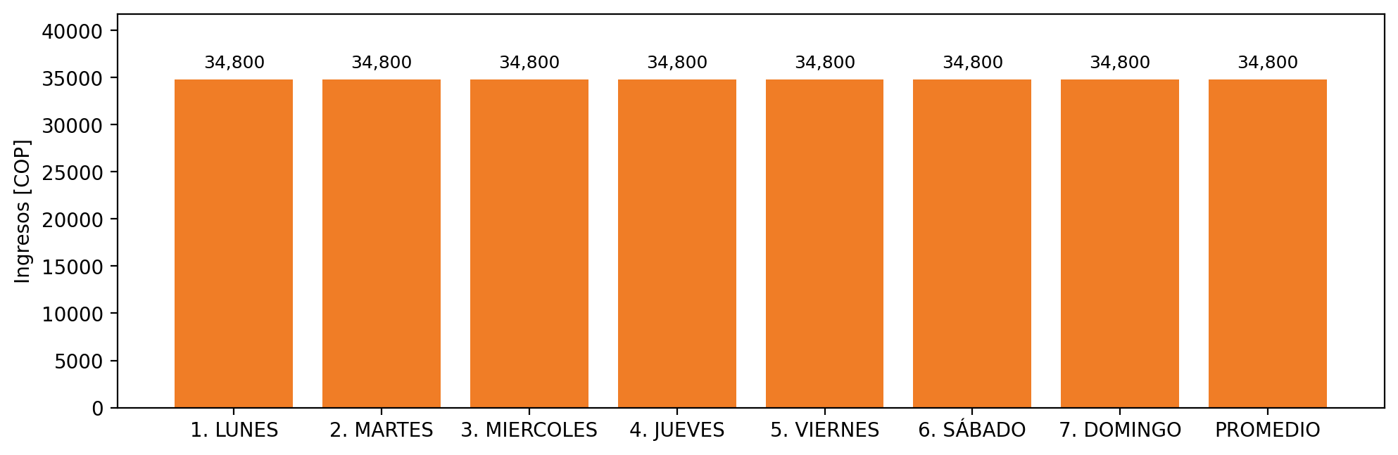

|  |  |  |  |  |  |  |  |  |  |
| --- | --- | --- | --- | --- | --- | --- | --- | --- | --- |
| **FRONTERA COMERCIAL** | **TIPO DDV** | **COD SIC** | **PREDIO** | **PROMEDIO** | **MARGEN** | **ÚLTIMA DESCONEXION** | **DÍAS CERTIFICADOS** | **ACTUALIZACION** | **PROXIMA PRUEBA DDV** |
| CEMENTOS ATLANTICOS SAS | Frt36860 | Frt24826 | Prd01695 | 21,840 | NO APLICA | 2021-06-23 | 99.0 | 2023-04-15 | 2021-11-30 |
| CEMENTOS ATLANTICOS SAS | Frt41951 | Frt24826 | Prd01695 | 21,840 | NO APLICA | 2021-06-23 | 38.0 | 2026-04-15 | 2021-11-30 |