|  |  |  |  |
| --- | --- | --- | --- |
| 1 | | 48,000 | |
| **NUMERO DE FRONTERAS** | | **ENERGIA AGREGADA** | |







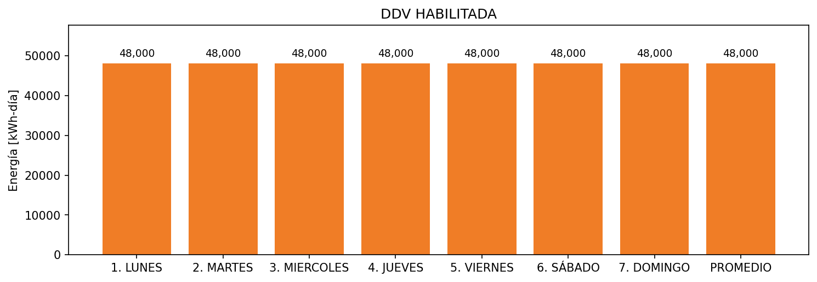

|  |  |  |  |  |  |  |  |  |  |
| --- | --- | --- | --- | --- | --- | --- | --- | --- | --- |
| **FRONTERA** | **COD SIC** | **FRT DDV** | **TIPO DDV** | **PROMEDIO** | **PRÓXIMA ACTUALIZACIÓN** | **MARGEN DE ERROR** | **ÚLTIMA PRUEBA DDV** | **DÍAS PARTICIPACIÓN** | **FECHA REFERENCIA PRÓXIMA PRUEBA DDV** |
| SOCIEDAD PORTUARIA DE SANTA MARTA - SMITCO | Frt11901 | Frt43293 | GPE | 48,000 | 2026-04-15 | NO APLICA | 2021-10-13 | 0.0 | 2022-03-08 |