|  |  |  |  |
| --- | --- | --- | --- |
| 1 | | 29,568.0 | |
| NUMERO DE FRONTERAS | | ENERGIA AGREGADA | |
|  | | | |
|  | |  | |
| CONTRATO | | VENCIMIENTO CONTRATO | |
|  | | | |
| 95,073,739 | 133 | | 3,819,880 |
| INGRESO 2020 | DÍAS CERTIFICADOS 2020 | | ENERGIA RESPALDADA 2020 |
|  | | | |
| 96,060,236 | 146 | | 4,137,393 |
| INGRESO 2021 | DÍAS CERTIFICADOS 2021 | | ENERGIA RESPALDADA 2021 |

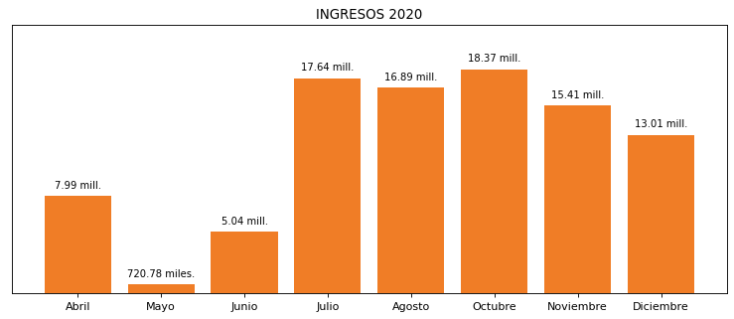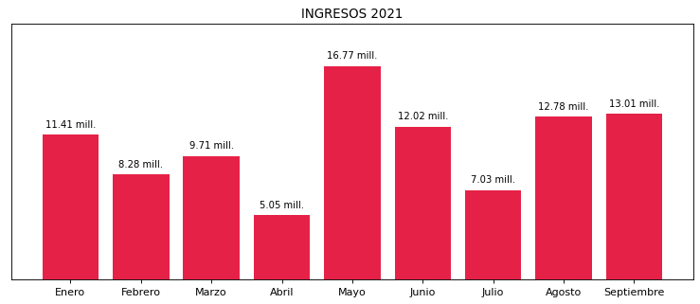

|  |
| --- |
| **SMI**  USUARIO |

|  |
| --- |
| **Juan Marin**  Ejecutivo de cuenta |

|  |
| --- |
| **Camilo Restrepo / Coordinador de Planeamiento Financiero / crestrepo@smi.com.pe**  PUNTO FOCAL |

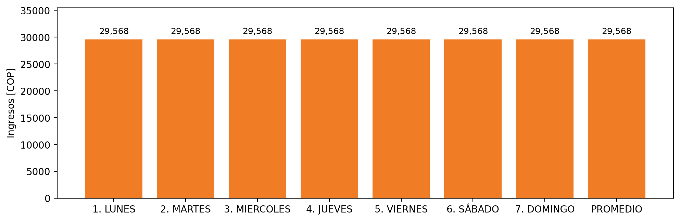

|  |  |  |  |  |  |  |  |  |  |  |
| --- | --- | --- | --- | --- | --- | --- | --- | --- | --- | --- |
| **FRONTERA** | **COD SIC** | **PREDIO** | **FRT DDV** | **TIPO DDV** | **PROMEDIO** | **PRÓXIMA ACTUALIZACIÓN** | **MARGEN DE ERROR** | **ÚLTIMA PRUEBA DDV** | **DÍAS PARTICIPACIÓN** | **FECHA REFERENCIA PRÓXIMA PRUEBA DDV** |
| SMI COLOMBIA SAS | Frt25132 | Prd01516 | Frt36036 | LBC | 29,568 | 2022-02-25 | 9,55 | 2021-07-16 | 39.0 | 2021-12-19 |