|  |  |  |  |
| --- | --- | --- | --- |
| 1 | | 29,568 | |
| **NUMERO DE FRONTERAS** | | **ENERGIA AGREGADA** | |
|  | | | |
| 95,073,739 | 133 | | 3,819,880 |
| INGRESO 2020 | DÍAS CERTIFICADOS 2020 | | ENERGIA RESPALDADA 2020 |
|  | | | |
| 109,849,004 | 169 | | 4,817,402 |
| INGRESO 2021 | DÍAS CERTIFICADOS 2021 | | ENERGIA RESPALDADA 2021 |

**HISTORICO REINTEGRO DDV**

|  |  |  |
| --- | --- | --- |
|  | **2020** | **2021** |
| **ENE** | - | 11.41 |
| **FEB** | - | 8.28 |
| **MAR** | - | 9.71 |
| **ABR** | 7.99 | 5.05 |
| **MAY** | 0.72 | 16.77 |
| **JUN** | 5.04 | 12.02 |
| **JUL** | 17.64 | 7.03 |
| **AGO** | 16.89 | 12.78 |
| **SEP** | - | 13.01 |
| **OCT** | 18.37 | 13.79 |
| **NOV** | 15.41 | - |
| **DIC** | 13.01 | - |

**Los valores de la tabla están en millones de COP**

**REINTEGRO MECANISMO DDV OCTUBRE 2021**

|  |  |  |  |  |  |
| --- | --- | --- | --- | --- | --- |
| FECHA | TIPO DIA | CANTIDADES RESPALDO | PRECIO PONDERADO USD | TRM | PNETO |
| 2021-10-06 | Miércoles | 29,567 | 5.98 | 3,784.44 | 599,540 |
| 2021-10-07 | Jueves | 29,561 | 5.98 | 3,784.44 | 599,418 |
| 2021-10-08 | Viernes | 29,567 | 5.98 | 3,784.44 | 599,540 |
| 2021-10-09 | Sábado | 29,567 | 5.98 | 3,784.44 | 599,540 |
| 2021-10-10 | Domingo - Festivo | 29,567 | 5.98 | 3,784.44 | 599,540 |
| 2021-10-11 | Lunes | 29,567 | 5.98 | 3,784.44 | 599,540 |
| 2021-10-12 | Martes | 29,566 | 5.98 | 3,784.44 | 599,520 |
| 2021-10-13 | Miércoles | 29,566 | 5.98 | 3,784.44 | 599,520 |
| 2021-10-14 | Jueves | 29,566 | 5.98 | 3,784.44 | 599,520 |
| 2021-10-15 | Viernes | 29,566 | 5.98 | 3,784.44 | 599,520 |
| 2021-10-19 | Martes | 29,561 | 5.98 | 3,784.44 | 599,418 |
| 2021-10-20 | Miércoles | 29,563 | 5.98 | 3,784.44 | 599,459 |
| 2021-10-21 | Jueves | 29,566 | 5.98 | 3,784.44 | 599,520 |
| 2021-10-22 | Viernes | 29,561 | 5.98 | 3,784.44 | 599,418 |
| 2021-10-23 | Sábado | 29,566 | 5.98 | 3,784.44 | 599,520 |
| 2021-10-24 | Domingo - Festivo | 29,566 | 5.98 | 3,784.44 | 599,520 |
| 2021-10-25 | Lunes | 29,566 | 5.98 | 3,784.44 | 599,520 |
| 2021-10-26 | Martes | 29,567 | 5.98 | 3,784.44 | 599,540 |
| 2021-10-27 | Miércoles | 29,567 | 5.98 | 3,784.44 | 599,540 |
| 2021-10-28 | Jueves | 29,566 | 5.98 | 3,784.44 | 599,520 |
| 2021-10-29 | Viernes | 29,566 | 5.98 | 3,784.44 | 599,520 |
| 2021-10-30 | Sábado | 29,567 | 5.98 | 3,784.44 | 599,540 |
| 2021-10-31 | Domingo - Festivo | 29,567 | 5.98 | 3,784.44 | 599,540 |

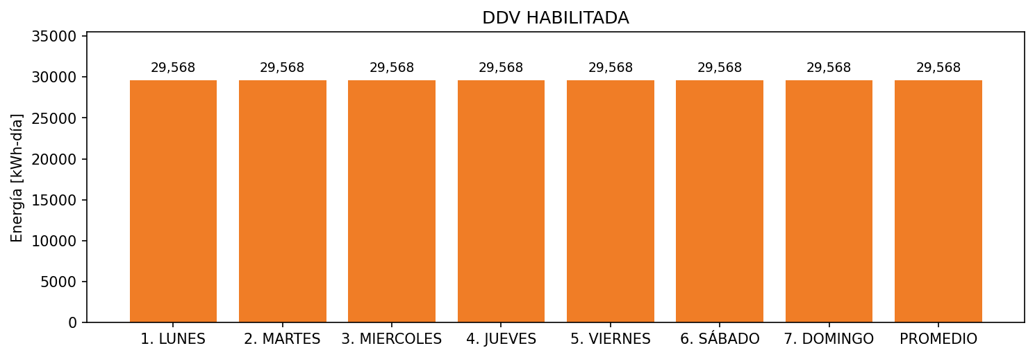

|  |  |  |  |  |  |  |  |  |  |
| --- | --- | --- | --- | --- | --- | --- | --- | --- | --- |
| **FRONTERA** | **COD SIC** | **FRT DDV** | **TIPO DDV** | **PROMEDIO** | **PRÓXIMA ACTUALIZACIÓN** | **MARGEN DE ERROR** | **ÚLTIMA PRUEBA DDV** | **DÍAS PARTICIPACIÓN** | **FECHA REFERENCIA PRÓXIMA PRUEBA DDV** |
| SMI COLOMBIA SAS | Frt25132 | Frt36036 | LBC | 29,568 | 2022-02-25 | 9,55 | 2021-07-16 | 62.0 | 2021-12-31 |