|  |  |  |  |
| --- | --- | --- | --- |
| 2 | | 34,800 | |
| **NUMERO DE FRONTERAS** | | **ENERGIA AGREGADA** | |
|  | | | |
| 34,386,822 | 68 | | 1,423,973 |
| INGRESO 2020 | DÍAS CERTIFICADOS 2020 | | ENERGIA RESPALDADA 2020 |
|  | | | |
| 108,568,136 | 175 | | 4,813,562 |
| INGRESO 2021 | DÍAS CERTIFICADOS 2021 | | ENERGIA RESPALDADA 2021 |

**HISTORICO REINTEGRO DDV**

|  |  |  |
| --- | --- | --- |
|  | **2020** | **2021** |
| **ENE** | - | 6.71 |
| **FEB** | - | 6.67 |
| **MAR** | - | 6.55 |
| **ABR** | - | 1.08 |
| **MAY** | - | 9.99 |
| **JUN** | - | 8.75 |
| **JUL** | - | 22.73 |
| **AGO** | - | 16.62 |
| **SEP** | - | 15.1 |
| **OCT** | 12.97 | 14.37 |
| **NOV** | 11.09 | - |
| **DIC** | 10.32 | - |

**Los valores de la tabla están en millones de COP**

**REINTEGRO MECANISMO DDV OCTUBRE 2021**

|  |  |  |  |  |  |
| --- | --- | --- | --- | --- | --- |
| FECHA | TIPO DIA | CANTIDADES RESPALDO | PRECIO PONDERADO USD | TRM | PNETO |
| 2021-10-01 | Viernes | 34,798 | 5.98 | 3,784.44 | 705,611 |
| 2021-10-07 | Jueves | 34,797 | 5.98 | 3,784.44 | 705,590 |
| 2021-10-08 | Viernes | 12,959 | 5.98 | 3,784.44 | 262,774 |
| 2021-10-09 | Sábado | 34,798 | 5.98 | 3,784.44 | 705,611 |
| 2021-10-10 | Domingo - Festivo | 34,797 | 5.98 | 3,784.44 | 705,590 |
| 2021-10-11 | Lunes | 34,798 | 5.98 | 3,784.44 | 705,611 |
| 2021-10-12 | Martes | 34,797 | 5.98 | 3,784.44 | 705,590 |
| 2021-10-13 | Miércoles | 34,797 | 5.98 | 3,784.44 | 705,590 |
| 2021-10-14 | Jueves | 34,796 | 5.98 | 3,784.44 | 705,570 |
| 2021-10-15 | Viernes | 34,797 | 5.98 | 3,784.44 | 705,590 |
| 2021-10-16 | Sábado | 34,797 | 5.98 | 3,784.44 | 705,590 |
| 2021-10-17 | Domingo - Festivo | 34,797 | 5.98 | 3,784.44 | 705,590 |
| 2021-10-18 | Domingo - Festivo | 34,798 | 5.98 | 3,784.44 | 705,611 |
| 2021-10-19 | Martes | 34,798 | 5.98 | 3,784.44 | 705,611 |
| 2021-10-20 | Miércoles | 34,792 | 5.98 | 3,784.44 | 705,489 |
| 2021-10-21 | Jueves | 34,797 | 5.98 | 3,784.44 | 705,590 |
| 2021-10-22 | Viernes | 34,797 | 5.98 | 3,784.44 | 705,590 |
| 2021-10-23 | Sábado | 34,797 | 5.98 | 3,784.44 | 705,590 |
| 2021-10-24 | Domingo - Festivo | 34,797 | 5.98 | 3,784.44 | 705,590 |
| 2021-10-25 | Lunes | 34,797 | 5.98 | 3,784.44 | 705,590 |
| 2021-10-26 | Martes | 34,797 | 5.98 | 3,784.44 | 705,590 |

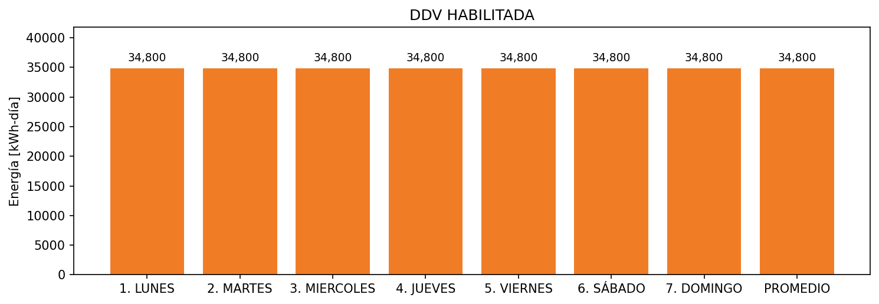

|  |  |  |  |  |  |  |  |  |  |
| --- | --- | --- | --- | --- | --- | --- | --- | --- | --- |
| **FRONTERA** | **COD SIC** | **FRT DDV** | **TIPO DDV** | **PROMEDIO** | **PRÓXIMA ACTUALIZACIÓN** | **MARGEN DE ERROR** | **ÚLTIMA PRUEBA DDV** | **DÍAS PARTICIPACIÓN** | **FECHA REFERENCIA PRÓXIMA PRUEBA DDV** |
| CEMENTOS ATLANTICOS SAS | Frt24826 | Frt36860 | GPE | 21,840 | 2023-04-15 | NO APLICA | 2021-06-23 | 119.0 | 2021-12-18 |
| CEMENTOS ATLANTICOS SAS | Frt24826 | Frt41951 | GPE | 12,960 | 2026-04-15 | NO APLICA | 2021-06-23 | 59.0 | 2021-12-18 |