|  |  |  |  |
| --- | --- | --- | --- |
| 1 | | 19,300.0 | |
| NUMERO DE FRONTERAS | | ENERGIA AGREGADA | |
|  | | | |
|  | |  | |
| CONTRATO | | VENCIMIENTO CONTRATO | |
|  | | | |
| 44,952,071 | 93 | | 1,953,923 |
| INGRESO 2021 | DÍAS CERTIFICADOS 2021 | | ENERGIA RESPALDADA 2021 |

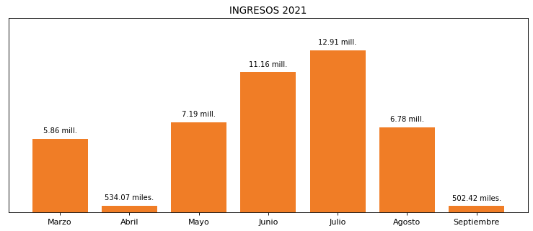

|  |
| --- |
| **ZUANA**  USUARIO |

|  |
| --- |
| **Edwin Torres**  Ejecutivo de cuenta |

|  |
| --- |
| **0**  PUNTO FOCAL |

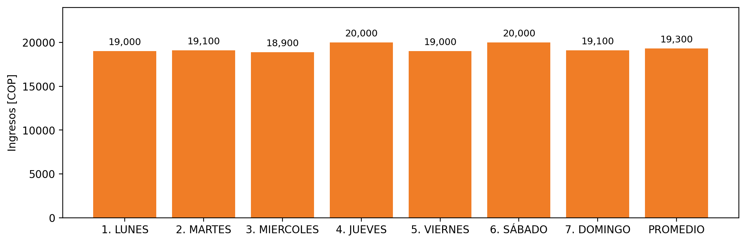

|  |  |  |  |  |  |  |  |  |  |  |
| --- | --- | --- | --- | --- | --- | --- | --- | --- | --- | --- |
| **FRONTERA** | **COD SIC** | **PREDIO** | **FRT DDV** | **TIPO DDV** | **PROMEDIO** | **PRÓXIMA ACTUALIZACIÓN** | **MARGEN DE ERROR** | **ÚLTIMA PRUEBA DDV** | **DÍAS PARTICIPACIÓN** | **FECHA REFERENCIA PRÓXIMA PRUEBA DDV** |
| ZUANA CLUB | Frt11150 | Prd02011 | Frt37814 | LBC | 19,300 | 2022-02-16 | 5,38 | 2021-10-07 | 0.0 | 2022-02-19 |