|  |  |  |  |
| --- | --- | --- | --- |
| 1 | | 19,300 | |
| **NUMERO DE FRONTERAS** | | **ENERGIA AGREGADA** | |
|  | | | |
| 50,435,224 | 105 | | 2,224,331 |
| INGRESO 2021 | DÍAS CERTIFICADOS 2021 | | ENERGIA RESPALDADA 2021 |

**HISTORICO REINTEGRO DDV**

|  |  |
| --- | --- |
|  | **2021** |
| **ENE** | - |
| **FEB** | - |
| **MAR** | 5.86 |
| **ABR** | 0.53 |
| **MAY** | 7.19 |
| **JUN** | 11.16 |
| **JUL** | 12.91 |
| **AGO** | 6.78 |
| **SEP** | 0.5 |
| **OCT** | 5.48 |
| **NOV** | - |
| **DIC** | - |

**Los valores de la tabla están en millones de COP**

**REINTEGRO MECANISMO DDV OCTUBRE 2021**

|  |  |  |  |  |  |
| --- | --- | --- | --- | --- | --- |
| FECHA | TIPO DIA | CANTIDADES RESPALDO | PRECIO PONDERADO USD | TRM | PNETO |
| 2021-10-17 | Domingo - Festivo | 21,718 | 5.98 | 3,784.44 | 440,383 |
| 2021-10-18 | Domingo - Festivo | 21,718 | 5.98 | 3,784.44 | 440,383 |
| 2021-10-19 | Martes | 22,750 | 5.98 | 3,784.44 | 461,309 |
| 2021-10-20 | Miércoles | 22,750 | 5.98 | 3,784.44 | 461,309 |
| 2021-10-21 | Jueves | 22,750 | 5.98 | 3,784.44 | 461,309 |
| 2021-10-22 | Viernes | 22,750 | 5.98 | 3,784.44 | 461,309 |
| 2021-10-23 | Sábado | 22,750 | 5.98 | 3,784.44 | 461,309 |
| 2021-10-24 | Domingo - Festivo | 22,414 | 5.98 | 3,784.44 | 454,496 |
| 2021-10-25 | Lunes | 22,558 | 5.98 | 3,784.44 | 457,416 |
| 2021-10-26 | Martes | 22,750 | 5.98 | 3,784.44 | 461,309 |
| 2021-10-27 | Miércoles | 22,750 | 5.98 | 3,784.44 | 461,309 |
| 2021-10-28 | Jueves | 22,750 | 5.98 | 3,784.44 | 461,309 |

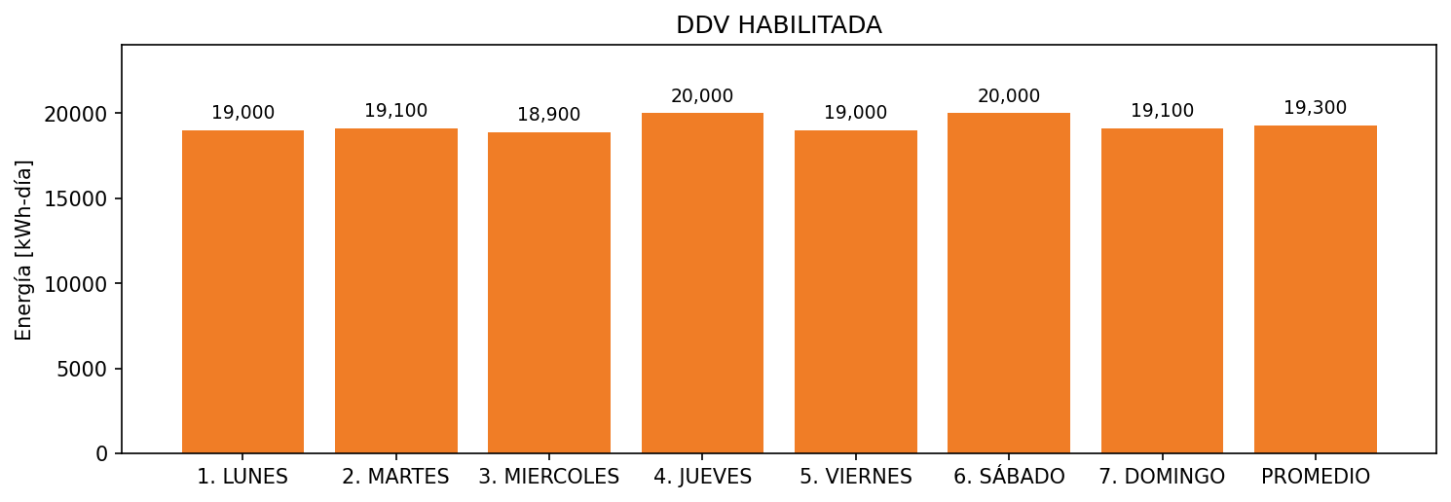

|  |  |  |  |  |  |  |  |  |  |
| --- | --- | --- | --- | --- | --- | --- | --- | --- | --- |
| **FRONTERA** | **COD SIC** | **FRT DDV** | **TIPO DDV** | **PROMEDIO** | **PRÓXIMA ACTUALIZACIÓN** | **MARGEN DE ERROR** | **ÚLTIMA PRUEBA DDV** | **DÍAS PARTICIPACIÓN** | **FECHA REFERENCIA PRÓXIMA PRUEBA DDV** |
| ZUANA CLUB | Frt11150 | Frt37814 | LBC | 19,300 | 2022-02-16 | 5,38 | 2021-10-07 | 12.0 | 2022-03-02 |