**Projektauftrag-2 Webauftritt Portfolio**

Technische Berufschule

M293

Nasrin Jafari

Table of Contents

Project Description 3

Site Map 3

# Project Description

The Project is a static website which is multiple page consists of 3 pages:

1. Home
2. Projects
3. Contact

# Site Map

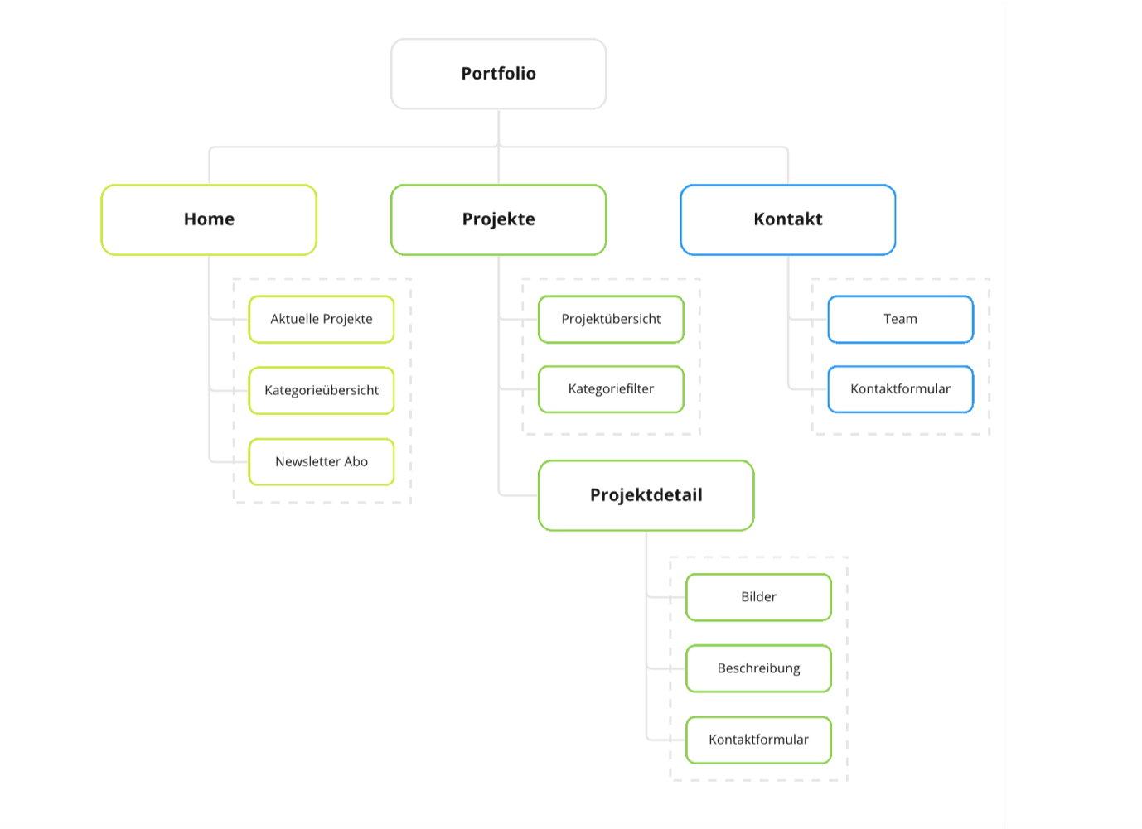

# Wireframe

Wireframes represent a general design idea of the page’s layout.

## Home page:

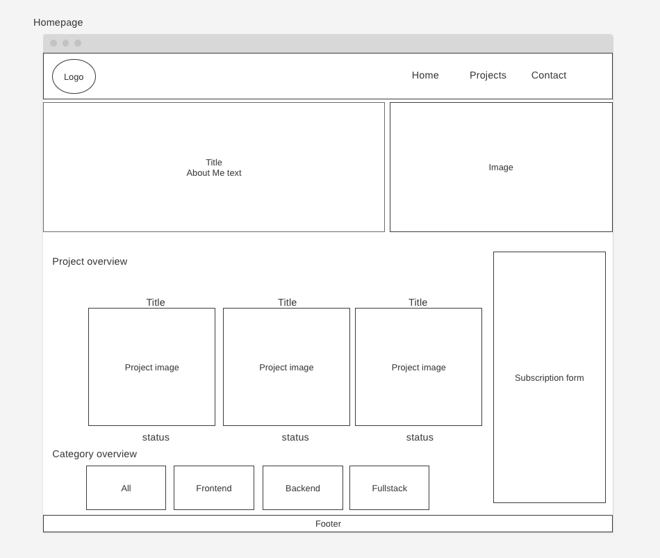

## Project page:

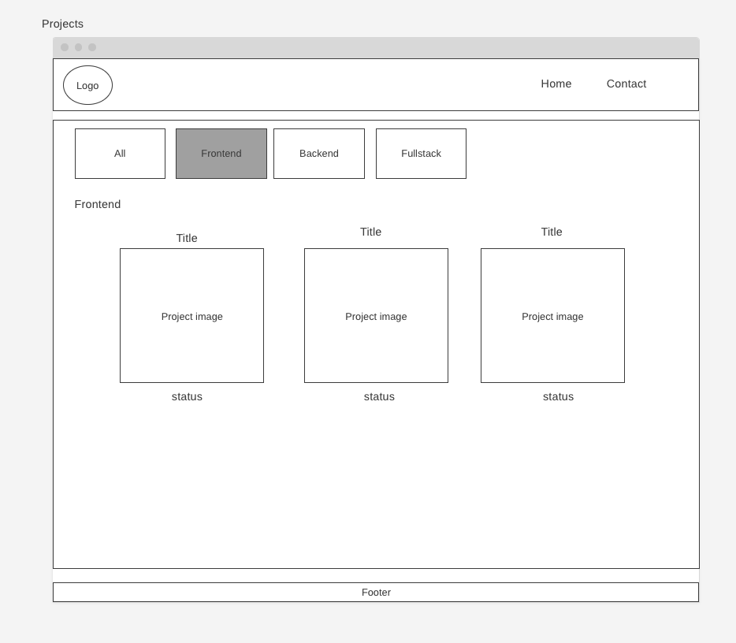

## Projectdetail page:

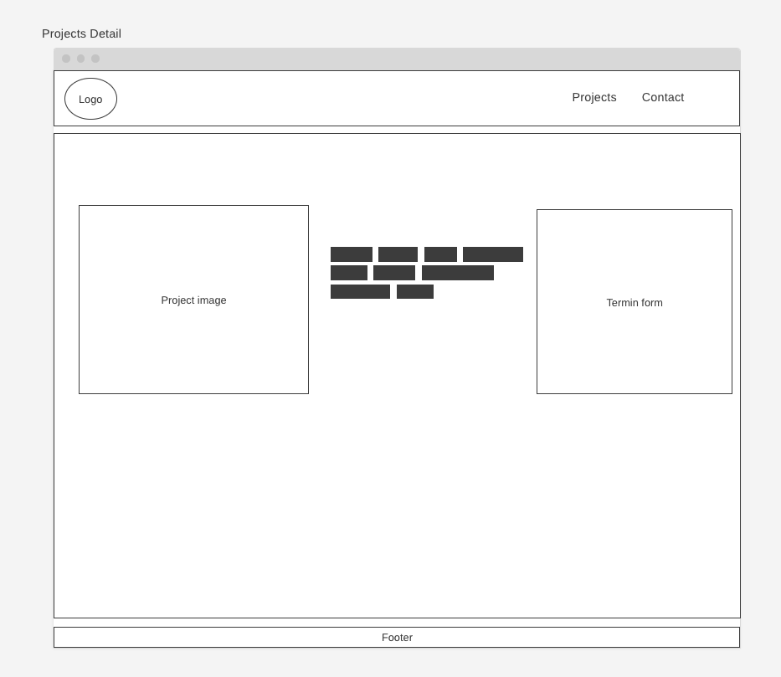

## Contact page:

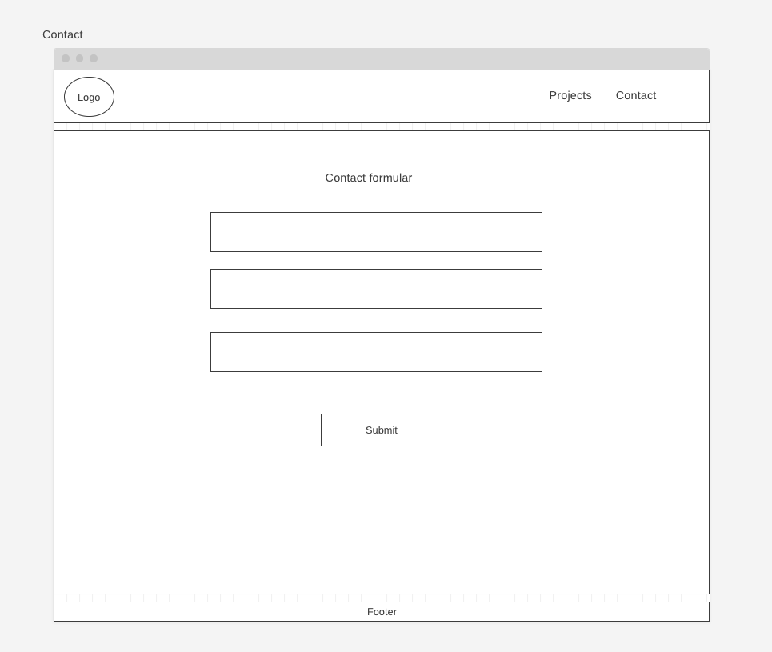

# Style Guide

Style guide shows what Fonts, Font sizes, what colors are used across the website.

## Fonts

The Fonts are used across the pages are:

* Poppins
* Helvetica
* Sans-serif

## Poppins:

### Regular:

Light:

### Medium:

### A black text with a white background Description automatically generatedBold:

## A black text on a white background Description automatically generatedHelvetica:

### Regular:

### Medium:

### Bold:

Sans-serif

### Regular:

### Medium:

### Bold:

## Font Sizes:

In general, The dominant font size is 1.1rem with 2rem spacing

## Color Palette:

### BackgroundColor:

#26262C

### Color:

#e6e7e9

### Theme-Color:

#cce5ff

### Navbar-Background:

#495057