**Game Name: Memory**

**Initial State Final State**

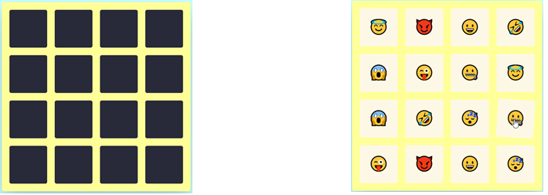

**Implementation Algorithm**

**Step 1: Each emoji is given a code. Time counter is set on when game commences.**

**Step 2: For each click on the card the emoji is set visible using mouse event.**

**Step 3: The opened card emoji code is compared with consequent next opening emoji from another card.**

**Step 4: If both are same, card visibility is made true. Static variable counter is incremented, which was initially 0.**

**Step 5: Else card visibility is false.**

**Step 6: Game completes when counter variable becomes 8(totally 16 squares in our game).**