Data Science Competition

Nicholas Stirling
Department of Science, Math, and Technology, Bellevue University
DSC680-T301 Applied Data Science (2265-1)
Professor Amirfarrokh Iranitalab
April 19, 2026

Competition Experience
For this assignment, I joined the Natural Language Processing with Disaster Tweets. Picking the competition was a little daunting, since the first ones presenting are several-month-long competitions with prizes. After exploring further, though, and finding the competitions that are continually running, this was an appropriate place to start. There were several options, but this was the competition I wanted to join because of several aspects that interested me. The natural language processing portion has been in several of my recent projects and has provided an opportunity for expression and refinement in alignment with defined objectives. As well, the objective of being able to differentiate and identify disasters amid the noise of the internet aligns with current ethical concerns regarding AI use and the verification of real events.
Joining the competition, downloading, and analyzing the data were straightforward. There was a bit of time understanding the submission criteria and evaluation methods. Once the requirements were understood, the approach was similar to that used for other language processing assignments. Cleaning was performed to remove common noise, such as punctuation, stopwords, and mixed-case words. There was also consideration of removing possible URLs that are common in tweets by removing items that begin with http. As with most of these projects, the model chosen to start with was logistic regression for quick implementation, analysis, and a baseline.
The initial implementation was fairly strong, resulting in an accuracy of 0.8. While this was suitable for the competition, I wanted to push the model further with some refinements. This was done by adjusting the weights to address possible misclassification of true disaster tweets, as true disaster tweets are in the minority. After prioritizing the recall value for disaster tweets to identify true negatives while balancing precision, a disaster recall of .9 was achieved. Overall, the accuracy value decreased by .02, which negatively affected the competition; this was more valuable for real-world application of the results.
The submission process was simple, and the results were provided immediately. The result placed me at 389 in the current leaderboard, which, while not optimal, was understandable for a first attempt. Seeing the amount of variance and the number of submissions being submitted was interesting and prompted me to review some of the other models to see approaches as well. I value the ability to see other approaches and compare them.

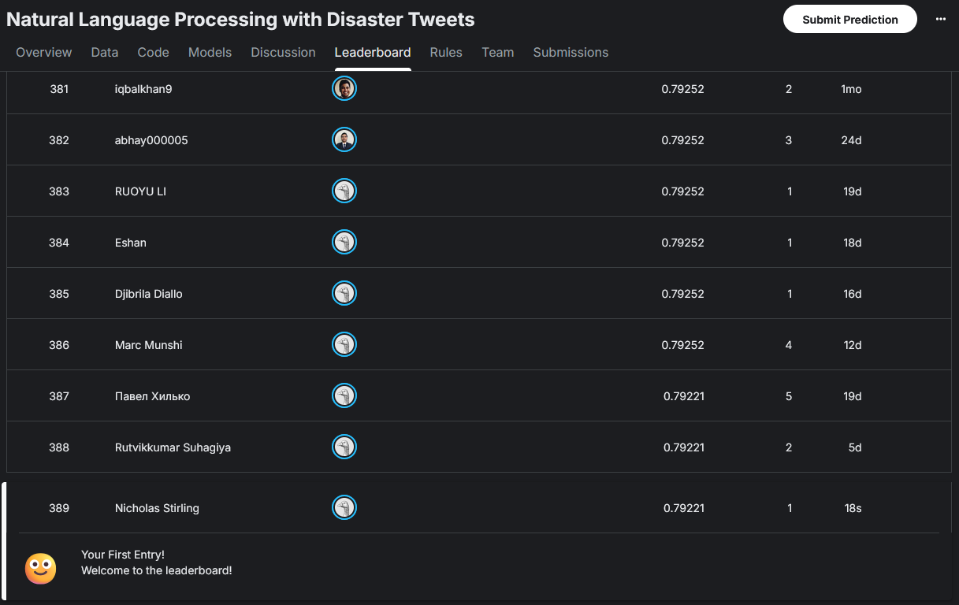

Citations
Natural Language Processing with Disaster Tweets. (n.d.). Kaggle.com. https://www.kaggle.com/competitions/nlp-getting-started

