

**Project Proposal**

**Project name: Online Consultancy**

**Course: CSE482**

**Section: 02**

**Submitted To:**

**Md Naqib Imtiaz Hussain**

**Submitted By:**

**Md. Asaduzzaman Sakib - 1521705642**

**Zubaer Ahmad -1520228042**

**Jalis Mahmud Tarif - 1521001042**

**Asaduzzaman -1620101042**

**Table of contents**

**Introduction** **2**

**Background and Product Context** **2**

**User Story** **3**

Use Case 1: 3

Use Case 2: 3

**Use Case Diagram:** **4**

**Use Case Description** **5**

**Solution Description** **6**

Architecture 6

Front-end plan 9

Back end development 9

**Performance plan:** **10**

Open-source web page tester (https://www.webpagetest.org/) 10

Google Page evaluation (https://developers.google.com/speed/pagespeed/insights/) 10

**Development Plan** **10**

Phase 1 11

Phase 2 11

Phase 3 11

**Project Schedule** **11**

**Conclusion:** **12**



# Introduction

This is a proposal of development of online consultancy where people can consult with doctors, engineers, lawyers, and other category of people. People can consult with doctors, engineers, lawyers and other advisors by paying a specific amount as consultation fees for their consultation. This document contains high requirements, product vision and user stories, phase wise development outline and expectation. This document will remain as a living document to be shared online collaboration to undergo phase wise changes as the product matures into a value generating platform.

# Background and Product Context

Currently, a number of online based consultation enjoy popularity in Bangladesh like online medical consultation, online lawyer consultation, online engineers consultation, online educational consultation etc. The first category is online medical consultation. They provide online consultation with doctors and give the treatment through their sites. People pay for the consultation and treatment. The second category is an online lawyer consultation. Here, people can consult with a lawyer for their needs. The third category is online engineers consultation. Here, people can consult with the engineers for their needs. Others categories are online education consultancy, online career consultancy and so on.

Considering all categories, combined those facilities in one frame through the service. Here, user and advisor need to sign up for the service. After logging into the service user can see the advisor’s list. User can choose the advisor for their consultation. There will be a chat system for their communication. User can start consultation with their advisors by paying the consultation fees through the online payment system. If there is a need for meeting physically then advisors can share their office location. User can consult with the different categories of advisor like lawyer, doctor, engineer and other kind of advisor for their needs. User also can see the advisor’s profile. Consultation fees amount will be written in advisor’s profile. User can search by the advisor name for their consultation. There will be a review/feedback system for both user and advisor where user also can complain about the advisor.

# User Story

## Use Case 1:

Mr. Lizan khan is a service holder who worked in a private company in Dhaka. He went to the office every morning and came back home at night. But when his wife and children got sick, she couldn’t manage time to take them to the doctor. Because it takes two or three hours to consult with a doctor includes traffic jams, doctors serial etc. Also he had to manage his boss. So it's very difficult to take care of his family when someone got sick. If there were some registered online portal to consult with doctor maybe he could take care of his family as well as he could manage his boss.

## Use Case 2:

Mr. Khorshed Alam is a service holder who recently bought a small piece of land for building a house. But later he knew that he engaged with a fraud and they gave him fake papers of this land. He got frustrated and went to court for finding lawyers. But there he also met with fake lawyers and he gave him some money. He also victim of the harassment in the court. At the end he got lawyer handled the landed matter. But this work could be done very easy. If there was an online portal to consult with a lawyer may be he wouldn't harassed by fake lawyers.

From the user story we can conclude that there needs an online portal to consult with doctors, lawyers, teachers etc. So to reduce this kind of scarcity we have decided to make a website where all kinds of social service matters will be handled and people who want to take services, he/she can consult with doctors , lawyers whatever he/ she wants.

# Use Case Diagram:

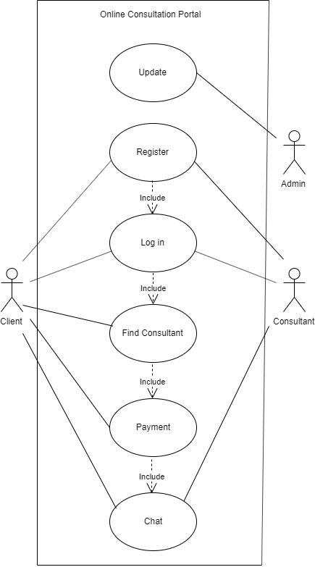

# Use Case Description

|  |
| --- |
| **Online Consult** |
| **Brief Description:** Client actor consults with Consultant Actor. |
| **Actors:** Client, Consultant, Admin. |
| **Basic flow of events:**   1. Client log into the system. 2. Client find Consultant. 3. Client fulfill the payment. 4. Client Chat with Consultant. 5. Consultant log into the system. 6. Consultant chat with Client. 7. Admin can update any user information required for the system as well as any kinds of fake information that is harmful for the website. |
| **Preconditions:**   1. Client is registered. 2. Consultant is registered. |
| **Postconditions:** Undefined. |
| **Non functional requirements:**  Access permissions for the particular system information may only be changed by the system’s data administrator |

# Solution Description

## Architecture

Users send requests through browser clients and web server send their request to the database and database and data receive the request and send response according to their response .

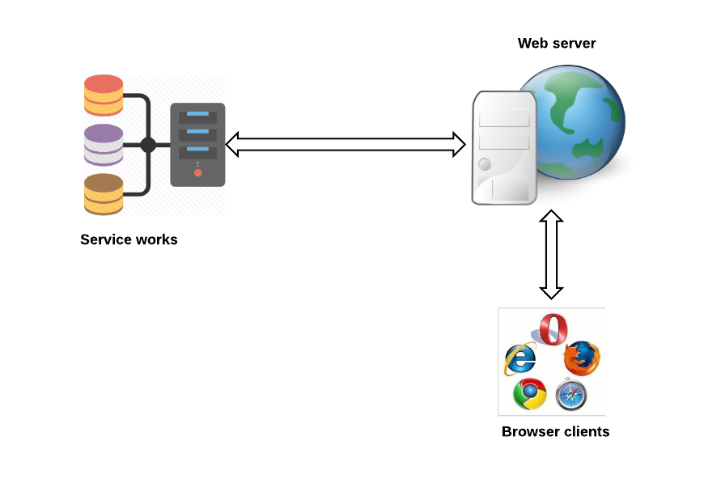

**Figure 1: Architecture plan**

At first we will focus on a very user friendly UI for browser clients. For this we will use HTML5, CSS3, BOOTSTRAP, JAVASCRIPT, JQUERY etc.



For user credential information such as user name,email,phone number and password,description etc we will store it in my sql database and user data will be secure.



For functionality of the entire project we will use PHP7.x which is one of the most popular programming language for web development. We also use github for our version control system.

 

## Front-end plan

A total of 8 page-templates in plan (as of April 30, 2017)

1. Main page
2. Search result page
3. user profile edit page
4. advisor profile edit page
5. super admin page
6. Register/login page(for user and advisor)
7. payment page
8. consultancy page
9. about us page

A map layout will be for our company location page using google map api

## Back end development

1. Account Creating, Password Recover:
   1. Sign up form, verification by mobile or email.
   2. Login
   3. Forgot Password
   4. MySQL Database
2. Profile Management:
   1. DB plan design and dev: MySql
   2. User Profile
   3. Advisor Profile
   4. Super Admin access(block, unblock user or advisor)
3. System Management:
   1. Chat system
   2. payment system
   3. review system
   4. others
4. Searching facility:
   1. fees based
   2. review based
   3. category based(doctor,lawyer,engineer etc)

# Performance plan

## Open-source web page tester (https://www.webpagetest.org/)

* For TTFB < 200ms
* Compressed data transfer,
* Image compression all image
* static content caching
* Use separate media server for faster media delivery
* Use Bangladeshi CDN for minimum latency.

### Google Page evaluation (https://developers.google.com/speed/pagespeed/insights/)

* Mobile 80/100 (bdjobs.com at 74/10)
* Desktop 85/100 (bikroy.com at 85/100)
* Average TTFB < 200ms
* Average DOMLoading < 3sec
* Maximum Page Loading time < 7 sec

# Development Plan

Development methodology will adopt scrum method. Scrum is an agile method that focuses on managing iterative development rather than specific agile practices. A daily meeting of the Scrum team that reviews progress and prioritizes work to be done that day. Ideally, this should be a short face-to-face meeting that includes the whole team. The ScrumMaster is responsible for ensuring that the Scrum process is followed and guides the team in the effective use of Scrum. He or she is responsible for interfacing with the rest of the company and for ensuring that the Scrum team is not diverted by outside interference. The Scrum developers are adamant that the ScrumMaster should not be thought of as a project manager. Others, however, may not always find it easy to see the difference. A development iteration. Sprints are usually 2-4 weeks long. An estimate of how much product backlog effort that a team can cover in a single sprint. Understanding a team’s velocity helps them estimate what can be covered in a sprint and provides a basis for measuring and improving performance.

There are three phases in Scrum.

## Phase 1

The initial phase is an outline planning phase where members establish the general objectives for the project and design the software architecture.

Duration: Total 9 weeks for development and 1 week for final deployment. In this phase full project will be done. The final project will be shown about 23rd to 27th December.

## Phase 2

Phase 2 will comprise of optimization and performance targets as detailed in the solution description.

## Phase 3

The project closure phase wraps up the project, completes required documentation such as system help frames and user manuals and assesses the lessons learned from the project.

# Project Schedule

As our total project divide into 4 checkpoints and each checkpoints we will get 2 weeks so we have planned to do our total project within this (4*2) weeks

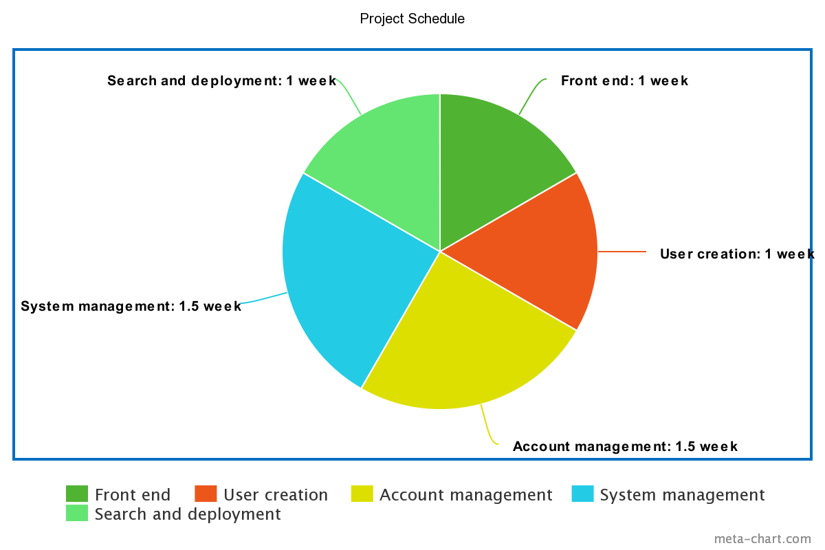

# Conclusion

In the proposal we have talked about our project ideas and it’s execution plans.All of our team members are very much excited to develop this system because it will a very beneficial system for our country if we can properly develop this.