|  |  |
| --- | --- |
| **GOLDEN MELODY FAMILY CHOIR**  **TURI IBISONGA**  **AUDIO VOL 4 LYRICS.**  **YEAR 2017** | DESRIPTION  Golden MELODY Family Choir has been established in two thousands and four (2004)at NYAMISHABA campus.  NOWDAYS IS IN ASA KIST /KHI  UR- NYARUGENGE CAMPUS |

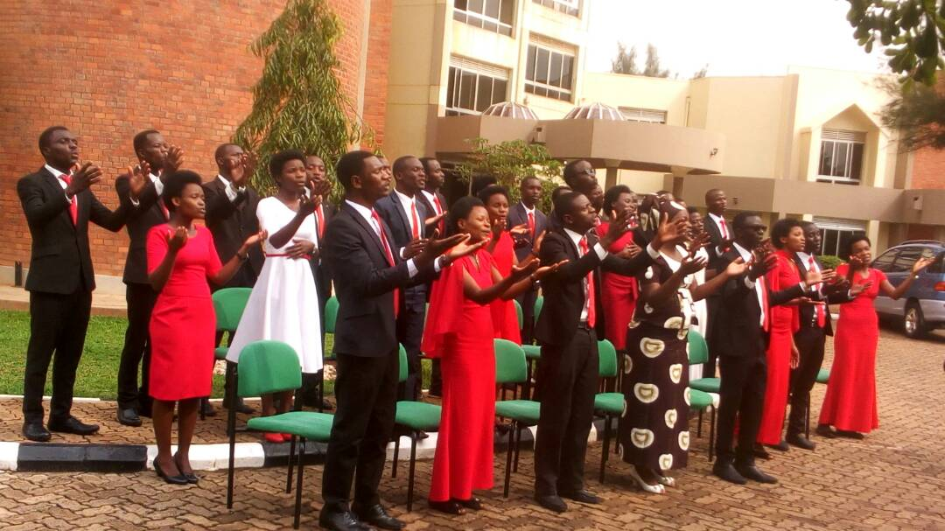

**URAKOMEYE (below)**

1. **Hariho bayal na ashitoleti n’izindi nyinc’abisirael bapfukamiye. Bazibaza ntizisubize bazitabaza ntizitabare ntizumva ntizibona ntanakimwe zijya zikora. Ariko harihO Imana imwe kandi ninay’ikomeye,Niy’Uwiteka elshadai Niyo Yehava yo iturengera, Mureke twese tuyikorere tuyihimbaze kuko idukunda**
2. **Yerekanye gukomera ikarumel umuriruvamwijuru mazukongorigitambo,nokumusozikaruval yahamije kwidukunda umukiza umwana wayo yesaratwitangira, ubwukomeyukadukunda ntayindimana ntayo**

**Kerets’iyaremy’isi n’ijur’igahanik’ikirer’irema n’inyanja, Niy’Uwiteka elshadai niyo yehava yo iturengera**

**Refrais:**

**Urakomeye Mana yacu,uruwigiciro cyinci ntawakwitesha ngo agirinditari wowe ushimirwe ko utajya utureka cyangwa ngo wijijishe habe ngo urahumbya ukwiriye gushimwa**

**TURIHAFI**

1. **Turihafi gutaha tukigir’iwacu mw’ijuru aho tutazongera kwibuk’iyisi n’uburyo satani yatunanizaga**
2. **Mwihangane nigihe gito mwekubabazwa nibyo tubona mwiyisi umwami yes’azaza abimareho twibagirweko twahuye nabyo.**
3. **Hahirw’abames’ibishura byabo mumaraso yumukiza yesu abonibo bazambikwikamba ryera barye no kuri cyagiti cy’ubugingo**

**REFRAIS:**

**Tuzitahiriwacu mwijuru mugihugu cy’amata n’ubuki ahataba ibyago n’inzara ahubwo harangwa amahoro masa.**

**HAZABAHO UMUNSI (innocent and isaac)**

1. **Byose bizashiraho hazabahw’amahor’ahinde abana b’Imana ntibazongera kwikang’ikibi cyose heehhh,ibishavuz’imitima,ibitugora bizarangira tuzabamahoro.**

**1.All Struggles will terminate, there will be everlasting peace, God’s children will fear no more, Ehhhh! No more sorrows and difficulties , we will live peacefully.**

**Refrais:**

**Hazabah’umuns’umwe ubw’ishavu rizashiraho impanda nivug’abera bazazamurwa mukirere bazabisezeraho hehe kurira no kubogoza, ibyakera bizab’amateka tuzabamahoro.**

**There will be a day, when the sorrows will end, when the Trumpets sound loudly the Saints will rise up**

1. **Iyis’iratubabaza ihor’itwivumbura rwose tuba mu buzima buzunguruka ufite non'ejarabura haaah,imibereho tubamo iratugora tugahangayika ariko bizashira**
2. **Ntiziger’iduhana mubihe bib’ibana natwe izere yesu guma mu isezerano no munyanja y’ibibazo hahand’ubona byose byanze izacinzira maze wambuke tuzagera hakurya**

**ISABATO by emmy passy (below)**

1. Iman’ **ihimbarizwineza yayo kubw’urukundo rwinshi ikund’umuntu imaze kurema imuh’isabato irayez’iyih’umugisha ngo aruhuke*2 ayinezererwemo**

**Refrais**

**Dushoboze kukunambaho mwami ushobora byose tweze isabato duhamye ukuri nkuko bikwiye nubwo dusatiriye igihe cy imibabaro wayakobo duhe imbaraga zogushikama tuzabane iteka.**

1. **Satan’umwanzi ntiyanyuzwe nabyo yariganije benci bazirur’isabato nyamar’isabato munsi wa karindwi itwibutsa kuremwa kwacu no gucungurwa*2 dukesh’umuremyi**
2. **Is’irashirana no kwifuza kwayo arikw’amategeko yera azahoraho turahamiriz’abatuyisi bose kw’amategeko y’Imana atazavaho*2 ikiza ni ukuyumvira**

**URUTARE (Samuel iy)**

1. **Dufite umucunguzi yesu utwitaho ibihe byose ,iyo turushye tunaniwe, dutentebutse, ducitse intege araduhumuriza akadusubizamo imbaraga.**

**Refrais:**

**Nikomeje kurutare rusumba byose byose naho ahandi hose nasanze ari umusenyi kubaho muri iyisi mfite ubwishingizi muri we nibyo bimbashisha gutsinda ibingerageza.**

1. **Byatumarira iki gutunga ibyiyisi byose ariko tudafite yesu mumibereho yacu ibyo tubona muriyisi byose bishira mukanya gato shaka yesu bigishoboka niwe butunzi butazashira**
2. **Isi ducumbitsemo ntigiramarangamutima ngotuyigire incuti nyancuti uko byamera kose irahindukikatwerekako igiye kurangira ntabuhungiro buyirimo.**

**ABAKURAMBERE by emmy passy (Samuel)**

1. **Abakurambere bacu batoranyijwe n’Imana ngo bayihagararireee ibana nabo irabarwanirira ibaha’amasezerano menshi, igihe kigeze’iradutora ngo tub’ishyanga ryasigaye rikomeza amategeko rifite guhamya kwa Yesu**

**REFRAIS:**

**Tur’ibosonga by’Imana muze tuyihesh’ikuzo dukiranuka muri byose tunezerewe.,dufit’imitima ishima inyuzwe nubuntu bwayo yesu dutsindire inarige mumurimo wawe**

1. **Twahizimihigo myinshi tuti nuturokora tuzagukorera yarabikoze ndetse yaduhaye nibirenzeho fatumwanya nshuti uyishime uhigure n’imihigo izina ryayo rihabwe ikuzo mwisi no mwijuru**
2. **Urukundo rwawe yesu nirwo ruturehereza gukora umurimo wawe impagarike igihe impano nubutunzi tubikwegurire ubikoreshe mumurimo wogukiza abandi kuko uri hafi ukatujyana aheza waduteguriye.**

**IGISONGA (theogene)**

1. **Aho yesu yankuye nihabi cyane rwose yambereye iteme rimpuza n’imana urukundo yamkunze rwankozeho.**
2. **Ineza wangiriye nabuze uko nyivuga,irenze vubwenge bwanjye.gusa mpa kuyihamya uko bikwiriye ntebutse ingoma yawe.**

**REF: Nakwiyuriki mwami w’ubuntu butangaje ko ntacyo mfite gikwiriye,mpa kuba igisonga wishimira mb’ uwo wifuza mwami.**

**KUBW’URUKUNDO**

* **Niki cyantanya n’urukundo rwawe yesu niki cyantandukanya nawe. ni amakuba oya,ni ibyago oya ntacyantandukanya nawe mwami,nzakunambaho iteka ryose kugeza ubwo uzagarukira.**
* **Urukundo Yesu yankunze rwampinduye umwana w’Imana.sinkiri imbata y’icyaha ndi uwa yesu kuko yambabariye ibyaha byanjye nzamunambaho iteka ryose kugeza ubwo azagarukira.**
* **Nubwo satani ahora ashaka ko ndimbuka agahora antega imitego niringiye YEsu, niwe nsinzi yanye ntazigera narinwe antererana nzamunambaho iteka ryose kugeza ubwo azagarukira.**

**REF: Urwo rukundo wankunze ruhebuje yankunze njye ntaramumenya ,yemeye gupfira umunyab.yaha nkanjye kugirango umuheshe bugingo buhoraho.**

**ARAJE (eraste)**

1. **Ndabizi yuko azagaruka azaza Yesu yarabivuze ikirenze ibyuko kumenya yuko azaza nuko buri muntu wese yamwitegura. Bimwe yaduhayeho ibimenyetso byibizaranga kugaruka kwe dore byose byashyizwe kumugaragaro ubura amaso mugenzi dore yesu araje.**
2. **Ntanumwe uzi isha cyangwa se igihe ibyo niby’umwami we nyiribihe gusa bidusaba guhora twiteguye bavandimwe tutazaba nkabo kwa nowa. Ubwo baririmbaga ngo ni amahoro badamaraye batikanga ikibi nibwo imvura nyinshi yarengeye isis yose uwanzekumvira yararimbutse.**
3. **Abasigaye bategereje kugaruka kwe ngaho nimunezerwe bwira abagenzi ko turi kururembo rwahariya dusiganirwa kugera dufite ihirwe imbere y’Imana niba tutari ubwoko bugawa azanye ibihembo kandi umuntu azahabwa ibikwiranye n’imirimo yose yakoze.**

**REF: Ari hafi ari bugufi abiteguye barambuye amaboko yo kwakira ibyasezeranijwe ari bugufi dore araje mukobwa w’isiyoni irimbishe umukwe ageze kwirembo araje gutwar umugni we araje Yesu araje.**

**AMAMAZA (eraste)**

1. **Mfite inkuru nziza ishimishije ko Yesu mukiza wacu agiye kugaruka maze amareho icyaha ningaruka zacyo ntabyago ntantambara zizongera kubaho.**
2. **Muri icyo gihugu tuzishimana na Yesu wadukunze ibihe bidashira ,azaduhanagura amarira twarize tuzaba ibikomangoma abatambyi b’ubwami**

**REF: ( mfite ibyiringiro yuko) nzataha iwacu( nubwo mbarizwa mwisi) nigihe gitoya**

**(Yesu)mukiza( agiye) kugaruka( azaba) ashagawe (naba)marayika(ite) gure ku(zamu)sanganira amamaza iyo nkuru mwijwi rirenga.**

***PROPOSAL OF AUDIO VOL 5***

NYIGIDSHA KUBA HAFI YAWE MWAMI YESU

1. Nyigisha kuba hafi yawe mwami Yesu,ngume mumaboko mubiganza byawe unyigishe kubaha ijambo ryawe ngendere mubitunganye nzaneshe.
2. Rf :Ndikumwe nawe mwami Yesu nizeye ko uzatsinda nubwo Satani antega imitego munzira, Sinzigera nshibbwa intege nibingerageza kuko Ndikumwe n,Imana ushobora byose.
3. Murugendo ndimo hano muri iyisi mpuramo nibindushya bikanshogoza ariko ngufite sinzatinya ibihe byose mwami nizeyeko nzanesha.
4. Dupfukamye imbere yawe duciye bugufi tuzamuye ijwi rirenga tukwinginga mwami icyubahiro nubutware no gukomera mukiza ni ibyawe iteka ryose himbazwa.
5. Rf2: Ndifuza kuzaba mubwami bwiza ndifuza kuzagera muri Edeni wanteguriye,Aho waringanije imyaka nyinshi kugirango nzahature turi kumwe.

ISABATO

1.Iman’ihimbarizw’ineza yayooo kubw’urukundo rw’insh’iiikund’umuntu imaze kurema imuh’isabato irayez’iyih’umugishaaa ngw’aruhuke (ngw’aruhuke) ngw’ayinezererwemo.

To God be the glory for his amazing kindness and his incomparable love to human being ,after creation he gave him the Sabbath ,keep holy so that he will rest in and cerebrate it

REF: Dushobooze kukunambaho man’ishoborabyose twez’isabato ,duhamy’ukurii nkuko bikwiye nubwo dusatiriy’igihe cy’umubabaro wa yakobo duh’imbaraga zo gushikama tuzaram’itekaa

Help to stand on you almighty God so that we keep your holy Sabbath ,witness the truth as it is even if we are approaching to the jacob’s sadness ,strengthen us so that we will get eternal life.

2.satan’umwanzi ntiyanyuzwe nabyo yariganije benshi bazirur’isabato nyamar’isabato munsi wa karindwi itwibutsa kuremwa kwacu no gucungurwa(no gucungurwa) dukesh’umuremyi

Enemy satan disagreed them and tempted many to disobey the Sabbath however Sabbath of seventh day it remind us about our creation and redemption from our creator.

3.is’irashirana no kwifuza kwayoo arikw’amategeko yera azahoraho turahamiriz’abatuy’isi bose kwamategeko y’Imana atazavaho(atazavaho) ikiza n’ukuyumvira

World is ending with its desires but the holy law will stay forever ,we are witnessing to all world’s dwellers that God’s ten commandments will never became expired ,the Best choice is to obey them.

BYARASHIZE

1.Wampumurije Umutima,Ubwo nari nihebye naragutakiye uranyumva,Mwami wumvise gusenga wita kumaganya yanjye nanjye nzakunambaho iteka.

Rf:Ubu kubaho nigunze byarashize kuko namenye uwo mbwira byose, kandi ntanyumvira ubusa bakunda bihebuje ikiruta byose bampaye ubugingo.

2.Ujyu ugira ibibazo byinshi bikugoye ukabura uwo ubwira agahinda kawe !, inshuti nabavandimwe ntihagire ukwitaho gusa hari uwo kumbwira ibyawe kandi ntiyumvira ubusa oya.

3.Amanywa nakubera umwijima uri mubigeragezo ntawundi wo kukwitaho ni Yesu, niwe wumva Gusenga yita kumaganya yacu nanjye nzamunambaho iteka.

KUBWAWE

Rf:Mwami kubwawe nibwo twiringiye ubugingo mwami kubwawe nibwo tuzaramba iteka iby’iyisi ntamumaro dukeneye umucyo,murikira abana bawe babeho.

* Rf: Lord!, For your sake we are assure of everlasting life, Lord!, for your sake we will stay along, for all of the World are useless, we need your light, Light for your Children so as they live.

1. Dore isi iragenda ihinduka vuba nabayiriho ntibitaye kumana babwiriza ubutumwa ariko ntibumva, nyamara ingoma yayo irashira.

1.Look, The World is changing quickly, Its citizens are not dependable to God, they’re recently predicated Gospel form God but they’re unable to understand, but its Kingdom tends to terminate.

1. Dore amahanga yose akutse umutima arangamiye ubutunzi bwi yisi,Imana yabo ni inda n’amafaranga,ntibazi iriva ntibazi n’irizima.

2.Look,all nations are fearfull, Exposing the earth properties(richness),Their god is selfish for money, they do not know what is going on.

MANA YANJYE NIRINGIRA

1.Mana yanjye niringira manura umwuka wawe ngotumenye ibyisezerano ryawe ry’agakiza kanyuze mumwana wawe Yesu.

1.Oh! My God whom I believe in, Send your Holy Spirit to us, so that we may knew ,about your promise of Salvation throught Jesus Your Son.

Rf: Niki cyantanya na Yesu, Kuva menye ibyo yankoreye , kumusaraba ndahakunda ntacyo njye nahanganya.

Rf: What can separate me from Jesus, Since I knew what he have done to me, I like the cross nothing comparable to it.

2.Icyagaragariyeyo ntanumwe wacyiyumvisha habe na hato Keretse Umwuka wenyine niwe utwemeza iby’icyaha cyose tugakira.

2.What revealed there, no one can understand it , No any, Except the Holy Spirit who makes us accept all of our Sins and then after become righteousness.