

**REGNO: 23RP00257**

**PRACTICAL ASSIGNMENT 1**

**EMBEDDED SYSTEM**

**B-Tech Students at IPRC TUMBA**

Dear students take your time and revise EasyEDA ( as an online software we used to design embedded system) by **re-designing** this circuit and get Circuit schematic, PCB 2D and 3D layout!

Your submission will be made in two ways :

1. You will design it in your computer and every student will take 5 minutes to present his or her work .
2. After designing your circuit , you will create a word document and write all steps you have used with screenshots for each step until you get final result.

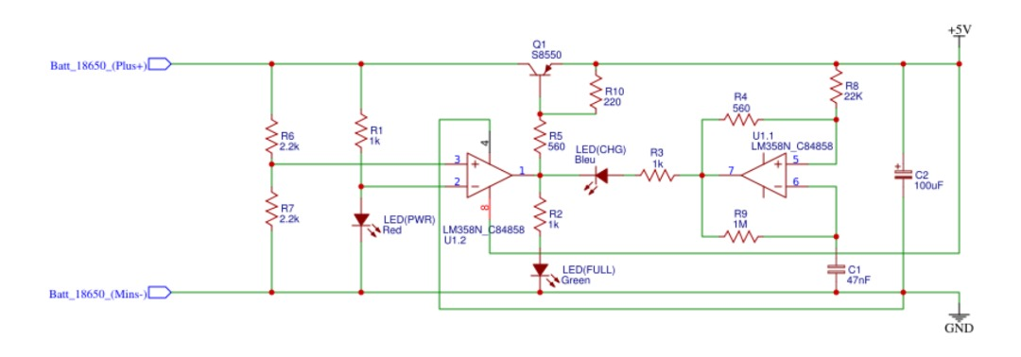

Submit your word document on Sunday on 3/03/2024 via my email: [felixharerimana0@gmail.com](mailto:felixharerimana0@gmail.com)

**Solution**

**Components used:**

1. **The LM358N** is a dual operational amplifier chip commonly used for amplification and signal processing in electronic circuits.
2. **Resistors** limit current flow, control voltage levels, divide voltage, and protect components by offering resistance to the flow of electrical current, The resistance value is measured in ohms (Ω).
3. **Capacitors:** store and release electrical energy, filter out noise, stabilize voltage, and block DC while allowing AC signals to pass.
4. **"LED (CHG)"** typically refers to a charging indicator LED, commonly found on electronic devices to indicate when the device is charging.
5. **"LED (PWR)red"** likely refers to a red LED indicator light indicating power. It's a light-emitting diode (LED) designed to emit red light when powered.
6. **LED(FULL),** or light-emitting diode, emits full green light when activated. Its energy-efficient and long-lasting properties make it a popular choice for various lighting applications, including displays, indicators, and decorative lighting.
7. **GND** typically stands for "ground" in electronic circuits. It serves as a reference point for voltage levels and is often connected to the Earth. In electrical schematics, GND represents the point of zero
8. **+5V** represents a voltage level of 5 volts in electronic circuits. It's commonly used as a power supply voltage for various components, such as microcontrollers, sensors, and other integrated circuits.
9. **The Batt_18650_(Plus+)** is a rechargeable lithium-ion battery commonly used in electronic devices. It provides a reliable power source with high energy density and is popular in applications like flashlights and portable electronics.
10. "Batt_18650_(Minus-) refers to the negative terminal of an 18650 lithium-ion battery. It is the end where electrons flow out during discharge and return during charging."
11. **Project Circuit image:**A project circuit refers to the electrical connections and components assembled together to perform a specific function or task as part of a project. It can include various elements such as power sources, sensors, actuators, microcontrollers, and other electronic components arranged in a specific configuration to achieve the desired outcome. The circuit is typically designed and implemented based on the requirements and objectives of the project.

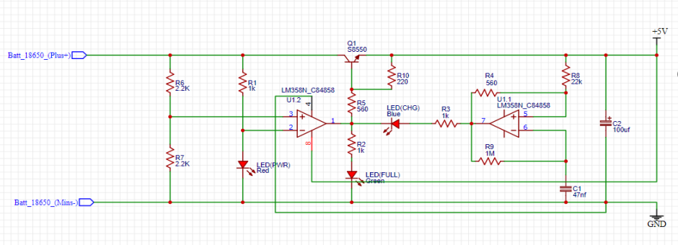

1. **PCB Image:**A PCB (printed circuit board) image is a visual representation or layout of the conductive traces, pads, and components on a PCB. It provides a detailed view of the connections and arrangement of electronic elements, aiding in design, manufacturing, and troubleshooting processes for electronic circuits.

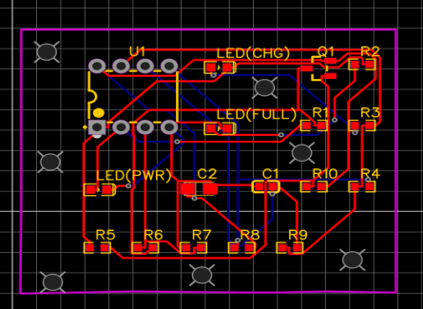

1. **2D**

In a 2D context, objects and representations exist on a two-dimensional plane, possessing only length and width dimensions. It lacks depth, with visualizations typically seen on paper or screens.

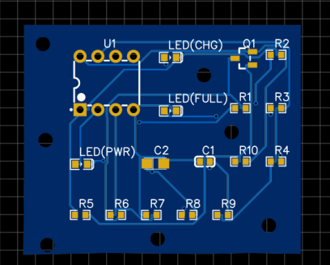

1. 3D, or three-dimensional, refers to objects or environments that have width, height, and depth. In the context of technology, it often involves computer-generated imagery or physical models that provide a realistic representation of objects.

