https://github.com/Ntando-hub/PAT-1---SUBTASK2.git
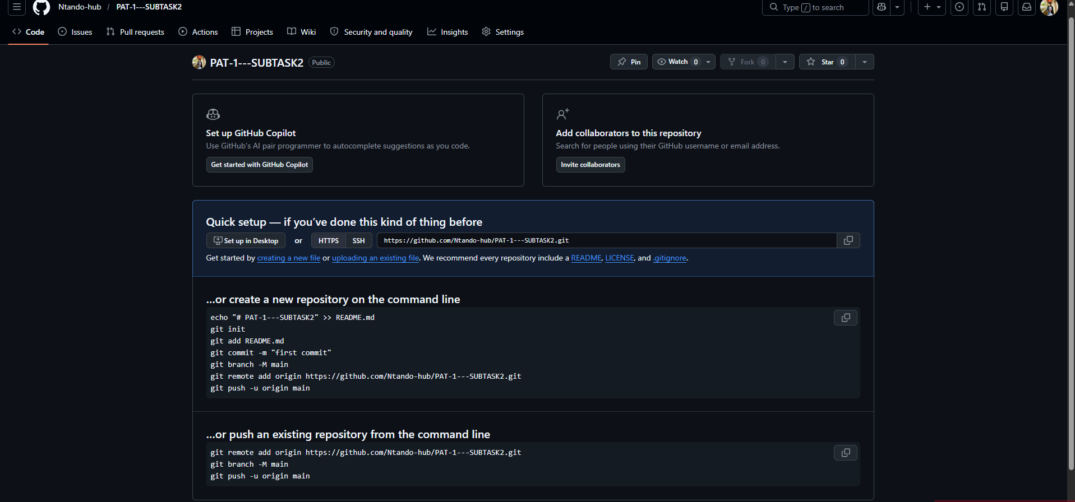

INPUT | PROCESS | OUTPUT
First temperature reading | Read 1st temperature | Store 1st temperature
Second temperature reading | Read 2nd temperature | Store 2nd temperature
Third temperature reading | Read 3rd temperature | Store 3rd termperature
Temperature values | Calculate increase between 1st and 2nd reading | Determine if increase is greater than 50 0r less than 10
Temperature comparsion | If increase > 50 | Output : reduce the fryer heat before taking the third reading
Temperature comparsion | If increase < 10 | Output : increase the fryer heat before taking the third reading
Third reading | Check if temperature is between 150 and 190 | Output : you may start frying the magwinyas
Third reading | Check if temperature is outside 150 - 190 | Output : oil is not ready for frying

