Verba Dictionary Mobile Application — System Design
Documentation
Client:
LexiTech Solutions Ltd, Kigali City
Project:
Cross-Platform Dictionary Mobile Application
API:
Free Dictionary API —
https://api.dictionaryapi.dev/api/v2/entries/en/

Tech Stack:
React Native
+
Expo · TypeScript · Axios · React Navigation

Table of Contents

- Data Flow Diagram (DFD) — Level 0 (Context)
- Data Flow Diagram (DFD) — Level 1 (Detailed)
- Application Architecture
- Navigation Flow
- API Endpoints
- Required Pages / Screens
- Component Hierarchy
- Data Models (Entity Relationship)

Data Flow Diagram — Level 0 (Context)

The Context DFD shows the system boundary of the Verba application and its interaction with external entities.
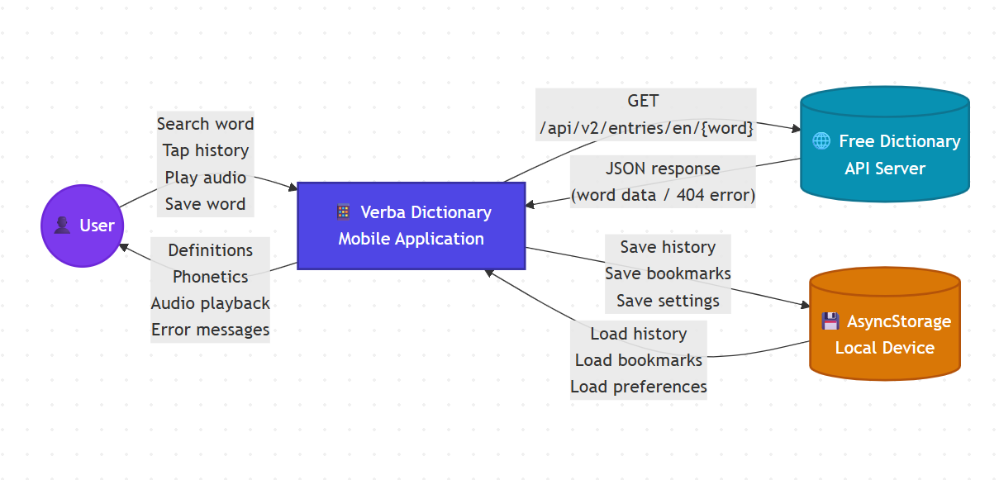

Entities Explained
Entity | Type | Description
User | External | End-user on Android/iOS device
Verba Application | Process | The React Native mobile app (system boundary)
Free Dictionary API | External | REST API providing word data at dictionaryapi.dev
AsyncStorage | Data Store | On-device persistent storage for history, saved words, settings

Data Flow Diagram — Level 1 (Detailed)

This decomposes the system into its internal processes, showing how data flows between each Activity defined in the Integrated Situation.

Process Descriptions
Process | Activity | Description
1.0 | Activity 1 | Validates input (non-empty check), formats word (trim, lowercase)
2.0 | Activity 1 | Sends Axios GET to API, parses JSON via apiParser.ts , handles HTTP errors
3.0 | Activity 2 | Extracts word, phonetics, meanings, definitions, examples for display
4.0 | Activity 3 | Loads audio URL via expo-av , manages play/pause/stop states
5.0 | Activity 4 | Drawer menu renders history, allows re-search by tapping items
6.0 | Activity 5 | Detects 404, timeout, network errors; shows appropriate error screens
7.0 | Extended | Saves words to collections (Favorites/Academic/Travel), tracks mastery

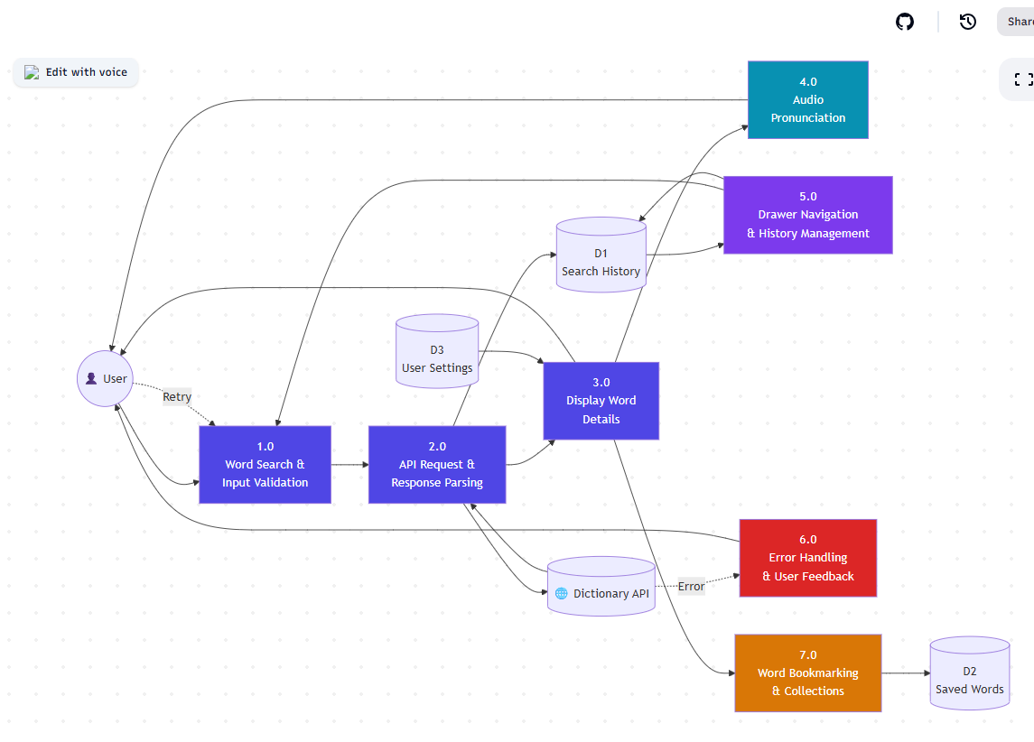

Application Architecture

The layered architecture showing the separation of concerns from UI to data.
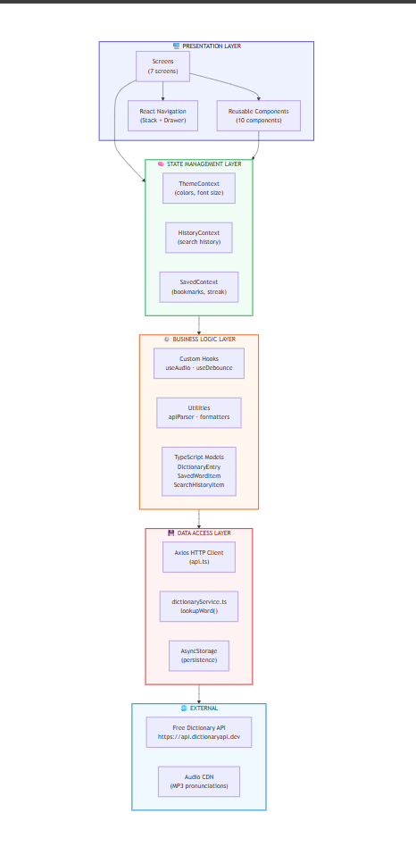

Layer Responsibilities
Layer | Responsibility | Key Files
Presentation | UI rendering, user interaction, screen layout | *Screen.tsx , *Component.tsx ,  AppNavigator.tsx
State | Global app state via React Context + useReducer | ThemeContext , HistoryContext ,  SavedContext
Business | Domain logic, hooks, data transformation | useAudio.ts , useDebounce.ts , apiParser.ts
Data | HTTP communication, local persistence | api.ts , dictionaryService.ts ,  AsyncStorage
External | Third-party services | Dictionary API, Audio CDN

API Endpoints

Base URL
https://api.dictionaryapi.dev/api/v2/entries/en/

API Request & Response Reference
Request
Field | Value
Method | GET
URL | https://api.dictionaryapi.dev/api/v2/entries/en/{word}
Headers | Accept: application/json , Content-Type: application/json
Timeout | 8000ms
Library | Axios (as required by Integrated Situation)
Success Response (200 OK)
{

"title"
:

"No Definitions Found"
,

"message"
:

"Sorry pal, we couldn't find definitions for the word you were looking for."
,

"resolution"
:

"You can try the search again at a later time or head to the web instead."
}
[

{

"word"
:

"hello"
,

"phonetic"
:

"/həˈloʊ/"
,

"phonetics"
:

[

{

"text"
:

"/həˈloʊ/"
,

"audio"
:

"https://api.dictionaryapi.dev/media/pronunciations/en/hello-us.mp3"
,

"sourceUrl"
:

"https://commons.wikimedia.org/..."

}

]
,

"meanings"
:

[

{

"partOfSpeech"
:

"noun"
,

"definitions"
:

[

{

"definition"
:

"\"Hello!\" or an equivalent greeting."
,

"synonyms"
:

[
"greeting"
]
,

"antonyms"
:

[
]
,

"example"
:

"She began the conversation with a hello."

}

]
,

"synonyms"
:

[
"greeting"
]
,

"antonyms"
:

[
]

}

]
,

"sourceUrls"
:

[
"https://en.wiktionary.org/wiki/hello"
]

}
]
Error Response (404 Not Found)
Error Code Mapping
HTTP Status | Axios Error | App Error Code | User-Facing Message
200 | — | — | Display results
404 | error.response.status === 404 | WORD_NOT_FOUND | “Linguistic Discovery Pending”
5xx | error.response (non-404) | SERVER_ERROR | “Connection Lost”
No response | error.request (timeout) | NETWORK_TIMEOUT | “You’re offline”
Parse fail | catch | UNKNOWN_ERROR | “Something went wrong”
Empty input | Validation | EMPTY_QUERY | Alert: “Please enter a word”

Required Pages / Screens

Screen Details Table
# | Screen | Route | Purpose | Activity | Key Components
1 | SplashScreen | — (initial) | Brand loading + firstlaunch check via AsyncStorage | — | Logo, progress indicator
2 | OnboardingScreen | Onboarding | 4-step horizontal carousel introducing app features | — | Carousel, dot indicators,  Skip/Next/Get Started buttons
3 | DiscoverScreen | Discover | Home screen with search bar, WotD card, trending words, bento grid stats | Act 1, 4 | SearchBar, WordCard, suggestions panel
4 | WordDetailsScreen | WordDetails | Full word display:  phonetics, meanings, definitions, examples, audio, synonyms/antonyms | Act 2, 3 | MeaningCard,  DefinitionItem,  ExampleText,  PronunciationButton
5 | HistoryScreen | History | Chronological list of all previously searched words | Act 4 | HistoryItem, search/filter, clear all
6 | SavedWordsScreen | SavedWords | Bookmarked words organized by collection, quiz feature | Extended | WordCard (mini), collection tabs, quiz modal
7 | SettingsScreen | Settings | Theme toggle, font size, notifications, autoplay, data management | Extended | Toggle switches, sliders, action buttons

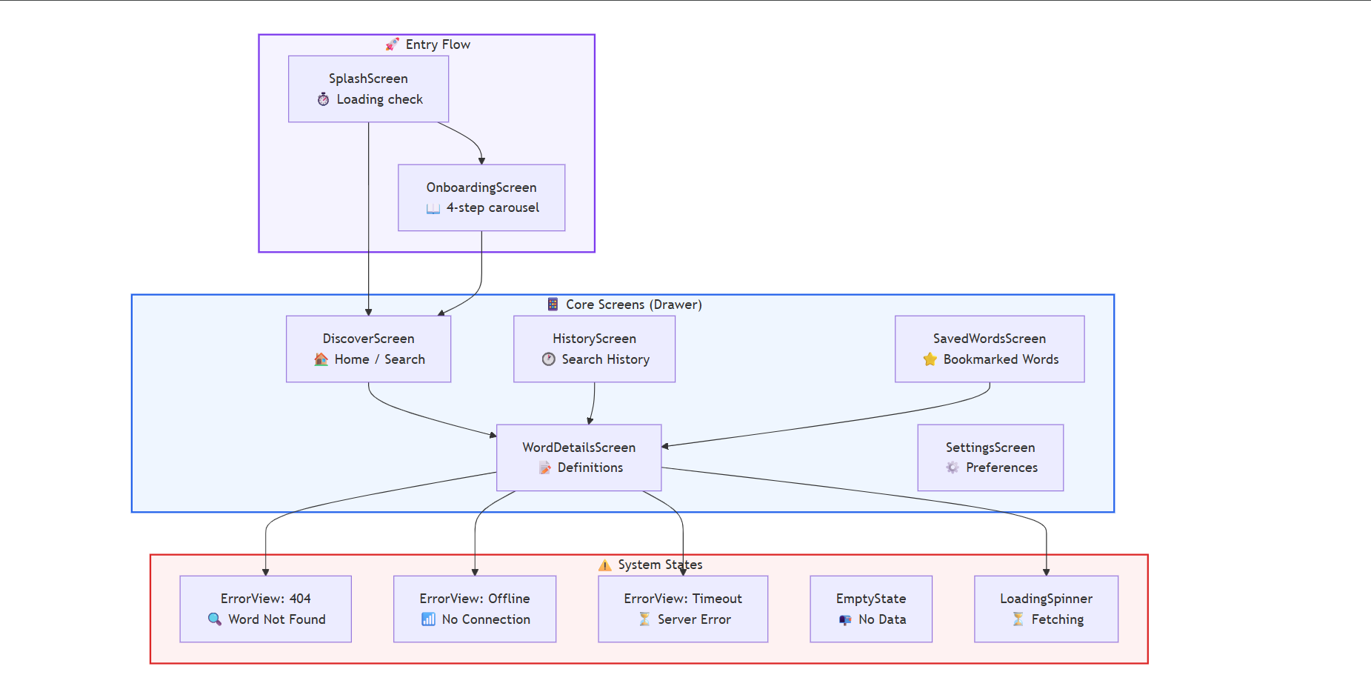

Screen-to-Activity Mapping
Activity | Primary Screen | Supporting Screens
Activity 1: Word Search & API  Integration | Discover Screen | Word Details Screen
Activity 2: Display Word Details | Word Details Screen | —
Activity 3: Audio Pronunciation | Word Details Screen | Discover Screen (WotD audio)
Activity 4: Drawer Navigation &  History | DrawerContent,  HistoryScreen | DiscoverScreen (recent chips)
Activity 5: Error Handling & Feedback | ErrorView component | WordDetailsScreen,  DiscoverScreen

Component Hierarchy

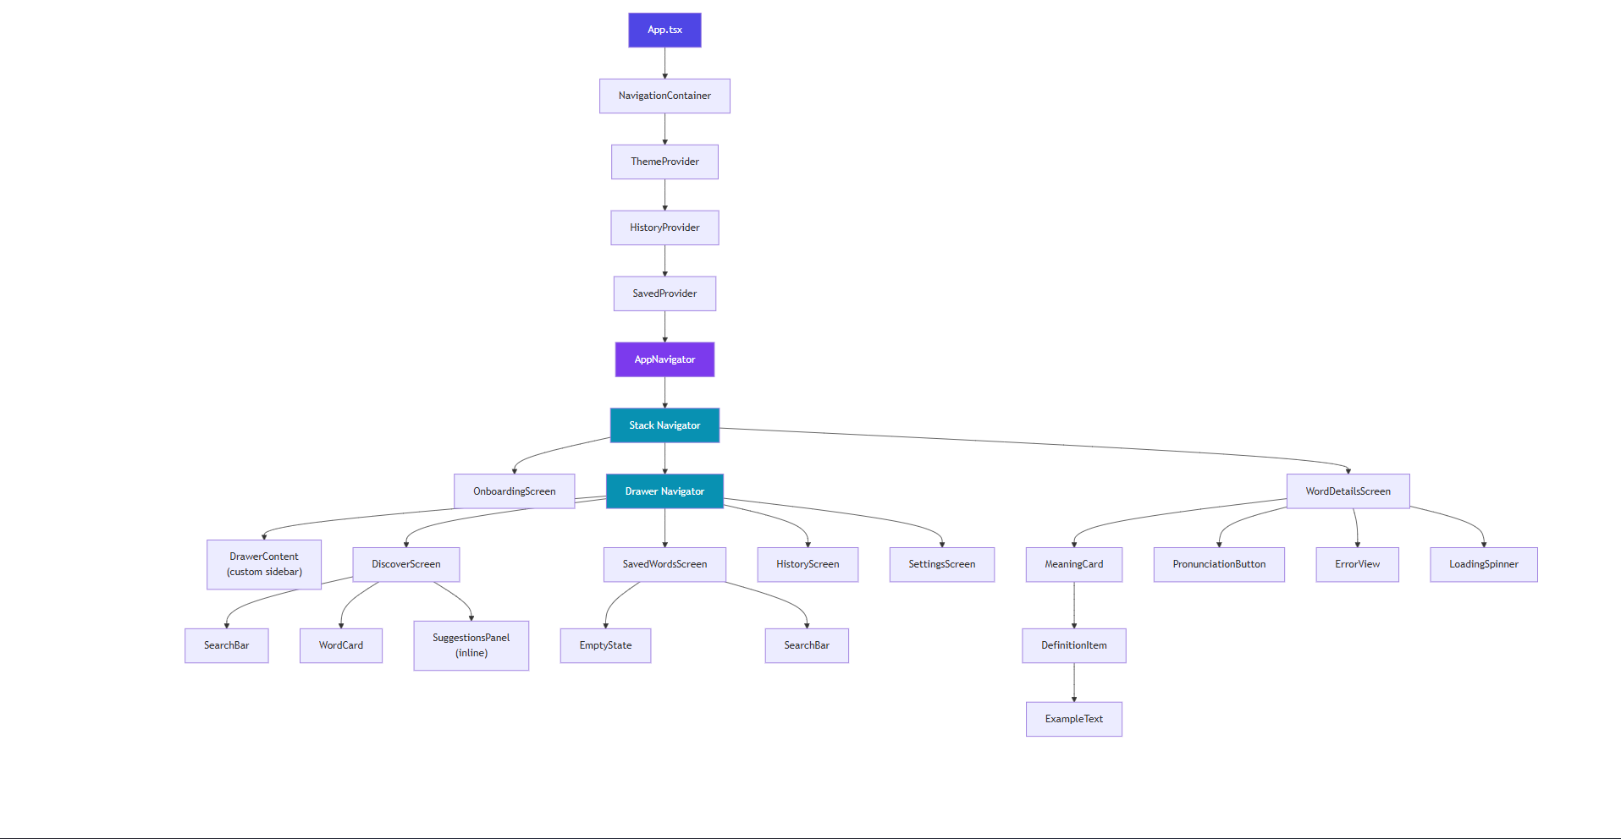

Data Models (Entity Relationship)
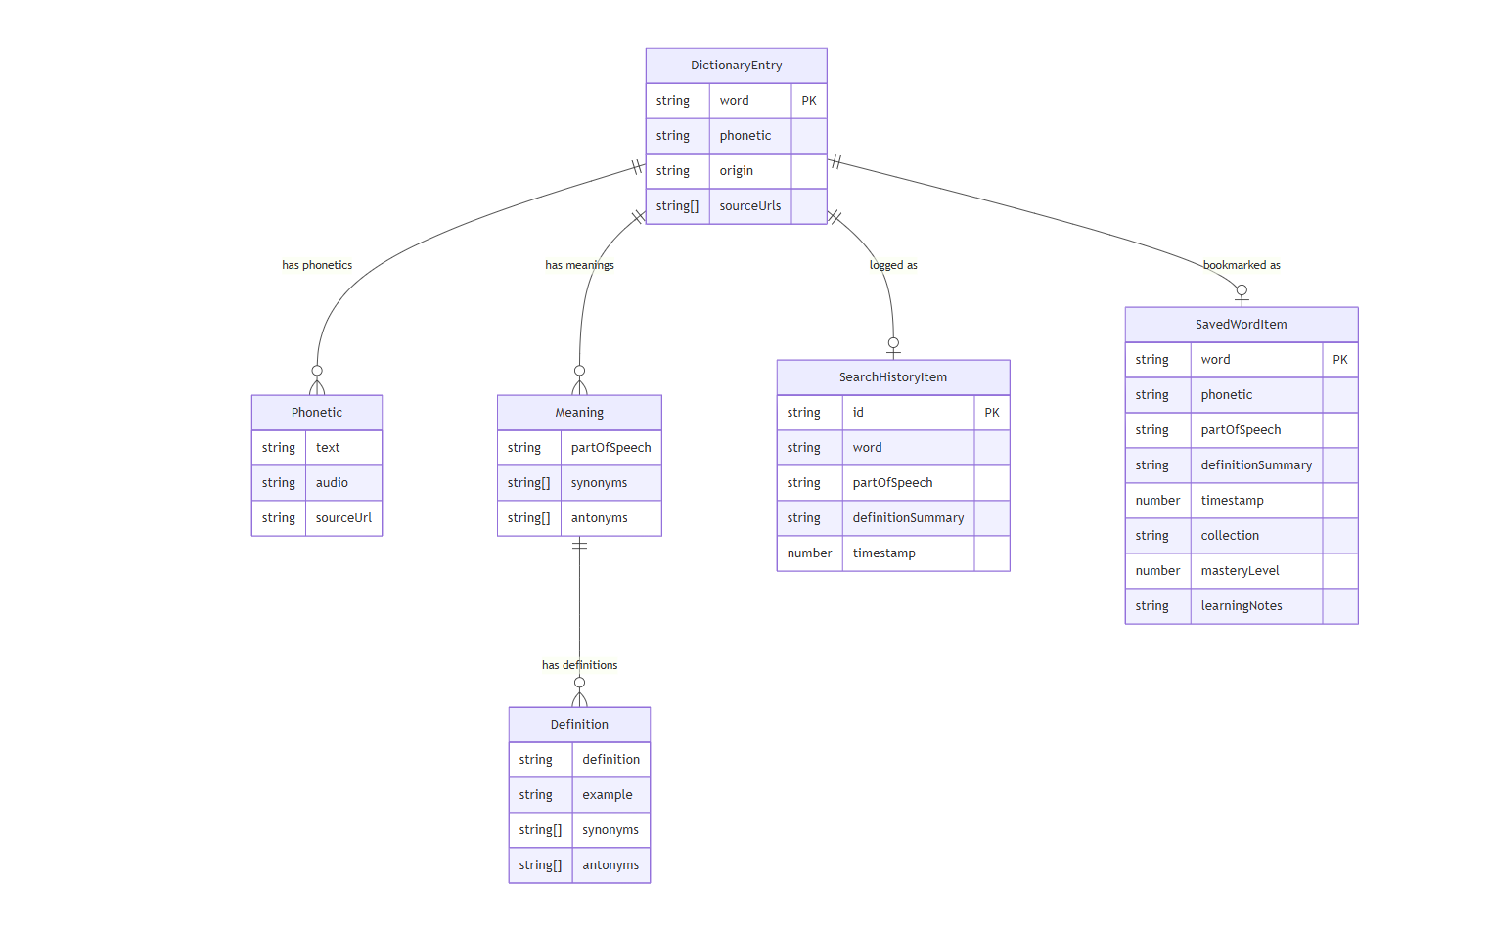

Type Definitions (TypeScript)
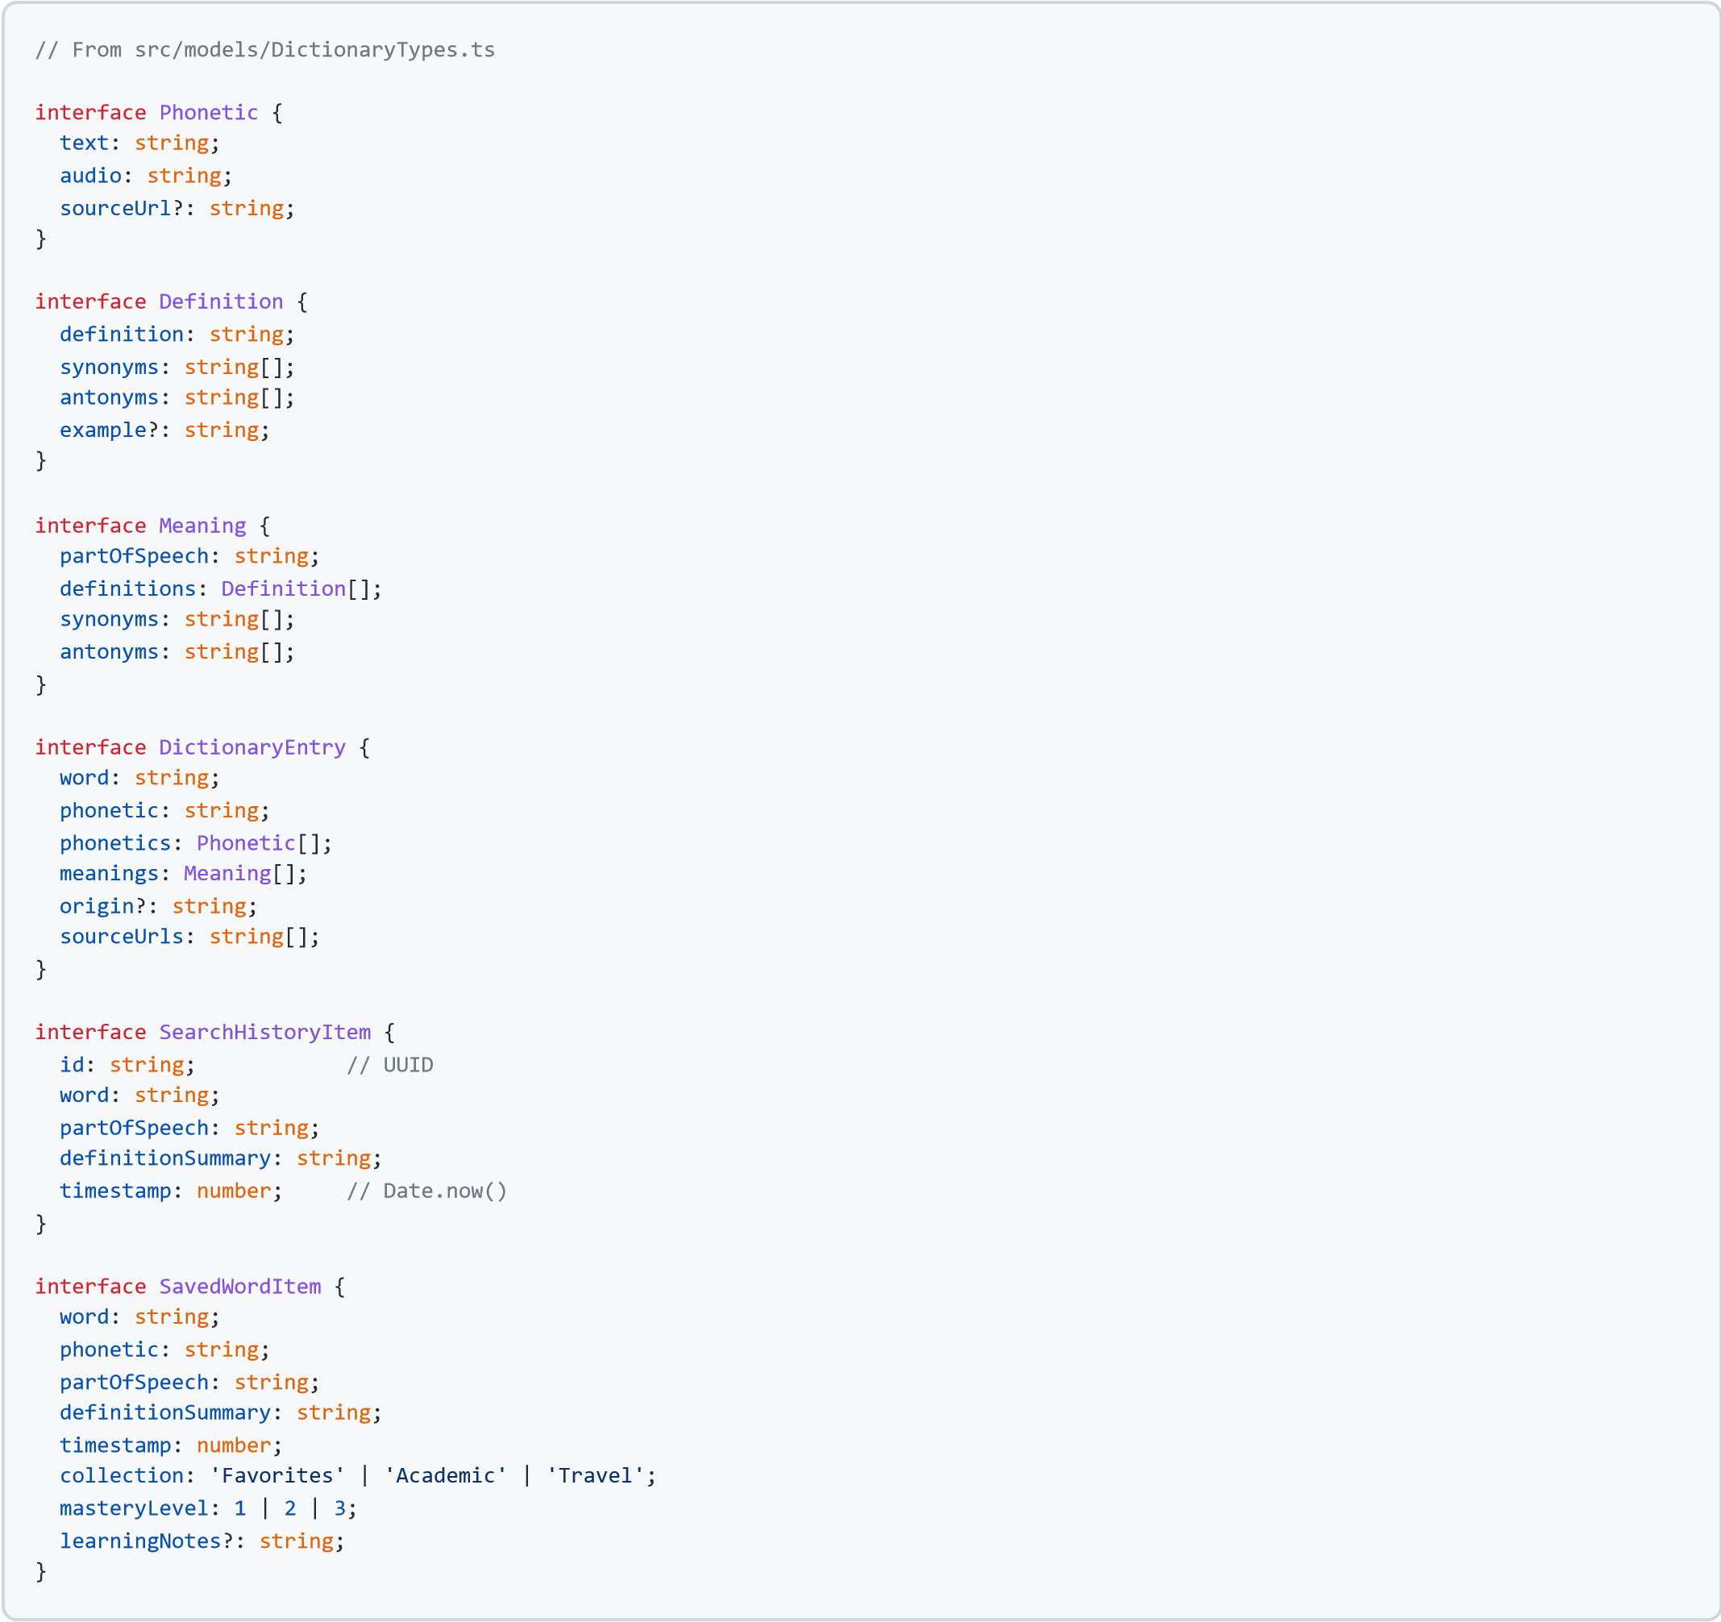

Directory Structure
D:\Mobile\Verba-Mobile\
├── App.tsx # Root component with providers
├── package.json # Dependencies (expo, axios, react-navigation)
├── babel.config.js # Babel with reanimated plugin
├── app.json # Expo configuration
├── Integrated Situation.md # Requirements document
│
└── src/
├── assets/ # Static assets (fonts, images)
│
├── components/ # Reusable UI components
│ ├── SearchBar.tsx # Text input with clear/submit
│ ├── WordCard.tsx # WotD hero card (word, phonetic, audio, definition)
│ ├── MeaningCard.tsx # Part-of-speech card with definitions
│ ├── DefinitionItem.tsx # Single definition with left-bar indicator
│ ├── ExampleText.tsx # Italic example sentence
│ ├── PronunciationButton.tsx # Audio play/pause button (expo-av)
│ ├── ErrorView.tsx # Error states (404, offline, timeout)
│ ├── EmptyState.tsx # Empty collection / no results
│ ├── LoadingSpinner.tsx # Animated loading indicator
│ └── HistoryItem.tsx # History list row (swipeable)
│
├── screens/ # Full-page screen components
│ ├── SplashScreen.tsx # Brand intro + first-launch check
│ ├── OnboardingScreen.tsx # 4-step feature carousel
│ ├── DiscoverScreen.tsx # Home: search, WotD, trending, stats
│ ├── WordDetailsScreen.tsx # Full word detail view
│ ├── HistoryScreen.tsx # Search history list
│ ├── SavedWordsScreen.tsx # Bookmarked words + quiz
│ └── SettingsScreen.tsx # App preferences
│
├── navigation/ # Navigation configuration
│ ├── AppNavigator.tsx # Stack + Drawer navigator setup
│ └── DrawerContent.tsx # Custom drawer sidebar
│
├── context/ # React Context providers
│ ├── ThemeContext.tsx # Dark/light mode + font scaling
│ ├── HistoryContext.tsx # Search history state
│ └── SavedContext.tsx # Saved words + streak state
│
├── hooks/ # Custom React hooks
│ ├── useAudio.ts # Audio playback via expo-av
│ └── useDebounce.ts # Input debouncing (200ms)
│
├── services/ # Data access layer
│ ├── api.ts # Axios instance (baseURL, timeout, headers)
│ └── dictionaryService.ts # lookupWord() with error classification
│
├── models/ # TypeScript type definitions
│ └── DictionaryTypes.ts # All interfaces
│
├── utils/ # Utility functions
│ └── apiParser.ts # Raw API JSON → DictionaryEntry
│
└── styles/ # Design system
└── theme.ts # Colors, spacing, typography tokens

