

<new-space.info>

Project Report

DT228

Computer Science

**<Alex Nuzum>**

School of Computer Science

Technological University Dublin

**<11.12.2019>**

Declaration

I hereby declare that the work described in this dissertation is, except where otherwise stated, entirely my own work and has not been submitted as an exercise for a degree at this or any other university.

Signed:

Alexander Nuzum

<Alex Nuzum>

<11/12/2019>

Table of Contents

*1.* Problem Description 2

*2.* Research 3

*3.* Technology Selection and Site Architecture 6

*4.* Low Fidelity Prototype 7

*5.* Development Plan 10

*6.* Testing Plan 10

*7.* Site Evaluation 11

*8.* Deployment 11

Appendices 5

# **Problem Description**

The website that I have designed has information on all the major NewSpace companies. NewSpace companies are commercial aerospace companies that function separately from government agencies such as NASA, Canadian Space Agency, Indian Space Research Organisation etc. The website has information about the different products that these companies have to offer. This also includes videos and other information about the companies.

The homepage gives an overview of what NewSpace means and how we as a species got to this stage. This is not a space history website and therefore doesn’t go into a lot of detail about the history of spaceflight. It does however mention the notable moments in spaceflight history. Such events include the invention of fireworks by the Chinese, the first modern rocket engine and the Apollo program.

The second page is all about Space Exploration Technologies Inc (SpaceX). There is background information about the company. This page describes how and why it was formed. It also has information and videos about the companies three main product offerings, the Falcon 9, Falcon Heavy and Starship rockets. Starship is the only one yet to fly. In the future I would like to add more detailed statistics such as the thrust of the merlin and raptor engines, the payload capacities of each rocket and so on.

There is also a webpage about Blue Origin, a commercial space tourism company. This page highlights their goal of having a trillion people living and working in space.

There is information about the two rockets that they are developing: New Shepard and New Glenn. This page also details the pre-launch, launch and post launch procedures for commercial astronauts. Once again, I wish to go into more detail in the future.

The last two pages of the website are the credits page and the signup page. The credits page has a list of all the images on the website. I added this so that you could see where the images where sourced from. Although most of them are free to use, some of them were taken by professional photographers. The signup page includes a form with form validation. There is also some other info such as the twitter feed for the websites new twitter account @NSpace19.

The archetypical users of this website are people who like space related info or are just getting into it. This might include news on space technologies and upcoming launches. User of this site might want to learn more about NewSpace or might cite it as a source when making YouTube videos or writing articles.

The site solves the problem of not having a central portal for NewSpace news. There are many websites about space and space related technology but not one dedicated solely to information on the commercial spaceflight industry.

# **Research**

There are many websites similar to mine. The three main websites that come to mind are <https://space.com/>, <https://everydayastronaut.com/> and <https://www.nasaspaceflight.com/>.

**Space.com**

Space.com has all its information organised into different sections. The main sections are news, tech, spaceflight, science and astronomy, search for life, and sky watching. The website also has information about space themed entertainment such as sci-fi. Not only does it have news. It also has a form where people can talk about the space related stuff that interests them. There are also reviews of astronomy products. This includes telescope reviews and information about “All About Space”, a great space magazine.

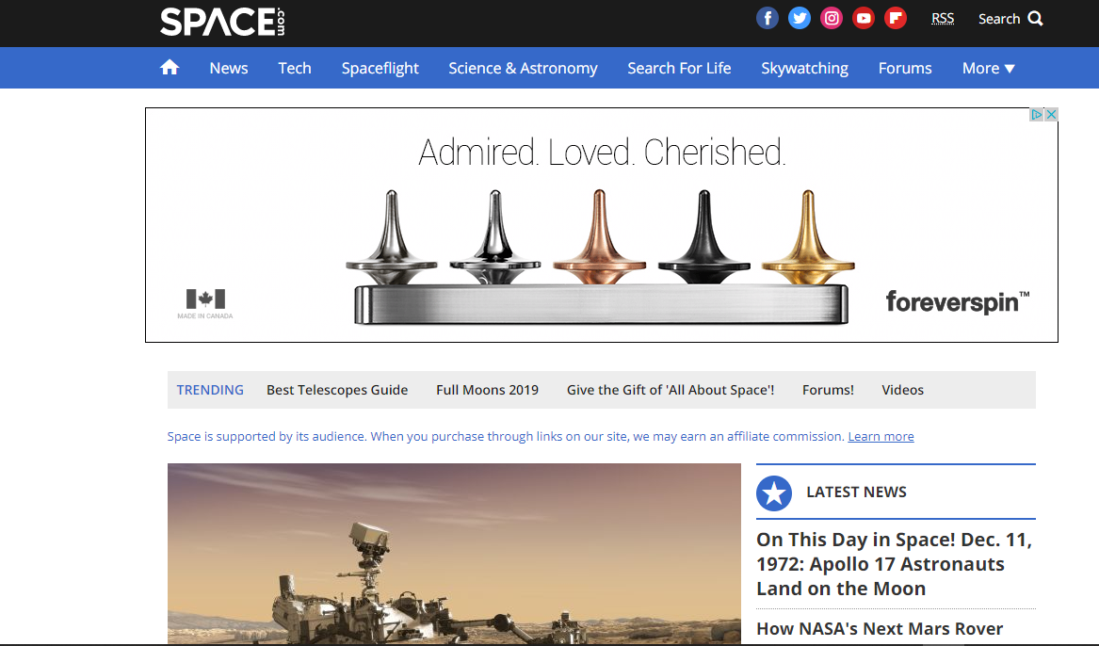

Figure 1 The space.com homepage

**Everydayastronaut.com**

The next website I looked at was <https://everydaystronaut.com>. This is the website of The Everyday Astronaut. He is very popular among the spaceflight enthusiast community. The website has five categories: News, Prelaunch previews, shop, partners and an about page. The news section has all the space news. The prelaunch preview has info about upcoming missions. The shop has Everyday astronaut merchandise and the partners and about pages has list of partners and the history of Everyday Astronaut respectively.

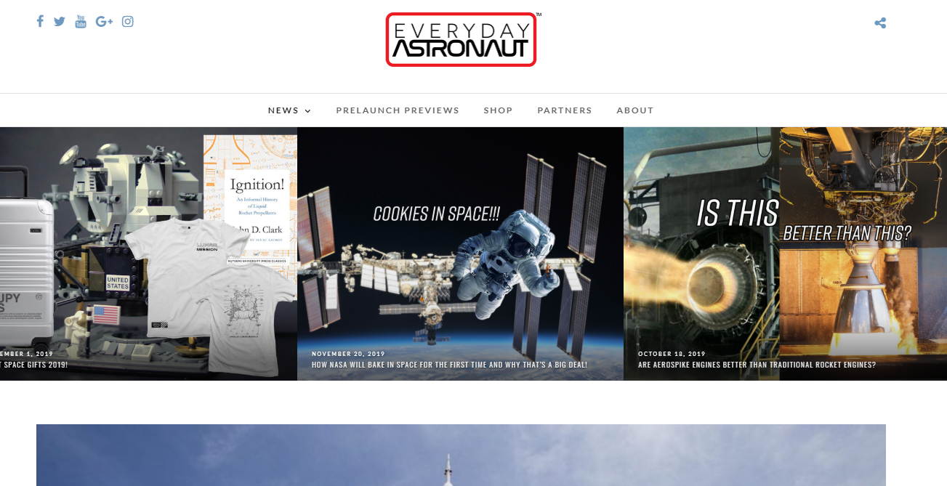

Figure 2The space.com homepage

**Nasaspaceflight.com**

Nasaspaceflight.com (NSF) is a news website for spaceflight. On the website, there is a form for talking to people, an image repository, news about NASA, SpaceX and ISS etc. On the homepage there are main headlines and some links to popular form posts. There is one major headline on the left and three other smaller headlines of the right. Underneath that, there are more nes

The image repository – named L2 – is a paid subscription service where people can gain access to images from the space industry. These images cannot be found anywhere else. Signing up to this service give users access to a restricted part of the website.

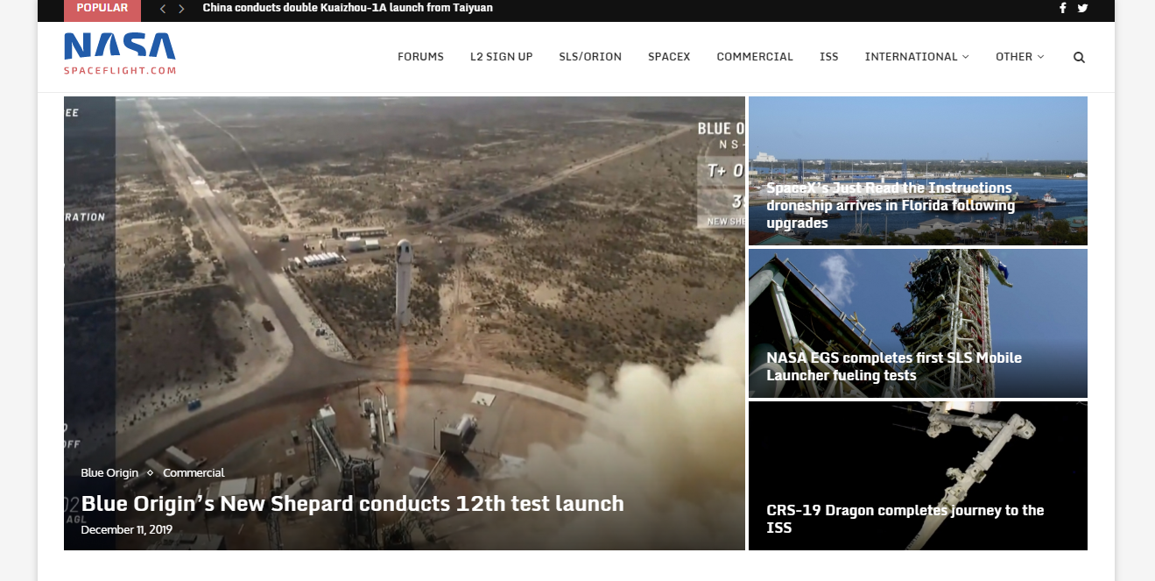

Figure 3 Nasaspaceflight.com

# 

# **Technology Selection and Site Architecture**

I will use vanilla html/css/JavaScript. I will avoid using bootstrap, jQuery and other similar libraries. The website will use JavaScript, to enhance the functionality of the webpage but will not be necessary to the running of the website. The website will use HTML5 and CSS3. The website will also use ECMAScript 6 and utilise JavaScript functionality such as element.scrollIntoView() and ${variable}.

The website will use responsive design. The website will look visually stunning in desktop browser but due to the screen size of mobile devices it will not look as good. It will still really good on mobile though. The website will have navigation bar on the desktop but will have a hamburger menu on mobile. The website will be designed for mobile using media queries. The website will be as responsive as possible in order to minimise the need for css media queries.

I expect that most users will view the website on the desktop or on iPads, but some users will prefer to view the website on their mobile phones.

The website will be cross browser compatible. It will only use web technologies that are supported by al major browsers except Internet Explorer. If a html/css/JavaScript feature is not supported by a specific browser, I will make sure that it is cosmetic and not essential to the smooth running of the site. The website will utilise graceful degradation.

# A screenshot of a cell phone Description automatically generatedA screenshot of a cell phone Description automatically generatedLow Fidelity Prototype

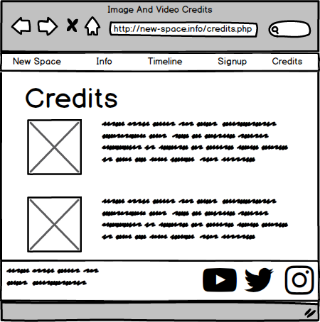

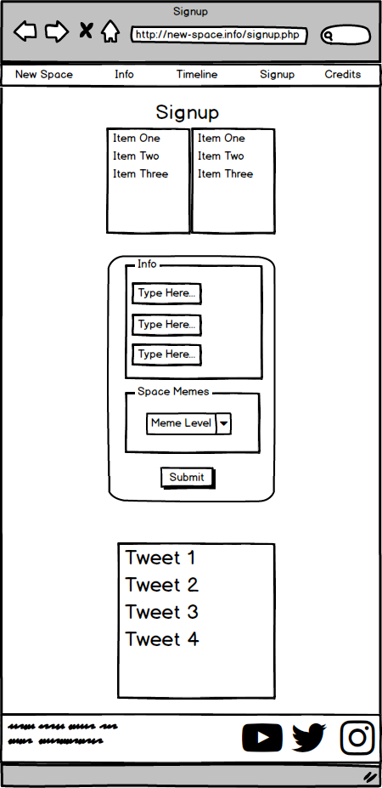

The low-fidelity prototypes follow 5 out of 10 of Jakob Nielsen’s usability heuristics. The five that they follow are using familiar metaphors & language, consistent user interface, making info easy to find, error recovery, and minimalism. The rest are irrelevant to my website. There is no need for undo functionality or making advanced tasks efficient because this is only an info website, not an app.

# 

# **Development Plan**

The website was developed one page at time. I started with the homepage. Firstly, I started writing out the content that I wanted for my website. I wanted the website to be as beautiful as possible. I knew that my web development skills were great, but my design skills were lacking. I decided to download images off the internet that looked good. My logic was that professionally taken photos would make the website look ten times better. In the future, I will eventually add my own graphics but for the purpose of the project, these images are great.

I build and designed every page of the website. Once each page was done, I went back and made it responsive. I repeated this until the website was done. At this stage, I went back and made sure the website looked good. I added more content to each page if it didn’t look good.

I also had a blue and white theme on my website. I decided that it didn’t look cool enough, so I changed the theme to gainsboro and really dark grey. This made it look so much better.

# **Testing Plan**

I tested the website using the W3C HTML validator to validate the website. I checked the for any html errors and I fixed them. I also used the W3C CSS. I kept getting parse errors which I didn’t understand. I looked this up on <https://stackoverflow.com> and someone suggested that there were some weird characters in the document that wouldn’t usually cause problems to the CSS.

The Chrome devtools have become an essential part of life. I used it to check for JavaScript and to check why my css wasn’t working. It is very useful because it tells you whether a certain CSS property is being overridden by another property. It also allows you to change the CSS values on the fly and add breakpoints to the JavaScript.

The website is cross browser compatible, but it does not work 100% in Internet Explorer. Other than that, the website is cross browser compatible.

# **Site Evaluation**

Once the website was completely finished, I evaluated the website based on Nielsen’s 10 heuristics. This is comparable to the low fidelity prototypes. The website does follow 5 out of 10 of Nielsen’s usability heuristics. The five that they follow are the same as the lo-fi prototypes. These are, using familiar metaphors & language, consistent user interface, making info easy to find, error recovery, and minimalism. The rest are irrelevant to my website. There is no need for undo functionality or making advanced tasks efficient because this is only an info website, not an app.

There is also no in place hints on the website because there is no way to got confused by the website. The only thing remotely related to in place hints are on the 404 page.

You must describe how you evaluated your website using appropriate heuristics.

# **Deployment**

I used <https://000webhost.com> for webhosting and I also used GoDaddy for the domain name. I bought a domain name from them for the cost of 2 bags of lemons: €1.35. I uploaded the website to 000webhost and parked the website so that it linked to my domain <http://new-space.info/>. I used FileZilla to upload the website to 000webhost.

I used the <title></title> tag for search engine optimisation because it gives Google’s spider’s something to crawl over. I also put lots of quality content onto the page so that Google Search thinks that is a quality website and puts it in number 1 place on Google Search.

# **Appendix**

Web Dev 1

Weekly Project Report – Week 1

Please provide a brief overview of the research or tasks that were completed on your project this week. (This should take no longer than 10 minutes to complete):

I Decided what is was going to do for my project. My project idea is a website on the current and future developments of the NewSpace industry. I will have pages about SpaceX, Blue Origin, Virgin Galactic etc.

I started designing the home page of the website and brushing up on my knowledge of the history of rocketry. I downloaded some pictures to use for the hero header and added them to the page.

Web Dev 1

Weekly Project Report – Week 2

Please provide a brief overview of the research or tasks that were completed on your project this week. (This should take no longer than 10 minutes to complete):

I finished the homepage of my website and did ½ of the second page. This included downloading different images and finding links to videos that are going on the two pages.

I did the homepage on Tuesday and most of the second page on Thursday.

Web Dev 1

Weekly Project Report – Week 3

Please provide a brief overview of the research or tasks that were completed on your project this week. (This should take no longer than 10 minutes to complete):

I worked on the third page of my website and also started working on a credits page. I want to be able to put this online and turn it into an always up to date news source so I need to give credit to the different image that are on all the different pages. I also completely finished the first and second page, making it look good on mobile devices.

Web Dev 1

Weekly Project Report – Week 4

Please provide a brief overview of the research or tasks that were completed on your project this week. (This should take no longer than 10 minutes to complete):

This week I finished designing the 3rd page of the website. I also started to make the webpage responsive so that it looks good on smaller screens and mobile devices. If designed the credits page so I could credit the people or websites that took / rendered the images and videos that I am using on the website.

Lastly, I bought a web domain – <http://new-space.info/> - for the price of 4 lemons, 85c

Web Dev 1

Weekly Project Report – Week 5

Please provide a brief overview of the research or tasks that were completed on your project this week. (This should take no longer than 10 minutes to complete):

This week I finished the 4th page of the website and I started work on the last webpage. The last webpage will have a signup form where you can submit your details. I am definitely not creating a user information farm that I can use to send them unsolicited adverts. I also finished the credits page where I display the credits to all the images on the website.