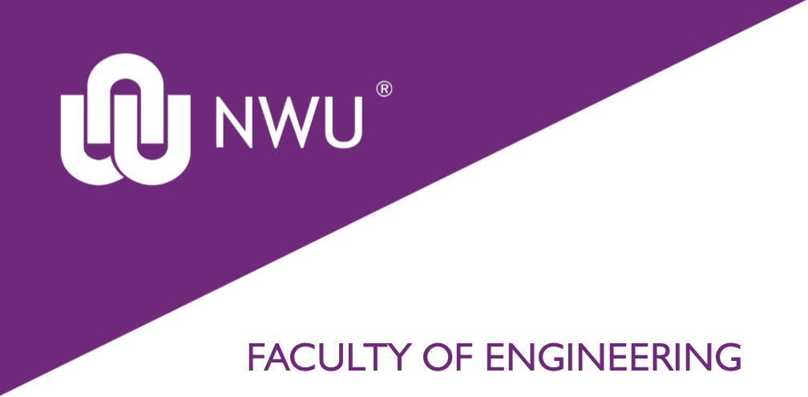

INGB 413:
GA Individual Exam Assignment
QUALITY ASSURANCE

By
Nthabiseng Maoka
30224926

Submitted in pursuit of the degree
BACHELOR OF ENGINEERING
IN
INDUSTRIAL ENGINEERING

Lecturer: Dr Maria van Zyl
Due date: 30/05/2026

North-West University: Potchefstroom Campus

