6. Detail Design Specifications
This chapter converts the DigMore Co. demand and product specification into the quantitative parameters that govern the new facility: production rates, raw-material quantities, machine and operator requirements, workstation layouts, material handling, storage, receiving and dispatch, support facilities and floor space, including the 10 % future expansion allowance. Each parameter is derived from the 2026 assignment brief or the supporting calculation workbook, and each subsection closes with its implications for material flow and the Master Facility Plan. All equipment named is a market example used for sizing and illustration only; final selection requires supplier quotation.
[ INSERT FIGURE 1 — draw simple exploded view (15 min, diagrams.net) ]
Figure 1: Folding mini shovel component breakdown — back handle, middle handle, shovel head and hinge connector (Ø31.70 × 3.18 mm aluminium tube; 2.5 mm aluminium sheet). Author’s own, from the 2026 brief.
Open source page: https://app.diagrams.net

6.1 Demand and Production Requirements
The facility must produce 400 000 folding mini shovels per year over 220 working days on a single 9-hour shift containing one 30-minute lunch and two 15-minute tea breaks, leaving 480 productive minutes per day. Equipment is sized on the full 480 minutes (availability 1.0) — a design assumption with no setup or breakdown allowance, tested in Section 6.3. The daily requirement is rounded up to avoid an annual shortfall:
Daily demand = ⌈400 000 / 220⌉ = ⌈1 818.2⌉ = 1 819 shovels/day (1)
Takt time = 480 min / 1 819 = 0.264 min/shovel = 15.83 s/shovel (2)
Hourly production is 1 819 / 8 ≈ 228 shovels per hour. The 5 % scrap allowance applies only to tube cutting and sheet stamping, so those operations and all upstream of them run at a gross rate of good ÷ 0.95.
Table 1: Demand and production parameters
Parameter | Value | Unit | Basis
Annual demand | 400 000 | shovels/yr | Brief
Working days | 220 | days/yr | Brief
Effective time | 480 | min/day | Shift 540 − breaks 60
Availability | 1.0 | – | Assumption (sensitivity §6.3)
Daily demand | 1 819 | shovels/day | Equation (1)
Takt time | 15.83 | s/shovel | Equation (2)
Scrap allowance | 5 (cut & stamp only) | % | Brief

Table 2: Part-level daily requirement
Part | Qty/shovel | Good/day | Gross/day
Back handle section (tube) | 1 | 1 819 | 1 915
Middle handle section (tube) | 1 | 1 819 | 1 915
Total tube sections | 2 | 3 638 | 3 830
Shovel head (sheet) | 1 | 1 819 | 1 915
Hinge connector (sheet) | 1 | 1 819 | 1 915

Packaging converts output into unit loads: 1 819 bought-out bags, 182 boxes (10/box) and 5 pallets (400/pallet) per day. Orders of one pallet or less are customer-collected; larger orders ship on DigMore’s own fleet.
Key findings and layout implications. Takt of 15.83 s against brief cycle times of up to 120 s makes parallelisation the facility’s sizing mechanism: sharpening (120 s), knurling (60 s), serrating (60 s) and polishing (60 s) require machine banks that dominate floor area and WIP staging. The product structure fixes the flow architecture before any layout is drawn: tube and sheet streams fabricate in parallel; the two sheet parts converge at riveting into the head subassembly; the streams converge only at final assembly, where three powder-coated items meet (back handle, middle handle, head subassembly).
[ INSERT FIGURE 2 — flow diagram (20 min, diagrams.net) ]
Figure 2: High-level material flow from receiving to dispatch — parallel streams, riveting convergence, finishing and enclosed coating, final-assembly convergence, packaging and dispatch routes. Author’s own.
Open source page: https://app.diagrams.net

6.2 Raw Material Requirements
Aluminium round tube (Ø31.70 × 3.18 mm) arrives as 6 m stock, the standard South African mill length (Premium Aluminium). The yield per tube must include saw kerf; a practical allowance of 2.5 mm is adopted from cold-saw blade data (an allowance, not a standard — confirm against the selected blade):
Gross sections/day = 3 638 / 0.95 = 3 829.5 ≈ 3 830 tube sections/day (3)
Sections/tube = ⌊6 000 / (150 + 2.5)⌋ = 39 sections (4)
Tubes/day = ⌈3 829.5 / 39⌉ = 99 ⇒ 990 tubes per two-week cover (5)
Shovel heads and hinge connectors are stamped from 2 500 × 1 250 × 2.5 mm sheet — a standard South African size (Euro Steel) — at an assumed 75 % nesting efficiency:
Parts/sheet: heads ⌊3.125×0.75/0.0238⌋ = 98; hinges ⌊3.125×0.75/0.004⌋ = 585 (6)
Sheets/day = ⌈1 914.7/98⌉ + ⌈1 914.7/585⌉ = 20 + 4 = 24 ⇒ 240 sheets per two weeks (7)
Table 3: Two-week raw-material requirement and delivery unit loads
Material | Daily | 2-week stock | Delivery unit load | Offload
Al tube 6 m | 99 | 990 | Strapped bundle ≈25 [VERIFY] → 4 bundles/day | Forklift side-offload, ground bay
Al sheet 2 500×1 250 | 24 | 240 | Pallet ≈60 sheets [VERIFY] | Shared dock
Packaging bags | 1 819 | 18 190 | Carton/pallet, weekly | Dock
Rivets (2/shovel assumed) | 3 638 | 36 380 | Carton, weekly [VERIFY] | Dock

Key findings and layout implications. The two stores are physically dissimilar: 990 six-metre tubes need cantilever racking with long-side forklift access, while 240 sheets stack beside the presses. The tube offload face, storage face and saw feed face are designed as the same face, eliminating two handlings. Replenishment is light (2–3 consolidated deliveries per week), so receiving is sized by dispatch rather than inbound volume.

6.3 Manufacturing Time and Capacity
Each brief-specified process is tested against the 480 effective minutes per day:
Machines = ⌈(gross units/day × cycle time) / (480 × 60 s)⌉ (8)
Utilisation = required minutes per day / (machines × 480) (9)
Example — sharpening: ⌈1 819 × 120 / 28 800⌉ = ⌈7.58⌉ = 8 machines at 3 638/(8×480) = 94.7 %. Operators are assigned 1:1 to machines (workbook baseline).
Table 4: Per-process capacity analysis (core exhibit)
Process | Gross/day | Cycle (s) | Req. min/day | Machines | Util. | Operators
Tube cutting | 3 830 sections | 15 | 957 | 2 | 99.7 % | 2
Internal threading | 1 915 | 20 | 638 | 2 | 66.5 % | 2
End narrowing | 1 915 | 5 | 160 | 1 | 33.2 % | 1
Knurl + ext. thread | 1 915 | 60 | 1 915 | 4 | 99.7 % | 4
Head stamping | 1 915 | 2 | 64 | 1 | 13.3 % | 1
Hinge stamping | 1 915 | 2 | 64 | 1 | 13.3 % | 1
Hinge bending | 1 819 | 5 | 152 | 1 | 31.6 % | 1
Head shaping | 1 819 | 2 | 61 | 1 | 12.6 % | 1
Blade sharpening | 1 819 | 120 | 3 638 | 8 | 94.7 % | 8
Blade serrating | 1 819 | 60 | 1 819 | 4 | 94.7 % | 4
Riveting | 1 819 | 5 | 152 | 1 | 31.6 % | 1
Hand polishing | 1 819 | 60 | 1 819 | 4 | 94.7 % | 4
Final assembly | 1 819 | 30 | 910 | 2 | 94.7 % | 2
Packaging + check | 1 819 | 30 [VERIFY] | 910 | 2 | 94.7 % | 2
TOTAL |  |  |  | 34 | avg 62.5 % | 34

Key findings and layout implications. Sharpening is the bottleneck by workload (3 638 machine-min/day; 8 of 34 machines); tube cutting and knurling hold the least headroom (99.7 % — under two minutes of slack per machine per day; mitigations: bundle cutting and the faster inherent thread-rolling cycle). The 94.7 % family shares one cause, so one added unit anywhere in it buys 10–12 % headroom. At 90 % availability the requirement rises to 41 machines (+7, ≈42 m²) — reserved as positioned expansion ground, not base plan. Equipment-dependent processes add one ageing oven, a blast installation and two powder-coating lines: ⌈5 457/(600×8)⌉ = 2 lines, since a single line needs 9.1 h and overtime is not the base plan. Production-related staff total 43 of 60 (34 line + 4 equipment/QA + 5 material handlers).

6.4 Manufacturing Processes and Workstations
Each workstation below states the process, the selected machine class with specifications, and the workstation layout: machine footprint, WIP before and after, operator movement area, aisle width and material handling. Workstation floor space follows the standard build-up:
A(station) = A(machine) + A(operator) + A(WIP in/out) + A(access) = 1.0+1.5+2.0+1.5 = 6.0 m² (10)
Stations whose true geometry exceeds the 6 m² allowance (saw strips, packaging) carry explicit corrections into Section 6.8. Aisle design bases: 0.5–0.9 m operator movement inside stations, 2.0 m trolley/milk-run lanes, 3.5 m forklift aisles.

6.4.1 Tube Cutting
Process. Six-metre tubes are cut to 150 mm handle sections at 15 s/cut — the head of the tube stream and one of two scrap-generating steps (5 %): 3 830 sections/day on two automatic non-ferrous saws with 6 m bar feed.
Table 5: Tube Cutting — machine and workstation specifications
Specification | Value | Basis
Equipment | Auto non-ferrous saw + bar feed | Market example: ProfiFeed A420
Cell size | 9.0 × 2.0 m = 18 m² (×2) | Drawing; 6 m magazine
Machines / operators | 2 / 2 (99.7 %) | Capacity table
WIP before / after | Rack face (990 tubes) / 1.7 m² bins | Drawing
Operator movement | 7.9 × 0.9 m = 7.1 m² | Drawing
Cost | Quotation required (Low) | Supplier sells on enquiry

[ INSERT FIGURE 3 — machine photo (open link, screenshot/redraw) ]
Figure 3: Automatic aluminium saw with bar feeder. Market example for sizing and illustration only — redraw or insert supplier image with permission.
Open source page: https://profifeedtech.com/products/aluminium-fully-automatic-saw-a420/
Workstation. The operator loads tubes from the cantilever rack along the same face as the bar magazine (zero transfer), monitors the cycle and clears section bins; the blade is fully guarded with magazine interlock and the cell sits in the noise-PPE zone. The 6 m infeed makes the cell a 9 m strip — a +24 m² correction to the uniform allowance carried into §6.8.
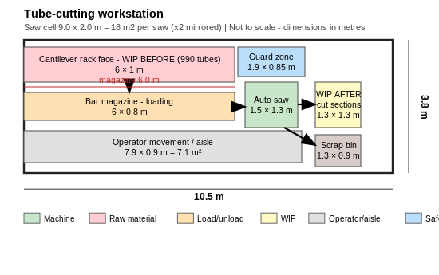
Figure 4: Tube-cutting workstation layout — rack face feeds the 6 m magazine; guarded saw; WIP-after bins; scrap on the waste route (Author’s own.)
Material handling. Tube bundles arrive by forklift side-offload at the ground-level bay straight onto the racks; cut sections leave hourly by milk-run tube cart (≈400 sections/cart, ≈10 trips/day); the scrap bin exchanges on the waste route.

6.4.2 Internal Threading
Process. The middle handle section receives its internal thread (20 s/pipe; 1 915 pipes/day) so the externally threaded back handle can screw into it.
Table 6: Internal Threading — machine and workstation specifications
Specification | Value | Basis
Equipment | Torque-limited tapping machine | Market example: Roscamat Tiger (to M30 in Al; 1 020 mm radius)
Cell size | 3.0 × 2.0 m = 6 m² (×2) | Equation (10)
Machines / operators | 2 / 2 (66.5 %) | Capacity table
WIP before / after | 0.7 m² bin each side | Drawing
Cost | Quotation required (Low) | Distributor enquiry

[ INSERT FIGURE 5 — machine photo (open link, screenshot/redraw) ]
Figure 5: Electric tapping machine. Market example for sizing and illustration only — redraw or insert supplier image with permission.
Open source page: https://www.cotswold-machinery-sales.co.uk/roscamat-tapping-machines/electric-tapping-machines/roscamat-tiger-electric-tapping-machine/
Workstation. Bench-height fixture eliminates wrist torque (clutch-protected tap holders); seated/standing posture with task lighting and a swarf bin. Its 66.5 % utilisation provides slack that absorbs saw interruptions.
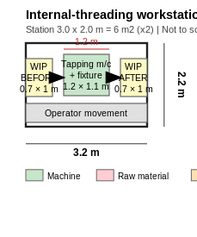
Figure 6: Internal-threading workstation — bench cell with fixture, WIP bins at bench height (Author’s own.)
Material handling. Cut sections arrive by tube cart; threaded pipes move by cart to powder-coat staging.

6.4.3 End Narrowing
Process. One end of the back handle is swaged to the grip diameter in a single 5 s ram stroke (1 915 pipes/day).
Table 7: End Narrowing — machine and workstation specifications
Specification | Value | Basis
Equipment | Ram-type tube end former | Market class: Hippo (model for Ø31.7 at quotation)
Cell size | 3.0 × 2.0 m = 6 m² (×1) | Equation (10)
Machines / operators | 1 / 1 (33.2 %) | Capacity table
Cost | Quotation required (Low) | Custom model

[ INSERT FIGURE 7 — machine photo (open link, screenshot/redraw) ]
Figure 7: Tube end-forming machine. Market example for sizing and illustration only — redraw or insert supplier image with permission.
Open source page: https://www.hippobender.com/tube-end-former/
Workstation. Two-position loading keeps hands clear of the die; at 33 % utilisation this is the tube stream’s flex station and directly precedes knurling in a one-piece-flow lane.
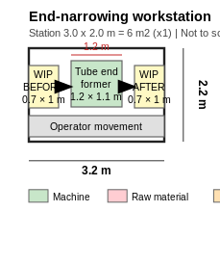
Figure 8: End-narrowing workstation — single-stroke swage between WIP bins (Author’s own.)
Material handling. Cart in from cutting; direct lane out to the knurling bank.

6.4.4 Knurling and External Threading
Process. The narrowed grip is knurled and externally threaded in one 60 s rolling cycle (1 915/day) — the tube stream’s capacity constraint.
Table 8: Knurling and External Threading — machine and workstation specifications
Specification | Value | Basis
Equipment | 2-die thread/profile rolling machine | Market example: Profimach PTR 42 (Ø6–42 mm; 150 kN; 1 500×1 580×1 140 mm; 4 kW)
Bank size | 8.4 × 3.4 m = 28.6 m² | Drawing
Machines / operators | 4 / 4 (99.7 %) | Capacity table
WIP | Full-length infeed buffer strip (mandatory) | 99.7 % — no recovery margin
Cost | Quotation required (Low) | Supplier enquiry

[ INSERT FIGURE 9 — machine photo (open link, screenshot/redraw) ]
Figure 9: Two-roll thread rolling machine. Market example for sizing and illustration only — redraw or insert supplier image with permission.
Open source page: https://profimach.com/special-machine/2-roll-thread-roll-machines-ptr-series
Workstation. Rolling is chipless and work-hardens the thread — suited to the thin tube wall. Operators load between dies at elbow height; each machine keeps maintenance clearance because the bank cannot afford downtime. The milk-run replenishes the buffer hourly.
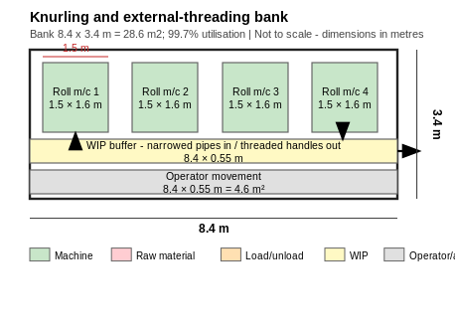
Figure 10: Knurling/external-threading bank — four machines with mandatory infeed WIP buffer and shared operator aisle (Author’s own.)
Material handling. Buffer fed by milk-run; threaded back handles join middle handles on carts to powder-coat staging.

6.4.5 Shovel-Head and Hinge Stamping (press cell)
Process. Head blanks (0.17×0.14 m) and hinge blanks (0.08×0.05 m) are blanked from 2.5 mm sheet at 2 s/part each (1 915 gross/day each; 5 % scrap). The two presses share one cell: one sheet supply, one skeleton-scrap route, one supervision point.
Table 9: Shovel-Head and Hinge Stamping (press cell) — machine and workstation specifications
Specification | Value | Basis
Equipment | Gap-frame mechanical press (×2) + dies | Market example: Stamtec OCP-35 (35 t; 70–180 SPM; 930×1 200×2 100 mm)
Cell size | 6.4 × 4.0 m = 25.6 m² | Drawing
Machines / operators | 2 / 2 (13.3 % each) | Capacity table
Option | 1 press + quick die change @ ≈27 % | Carried to layout alternatives
Cost | Quotation required (Low); dies separate | Quote request only

[ INSERT FIGURE 11 — machine photo (open link, screenshot/redraw) ]
Figure 11: Gap-frame mechanical press. Market example for sizing and illustration only — redraw or insert supplier image with permission.
Open source page: https://www.stamtec.com/presses/mechanical-presses/1-point-gap-frame-press/ocp-series-gap-frame-press
Workstation. Sheets weigh ≈21 kg, at the single-person repetitive limit — an infeed support table and two-person lift or assist are specified at detailed design. Light curtains guard both presses; die-change access is preserved at the rear.
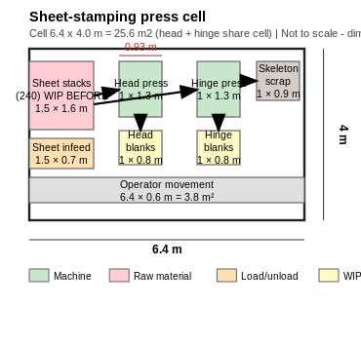
Figure 12: Sheet-stamping press cell — shared sheet stacks, two presses, blank bins, skeleton-scrap bin (Author’s own.)
Material handling. Sheets forklift-delivered to the stacks; blanks leave in bins on the milk-run; skeleton scrap shares the waste route with saw offcuts.

6.4.6 Hinge Bending and Head Shaping
Process. Hinge blanks are bent to bracket geometry (5 s; 1 819/day) on a small press brake with fixed V-die; head blanks are formed to the dished profile (2 s; 1 819/day) on the same press platform as stamping for spares and training commonality.
Table 10: Hinge Bending and Head Shaping — machine and workstation specifications
Specification | Value | Basis
Equipment | Electric press brake + V-die; forming press + die set | Examples: Euromac FX Bend class; Stamtec OCP class
Cells | 8.5 m² (brake, guard incl.) + 6 m² (forming) | Drawings
Machines / operators | 1 + 1 / 1 + 1 (31.6 %, 12.6 %) | Capacity table
Cost | Quotation required (Low) | Dims/tonnage at quote

[ INSERT FIGURE 13 — machine photo (open link, screenshot/redraw) ]
Figure 13: Electric press brake. Market example for sizing and illustration only — redraw or insert supplier image with permission.
Open source page: https://www.cotswold-machinery-sales.co.uk/euromac-bending-machines/electric-press-brakes/fx-bend-850/
Workstation. Light curtain at the pinch point; bench-style flow left-to-right. The forming press’s output buffer is deliberately oversized: it feeds the sharpening bank, which must never starve.
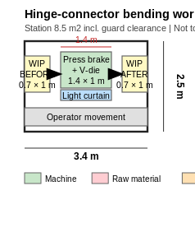
Figure 14: Hinge-bending workstation — light-curtain guarded brake between WIP bins (Author’s own.)
Material handling. Bins by trolley from stamping; bent hinges to riveting staging; formed heads to the sharpening WIP lane.
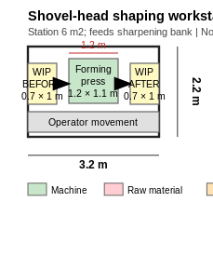
Figure 15: Shovel-head shaping workstation — single-stroke forming between WIP bins (Author’s own.)

6.4.7 Blade Sharpening — facility bottleneck
Process. Each formed head is ground to its cutting bevel at 120 s — the longest cycle in the plant: 1 819 heads/day on eight parallel grinding stations at 94.7 %.
Table 11: Blade Sharpening — facility bottleneck — machine and workstation specifications
Specification | Value | Basis
Equipment | Pedestal belt grinder + extraction base (×8) | Market example: Fein GRIT GI75 (75×2 000 mm belt; 4 kW; 415 V; non-ferrous rated)
Bank size | 8.4 × 6.2 m = 52.1 m² | Drawing
Machines / operators | 8 / 8 (94.7 %) | Capacity table
Unit cost | ≈ R72 800 (£3 293 incl UK VAT @ R22.11/GBP, 10 Jun 2026; excl. shipping/duties) | Converted price (Medium)
Bank cost (with serrating, 12 units) | ≈ R873 600 | Converted price (Medium)

[ INSERT FIGURE 16 — machine photo (open link, screenshot/redraw) ]
Figure 16: Abrasive belt grinder with extraction base. Market example for sizing and illustration only — redraw or insert supplier image with permission.
Open source page: https://www.echopkins.com/shop/fabrication/large-abrasive-machines/belt-grinders/pedestal/fein-gi75-abrasive-belt-grinder/
Workstation. Workpieces present to the belt at chest height with anti-fatigue mats and task lighting. Grinding aluminium creates combustible dust: each row connects to a dedicated extraction trunk and collector (combustible-metals practice, e.g. NFPA 484 — local equivalent to be confirmed), never mixed with spark sources. The bank is the plant’s dominant noise zone and is acoustically zoned away from assembly and offices.
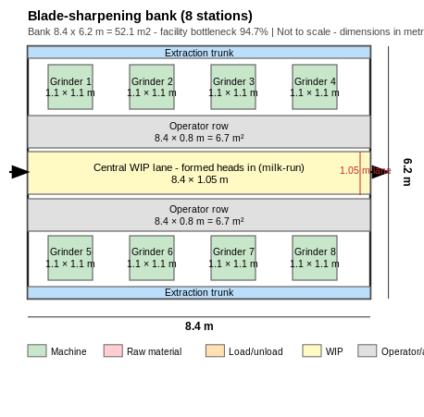
Figure 17: Blade-sharpening bank — two facing rows of four grinders, rear extraction trunks, operator rows and central milk-run WIP lane (Author’s own.)
Material handling. The central WIP lane is milk-run fed hourly — at 94.7 % the operators never leave the row; the buffer holds several hours of supply because lost bottleneck time cannot be recovered within the shift.

6.4.8 Blade Serrating and Hand Polishing
Process. Serration (60 s) follows in-line at four stations; after heat treatment and blasting, hand polishing/deburring (60 s) at four benches removes residue and prepares the surface for coating — both at 94.7 %.
Table 12: Blade Serrating and Hand Polishing — machine and workstation specifications
Specification | Value | Basis
Equipment | Profiled abrasive stations (grinder class as 6.4.7); polishing benches (fabricated) | Bank homogeneity; notcher alternative (Euromac VA Multi 220/6R: 6.5 mm; 50–80 spm) at quotation trial
Rows | 26.9 m² + 26.0 m² | Drawings
Stations / operators | 4 + 4 / 4 + 4 (94.7 %) | Capacity table
Cost | Serrating in grinder subtotal; benches: fabrication quote (Low)

[ INSERT FIGURE 18 — machine photo (open link, screenshot/redraw) ]
Figure 18: Hydraulic notching machine (serration alternative). Market example for sizing and illustration only — redraw or insert supplier image with permission.
Open source page: https://www.cotswold-machinery-sales.co.uk/euromac-bending-machines/notching-machines/va-multi-220-6r-notching-machine/
Workstation. Same combustible-dust and noise regime as sharpening; polishing adds inspection-grade lighting and acts as the de facto pre-coat surface check, anchoring the boundary to the coating enclosure.
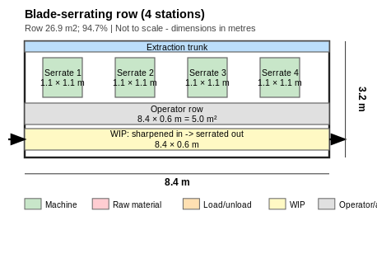
Figure 19: Blade-serrating row — in-line continuation of the sharpening lane (no trolley transfer in) (Author’s own.)
Material handling. Direct bin transfer from sharpening; polished subassemblies leave by trolley to powder-coat staging on a short clean route.
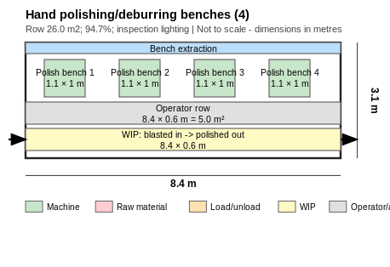
Figure 20: Hand polishing/deburring benches — bench extraction and inspection lighting (Author’s own.)

6.4.9 Riveting — convergence of the sheet parts
Process. The bent hinge is riveted to the serrated head at 5 s/shovel (1 819/day), creating the head subassembly. Radial forming was selected over direct pressing because its rolling action forms the rivet at a fraction of the force, protecting the thin 2.5 mm joint — the hinge must still pivot freely.
Table 13: Riveting — convergence of the sheet parts — machine and workstation specifications
Specification | Value | Basis
Equipment | Pneumatic radial riveting machine | Market class: AGME RA (two-hand control; data sheets published)
Cell size | 3.7 × 2.6 m = 9.6 m² | Drawing
Machines / operators | 1 / 1 (31.6 %) | Capacity table
Rivets | 2/shovel assumed; 5 s coverage [VERIFY] | Product engineering
Cost | Quotation required (Low) | Model per rivet spec

[ INSERT FIGURE 21 — machine photo (open link, screenshot/redraw) ]
Figure 21: Radial riveting machine. Market example for sizing and illustration only — redraw or insert supplier image with permission.
Open source page: https://www.agme.net/en/riveting-machines/radial-riveting-machines
Workstation. The first station where two part flows must arrive in matched quantities: both buffers carry visual min/max levels. Two-hand control enforces hands-clear forming; compressed-air drop and alignment task light at the bench.
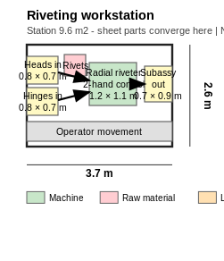
Figure 22: Riveting workstation — matched inbound buffers (heads, hinges, rivet shelf) with min/max marking; two-hand control (Author’s own.)
Material handling. Heads from serrating and hinges from bending arrive by trolley; subassemblies leave to the heat-treatment day buffer.

6.4.10 Heat Treatment (Ageing)
Process. Head subassemblies are strengthened by precipitation ageing (route, e.g. a T6-type age, subject to alloy confirmation): one 6 h batch per shift sized to the full 1 819/day in a single batch oven — the line’s batch decoupling point and its largest WIP holding.
Table 14: Heat Treatment (Ageing) — machine and workstation specifications
Specification | Value | Basis
Equipment | Aluminium ageing batch oven | Market class: Wisconsin Oven (≈120–205 °C for several hours; example chambers ≈2.4 m cube)
Zone | 9.4 × 5.4 m = 50.8 m² of the 80 m² allowance | Drawing
Day buffers | ≈5 pallets each side (+19.2 m² correction) | §6.8
Ovens / operators | 1 / shared pool | Capacity table
Cost | Quotation required (Low) | Chamber sizing-critical

[ INSERT FIGURE 23 — machine photo (open link, screenshot/redraw) ]
Figure 23: Aluminium ageing batch oven. Market example for sizing and illustration only — redraw or insert supplier image with permission.
Open source page: https://www.wisoven.com/products/batch-ovens/aluminum-age-ovens
Workstation. Thermal clearance surrounds the oven against the services wall with high-level heat relief; hot racks are handled with load car and PPE. As every shovel head passes through one oven, it is a single point of failure flagged for the MFP risk discussion.
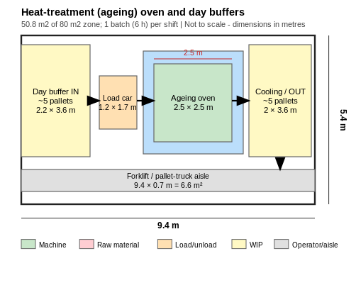
Figure 24: Heat-treatment area — day buffer IN, load car, oven with thermal clearance, cooling/OUT buffer, forklift aisle (Author’s own.)
Material handling. Subassemblies accumulate in the IN buffer through the shift; racks roll to blasting after cooling. Pallet truck/tug handling, not manual carry.

6.4.11 Sandblasting
Process. Aged subassemblies are blasted to a uniform keying surface (negligible mass effect per the brief); throughput and booth count are supplier-dependent [VERIFY] — manual blasting of 1 819 parts/day at even 15 s consumes most of a shift, so an automated cabinet is tested at quotation.
Table 15: Sandblasting — machine and workstation specifications
Specification | Value | Basis
Equipment | Enclosed blast booth + media recovery + dust collector | Market class: Airblast AFC modular rooms
Zone | 6.4 × 5.0 m = 32.0 m² (remainder of 80 m²) | Drawing
Operators | Shared pool | Personnel
Utilities | Major compressed-air consumer (sizes compressor plant) | §6.7
Cost | Quotation required (Low) | Design-and-build

[ INSERT FIGURE 25 — machine photo (open link, screenshot/redraw) ]
Figure 25: Enclosed blast room with media recovery. Market example for sizing and illustration only — redraw or insert supplier image with permission.
Open source page: https://airblastafc.com/blast-solutions/blast-rooms/
Workstation. Sealed enclosure with entry control and PPE; spent media and collected combustible dust leave in sealed drums on the waste route, segregated from general scrap.
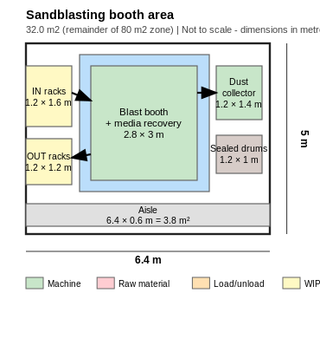
Figure 26: Sandblasting area — enclosed booth, services-wall dust collector, sealed waste drums, IN/OUT racks (Author’s own.)
Material handling. Racked subassemblies in from oven cooling; blasted parts out by trolley to polishing without re-contamination.

6.4.12 Powder Coating — fully enclosed
Process. Both handles and the head subassembly are coated — three items per shovel, 5 457 items/day. At the assumed 600 parts/h a single line needs 9.1 h, exceeding the shift; since overtime is not the base plan, two conveyorised lines run at ≈57 % each: Lines = ⌈5 457/(600×8)⌉ = 2.
Table 16: Powder Coating — fully enclosed — machine and workstation specifications
Specification | Value | Basis
Equipment | Conveyorised powder line ×2 (booth + recovery, cure oven, overhead conveyor) | SA turnkey example: P.I. Marketing
Enclosure | 15.0 × 8.0 m = 120 m² — matches allowance exactly | Drawing; brief requires full enclosure
Lines / operators | 2 / shared pool | Eq. above
Rate / cure | 600 parts/h assumed; dwell [VERIFY] | Workbook
Cost | Quotation required (Low) — largest capital item | Turnkey quote

[ INSERT FIGURE 27 — machine photo (open link, screenshot/redraw) ]
Figure 27: Conveyorised powder-coating plant (South African turnkey supplier). Market example for sizing and illustration only — redraw or insert supplier image with permission.
Open source page: https://www.pimarketing.co.za/
Workstation. The enclosure runs at negative pressure with filtered extraction and make-up air; personnel enter via airlock; parts cross the wall only at trolley openings. Organic powder is combustible — this fire regime is kept entirely separate from the aluminium-dust regime [fire engineer VERIFY]. Coated parts stay on non-marking hooks/trolleys until assembly.
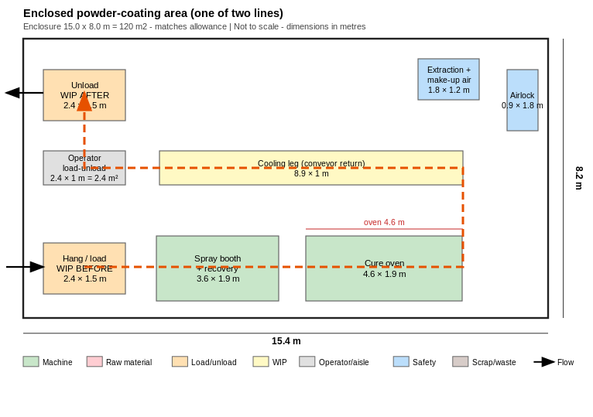
Figure 28: Enclosed powder-coating area — conveyor loop (orange dashed): load → booth → cure oven → cooling → unload; airlock; extraction and make-up air (Author’s own.)
Material handling. Handles and polished subassemblies arrive at the hang station by milk-run; coated sets leave the unload station to assembly staging. The overhead conveyor is the plant’s only fixed handling system — its geometry is frozen before the building design.

6.4.13 Final Assembly and Packaging
Process. The streams converge here only: the back handle screws into the middle handle, the handle joins the head subassembly at the hinge, and the fold is function-checked (30 s; two benches at 94.7 %). Packaging (30 s assumed [VERIFY] — brief: workstation-dependent) doubles as the final visual inspection: bag, box (10/box), palletise (5 pallets/day), with a quarantine bin keeping the quality gate auditable.
Table 17: Final Assembly and Packaging — machine and workstation specifications
Specification | Value | Basis
Equipment | Manual benches ×4 (fabricated) + holding fixtures; optional carton sealer | Brief: manual + visual check
Cells | Assembly 13.6 m²; packaging 19.8 m² drawn (18 m² corrected) | Drawings; §6.8
Stations / operators | 2 + 2 / 2 + 2 (94.7 %) | Capacity table
Inbound | 3 matched part flows with min/max marking | Layout rule
Cost | Fabrication quotes (Low)

[ INSERT FIGURE 29 — machine photo (open link, screenshot/redraw) ]
Figure 29: Hand pallet truck at pallet build (R4 695 incl VAT — verified retail price). Market example for sizing and illustration only — redraw or insert supplier image with permission.
Open source page: https://www.adendorff.co.za/mac-afric-2-ton-pallet-truck-685-x-1220-mm-gpallt000
Workstation. Assembly is clean, quiet, elbow-height work; a shortage of any one of the three coated items stops the line, so all three bins carry min/max marks. Packaging adds inspection-grade lighting, point-of-use bag/box shelving and no above-shoulder pallet lifts.
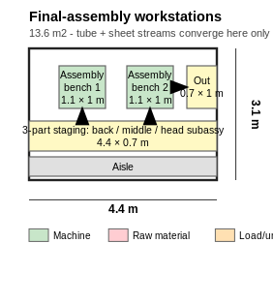
Figure 30: Final-assembly cell — three-part staging strip within reach envelope; the only convergence of tube and sheet streams (Author’s own.)
Material handling. Completed shovels pass bench-to-bench by bin — the shortest handling link in the plant; full pallets move by hand pallet truck to finished-goods racking (FIFO putaway end).
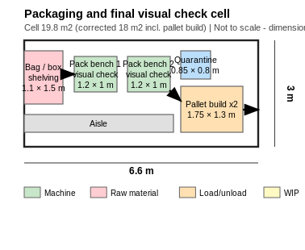
Figure 31: Packaging and final visual check cell — consumable shelving, quarantine bin, pallet-build positions (Author’s own.)

6.5 Receiving and Dispatch
Flows are small but asymmetric in unit type: inbound arrives as 6 m bundles and palletised sheets a few times per week; outbound leaves daily as five pallets on DigMore’s fleet plus customer-collected small orders. One time-shared leveller dock (receive mornings, dispatch afternoons — loading 5 pallets takes ≈30 min) and one ground-level bay for tube bundles and skip exchange cover the duty within the 250 m² allowance; a knock-out panel reserves a second dock as the cheapest expansion. The six truck bays (360 m²) are fleet parking, not loading docks. Trucks marshal on the industrial side under one-way circulation; customers reach a pedestrian-only collection counter on the visitor side and never enter the yard or factory. Dock levellers and seals are standard SA catalogue items (Maxiflex); the single shared counterbalance forklift is viable because total truck movements are only 3–5 per day.
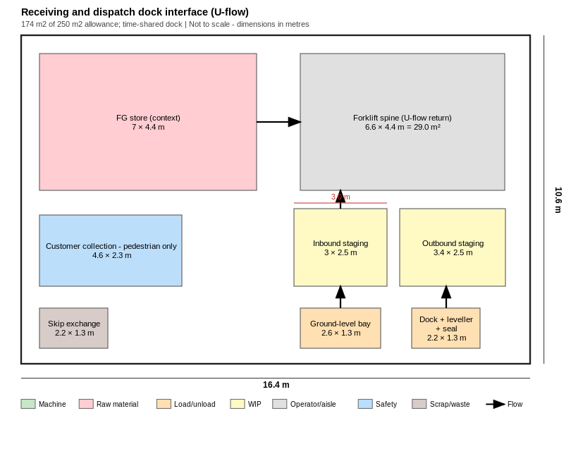
Figure 32: Receiving and dispatch dock interface — five warehouse areas in U-flow; time-shared dock; segregated customer collection (Author’s own.)
Key findings and layout implications. The tube store must sit on the truck-apron perimeter (a flatbed-plus-forklift side offload needs a straight apron), finished goods beside the shared dock with packaging behind it, and the customer interface on the visitor face. U-flow versus straight-through is the biggest flow decision distinguishing the layout alternatives; at these volumes U-flow wins — shared dock, forklift and staging at no throughput cost.

6.6 Storage and Material Handling
Floor positions = ⌈unit loads / levels⌉; A(store) = positions × 1.2 m² × 1.6 aisle factor (11)
Table 18: Storage sizing summary
Store | Loads | Positions | Floor area
Raw tube (2 wk) | 990 tubes | 4 cantilever racks | 38.4 m²
Raw sheet (2 wk) | 240 sheets | 2 stacks | 10.0 m²
WIP (aggregate) | 5 pallet-equiv | 2 | 3.8 m² (+19.2 m² oven buffers, §6.8)
Finished goods (4 wk) | 91 pallets | 31 (3 levels) | 59.5 m²
Scrap / waste | 4 segregated streams | skips + drums | 40.0 m²
TOTAL |  |  | 151.8 m²

Finished goods use three-level selective racking rather than denser drive-in: with a single SKU drive-in is tempting, but it enforces LIFO and the four-week cover must turn FIFO. Two single-deep rows face one 3.5 m forklift aisle with the pick face at the collection end (Krost class; published SA range R1 500–4 000 per pallet position → R139 500–372 000). Cantilever racks face an aisle that doubles as the saw feed lane. The waste store segregates saleable aluminium scrap, sealed combustible-dust drums, spent media and general waste at the ground bay for skip exchange.
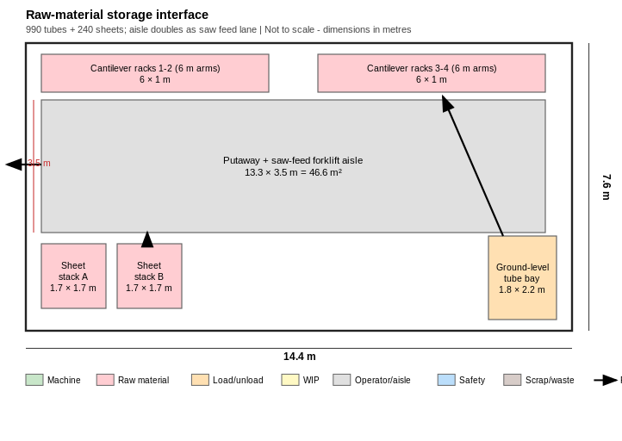
Figure 33: Raw-material storage interface — receiving adjacent to storage; the putaway aisle doubles as the saw feed lane (Author’s own.)
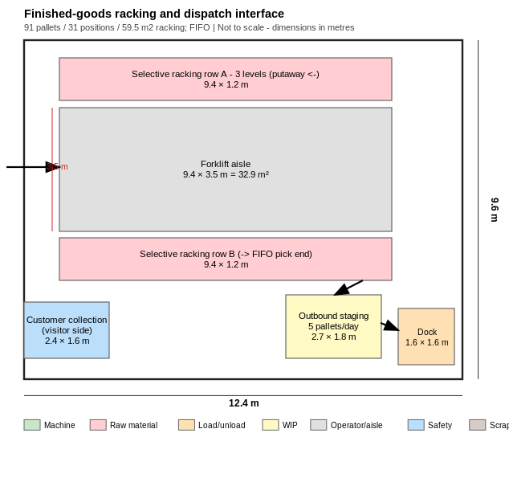
Figure 34: Finished-goods racking and dispatch — FIFO putaway-to-pick; 3.5 m forklift aisle; customer counter on the visitor side (Author’s own.)
Operator movement rule. Stations above 90 % utilisation are never self-served: at 94.7 % a station holds only 25 minutes of slack per shift, and an operator fetching for five minutes per hour destroys ≈8 % of capacity. The five material handlers therefore run an hourly fixed-route milk-run with two-bin kanban at every station; the press cell (13–33 %) self-serves during idle time. Fleet: one electric counterbalance forklift (≈2.5 t, long-load forks — Toyota Forklift SA class), one powered pallet truck, two hand pallet trucks (R4 695 each, verified), a tugger and four fabricated tube carts. Aisles: 3.5 m forklift, 2.0 m trolley, separated pedestrian walkways; the rack aisle is straight-through because a 6 m load cannot swing at the face.
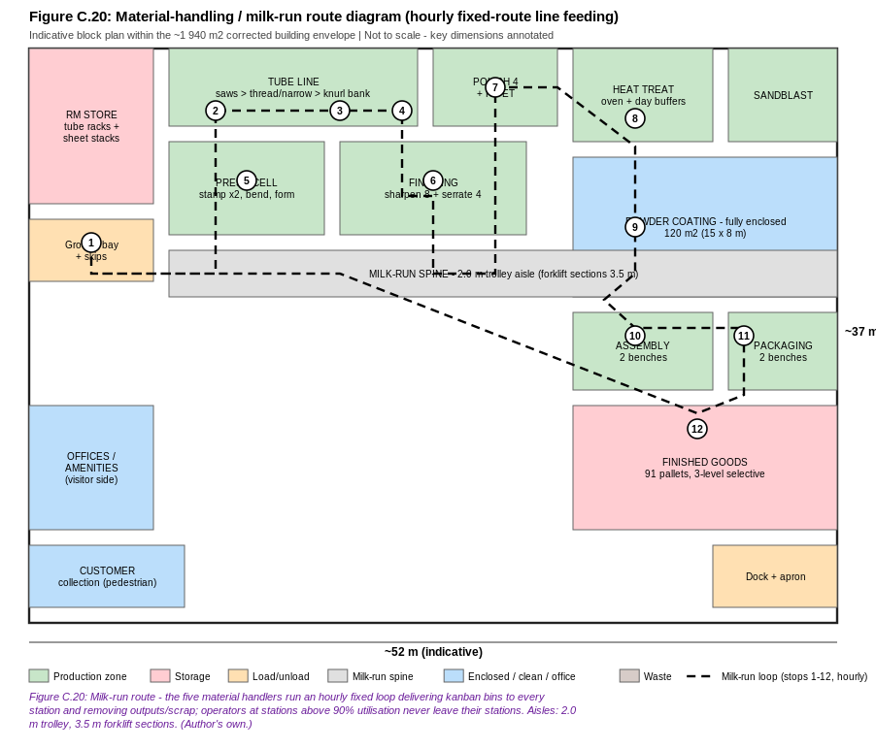
Figure 35: Material-handling milk-run route — hourly loop, stops 1–12, within the ≈1 940 m² envelope; route length is a layout-scoring metric (Author’s own.)
Key findings and layout implications. Every store is placed by its consumer, not by storage convenience. The minimal fleet only works if the layout provides a single shared forklift spine and keeps receiving and dispatch at one end — the U-flow argument. Milk-run circuit length directly prices material-handling labour and is therefore an evaluation criterion for the three layout alternatives.

6.7 Supporting Facilities
Table 19: Personnel allocation (total 60)
Category | Headcount | Note
Management (Plant, Operations, Inventory) | 3 | Brief
Administration (Reception, Purchasing, Sales ×2, Finance, Marketing, HR) | 7 | Brief; Sales count assumed
Plant supervisors | 4 | Glazed floor cubicles at bottleneck zones
Security | 3 | Gatehouse + reception side
Line operators | 34 | 1:1 with machines
Equipment-dependent & QA | 4 | Oven/blast/powder/inspection pool
Material handlers / forklift | 5 | Milk-run, stores, dock

Offices total 260 m² (26 non-operators × 10 m² — an aggregate allowance, not individual offices) on the visitor side, outside production flow, noise and dust; supervisors sit on the floor overlooking the knurling and sharpening banks. Amenities total 240 m² (60 × 4 m²): change rooms forming the PPE boundary, restrooms for both wings, a cafeteria sized for one 60-person sitting, first aid at the finishing/coating boundary and a janitorial store — exact regulatory provisions confirmed during detailed building design. Parking provides 70 car bays (1 750 m²) plus the 6 fleet bays (360 m²): 2 110 m² of external vehicle area. Utilities concentrate on one services wall: electricity (ageing and cure ovens dominant), compressed air (blasting major; ring main along the milk-run spine), water/plumbing, and three never-interconnected extraction systems (aluminium dust; powder enclosure; oven heat) under two distinct fire regimes — fire-engineering design to be confirmed.

6.8 Space Requirements
A(building) = (A(functional) × 1.30 circulation) × 1.10 expansion (12)
Table 20: Space corrections — reconciled, not absorbed
Item | Workbook base | Design value | Increase
Saw infeed strips (2 × 9.0×2.0 m) | 12 m² | 36 m² | +24 m²
Packaging cell incl. pallet build | 12 m² | 18 m² | +6 m²
Oven WIP day buffers (≈10 pallet positions) | 3.8 m² | 23.0 m² | +19.2 m²
TOTAL correction |  |  | +49.2 m²

Table 21: Final building and site areas (recommended for the MFP)
Component | Workbook | Corrected design value
Functional subtotal | 1 305.8 m² | 1 355.0 m²
+ 30 % circulation | 1 697.5 m² | 1 761.5 m²
+ ≈10 % expansion | 1 867 m² | ≈ 1 940 m²
+ vehicles 2 110 m² → site | 3 977 m² | ≈ 4 050 m²

The corrections are deliberately not charged to the 10 % expansion allowance, which exists for growth: ≈42 m² is positioned at the 94.7 %+ banks (the +7-machine availability case), a knock-out panel at the dock, headroom beside finished-goods racking, and the remainder as shell beside the press cell (which grows by die-sets, not area) — never inside the powder enclosure or extraction footprints.
Close-out. This chapter fixes: a takt of 15.83 s from 1 819 shovels/day; two-week stocks of 990 tubes and 240 sheets; seventeen processes resolved into 34 line machines plus an ageing oven, blast installation and two enclosed powder lines; 60 staff; a lean one-dock U-flow with segregated customer collection; 151.8 m² of storage served by an hourly milk-run; and a corrected building of ≈1 940 m² on ≈4 050 m² of building-plus-vehicle area. The layout alternatives that follow are different geometric answers to these constraints and are scored on demand attainment at takt, flow distance and milk-run circuit length, hazard separation, storage and handling efficiency, site safety, expansion positioning and implementability.

