Table of Contents

Appendix C: Workstation Layouts and Costed Equipment Schedule (v2)
This appendix presents detailed plan-view workstation layouts (Figures C.1–C.19 below; each figure also exists as an editable .drawio file) with full dimension/specification tables and costed equipment schedules. Every drawing shows overall dimensions, machine footprints, operator-movement areas, WIP-before and WIP-after zones, loading/unloading sides, scrap and safety zones, flow arrows, an embedded legend, a scale note (“not to scale — dimensions in metres”) and an academic caption. All drawings are original (author’s own); where machine proportions were informed by a verified supplier page this is stated per figure and the supplier image was redrawn, not copied. Colour code per Figure C.0: machines light green; raw material light red; load/unload orange; WIP light yellow; operator movement/aisles grey; safety/exclusion light blue; waste light brown; flow arrows black; powder-coat conveyor orange dashed.
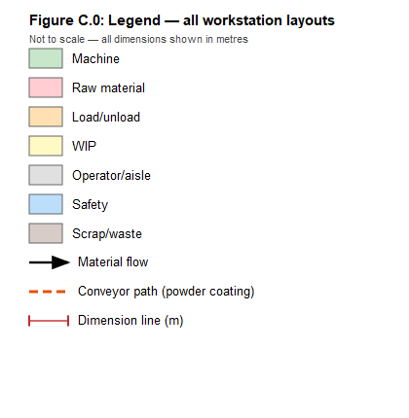
Figure C.0: Workstation layout legend — colour code for all Appendix C drawings. (Author’s own.)
Layout logic applied throughout (facilities-design practice; Tompkins et al. method): receiving adjacent to storage (Fig. C.18); storage connected to receiving, packing and dispatch (Figs C.17–C.19); packing connects storage to shipping (Fig. C.16→C.17); shipping has staging for completed orders plus pallet-jack/forklift access (Fig. C.19); U-flow with a time-shared dock because in/out volumes are small and a single forklift serves both — while customer and truck flows stay fully separated; high-utilisation stations are milk-run fed so operators never leave station; expansion ground per §6.8. Aisle-width design bases: operator movement 0.5–0.9 m within stations; trolley/milk-run 2.0 m; counterbalance forklift 3.5 m.
Drawn-area convention. Drawn zone areas include shares of the 30 % circulation allowance and adjacent interfaces (buffer strips, extraction trunks, staging). Functional areas per Tables 6.33–6.35 are unchanged: the drawings do not alter the corrected 1 940 m² building / ≈ 4 050 m² site basis.
Cost basis. No prices invented. Levels: Direct price (opened page, published price); Converted price (GBP→ZAR at R22.11/GBP, exchangerates.org.uk, accessed 10 June 2026; excludes shipping/duties); Comparable estimate (supplier-published SA budgeting range); Quotation required (no traceable price — confidence Low). ZAR retail prices include VAT.

C.1 Tube cutting
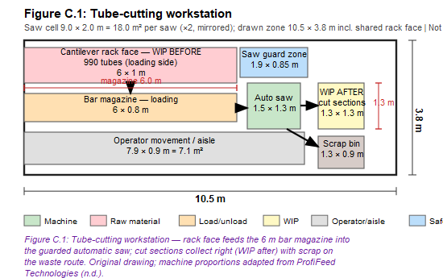
Figure C.1: Tube cutting — plan-view workstation layout. (Author’s own; not to scale, dimensions in metres.)
Design note. The saw cell is a 9.0 × 2.0 m strip because the 6 m bar magazine dominates; the rack face is both store and WIP-before, so putaway and consumption share one face (zero transfer). Scrap exits the rear to the waste route. Two mirrored cells share the rack aisle.
Table C.1: Tube-cutting workstation specifications
Equipment specification | Value | Basis / source
Overall workstation dimensions (L × W) | 9.0 × 2.0 m per saw (drawn zone 10.5 × 3.8 m incl. rack face) | Drawing calculation; §6.8 correction
Total workstation area | 18.0 m² per saw (×2) | L × W
Machine dimensions (L × W × H) | Saw 1.5 × 1.3 m allowance; quotation-dependent | ProfiFeed A420 page publishes no dimensions
Operator movement area | 7.9 × 0.9 m = 7.1 m² | Drawing calculation
Aisle width | 0.9 m operator; 3.5 m rack/forklift aisle (Fig. C.18) | Material-handling design basis
WIP before | Rack face — 990 tubes (2-week stock) | Table 6.5
WIP after | 1.3 × 1.3 m = 1.7 m² cut-section bins | Drawing
Operators / machines | 2 / 2 (99.7 %) | Table 6.25
Unit cost / total cost | Quotation required | ProfiFeed Technologies (n.d.)
Cost basis / confidence | Quotation required / Low | Price on application

C.2 Internal threading
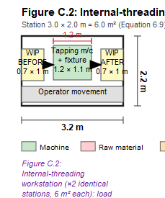
Figure C.2: Internal threading — plan-view workstation layout. (Author’s own; not to scale, dimensions in metres.)
Design note. Classic 6 m² bench cell (Eq. 6.9); 66.5 % utilisation gives slack that absorbs saw interruptions, so its buffers stay small.
Table C.2: Internal-threading workstation specifications
Equipment specification | Value | Basis / source
Overall workstation dimensions (L × W) | 3.0 × 2.0 m | Drawing calculation
Total workstation area | 6.0 m² (×2 stations) | Equation 6.9
Machine dimensions | Bench machine 1.2 × 1.1 m; 1 020 mm working radius | Cotswold (n.d.a)
Operator movement area | 3.2 × 0.5 m = 1.6 m² | Drawing calculation
Aisle width | 0.5 m in-station | Design basis
WIP before / after | 0.7 m² bin each side | Drawing
Operators / machines | 2 / 2 (66.5 %) | Table 6.25
Unit / total cost | Quotation required | Distributor enquiry
Cost basis / confidence | Quotation required / Low | Price on application

C.3 End narrowing
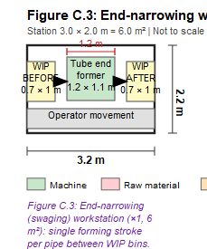
Figure C.3: End narrowing — plan-view workstation layout. (Author’s own; not to scale, dimensions in metres.)
Design note. Identical cell geometry to C.2; placed to feed the knurling bank in a one-piece-flow lane (§6.3.3). 33.2 % utilisation = future-flexibility station.
Table C.3: End-narrowing workstation specifications — as Table C.2 with: machine = tube end former (model for Ø31.70 mm at quotation); 1 station / 1 operator (33.2 %); unit/total cost Quotation required (Hippo, n.d.); basis Quotation / confidence Low.

C.4 Knurling and external threading bank
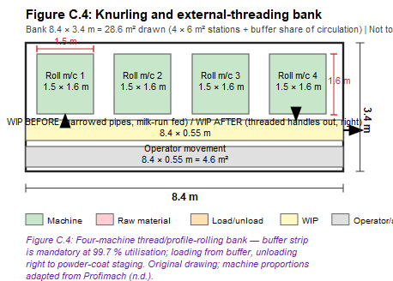
Figure C.4: Knurling and external threading bank — plan-view workstation layout. (Author’s own; not to scale, dimensions in metres.)
Design note. Four machines in a bank with a full-length buffer strip on the infeed: at 99.7 % utilisation the bank has < 2 min/day slack, so the buffer decouples it from upstream stoppages and the milk-run replenishes it hourly.
Table C.4: Knurling/external-threading bank specifications
Equipment specification | Value | Basis / source
Overall dimensions (L × W) | 8.4 × 3.4 m | Drawing calculation
Total area | 28.6 m² drawn (4 × 6 m² + buffer share of circulation) | L × W
Machine dimensions (L × W × H) | 1 500 × 1 580 × 1 140 mm (PTR 42 class) | Profimach published spec
Operator movement area | 8.4 × 0.55 m = 4.6 m² | Drawing
Aisle width | 0.55 m in-station; milk-run lane 2.0 m adjacent | Design basis
WIP before | Buffer strip 8.4 × 0.55 m = 4.6 m² (narrowed pipes) | Drawing; §6.3.4
WIP after | Same strip, outflow right to coat staging | Drawing
Operators / machines | 4 / 4 (99.7 %) | Table 6.25
Unit / total cost | Quotation required | Profimach (n.d.)
Cost basis / confidence | Quotation required / Low | Price on application

C.5 Sheet-stamping press cell
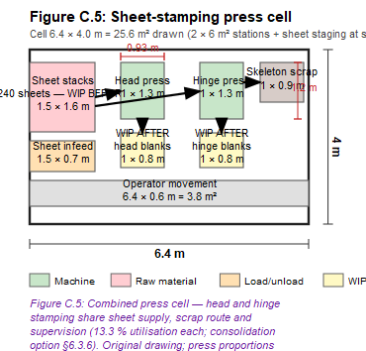
Figure C.5: Sheet-stamping press cell — plan-view workstation layout. (Author’s own; not to scale, dimensions in metres.)
Design note. Head and hinge stamping are combined into one cell: shared sheet stacks, shared skeleton-scrap route, shared operator skills; both presses at 13.3 % keep the consolidation option (one press + quick die change) open.
Table C.5: Press cell specifications
Equipment specification | Value | Basis / source
Overall dimensions (L × W) | 6.4 × 4.0 m | Drawing calculation
Total area | 25.6 m² drawn (2 × 6 m² stations + sheet staging at store interface) | L × W
Machine dimensions (W × D × H) | 930 × 1 200 × 2 100 mm each (OCP-35) | Stamtec published spec
Operator movement area | 6.4 × 0.6 m = 3.8 m² | Drawing
Aisle width | 0.6 m in-cell; sheet infeed 2.5 m approach | §6.3.5
WIP before | Sheet stacks 1.5 × 1.6 m (240 sheets; counted in storage 10 m²) | Storage_3D
WIP after | Blank bins 2 × 0.8 m² | Drawing
Operators / machines | 2 / 2 (13.3 % each) | Table 6.25
Unit / total cost | Quotation required (+ dies as separate tooling) | Stamtec (n.d.)
Cost basis / confidence | Quotation required / Low | Price on application

C.6 Hinge bending
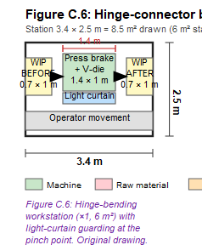
Figure C.6: Hinge bending — plan-view workstation layout. (Author’s own; not to scale, dimensions in metres.)
Design note. Bench brake with fixed V-die and light-curtain guard; sits between hinge stamping and riveting in a straight short-flow lane.
Table C.6: Hinge-bending workstation specifications — overall 3.4 × 2.5 m = 8.5 m² drawn (6 m² station + guard clearance); machine 1.4 × 1.0 m (tonnage at quotation); operator movement 1.7 m²; aisle 0.5 m; WIP 0.7 m² each side; 1 / 1 (31.6 %); cost Quotation required (Cotswold, n.d.b) / Low.

C.7 Shovel-head shaping
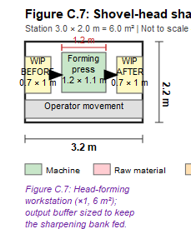
Figure C.7: Shovel-head shaping — plan-view workstation layout. (Author’s own; not to scale, dimensions in metres.)
Design note. Same press platform as C.5 (spares/training commonality); output buffer sized to keep the sharpening bank continuously fed.
Table C.7: Head-shaping workstation specifications — overall 3.0 × 2.0 m = 6.0 m²; machine 1.2 × 1.1 m allowance (OCP class; forming tonnage at die design); operator movement 1.6 m²; WIP 0.7 m² each side; 1 / 1 (12.6 %); cost Quotation required / Low.

C.8 Blade-sharpening bank
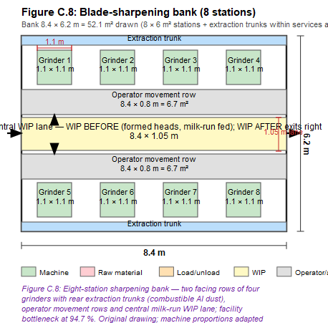
Figure C.8: Blade-sharpening bank — plan-view workstation layout. (Author’s own; not to scale, dimensions in metres.)
Design note. Two facing rows of four grinders around a central milk-run WIP lane: operators never leave the row (94.7 %), extraction trunks run at the rear of each row, and the lane gives supervisors a single sight-line on queue depth.
Table C.8: Sharpening bank specifications
Equipment specification | Value | Basis / source
Overall dimensions (L × W) | 8.4 × 6.2 m | Drawing calculation
Total area | 52.1 m² drawn (8 × 6 m² + extraction trunks within services) | L × W
Machine dimensions | Grinder ≈ 1.1 × 1.1 m plan; 75 × 2 000 mm belt; 4 kW; 415 V | EC Hopkins published spec
Operator movement area | 2 rows × 8.4 × 0.8 m = 13.4 m² | Drawing
Aisle width | 0.8 m operator rows; central lane 1.05 m | Design basis
WIP before | Central lane 8.4 × 1.05 m = 8.8 m² (formed heads, milk-run fed) | Drawing; §6.6.5
WIP after | Same lane, outflow right to serrating | Drawing
Operators / machines | 8 / 8 (94.7 % — facility bottleneck) | Table 6.25
Unit cost | ≈ £3,293 incl UK VAT ≈ R72,800 (extraction config) | EC Hopkins price range top, accessed 10 June 2026
Total cost | ≈ R582,400 (8 ×) | Quantity × unit
Cost basis / confidence | Converted price (R22.11/GBP) / Medium | Verified UK retail; excl. shipping/duties

C.9 Blade-serrating row
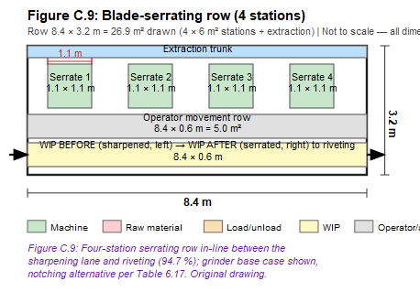
Figure C.9: Blade-serrating row — plan-view workstation layout. (Author’s own; not to scale, dimensions in metres.)
Design note. In-line continuation of the sharpening lane — sharpened heads cross by bin without trolley transport; equipment homogeneous with C.8 for cross-balancing.
Table C.9: Serrating row specifications — overall 8.4 × 3.2 m = 26.9 m² drawn (4 × 6 m²); machines as C.8 with formed contact wheel; operator movement 5.0 m²; WIP strip 8.4 × 0.6 m shared before/after; 4 / 4 (94.7 %); unit ≈ R72,800, total ≈ R291,200; basis Converted price / Medium (serration method itself to be proven at quotation trial; notching alternative quotation-only).

C.10 Riveting
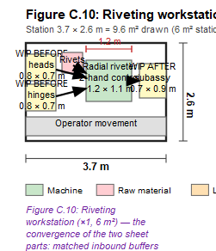
Figure C.10: Riveting — plan-view workstation layout. (Author’s own; not to scale, dimensions in metres.)
Design note. The sheet-stream convergence: two matched inbound buffers (heads, hinges) plus rivet point-of-use shelf; two-hand control enforces hands-clear forming; subassembly exits to oven staging.
Table C.10: Riveting workstation specifications — overall 3.7 × 2.6 m = 9.6 m² drawn (6 m² station + dual buffers); machine bench 1.2 × 1.1 m; operator movement 1.9 m²; WIP before 2 × 0.56 m² (heads, hinges) + rivets 0.3 m²; WIP after 0.63 m²; 1 / 1 (31.6 %); cost Quotation required (AGME, n.d.; model per rivet spec [VERIFY]) / Low.

C.11 Heat treatment and oven buffers
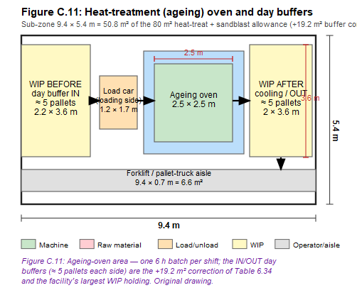
Figure C.11: Heat treatment and oven buffers — plan-view workstation layout. (Author’s own; not to scale, dimensions in metres.)
Design note. Batch decoupling point: IN buffer accumulates a day of subassemblies; one 6 h batch per shift; cooling/OUT buffer feeds blasting. Thermal clearance and services-wall placement per §6.3.12.
Table C.11: Heat-treatment area specifications
Equipment specification | Value | Basis / source
Overall dimensions (L × W) | 9.4 × 5.4 m sub-zone | Drawing calculation
Total area | 50.8 m² of the 80 m² allowance (+19.2 m² buffer correction, Table 6.34) | §6.8
Machine dimensions | Oven ≈ 2.5 × 2.5 m plan (chamber at quotation — sizing-critical) | Wisconsin Oven examples
Operator movement area | Forklift/pallet-truck aisle 9.4 × 0.7 m = 6.6 m² | Drawing
Aisle width | 0.7 m drawn local; 2.0 m milk-run access | Design basis
WIP before | Day buffer IN 2.2 × 3.6 m = 7.9 m² (≈ 5 pallets) | Drawing; §6.6.2
WIP after | Cooling/OUT 2.0 × 3.6 m = 7.2 m² (≈ 5 pallets) | Drawing
Operators / machines | Shared pool / 1 oven | Table 6.27
Unit / total cost | Quotation required | Wisconsin Oven (n.d.)
Cost basis / confidence | Quotation required / Low | Custom-sized capital item

C.12 Sandblasting
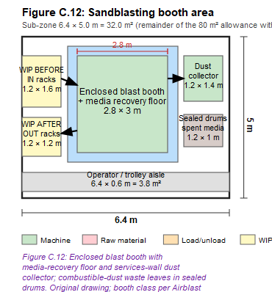
Figure C.12: Sandblasting — plan-view workstation layout. (Author’s own; not to scale, dimensions in metres.)
Design note. Enclosed booth with media-recovery floor; dust collector on the external services wall; sealed combustible-dust drums on the waste route; IN/OUT racks keep blasted parts clean en route to polishing.
Table C.12: Sandblasting area specifications — overall 6.4 × 5.0 m = 32.0 m² (remainder of 80 m² with C.11); booth 2.8 × 3.0 m + collector 1.2 × 1.4 m; operator/trolley aisle 3.8 m² (0.6 m); WIP before 1.9 m² IN racks / after 1.4 m² OUT racks; shared pool; cycle/booth count [VERIFY]; cost Quotation required (Airblast AFC, n.d.) / Low.

C.13 Hand polishing/deburring row
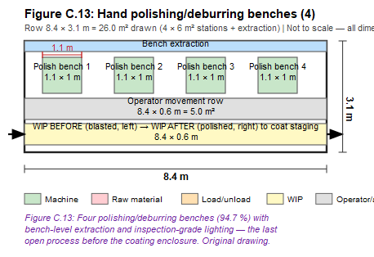
Figure C.13: Hand polishing/deburring row — plan-view workstation layout. (Author’s own; not to scale, dimensions in metres.)
Design note. Last open process before the coating enclosure; bench extraction joins the finishing-zone combustible-dust system; inspection-grade lighting doubles as pre-coat surface check.
Table C.13: Polishing row specifications — overall 8.4 × 3.1 m = 26.0 m² (4 × 6 m²); bench 1.1 × 1.0 m each; operator movement 5.0 m² (0.6 m row); WIP strip shared before/after; 4 / 4 (94.7 %); benches fabrication quote required / Low (no comparable SA catalogue price verified).

C.14 Powder-coating enclosed area
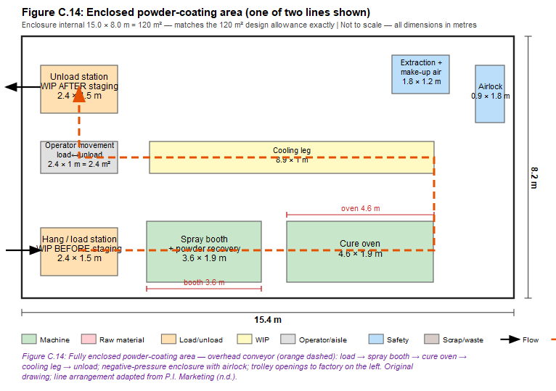
Figure C.14: Powder-coating enclosed area — plan-view workstation layout. (Author’s own; not to scale, dimensions in metres.)
Design note. The conveyor loop (orange dashed) runs load → spray booth → cure oven → cooling leg → unload; the enclosure is held at negative pressure with filtered extraction and make-up air, personnel enter via airlock, and parts cross the wall only at the trolley openings. Area check: enclosure internal 15.0 × 8.0 m = 120 m² — matches the 120 m² design allowance exactly (one of two lines shown; the second line mirrors within the same enclosure per §6.3.15).
Table C.14: Powder-coating area specifications
Equipment specification | Value | Basis / source
Overall dimensions (L × W) | 15.0 × 8.0 m internal | Inputs allowance; drawing
Total area | 120 m² — matches allowance | §6.8
Equipment dimensions | Booth 3.6 × 1.9 m; cure oven 4.6 × 1.9 m (line-dependent at quotation) | Drawing allowances
Operator movement area | Load↔unload corridor 2.4 × 1.0 m = 2.4 m² + enclosure circulation | Drawing
Aisle width | 1.0 m internal corridor; conveyor overhead | Design basis
WIP before | Hang/load staging 2.4 × 1.5 m = 3.6 m² | Drawing
WIP after | Unload staging 2.4 × 1.5 m = 3.6 m² | Drawing
Operators / lines | Shared pool / 2 lines (≈ 57 % each) | Equation 6.10
Unit / total cost | Quotation required (turnkey) | P.I. Marketing (n.d.)
Cost basis / confidence | Quotation required / Low | Largest single capital item

C.15 Final assembly
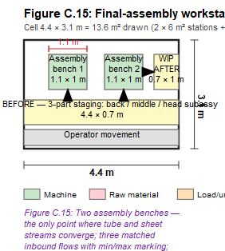
Figure C.15: Final assembly — plan-view workstation layout. (Author’s own; not to scale, dimensions in metres.)
Design note. The only convergence of tube and sheet streams: the three-part staging strip presents back handles, middle handles and head subassemblies within reach, each with min/max marking — a shortage of any one stops the station.
Table C.15: Final-assembly specifications — overall 4.4 × 3.1 m = 13.6 m² drawn (2 × 6 m² + staging strip); benches 1.1 × 1.0 m; operator movement 2.0 m²; WIP before staging 4.4 × 0.7 m = 3.1 m²; WIP after 0.7 m²; 2 / 2 (94.7 %); benches + cradle fixtures fabrication quote required / Low.

C.16 Packaging and final visual check
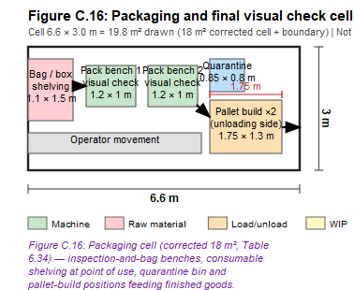
Figure C.16: Packaging and final visual check — plan-view workstation layout. (Author’s own; not to scale, dimensions in metres.)
Design note. Packing connects storage to shipping: consumables at point of use, inspection benches as the quality gate (quarantine bin keeps it auditable), pallet-build positions feeding the FG store directly.
Table C.16: Packaging cell specifications — overall 6.6 × 3.0 m = 19.8 m² drawn (18 m² corrected cell, Table 6.34); benches 1.2 × 1.0 m ×2; operator movement 2.1 m²; WIP before = consumable shelving 1.1 × 1.5 m + assembled shovels by bin; WIP after = pallet build 1.75 × 1.3 m = 2.3 m²; 2 / 2 (94.7 %; 30 s cycle [VERIFY]); benches/shelving fabrication quote required; optional carton sealer Quotation required / Low.

C.17 Finished-goods racking and dispatch interface
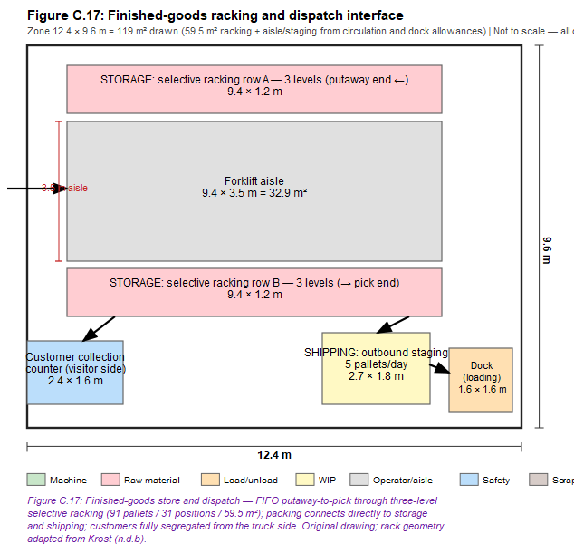
Figure C.17: Finished-goods racking and dispatch interface — plan-view workstation layout. (Author’s own; not to scale, dimensions in metres.)
Design note. Five-areas logic on the outbound side: storage (two selective rows, FIFO putaway→pick), shipping staging (5 pallets/day), dock loading, and the customer-collection counter as a pedestrian-only interface on the visitor side.
Table C.17: FG racking and dispatch specifications
Equipment specification | Value | Basis / source
Overall dimensions (L × W) | 12.4 × 9.6 m zone | Drawing calculation
Total area | 119 m² drawn (59.5 m² racking + aisle/staging from circulation and dock allowances) | Eq. 6.13–6.14
Racking dimensions | 2 rows × 9.4 × 1.2 m; 3 levels; 31 floor positions / 93 pallet positions | Storage_3D
Operator movement area | Forklift aisle 9.4 × 3.5 m = 32.9 m² | Drawing
Aisle width | 3.5 m forklift | Material-handling design basis
WIP before | Putaway from packaging (left arrow) | Fig. C.16
WIP after | Outbound staging 2.7 × 1.8 m = 4.9 m² | Drawing
Operators | Material handlers (pool of 5) | Personnel sheet
Unit cost | R1,500–4,000 per pallet position | Krost published SA range
Total cost | R139,500–R372,000 (mid ≈ R256,000) | 93 positions × range
Cost basis / confidence | Comparable estimate (supplier-published range) / Medium | Not a quote

C.18 Raw-material storage interface
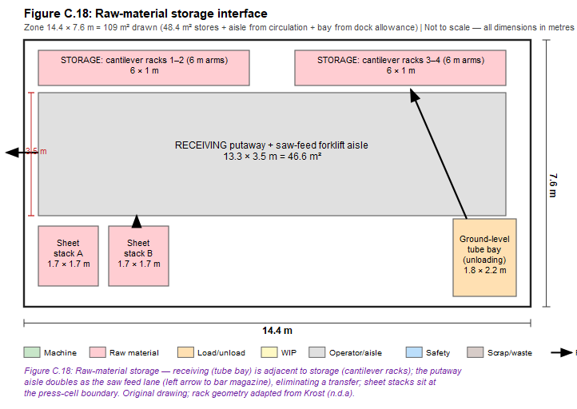
Figure C.18: Raw-material storage interface — plan-view workstation layout. (Author’s own; not to scale, dimensions in metres.)
Design note. Receiving is adjacent to storage: the ground-level tube bay offloads straight to the cantilever racks, and the 3.5 m putaway aisle doubles as the saw feed lane — one aisle serves receiving, storage and production feeding with zero re-handling.
Table C.18: Raw-material storage specifications — overall 14.4 × 7.6 m = 109 m² drawn (48.4 m² stores + aisle from circulation + bay from dock allowance); racks 4 × (6.0 × 1.0 m), 250 tubes each, arm rating per quotation; sheet stacks 2 × (1.7 × 1.7 m); forklift aisle 13.3 × 3.5 m = 46.6 m²; aisle width 3.5 m; WIP = the 2-week stores themselves (990 tubes / 240 sheets); cantilever racking Quotation required (Krost cost guide publishes no per-bay figure) / Low.

C.19 Receiving and dispatch dock interface
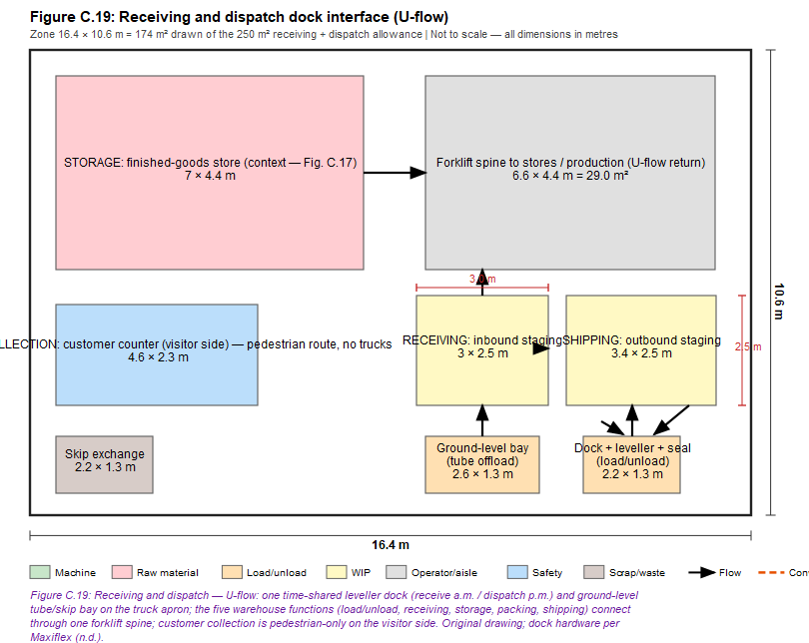
Figure C.19: Receiving and dispatch dock interface — plan-view workstation layout. (Author’s own; not to scale, dimensions in metres.)
Design note. Full five-areas U-flow: loading/unloading (dock + ground bay), receiving (inbound staging), storage (FG context + Fig. C.18), packing (collection counter prep) and shipping (outbound staging) connect through one forklift spine; trucks marshal on the apron side, customers and pedestrians on the visitor side — the flows never cross. Knock-out panel beside the dock is the expansion provision.
Table C.19: Receiving/dispatch interface specifications
Equipment specification | Value | Basis / source
Overall dimensions (L × W) | 16.4 × 10.6 m drawn zone | Drawing calculation
Total area | 174 m² of the 250 m² allowance (balance = apron-edge staging and door clearances) | Inputs
Equipment | 1 dock leveller + seal + door; 1 ground-level roller door | §6.5
Operator movement area | Forklift spine 6.6 × 4.4 m = 29.0 m²; pedestrian route on visitor side | Drawing
Aisle width | 3.5 m forklift; 2.5 m staging lanes | Design basis
WIP before | Inbound staging 3.0 × 2.5 m = 7.5 m² | Drawing
WIP after | Outbound staging 3.4 × 2.5 m = 8.5 m² | Drawing
Operators | Material handlers (pool) | Personnel sheet
Dock package cost | Quotation required | Maxiflex (n.d.)
Forklift / powered pallet truck | Quotation required | Toyota Forklift SA (n.d.)
Hand pallet trucks (2 t × 2) | R4,695 × 2 = R9,390 incl VAT | Adendorff product page, accessed 10 June 2026
Cost basis / confidence | Direct price (pallet trucks: High); rest Quotation / Low | Cost audit

C.20 Final cost-audit table
Table C.20: Capital cost audit summary
Category | Equipment | Qty | Unit cost | Total cost | Cost basis | Confidence
Machine | Automatic saw + bar feed | 2 | Quotation | Quotation | Quotation required | Low
Machine | Tapping machine | 2 | Quotation | Quotation | Quotation required | Low
Machine | Tube end former | 1 | Quotation | Quotation | Quotation required | Low
Machine | Thread/profile roller | 4 | Quotation | Quotation | Quotation required | Low
Machine | Gap-frame press (incl. forming) | 3 | Quotation | Quotation | Quotation required (dies extra) | Low
Machine | Electric press brake | 1 | Quotation | Quotation | Quotation required | Low
Machine | Belt grinder w/ extraction | 12 | ≈ R72,800 | ≈ R873,600 | Converted price (£3,293 @ R22.11) | Medium
Machine | Radial riveter | 1 | Quotation | Quotation | Quotation required | Low
Installation | Ageing batch oven | 1 | Quotation | Quotation | Quotation required | Low
Installation | Blast booth + recovery + collection | 1 | Quotation | Quotation | Quotation required | Low
Installation | Powder-coating line (turnkey) | 2 | Quotation | Quotation | Quotation required | Low
Fabricated | Polish/assembly/packing benches, fixtures | 8+ | Fabrication quote | — | Fabrication quote required | Low
Fabricated | Tube carts, trolleys, kanban bins | set | Fabrication quote | — | Fabrication quote required | Low
Storage | Selective pallet racking (93 pos.) | 1 | R1,500–4,000/pos. | R139,500–372,000 | Comparable estimate (published range) | Medium
Storage | Cantilever racking | 4 | Quotation | Quotation | Quotation required | Low
MH | Counterbalance forklift (electric) | 1 | Quotation | Quotation | Quotation required | Low
MH | Powered pallet truck | 1 | Quotation | Quotation | Quotation required | Low
MH | Hand pallet truck 2 t | 2 | R4,695 | R9,390 | Direct price | High
Dock | Leveller + seal + door package | 1 | Quotation | Quotation | Quotation required | Low
Priced subset |  |  |  | ≈ R1.14 m (midpoint) | Mixed | —
The priced subset supports budgeting structure only; quotation-only items (powder lines, oven, saws, presses, rollers) will dominate the capital budget.

C.21 Cost references
As Appendix C v1 §C.23 (Adendorff; EC Hopkins; Exchange Rates UK; Krost ×2 — all accessed 10 June 2026).

