



Faculty of Industrial Engineering

INGB 417:
GA Exam Individual Assignment

By
Kaylee Courtney Meyer 41763G3G

Submitted in pursuit of the degree

BACHELOR OF ENGINEERING
In INDUSTRIAL ENGINEERING

Lecturer: Mrs Willemien Kruger
1

Table of Contents

- Executive Summary 6
- Problem Background 6
- Design Objectives 6
- Design Requirements 7
- Assumptions and Constraints 7
- Detail Design Specification 8
  - Product and Raw Material Overview 8
    - Product Overview 8
    - Raw Materials Overview 9
  - Unit Description 9
    - Tabletop 10
    - Sliding Structure 10
    - Table Legs 11
    - Chairs 11
    - Unit Summary 11
  - Daily Demand Calculation 12
    - Finished Goods Demand 12
    - Raw Materials Demand 12
  - Manufacturing Process 13
  - Machinery, Capacity Planning and Labour 14
    - Cutting Operation 14
    - Bending Operation 14
    - Welding Operation 15
    - Powder Coating 17
    - Rubber Levelling Operation 18
    - Assembling Operation 18
    - Packing Operation 19
    - Visual Summary 20
  - Department Classification 22
    - Processing Departments 22
    - Holding and Handling Departments 31
    - Visual Summary of All Departments 39
- Design Alternatives 40
  - Department Blocks 40
  - Systematic Layout Planning 40
    - Alternative 1 40
  - Systematic Layout Planning 40
    - Alternative 1 41
    - Alternative 2 42
    - Alternative 3 42
- Evaluating Alternatives 43
- Final Design 44
- Business Case 45
- Final Recommendations and Remarks 46
Appendix 47
Appendix A 47
A1: Raised Staging Area 47
A2: Forklifts utilised 47
A3: Low-laying Gravity Roller 47
Appendix B 48
B1: Activity Relationship Diagram 48

List of Tables
Table 1: Assumptions and Constraints 8
Table 2: Product Specification (Table) 8

Table 6: Total Raw Materials per Unit 12
Table 7: Finished Goods Daily Requirements 12
Table 8: Raw Material Demand 12
Table 9: Cutting Operation 14
Table 10: Bending 15
Table 11: Automated Welding 15
Table 12: Manual Welding 16
Table 13: Automatic Powder Coating Booth 17
Table 14: Rubber Levelling 18
Table 15: Assembly 19
Table 16: Packing 20
Table 17: Area of Processing Departments 31
Table 18: Raw Material Storage 32
Table 19: Volume of Containers 33
Table 20: Prepared WIP 34
Table 21: Welded WIP 35
Table 22: Painted WIP 35
Table 23: Assembled WIP 36
Table 24: Finished Goods Storage 37
Table 25: Amenities 38
Table 26: Holding C Handling Summary 38
Table 27: Closeness Index 40
Table 28: Final Relationship Chart 40
Table 29: Weighted Factor Comparison Evaluation 43
Table 30: Capital Cost Calculations 45
Table 31: Risk and Mitigations 45
Table 32: High-Level Implementation Schedule 45
Table 33: Forklift Specs 47

List of Figures
Figure 1: Table Configurations 8

Figure 7: Bending Station 23
Figure 8: Auto-Weld Station 24
Figure 9: Man-Weld C Grind Station 25
Figure 10: Coating Station 26
Figure 11: Levelling Station 27
Figure 12: Assembly Station 28
Figure 13: Packing Station 29
Figure 14: Stacking Station 30
Figure 15: Bundled Raw Material 31
Figure 16: Stack C Bundle Measurements 32
Figure 17: Containers 33
Figure 18: Shelf 34
Figure 19: Large Order vs Small Order 37
Figure 20: Visual Summary of All Departments 39
Figure 21: Department Blocks 40
Figure 22: Relationship Diagram 41
Figure 23: Alternative 1 41
Figure 24: Alternative 2 42
Figure 25: Alternative 3 42
Figure 26: MFP 44
Figure 27: Raised Staging Area 47
Figure 28: Forklift 47
Figure 29: Low-laying Gravity Roller 47
Figure 30: Activity Relationship Diagram 48

material handling and storage strategies were chosen.

Three alternative facility layouts were developed and assessed based on the design objectives and requirements, with the most suitable option selected for further refinement into the final master facility plan. The business case for the new facility was also carefully examined to determine the cost, risk mitigations and schedule.

Problem Background
TIPTOP TABLES has been a manufacturer of outdoor tables and chairs in the South African market for the past 25 years. Among its product offerings, the company has recently experienced an increase in demand for its versatile 2-in-1 lightweight aluminium outdoor table set, which includes one table, designed to expand into a larger table if needed, and four matching chairs.

Current forecasts suggest a demand of up to 5 000 sets per month for this specific product line. However, TIPTOP TABLES' existing manufacturing facility is unable to meet this demand, as it is also used for the production of various other products. To address this challenge, management has identified the need for a new facility dedicated solely to the production of this outdoor set.

Design Objectives
The following design objectives, categorised under their relevant headings, have been established to ensure the successful design of TIPTOP TABLES' new manufacturing facility:

Production:
To design a manufacturing facility capable of meeting the projected monthly demand of 5000 aluminium outdoor sets, with built-in flexibility for future expansion.

Site:
To design and recommend a site that has access from public roads for all delivery and collection vehicles, complies with zoning and industrial safety regulations, and accommodates both current and future operational requirements.

Layout and Flow:
To develop a layout that minimises material handling and unnecessary movement of operators and goods, reduces bottlenecks, and has a logical flow of materials, from receiving to shipping, on a greenfield site.

Equipment and Machinery:
To select suitable machinery and equipment specifically for cutting, welding, grinding, powder coating, assembly, and packaging aluminium components that meet throughput requirements, ensure product quality, prioritise worker safety, and minimise downtime.

    - Produce a minimum of 5 000 aluminium outdoor sets per month.
    - Stock enough raw materials to support two weeks of production.
    - A 5% scrap rate must be factored in during the cutting stage of production.

Site:
The facility shall:
    - Be accessible to public roads for delivery and collection.
    - Allow space for truck deliveries and customer pickups.
    - Store all raw materials and components indoors.
    - Provide a designated collection point for customer orders.
    - Allocate 20% of the floor area for future expansion.
    - Include a separate enclosed welding area, considering safety and ventilation.
    - Provide robot safety zones around the automated welding stations.

Layout and Flow:
The facility shall:
    - Provide clear paths for material and operator movement between processes.
    - Include vehicle access routes for incoming and outgoing goods.
    - Allow for work-in-progress (WIP) storage areas between operations.
    - Accommodate stacking and temporary storage of outsourced chairs awaiting assembly.

Specific Design Requirements
The facility shall adhere to the following specific requirements set by TIPTOP TABLES:

    - Welded WIP shall have access to outside for the onloading of chairs.
    - Assembly WIP shall have access to the outside for the offloading of chairs.
    - Raw materials shall not be close to the automated welding operation.
    - The cutting process shall not be close to the automated welding operation
    - The WIP of cut parts shall not be close to the automated welding operation.
    - Manual welding shall not be close to the powder coating operation.
    - Manual welding shall not be close to the assembly operation.
    - Manual welding shall not be close to the packing operation.
    - Manual welding shall not be close to the finished goods storage.
    - Raw materials shall be close to the cutting operation.
    - The cutting operation shall be close to the WIP of cut parts.
    - Automated and manual welding shall be close to each other.
    - WIP of structures and tabletops shall be close to each other.
    - Packaging and finished goods shall be close to each other.

Assumptions and Constraints
Table 1 outlines some constraints and assumptions made throughout the design process. Other relevant assumptions are mentioned in the document where applicable.

Assumption/Constraint | Details
20 working days per month. 8 working hours per day. | The company currently operates a 9 hour shift per day, 5 days per week. Operators are given 30 minutes for lunch and two 15 minute tea breaks per day. Assume an average of 20 working days per month. Overtime or a Saturday shift is possible but should only be  considered to provide flexibility in capacity.
1 unit. | A unit will be considered the entire aluminium outdoor set, that contains one table and four chairs. Components of the unit will be  referred to as sub-units.
The thickness of the flat bar is considered negligible. | The table has a height of 0.7 m, with the only additional height coming from the flat bars, which are less than 0.01 m thick and  therefore considered negligible for the purposes of this study.
80/20 large and small orders. | Since TIPTOP TABLES is a manufacturer, we will assume that 80% of the products are sold wholesale and 20% are sold directly from the factory. Therefore, 80% of the daily demand will be packed in sets of five (large orders), while the remainder will be sold  individually (small orders).

Detail Design Specification

Product and Raw Material Overview
This section provides an overview of the product produced and the raw materials used. This will form the background for a detailed unit description that follows.

Product Overview
Table 2 below lists the measurements of the table from aluminium outdoor set.

Table 2: Product Specification (Table)
Measurement (m) | Small Table Configuration | Large Table Configuration
Length | 1,52 | 2,48
Width | 1,00 | 1,00
Height | 0,70 | 0,70

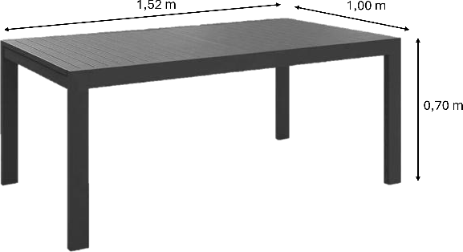
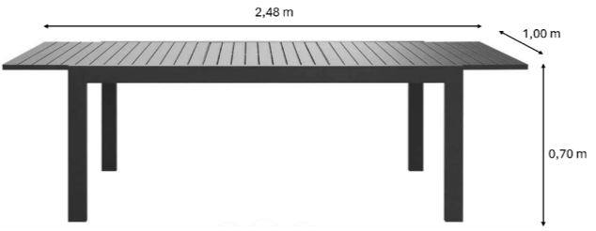
Figure 1 below visually illustrates the small and large table configuration with all relevant measurements.
Figure 1: Table Configurations

Table 3 below lists the details of the chairs from aluminium outdoor set.

Chair Section | Details
Chair frame | Made from 6m aluminium pipe tube
Rattan | Outsourced

Figure 3 below visually illustrates the chair form the aluminium outdoor set. As mentioned in problem background, each aluminium outdoor set consists of four rattan backing chairs.
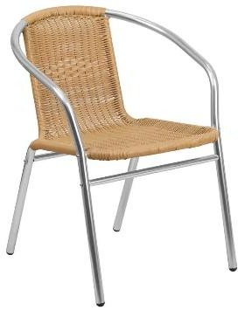
Figure 2: Rattan Backing Chair

Raw Materials Overview
The aluminium outdoor sets are manufactured using raw materials and is detailed in the table below. All raw materials are sourced from Aluminium Trading.

Table 4: Raw Materials
Raw Material | Usage | Length | Mass | Visual
Rectangular tubes (40mmx20mmx1,2mm) (height x width x thickness) | Used to make the frame for the tabletop as well as the inserted structure that allows the two tabletops to slide together for the small  configuration. | 6 m | 0,350 kg | 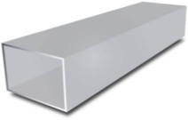
Flat bars  (101,6mmx9,52mm) | Used for the tabletop (this is welded to a frame). | 6 m | 2,621 kg | 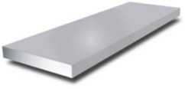
Square tubes  (60mmx60mm) | Used to make the table legs. | 6 m | 1,854 kg | 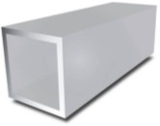
Round tubes  (25,4mmx1,6mm) | Used for making the chairs. | 6 m | 0,328 kg | 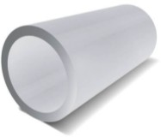

Unit Description
This section provides a more detailed description of a unit and specifically how the raw materials are applied and positioned to form it. This will enable a clearer understanding of the demand calculations presented in the following section. One aluminium outdoor unit consists of one table and four chairs and can be broken down into sub-units: Tabletop, Sliding Structure, Table Legs and Chairs. Below follows details on each sub-unit.

As shown in Table 4, rectangular tubes are used to manufacture the table frames. However, to achieve the final product dimensions of 1,52 m in length and 1 m in width in its small configuration, the raw material must be cut to the specific lengths indicated in the figure below.

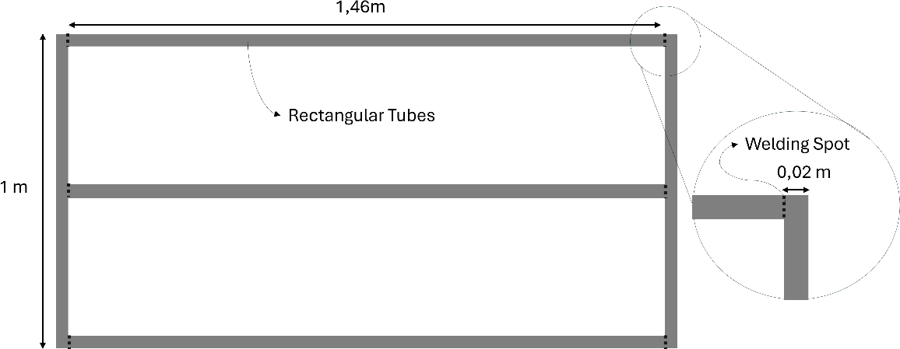
It is evident in the figure that the rectangular tube is positioned in a way that the 20 mm width is the measurement considered. The figure also highlights the key welding points, which account for this slight adjustment in material dimensions.
Figure 3: Table Frames
A total of 6,38m is needed for the table frame. After adding 5% scrap rate to account for the material loss in the cutting process a net total of 6,70m is needed. As mentioned in table 4, each rectangular tube only comes in 6m lengths, thus we will need 2 rectangular tubes for each table frame.

6.2.1.2 Table Surface
As mentioned in table 4, flat bars are used for the surface of the tabletop. Each tabletop consists of 15 flat bars each a 1m long, thus 15m is required per tabletop, and 30m per table, that is 5x 6m flat bars per table. It is assumed that no scrap is generated when cutting the flat bars therefore exactly 5x 6m flat bares are required. The

Sliding Structure
This structure allows for the two tabletops to slide into and apart from each other allowing a small or large configuration. Each unit requires one sliding structure and 20 screws to attach it. The figure below indicated the relevant measurements and welding spots.
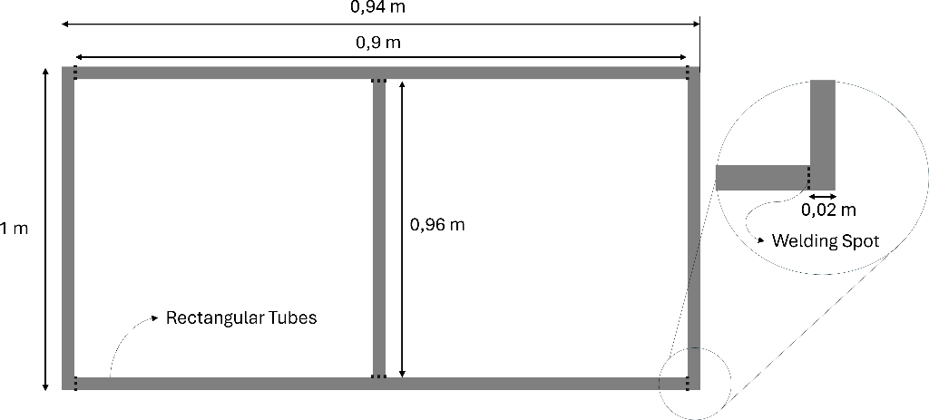

Table Legs
Square aluminium bars are used to manufacture the legs of the outdoor furniture sets, with each set requiring four legs. These legs are fitted into square sockets welded to the underside of the tabletop corners. The sockets will be sourced as raw materials. Rubber levelling feet will be attached to the bottom of each leg.

Each leg must be 0.69 m tall (0.70 m minus the 9.52 mm thickness of the flat bars). For simplicity, we round this to 0.70 m, considering the flat bar thickness negligible. As the square bars are supplied in 6 m lengths (see Table 4), and 2.94 m of tubing is needed per unit, including a 5% scrap allowance for cutting, each furniture set requires approximately 0.5 square tubes.

Chairs
As mentioned in table 4, round tubes are bent to produce the chairs. Each chair is made out of one 6 m round tube cut into 5, it is assumed the cutting of chairs 5% scrap rate is already included in the required 6m. The rattan backing is outsourced. Each unit consists of four chairs, thus 24m or 4x 6m round tubes are required per unit.

Unit Summary
The table below provides a summary of the detailed unit description above.

Table 5: Raw Materials per Unit
Raw Material Requirements per Unit
Sub-Unit | Raw Material Required | Sum of Raw Material Required | Number of Tubes/Bars/Parts Required
- | - | Summing of Raw Material | Summing of Raw Material
Tabletop: Table Frame | 3x 1,46 m Rectangular Tube 2x 1 m Rectangular Tube 5% scrap: [0,319m] | 6,7 m Rectangular Tube | 2
Tabletop: Table  Surface | 30x 1m Flat Bars | 30 m Flat Bars | 5
Sliding Structure | 2x 0,9 m Rectangular Tube 2x 1 m Rectangular Tube 1x 0,96 Rectangular Tube 5% scrap: [0,238m] | 5 m Rectangular Tube | 1
Table Legs | 4x 0,7 m Square Tube 5% scrap: [0,14m] | 2,94 m Square Tube | 0,5
Chairs | 20x 1,2m Round Tube (scrap included) | 24 m Round Tube | 4
*Square-holds | 4 x 1 Hold | 4 Holds | 4
*Screws | 20x 1 Screw | 20 Screws | 20
*Note that these aren’t considered ‘sub-units’, but rather raw material used in the application of sub-units.

Raw Material | Amount Required
Rectangular Tube | 3
Flat Bars | 5
Square Tube | 0,5
Round Tube | 4
Square-holds | 4
Screws | 20

Daily Demand Calculation
This section will make use of the information in table 5 for both finished goods and raw material demand calculations.

Finished Goods Demand
The total number of units and sub-units required per day is shown in the table below.
Table 7: Finished Goods Daily Requirements
 | Number of Sub-Units per Unit | Monthly Demand | Weekly Demand | Daily Demand
Extra information: | Mentioned under each sub-unit section | Number of Sub-units per Unit  * Units | Monthly Demand / 4 weeks | Weekly Demand  / 5 working days
Outdoor Sets (Units) | - | 5 000 | 1250 | 250
Tabletop (Sub-unit) | 2 | 10000 | 2500 | 500
Sliding Structure (Sub-unit) | 1 | 5000 | 1250 | 250
Table Legs (Sub-unit) | 4 | 20000 | 5000 | 1000
Chairs (Sub-unit) | 4 | 20000 | 5000 | 1000

Raw Materials Demand
Using the information from Tables 6 and 7, the daily raw material requirements were calculated, as shown in the table below. Since the raw material inventory must consistently reflect two weeks’ worth of stock, the corresponding two-week stock levels are also provided. It is assumed that deliveries occur once daily in the morning, with each delivery supplying one day’s worth of raw materials.
Table 8: Raw Material Demand
Raw Materials Demand
 | Amount per Unit | Amount per Day | 2 Week-Stock-Level
Extra information: |  | Amount per Unit * Daily Demand  of Units (250) | Amount per Unit * 10
Rectangular Tube | 3 | 750 | 7500
Flat Bars | 5 | 25000 | 6250
Square Tube | 0,5 | 125 | 1250
Round Tube | 4 | 1000 | 10000
Square-holds | 4 | 1000 | 10000
Screws | 20 | 5000 | 50000
*Large orders: Carton Boxes | 0,2 | 40 | 400
*Small orders: Carton Boxes | 1 | 50 | 500
*As per our assumption, 80% of the orders are large -40 bulk orders, each consisting of 5 outdoor sets. The remaining 30% are small orders, totalling 50 individual sets.



  - Manufacturing Process
The figure below presents a flowchart that visually outlines the complete production process of the aluminium outdoor set, including both the table and chairs. All operations and ‘work-in-progress’ areas are indicated.

Note important assumptions that were made regarding the production process:
    - The chair frame needs not to be grinded and polished after it is manually welded together.
    - The legs’ edges need not to be deburred after cutting.
13

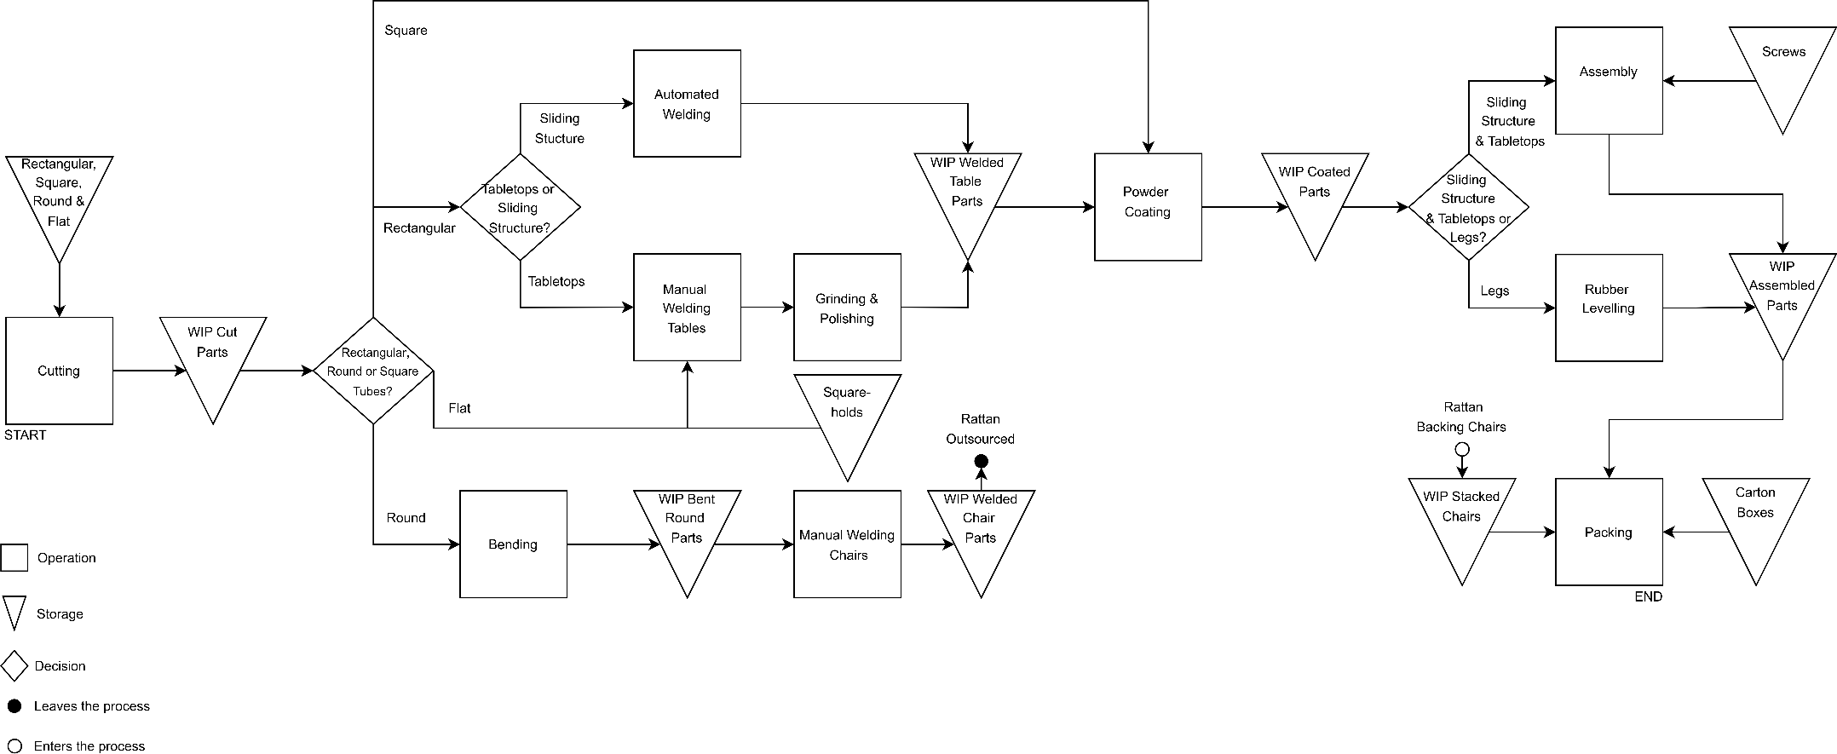
Figure 5: Entire Process Flowchart

effectively. This whole section serves as an introduction to station planning that follows.

Cutting Operation
The purpose of this operation is to use a Laser Cutting LF3015CNR Machine to cut rectangular tubes, square tubes and flat bars for the tables - and round tubes for the chairs. To meet production demands, a total of three machines are required.

Based on industry standards and the machine's features, it's typical for such machines to be operated by a single trained operator. The operator's responsibilities usually include, setting up the machine and loading materials and monitoring the cutting process. To meet production demands, a total of three operators are required.
Table S: Cutting Operation
Cutting
https://coastalengineering.co.za/cnc-plasma-cutting-machines/lf3015cnr/
Machine Specifications
Model |  |  |  | LF3015CNR
Laser |  |  |  | 1000 – 8000 w (Optional)
Accuracy |  |  |  | ±0.02 mm
Length |  |  |  | 4 600 mm
Width |  |  |  | 2 450 mm
Height |  |  |  | 1 700 mm
Capacity Planning
 | Demand per Day | Cutting Time for All Parts (minutes) |  | Time Needed for Cutting per Day (minutes) | Time Available per Machine per Day (minutes) |  | Machines Required
Extra information: | - | - |  | Demand per Day* Cutting Time for  All Parts | 8 hours*60 |  | Time Available per Machine per Day/Time Needed for Cutting  per Day [rounded up]
Tables | 250 | 1 |  | 250 | 480 |  | 1
Chairs | 1000 | 1 |  | 1000 | 480 |  | 2
TOTAL |  |  |  |  |  |  | 3
Labour
 | Number of Machines Required |  | Operators Required per Machine |  |  | Total Operators Required
Extra information: | - |  | - |  |  | Number of Machines Required*Operators Required  per Machine
Tables | 1 |  | 1 |  |  | 1
Chairs | 2 |  | 1 |  |  | 2
TOTAL |  |  |  |  |  | 3

Bending Operation
The purpose of this operation is to use a UNI76 21314 Bending Machine for bending the round tubes. To meet production demands, a total of seven machines are required.

Based on industry practices and operational materials, one trained operator is sufficient to run a single bending machine. Thus, to meet production demands, a total of seven operators are required.
Table 10: Bending
Bending
https://tinyurl.com/bdfebxu4
Machine Specifications
Model |  |  | UNI76 21314
Length |  |  | 1000mm
Width |  |  | 710mm
Height |  |  | 1100mm
Capacity Planning
 | Demand per Day | Bending Time for Part  (minutes) | Time Needed for Bending per Day  (minutes) | Time Available per Machine per Day (minutes) | Machines Required
Extra information: | - | - | Demand per Day* Bending Time for Part | 8 hours*60 | Time Available per Machine per Day/Time Needed for Bending per Day [rounded up]
Chairs | 1000 | 3 | 3000 | 480 | 7
TOTAL |  |  |  |  | 7
Labour
 | Machines Required | Operators Required per Machine |  | Total Operators Required
Extra information: | - | - |  | Machines Required*Operators Required per Machine
Chairs | 7 | 1 |  | 7
TOTAL |  |  |  | 7

Welding Operation
The welding operation is divided in two sections: Automated Welding and Manual Welding.

Automated Welding
The purpose of this operation is to use a Kawasaki BA006N-A Welding Robot Arm to automate the welding operation for the sliding structures. To meet production demands, a total of three robot arms are required.

Based on industry practices and Kawasaki’s operational materials:
        - One trained operator is usually sufficient to run a single welding robot arm.
        - One person must always watch for fire hazards, as per safety instructions
Thus, one operator per robot arm is required, and therefore we need a total of three operators.

Table 11: Automated Welding
Automated Welding
https://kawasakirobotics.nl/index.php?id_product=38&rewrite=ba006n&controller=product&id_lang=1&utm
Machine Specifications
Model | BA006N-A
Installation | Floor or Ceiling Mounting

Length |  |  | 500 mm
Width |  |  | 430 mm
Radius of Arm |  |  | 1800 mm
Capacity Planning
 | Demand per Day | Welding Time for All Parts (minutes) | Time Needed for Welding per Day (minutes) | Time Available per Machine per Day (minutes) | Robots Required
Extra information: | - | - | Demand per Day* Welding Time for All Parts | 8 hours*60 | Time Available per Machine per Day/Time Needed for Welding per Day [rounded up]
Sliding  Structures | 250 | 5 | 1250 | 480 | 3
TOTAL |  |  |  |  | 3
Labour
 | Number of Robots  Required | Operators Required per Machine |  | Total Operators Required
Extra  information: | - | - |  | Number of Robots Required*Operators Required per Machine
Sliding  Structures | 3 | 1 |  | 3
TOTAL |  |  |  | 3

Manual Welding
The purpose of this operation is to use a Pinnacle ProMIG Welder for the manual welding of tabletops and chairs. This operation doesn’t necessarily have a machine but rather a set of equipment. This set consists of a ProMIG Welder and a work bench. To meet production demands, a total of twenty-one sets are required. Specifically, eleven for tabletops and ten for chairs.

Only one operator can handle a piece of welding equipment at a time, therefore only one operator is required per set. To meet production demands, a total of twenty-one operators are required.

Table 12: Manual Welding
Manual Welding
Set of Equipment Specifications
Pinnacle ProMIG Welder |  |  | https://tinyurl.com/46tc7fh5
1x Work Bench |  |  | https://tinyurl.com/4pc74cm5
Work Bench: Length |  |  | 1600mm
Work Bench: Width |  |  | 1100mm
Work Bench: Height |  |  | 1500mm
Capacity Planning
 | Demand per Day | Welding Time for Part (minutes) | Time Needed for Welding per Day (minutes) | Time Available per Set per Day (minutes) | Sets of Equipment Required
Extra information: | - | - | Demand per Day* Welding Time for Part | 8 hours*60 | Time Available per Set per Day/Time Needed for Welding per Day [rounded up]
Tabletops | 500 | 10 | 5000 | 480 | 11
Chairs | 1000 | 5 | 5000 | 480 | 10

TOTAL |  |  |  | 21
Labour
 | Sets of Equipment Required | Operators Required per Set | Total Operators Required
Extra information: | - | - | Sets of Equipment Required *Operators Required per Set
Tabletops | 11 | 1 | 11
Chairs | 10 | 1 | 10
TOTAL |  |  | 21

Since grinding and polishing the tabletops is a quick task performed after welding to ensure a smooth finish, this operation will be integrated into the manual welding process. A die grinder will be added to the welder’s equipment, allowing the welder to grind each tabletop as needed (1 minute per tabletop). As a result, no additional operators or a separate grinding and polishing section are required.

Powder Coating
The purpose of this operation is to use an Automatic Powder Coating Booth to coat all structural components of the table. Please note that TIPTOP TABLES has specified that only the table is to be coated, not the chairs. The table structures include the tabletop, sliding structure, and legs. The booth accommodates five structures at a time, and based on the required throughput, one booth will be sufficient to meet production demand.

The one booth requires three operators for efficient operation: two operators will handle the loading and unloading of the structures, while one operator will manually assist the automatic spray system to ensure complete and even coating coverage.

Table 13: Automatic Powder Coating Booth
Automatic Powder Coating Booth
https://tinyurl.com/3hzz63wd
Set of Equipment Specifications
Model |  | COLO-S-0825
Length |  | 5000 mm
Width |  | 1200 mm
Height |  | 2580 mm
Capacity Planning
 | Demand per Day | Coating Time per Batch (minutes) | Time Needed for Coating per Day (minutes) | Time Available per Coating Booth per Day  (minutes) | Booths Required
Extra information: | - | - | Demand per Day* Bending Time for Part | 8 hours*60 | Time Available per Machine per Day/Time Needed for Bending per Day [rounded  up]
Tabletops | 500 | 0,5 | 250 | 480 | 0,5
Sliding Structure | 250 | 0,5 | 125 | 480 | 0,3
Legs | 1000 | 0,5 | 500 | 480 | 1,0

TOTAL |  |  |  | 1
Labour
 | Booths Required | Operators Required per Machine | Total Operators Required
Extra information: | - | - | Machines Required*Operators Required per Machine
Powder Coating Booth | 1 | 3 | 3
TOTAL |  |  | 3

Rubber Levelling Operation
The purpose of this operation is to install the rubber levelling feet into the table legs. This operation does not require a machine, but rather a simple set of equipment, which includes one rubber mallet and a workbench. The workbench is designed in a U-shaped steel frame, allowing the table legs to be securely positioned for hammering. More detail on this will be available in the following section.

To meet production demand, only one set of equipment is needed. As only one operator can handle the rubber mallet at a time, the total required operators is one.

Table 14: Rubber Levelling
Rubber Levelling
Set of Equipment Specifications
Rubber Mallet |  |  | https://tinyurl.com/2vpzu4r4
Work Bench: Length |  |  | 1000 mm
Work Bench: Width |  |  | 65 mm
Work Bench: Height |  |  | 650 mm
Capacity Planning
 | Demand per Day | Levelling Time per Leg (minutes) | Time Needed for Levelling per Day (minutes) | Time Available per Set per Day (minutes) | Sets Required
Extra information: | - | - | Demand per Day* Levelling  Time per Leg | 8 hours*60 | Time Available per Set per Day/Time Needed for Levelling per Day [rounded  up]
Legs | 1000 | 0,25 | 250 | 480 | 1
TOTAL |  |  |  |  | 1
Labour
 | Sets Required | Operators Required per Set |  | Total Operators Required
Extra information: | - | - |  | Sets Required*Operators Required per Set
Legs | 1 | 1 |  | 1
TOTAL |  |  |  | 1

c.5.c Assembling Operation
The purpose of the assembly operation is to attach the two tabletops to the sliding structure. This task does not require a machine but instead relies on a basic set of equipment, consisting of two

screwdrivers and a workbench. To meet production demand, three sets of equipment will be required.

The operation is best performed by two operators per set: one responsible for positioning the tabletops, and the other for positioning the sliding structure. Once aligned, both operators will insert and tighten 10 screws each using the screwdrivers. Therefore, to run three sets of equipment simultaneously, a total of six operators will be required.

Table 15: Assembly
Assembly
Set of Equipment Specifications
2x Screw Drivers |  |  | https://tinyurl.com/3nrr9ds9
Work Bench: Length |  |  | 1600mm
Work Bench: Width |  |  | 1100mm
Work Bench: Height |  |  | 15000mm
Capacity Planning
 | Demand per Day | Assembly Time per Table (minutes) | Time Needed for Assembly per Day (minutes) | Time Available per Assembly per Day (minutes) | Sets Required
Extra information: | - | - | Demand per Day* Assembly Time per Table | 8 hours*60 | Time Available per Assembly per Day/Time Needed for Assembly per Day [rounded up]
Table | 250 | 5 | 1250 | 480 | 3
TOTAL |  |  |  |  | 3
Labour
 | Sets Required | Operators Required per Set |  | Total Operators Required
Extra information: | - | - |  | Sets Required*Operators Required per Set
Table | 3 | 2 |  | 6
TOTAL |  |  |  | 6

c.5.7 Packing Operation
The purpose of this operation is to pack the final products. Tables are packed in carton boxes, with their legs loosely placed inside each box. Based on the assumption that 80% of orders are large, 40 carton boxes - each containing five table sets - are packed per day. The remaining 20% are small, individual orders, with 50 carton boxes packed daily, each containing one table set.
Chairs are packed by stacking: up to 20 chairs per stack for large orders, and 4 chairs per stack for small orders.

This task does not require machinery but instead relies on a basic set of manual equipment: one carton sealing tape dispenser for taping the carton boxes and one manual strapping tool for securing chair stacks.

To meet production demand, four sets of equipment will be used. Each table-packing station requires two operators - one for placing items in the carton and another for sealing it. Similarly,

Packing
Set of Equipment Specifications
Carton Sealing Tape Dispenser |  |  |  | https://tinyurl.com/23whn5zx
Manual Strapping Tool |  |  |  | https://tinyurl.com/yc74exxf
Capacity Planning
 | Total Tables/Chairs per Orders | Packing Time per Table/Chair (minutes) |  | Time Needed for Packing per Day (minutes) | Time Available for Packing per Day (minutes) | Set of Equipment Required
Extra information: | - | - |  | Demand per Day* Packing Time per Part | 8 hours*60 | Time Available for Packing per Day/Time Needed for Packing per  Day [rounded up]
40 Large Orders: Table | 200 | 5 |  | 1000 | 480 | 3
50 Small Order: Table | 50 | 5 |  | 250 | 480 | 1
40 Large Order: Chair | 200 | 0,5 |  | 100 | 480 | 1
50 Small Order: Chair | 50 | 0,5 |  | 25 | 480 | 1
TOTAL |  |  |  |  |  | 6
Labour
 | Sets of Equipment Required |  | Operators Required per Set |  | Total Operators Required
Extra information: | - |  | - |  | Sets Required*Operators Required per Set
40 Large Orders: Table | 3 |  | 2 |  | 6
50 Small Order: Table | 1 |  | 2 |  | 2
40 Large Order: Chair | 1 |  | 2 |  | 2
50 Small Order: Chair | 1 |  | 2 |  | 2
TOTAL |  |  |  |  | 12

c.5.2 Visual Summary
The table below provides a visual summary for all machines and/or equipment used by each operation discussed above.

Operation | Labour | Machinery/Equipment
Cutting | 3 | 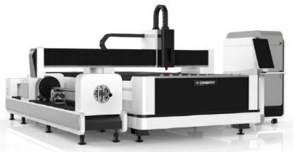

Bending | 7 | 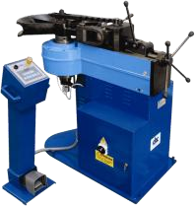
Automated Welding | 3 | 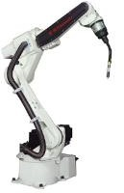
Manual Welding | 21 | 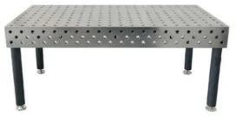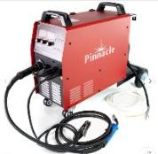  *Note that the workbench will be customised to incorporate clamps to hold down parts.
Powder Coating | 3 | 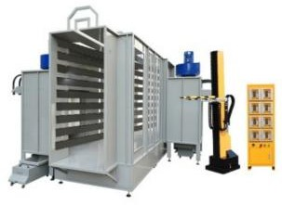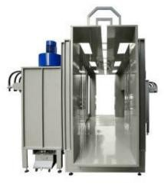
Rubber Levelling | 1 | 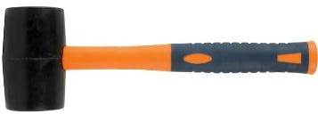
Assembly | 6 | 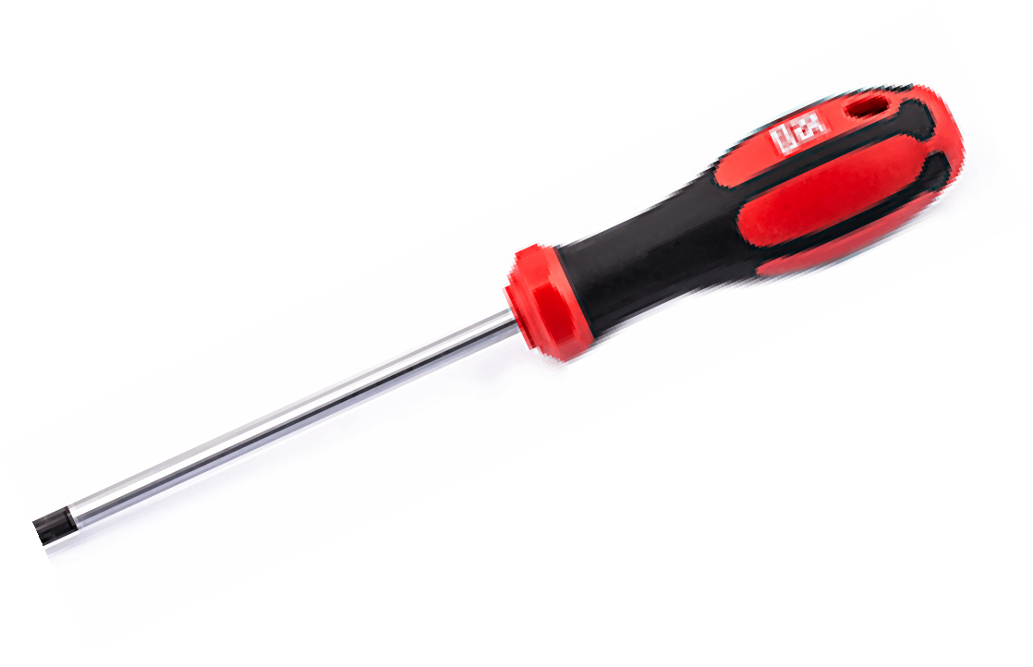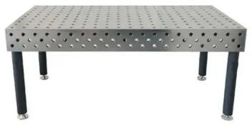
Packing | 6 | 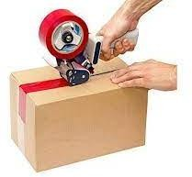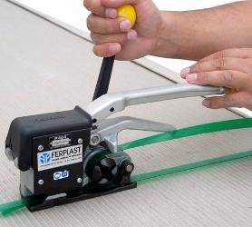
TOTAL | 52 | -



6.6 Department Classification

c.c.1 Processing Departments
The departments listed below are those directly involved in processing. The work-in-progress (WIP) and storage areas will be considered Holding C Handling Departments, which will be discussed in the following section (6.6.2 Holding C Handling Departments).

Preparation Department
This department is responsible for preparing the raw material for further steps in the process. It will consist of the cutting and bending operations.

Cutting
Table 9 indicated that 3 cutting machines are required. Each cutting station will consist of one machine. We thus, require 3 cutting stations, one specifically for cutting table parts, and two for cutting chair parts, to meet production demand. The figure below shows a detailed cutting station.
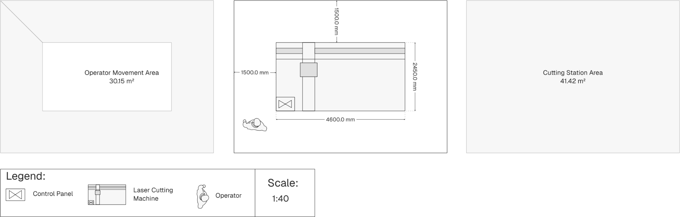
Figure c: Cutting Station


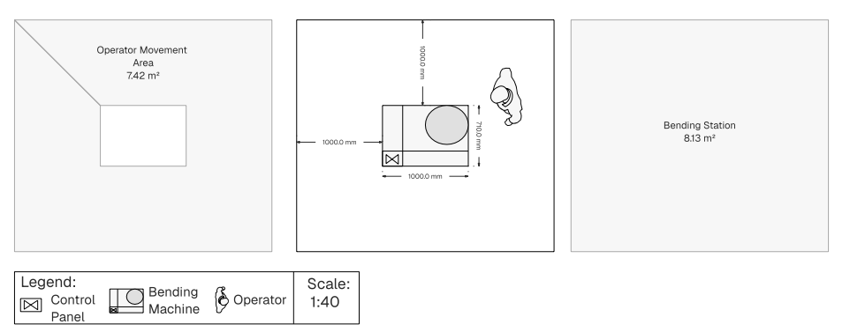

Bending
Table 10 indicated that 7 bending machines are required. Each bending station will consist of one machine. We thus, require 7 bending stations, to meet production demand. The figure below shows a detailed bending station.

Figure 7: Bending Station



Welding Department
This department is responsible for all the welding work required in the process, as well as the post-grinding work to ensure a smooth finish. It will consist of the automated welding, manual welding and grinding C polishing operations.

Automated Welding
Table 11 indicated that 3 automated welding robot arms are required. Each auto-weld station will consist of one robot. We thus, require 3 auto-weld stations, to meet production demand. The figure below shows a detailed auto-weld station.
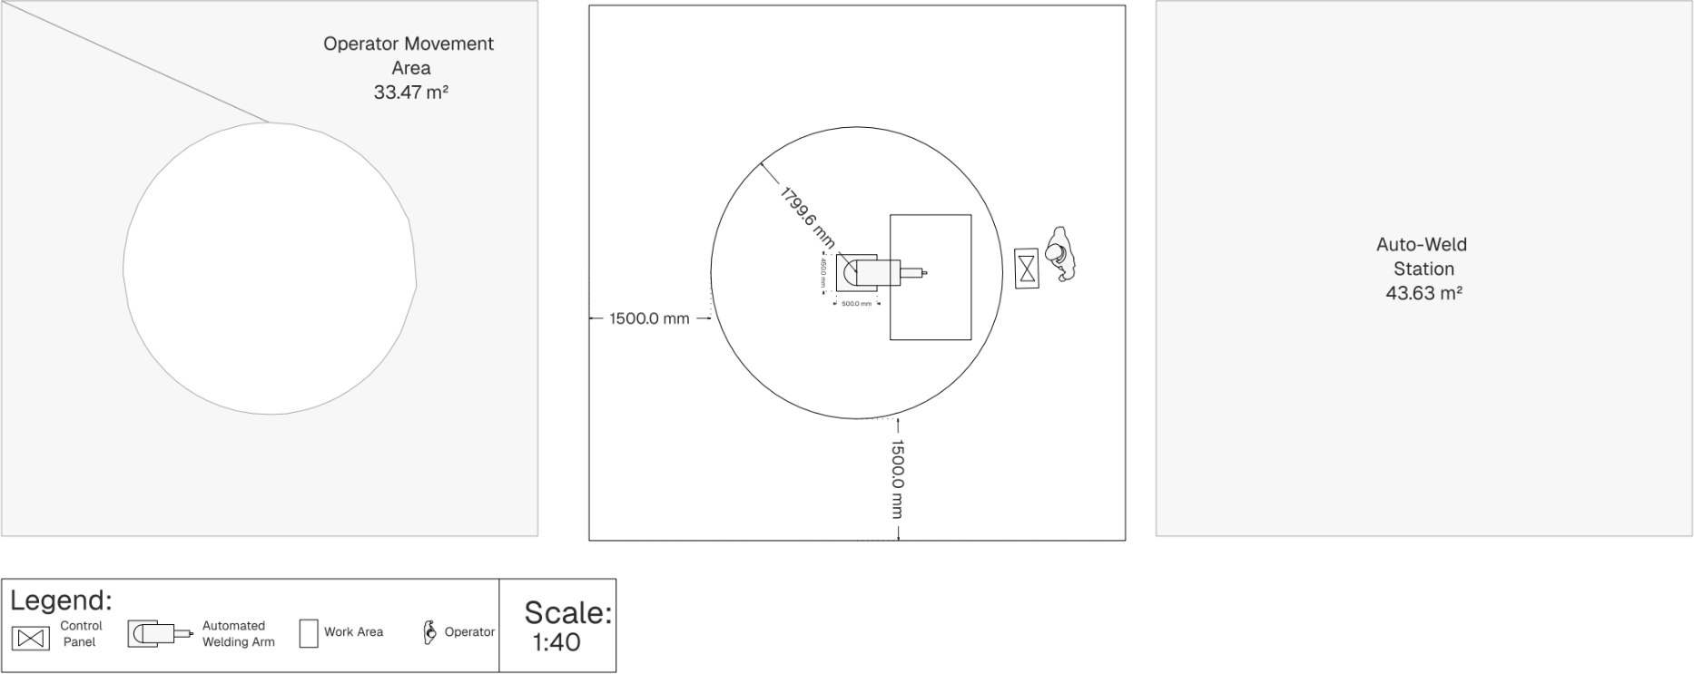

Safety Area
Figure 8: Auto-Weld Station


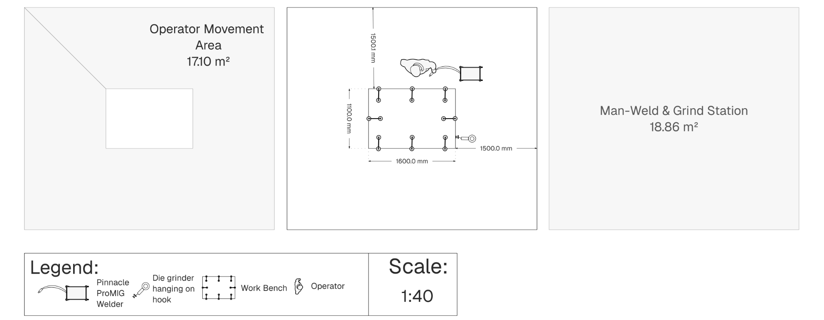

Manual Welding s Grinding
Table 12 indicated that 21 sets of manual welding equipment are required. Each set consists of a workbench with clamps on to position parts for welding, a Pinnacle ProMIG Welder and an additional Die Grinder. Each man-weld C grind station will consist of one set of equipment. We thus, require 21 man-weld stations (11 for table tops and 10 for chairs), to meet production demand. The figure below shows a detailed man-weld C grind station.

Figure S: Man-Weld & Grind Station



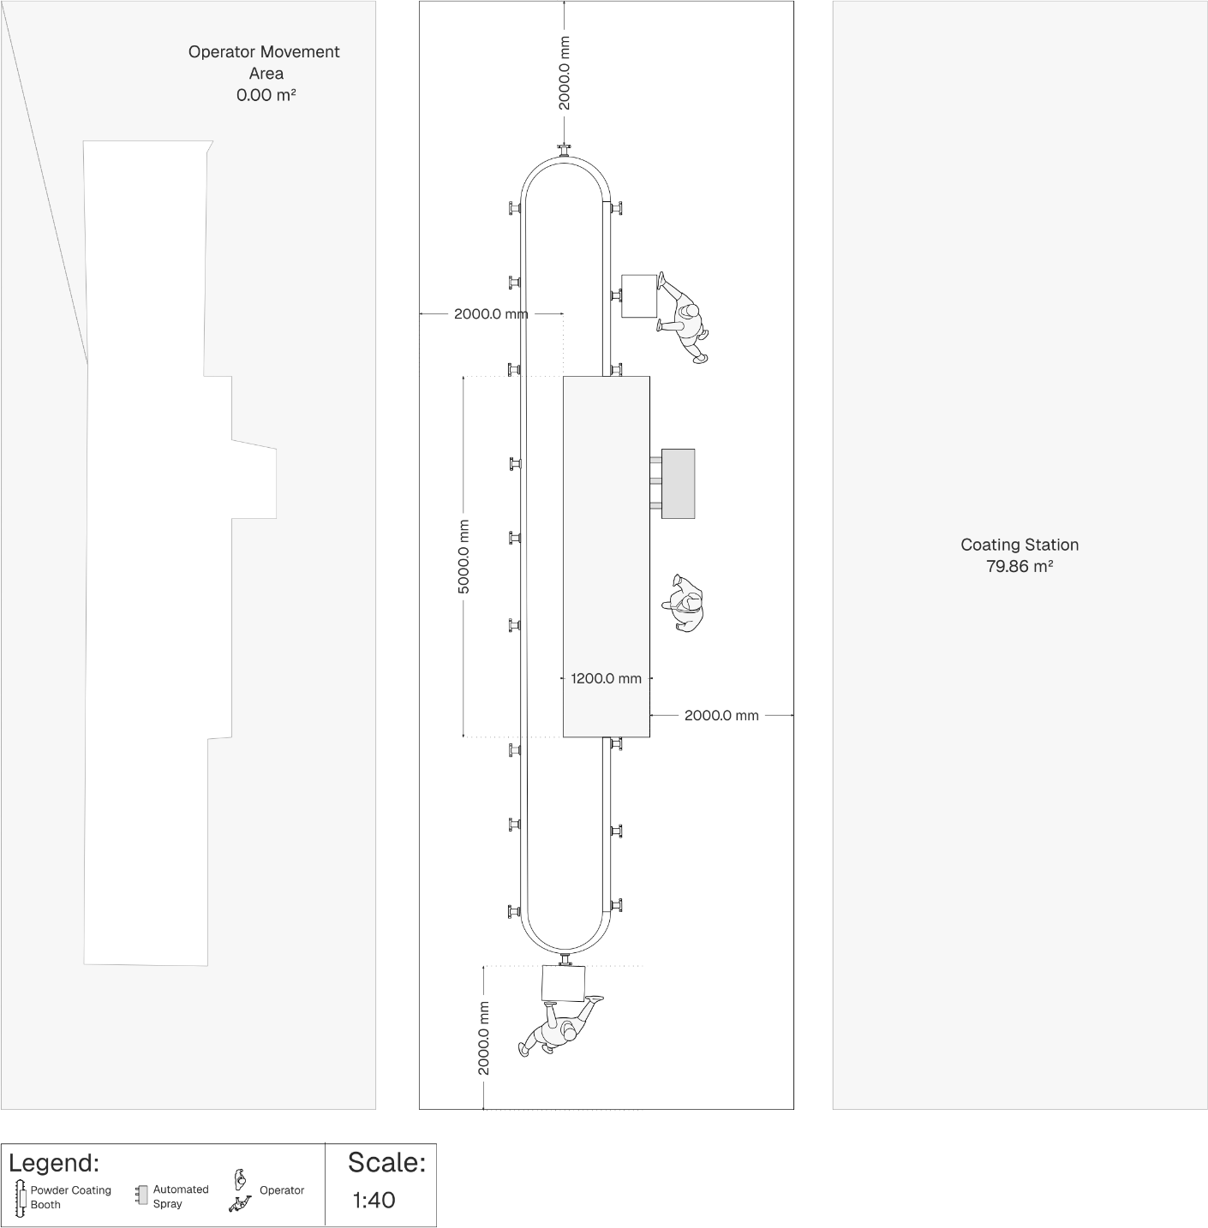
26

Painting Department
This department is responsible for all the coating work required in the process. It will consist of only the powder coating operation.

Powder Coating
Table 14 indicated that one powder coating booth is required for tabletops, sliding structures and legs. A coating station will consist of one powder coating booth. We thus, require 1 coating station, to meet production demand. The figure below shows a detailed coating station.

Figure 10: Coating Station



Assembly Department
This department is responsible for all the assembling work in the process. It will consist of the rubber levelling and assembly operation.

Rubber Levelling Operation
Table 15 indicated that one set of equipment is required for the levelling of legs. Each set consists of a workbench and a rubber mallet. Each levelling station will consist of one set of equipment. We thus, require 1 levelling stations, to meet production demand. The figure below shows a detailed grinding & polishing station.

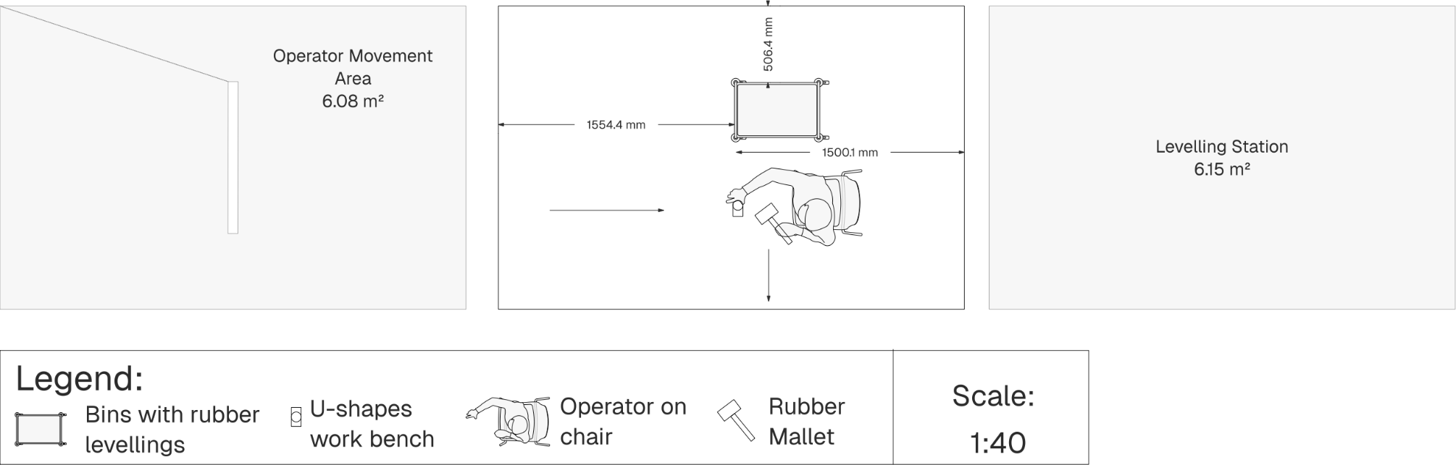
Figure 11: Levelling Station


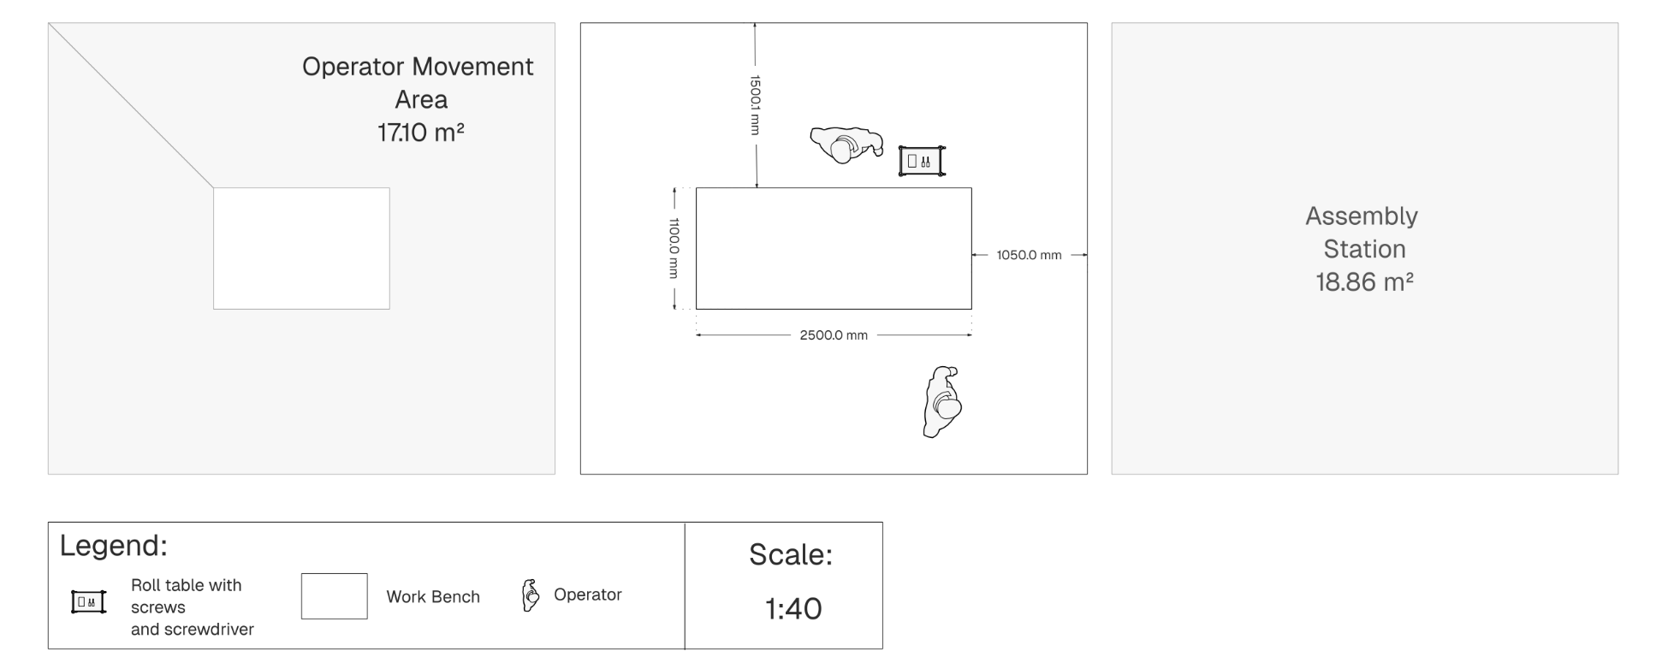

Assembly
Table 16 indicated that three sets of equipment is required for the assembly process. Each set consists of a workbench and two screwdrivers. Each assembly station will consist of one set of equipment. We thus, require 3 assembly stations, to meet production demand. The figure below shows a detailed assembly station.

Figure 12: Assembly Station



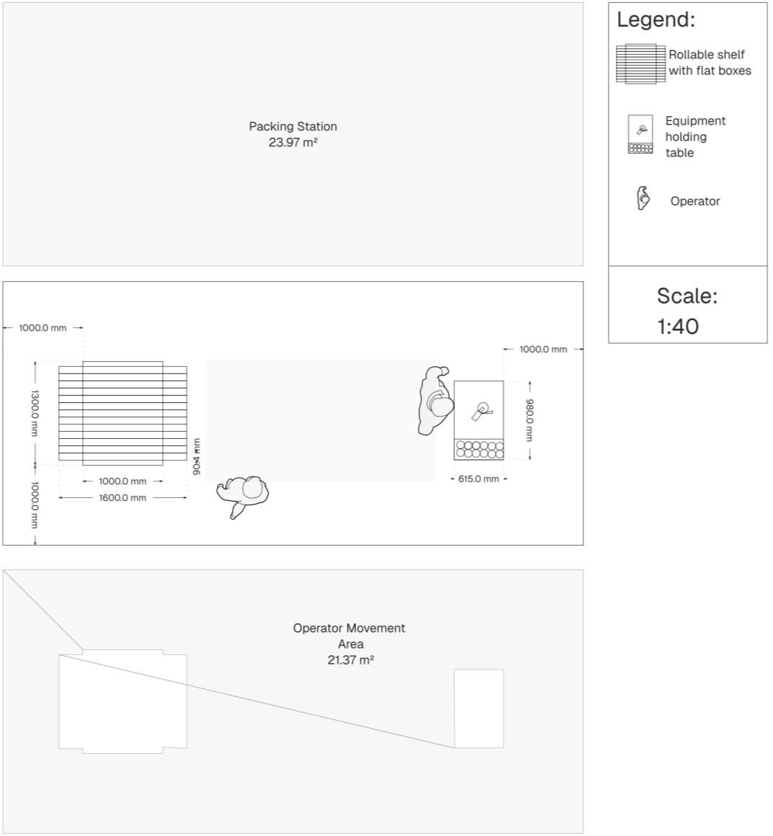

Packing Department
This department is responsible for all the packing work required in the process. It will consist of the packing and stacking operations both touched on in table 17.

Packing
Table 17 shows that three sets of equipment are required for the table packing process, with each packing station comprising one complete set. To meet production demand, 4 packing stations will be needed.

Three of these stations will be dedicated to large orders, while one will be allocated to small orders. Although all packing stations will have the same layout and components, the main difference lies in the 'rollable shelf with flat boxes.' For large orders, the shelf will hold 13 to 14 larger boxes, whereas for small orders, it will hold 50 smaller boxes. Despite this difference in box size, the shelf dimensions will remain unchanged, as the smaller boxes will still fit within the same space. The table on the side will hold the tape dispenser and the necessary tape. We will assume one tape roll is used per 10 boxes. Therefore, each large order packing station will require 2 rolls a day, while the small order packing station will require 5. A total of 7 rolls are needed per day, but the table will be stocked with a month’s worth of tape and filled once a month.

The figure below illustrates the detailed layout of a packing station.

Figure 13: Packing Station 29


30

Stacking
Table 17 shows that two sets of equipment are required for the chair stacking process, with each stacking station comprising one complete set. To meet production demand, 2 stacking stations will be needed.

One of these stations will be dedicated to large orders, while one will be allocated to small orders. Both stacking stations will look similar. The figure below illustrates the detailed layout of a stacking station – as there isn’t equipment, only a manual strapping tool the floor work area, where the stacking will mainly take place, is indicated. We will assume that each station goes through one roll of strapping per day, thus a total of 2 strapping rolls are required per day. The table will however be stocked with a month’s worth of strapping rolls.

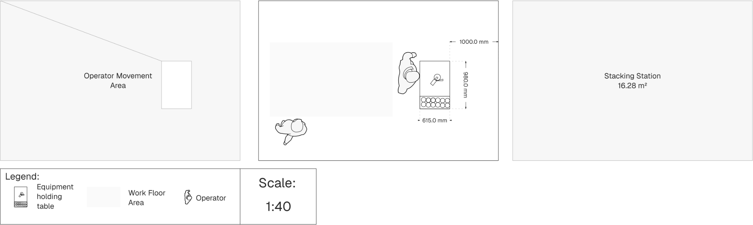
Figure 14: Stacking Station


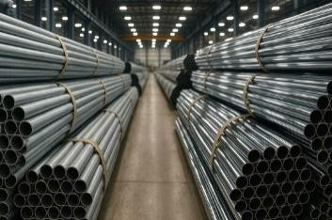
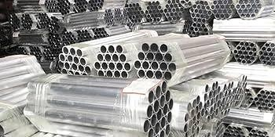
departments is 1174,98 m².
Bundle
Level
Stack
31
Figure 15: Bundled Raw Material

Table 17: Area of Processing Departments
Department | Stations | Area of Station (m²) | Number of Stations | Sum of Area (m²) | Extra Walk Room  20% | Total Area for Department  (m²)
Preparation | Cutting | 41,42 | 3 | 124,26 | 149,11 | 217,40
 | Bending | 8,13 | 7 | 56,91 | 68,29
Welding | Auto-Weld | 43,63 | 3 | 130,89 | 157,07 | 632,34
 | Man-Weld & Grind | 18,86 | 21 | 396,06 | 475,27
Painting | Coating | 79,86 | 1 | 79,86 | 95,83 | 95,83
Assembly | Levelling | 6,15 | 1 | 6,15 | 7,38 | 75,28
 | Assembly | 18,86 | 3 | 56,58 | 67,90
Packing | Packing | 23,97 | 4 | 95,88 | 115,06 | 154,13
 | Stacking | 16,28 | 2 | 32,56 | 39,07
TOTAL |  |  |  |  |  | 1174,G8
* Our facility will include 20% “empty floor space” in each department to accommodate future growth.

c.c.2 Holding and Handling Departments
The departments listed below are not directly involved in wire processing but are responsible for its transportation and storage between different areas; this section also includes a discussion of the amenities department.

Raw Material Storage
The purpose of this department is to store all raw materials mainly the aluminium products, rectangular-, square-, round tubes and flat bars, bought from Aluminium Trading. It is assumed that enough square-holds, screws and carton boxes are bought for 6 months at a time and held in their respective workstations.

As outlined in the daily demand calculations, one day’s worth of raw materials is delivered each morning. It is assumed that the supplier uses only back-door trucks for deliveries. A designated staging area will be provided for unloading, sized to accommodate the simultaneous operation of two forklifts, as both will be used during the offloading process. To facilitate easier unloading, the staging area will be elevated above ground level. The raised staging area, along with the forklifts and their specifications used in the facility, is illustrated in Appendix A1 and A2.

Raw materials will be stacked by forklift up to 20 levels high, except for square tubes, which will be limited to 10 levels. Each level contains 10 bundles, sorted by product type. All bundles contain 10 units, except for flat bars, which have 40 units per bundle.

Raw material will be moved from stacks to the cutting department via the two forklifts. Thus, a total of two employees are need for this entire department.
The figure below illustrates the arrangement of bundles, levels, and stacks.

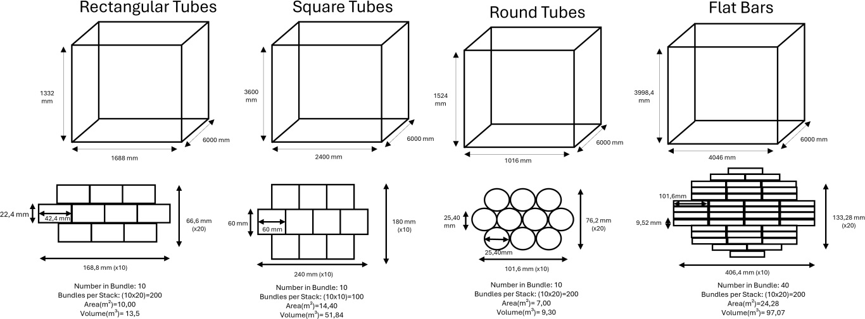
Figure 1c: Stack & Bundle Measurements

Using information and figures above, the following table was developed to determine the net total area needed for the raw storage material.

Table 18: Raw Material Storage
Raw Materials Storage
 | 2 Week-Stock-Level | Number of Bundles | Number of Stacks | Area of 1 Stack (m²) | Total Area of Stacks (m²)
Extra information: | - | 2 Week-Stock-Level/Number per bundle | Number of Bundles/ Bundles per stack [round  up] | Length x Width | Area of 1 Stack x Number of Stacks
Rectangular Tube | 7500 | 750 | 4 | 10 | 40
Flat Bars | 12500 | 312,5 | 2 | 24,28 | 48,56
Square Tube | 1250 | 125 | 2 | 14,4 | 28,8
Round Tube | 10000 | 1000 | 5 | 7 | 35
TOTAL |  |  |  |  | 152,36
Operator & Forklift Movement Area (18% of total) |  |  |  |  | 27,42
Staging Area (10% of total) [1 day worth] |  |  |  |  | 15,24
SUB-TOTAL (total + operator & forklift movement area + staging area) |  |  |  |  | 195,02
Future Growth (20%) |  |  |  |  | 39,00
NET TOTAL AREA (m²) |  |  |  |  | 234,02
Number of employees |  |  |  |  | 2

Prepared WIP
The purpose of this department is to store all parts that have been cut and bent in the preparation department and also to transport it from the preparation department to the welding department. We shall have enough storage capacity for 1 days’ worth of processing to ensure no bottlenecks form.

All parts will be stored in clearly labelled containers, grouped according to tube type and specific length. This ensures that operators at the next station can quickly and easily retrieve the required

for each cutting machine is required to collect the cut pieces and place them on the correct low-laying gravity roller, thus a total of 3 are required. The table below, based on data from Table 5 and Figure 17, outlines the required volume for each container.

Table 1S: Volume of Containers
Volume of Containers
Part | Raw Material Required  per Unit | Total of Each Part Per Day | Volume of Part (m³) | Total Volume of All Parts  (m³) | Department it needs to go to | Station it needs to go to
Extra information: | From Table 5 | Raw Material Required per Unit  * 250 | l x w x h using Figure 17 | Volume of Part  x Total of Each Part Per Day | - | -
Cut Rectangular Tube | 3x 1,46 m | 750x 1,46 m | 0,00139 | 1,04 | Welding | Man-Weld
 | 2x 1 m | 500x 1 m | 0,00095 | 0,47 |  | Man-Weld
 | 2x 0,9 m | 500x 0,9 m | 0,00085 | 0,43 |  | Auto-Weld
 | 2x 1 m | 500x 1 m | 0,00095 | 0,47 |  | Auto-Weld
 | 1x 0,96 | 250x 0,96 | 0,00091 | 0,23 |  | Auto-Weld
Cut Flat Bars | 30x 1m | 7500x 1m | 0,00097 | 7,25 | Welding | Man-Weld
Cut Square  Tube | 4x 0,7 m | 1000x 0,7 m | 0,00252 | 2,52 | Painting | Coating
Cut & Bent  Round Tube | 20x 1,2m | 5000x 1,2m | 0,00077 | 3,87 | Welding | Man-Weld

Each container will be 0,7 m high and equipped with a spring-loaded or counterbalanced floor that automatically adjusts to the container’s weight. As more parts are added, the floor lowers; as parts are removed, it rises. The floor will always be slightly slanted towards the next operation. This all ensures easy access without requiring operators to bend inside the container or walk around it to get a part. Using the volumes from Table 20 and the equation below, the dimensions of each container were calculated. The resulting container designs are illustrated in the figure below.
𝑉𝑜𝑙𝑢𝑚𝑒 + 0.5(𝐦³) ∗
𝑠𝑖𝑑𝑒 = √
0,7
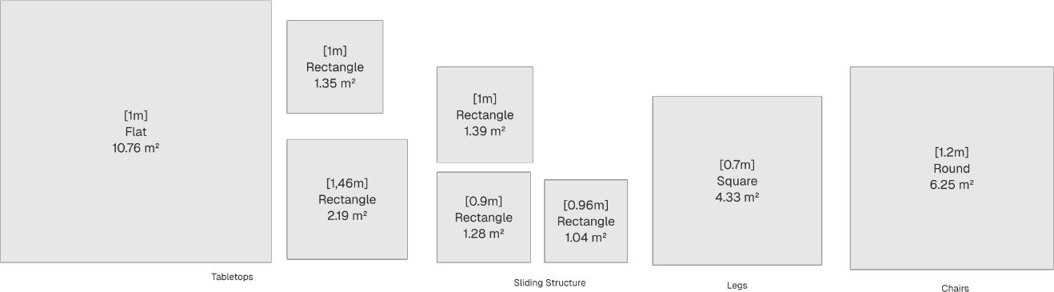
*0.5(m³) extra buffer is added to all volumes to accommodate for parts that may lay weird etc.
3
4
1
2
5
6
7
8
Figure 17: Containers
The table below thus indicates the total area required for the Prepared WIP Department.

Prepared WIP
Container | Area (m²)
Extra information: | From Figure 18
1 | 10,76
2 | 2,19
3 | 1,35
4 | 1,39
5 | 1,28
6 | 1,04
7 | 4,33
8 | 6,25
TOTAL | 28,59
Operator & Material Movement Area (18% of total) | 5,1462
SUB-TOTAL (total + operator & material movement area) | 33,7362
Future Growth (20%) | 6,74724
NET TOTAL AREA (m²) | 40,48
Number of employees | 3

Welded WIP
The purpose of this department is to store parts after welding and, where applicable, after grinding and polishing. It must accommodate one day’s worth of tabletops and sliding structures to avoid bottlenecks. Additionally, the department requires a designated staging area for the collection and drop-off of 1000 chairs that are sent to external rattan contractors.

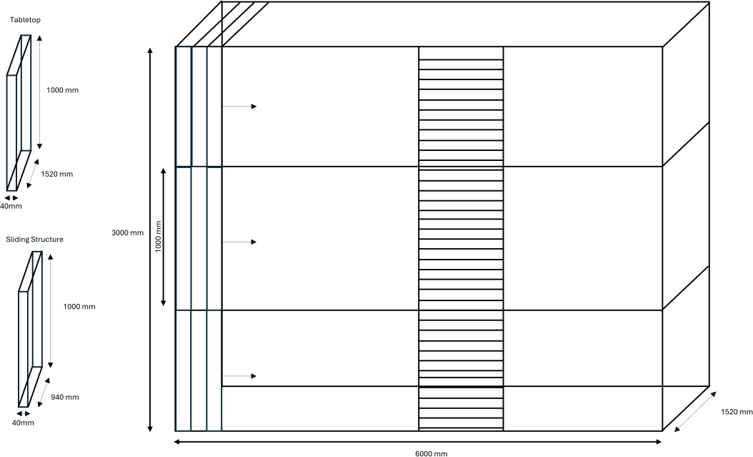
Operators from Welding Department will have to transport their welded pieces by hand to the welded WIP. Just before the Coating Station there will be two 6m long, 1,52m wide and 3m heigh shelves. These shelves will be considered the Welded WIP. Each smaller shelf within the large shelf is 0.041m wide, just big enough to fit both tabletop and sliding structure. The figure below illustrates this shelf in more detail.
Figure 18: Shelf

A gliding ladder is attached to the shelving unit to provide access to the upper levels. While parts can move directly from the welding station to the coating process, this WIP (Work-In-Progress) area is intended to hold minimal inventory under normal conditions. However, it must still allow sufficient space to accommodate for one days’ worth of parts in case of a downstream bottleneck or process disruption. In order words, the top shelf won’t often be utilised.

After the welding process, two employees manually stack the chairs directly onto the raised staging platform (see Appendix A1). No forklift is required, as the stacks are carried in and out by hand. The staging area will be designed to accommodate up to 1000 chairs, as the receival of ratan-backed chairs will be handled by the assembly department. Chairs are stacked in groups of 20, resulting in 50 stacks. As chair dimensions are not provided, each stack is assumed to occupy a 0.55m x 0.55m square footprint.

The table below indicates the total area required for Welded WIP.

Table 21: Welded WIP
Welded WIP
 | Number needed | Area (m²) per item | Total Area (m²)
Extra information: | - | l x b From Figure 19 | Number needed * Area (m²) per item
Shelves | 2 | 9,12 | 18
Chairs Stacks | 50 | 0,3025 | 15
TOTAL |  |  | 33
Operator Movement Area (18% of total) |  |  | 6,01
SUB-TOTAL (total + operator movement area) |  |  | 39
Future Growth (20%) |  |  | 7,87
NET TOTAL AREA (m²) |  |  | 47,24
Number of employees |  |  | 4

Painted WIP
The purpose of this department is to store tabletops, sliding structures, and legs after they have been coated. Three ‘runners’ will be responsible for transporting bins filled with coated products from the coating station to their designated storage racks.

There will be a total of two racks, for tabletops and sliding structures. The racks for tabletops and sliding structures will be identical to the one shown in Figure 19, with the same dimensions. Together, these two racks can hold up to 878 parts.

Coated legs, however, will be placed onto a low-lying gravity roller, which will guide them into a container like those used previously in Figure 18, now located directly next to the rubber levelling station.
Table 22: Painted WIP

Painted WIP
 | Number of  Storages needed | Area (m²) per Storage | Total Area (m²)
Extra information: | - | l x b From Figure 18 & 19 | Number of Storages needed * Area (m²) per Storage
Shelves | 2 | 9,12 | 18,24
Container for Legs | 1 | 4,33 | 4,33
TOTAL |  |  | 22,57

Operator Movement Area (18% of total) | 4,06
SUB-TOTAL (total + operator movement area) | 26,63
Future Growth (20%) | 5,33
NET TOTAL AREA (m²) | 31,G6
Number of employees | 3

Assembled WIP
The purpose of this department is to store tables (2 tabletops put together with 20 screws) and legs, as well as receive rattan-backed chairs.

After the tables are assembled, they are stacked by hand. This is done by one of the two operators from the assembly station therefore no need for additional employees here. Each stack is 2m high and contains 50 tables. There will thus be 5 stacks (2m high, 1.52m long, 1m wide).

After the legs are levelled, they are put directly into a similar container as in figure 19. Thus, there is also no need for an additional employee here.

The staging area that receives the rattan-backed chairs is the same size as the staging area where they are picked up. They are delivered in stacks of 20 chairs as well, therefore there will be 50 stacks. The two employees that loaded the truck earlier will now unload here, therefore no additional employees are necessary here, and the table below will indicate 0 by number of employees.

The table below indicates the total area required for Assembled WIP.

Table 23: Assembled WIP
Assembly WIP
 | Number needed | Area (m²) per storage | Total Area (m²)
Extra information: | - | l x b (text above) | Number needed/ Bundles per stack
Tables Stacks | 5 | 1,52 | 7,60
Container for Legs | 1 | 4,33 | 4,33
Chair Stacks (0.55mx0.55m) | 50 | 0,3025 | 15,13
TOTAL |  |  | 11,93
Operator Movement Area (18% of total) |  |  | 2,15
SUB-TOTAL (total + operator movement area) |  |  | 14,08
Future Growth (20%) |  |  | 2,82
NET TOTAL AREA (m²) |  |  | 16,8G
Number of employees |  |  | 0

Finish Goods Storage
This department is responsible for storing finished goods for both large and small orders. Since orders are dispatched daily, it only needs to accommodate one day’s worth of finished products.

There are 40 large orders (80%) and 50 small orders (20%) per day as per assumption. A dedicated section will be allocated for small orders, allowing customers to collect their purchases directly. This area will have the capacity to store 50 boxes and 50 chair stacks (with each stack containing 4 chairs).

Large orders will be stored in a separate section designed specifically for wholesale distribution and truck collections. This area will have the capacity to store 40 boxes and 50 chair stacks (with each stack containing 20 chairs).

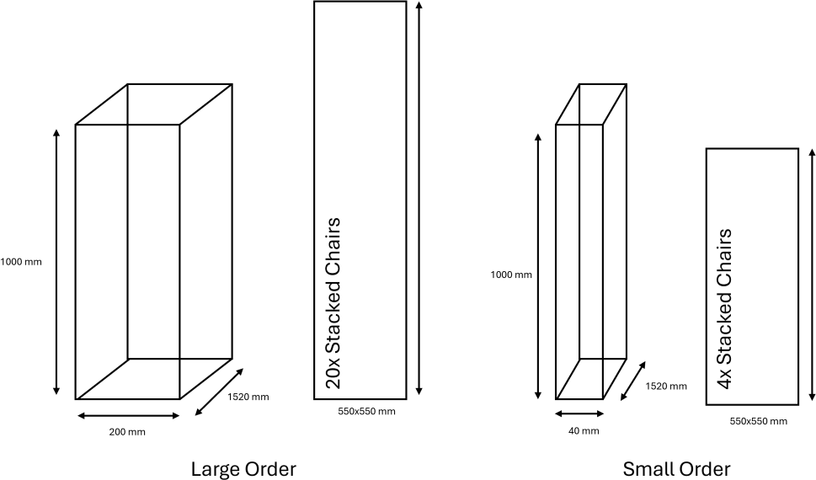
The figure below illustrates the different box sized and chairs stacked area.
Figure 1S: Large Order vs Small Order
Carton box
Carton box

These carton boxes will be stacked on top of each other; each stack will have 5 carton boxes. Thus, for large orders there will be 8 stacks of boxes and 40 stacks of chairs, as the chairs can’t be stacked higher than 20 per stack. Small order will have 10 stacks of boxes and 50 stacks of 4 chairs each.

There will be two operators working in the large order section, and two in the small order section. They will be responsible from transporting the boxes and stacked chairs from the Packing and Stacking Station to the WIP and stacking the boxes accordingly. They will transport this via hand.

The table below indicates the total area required for Finished Goods Storage.

Table 24: Finished Goods Storage
Finished Goods Storage
 | Number needed | Area (m²) per storage | Total Area (m²)
Extra information: | - | l x b (figure 20) | Number needed * Area (m²) per storage
Large orders: Box Stacks | 8 | 0,304 | 2,43
Large orders: Chair Stacks | 40 | 0,3025 | 12,10
Small orders: Boxes Stacks | 10 | 0,0608 | 0,61
Small orders: Chair Stacks | 50 | 0,3025 | 15,13
TOTAL |  |  | 14,53
Operator Movement Area (18% of total) |  |  | 2,62
SUB-TOTAL (total + operator movement area) |  |  | 17,15
Future Growth (20%) |  |  | 3,43
NET TOTAL AREA (m²) |  |  | 20,58
Number of employees |  |  | 4

Table 25: Amenities
Table Of Amenities
Amenity | Description | Area m2
Offices | The 3 management personnel, and 4 administrative personals will have a basic office consisting of a desk,  chair and laptop. The offices will be 10 m2 each. | 70
Bathroom | Single boardroom | 50
Reception area | Waiting area (8 seats), Reception desk, admin workstation, circulation | 109
Total Area for Amenities |  | 22G

6.6.2.8 Summary of Holding s Handling Departments
The table below now serves as a summary of all holding and handling departments’, listing their total area requirements for each. It is evident that the space required for all holding and handling departments is 620,17 m².
Table 2c: Holding & Handling Summary
Department | Labour | Total Area for Department (m²)
Raw Material Storage | 2 | 234,02
Prepared WIP | 3 | 40,48
Welded WIP | 4 | 47,24
Painted WIP | 3 | 31,96
Assembled WIP | 0 | 16,89
Finished Goods Storage | 4 | 20,58
Amenities | 8 | 229,00
TOTAL | 24 | 620,17

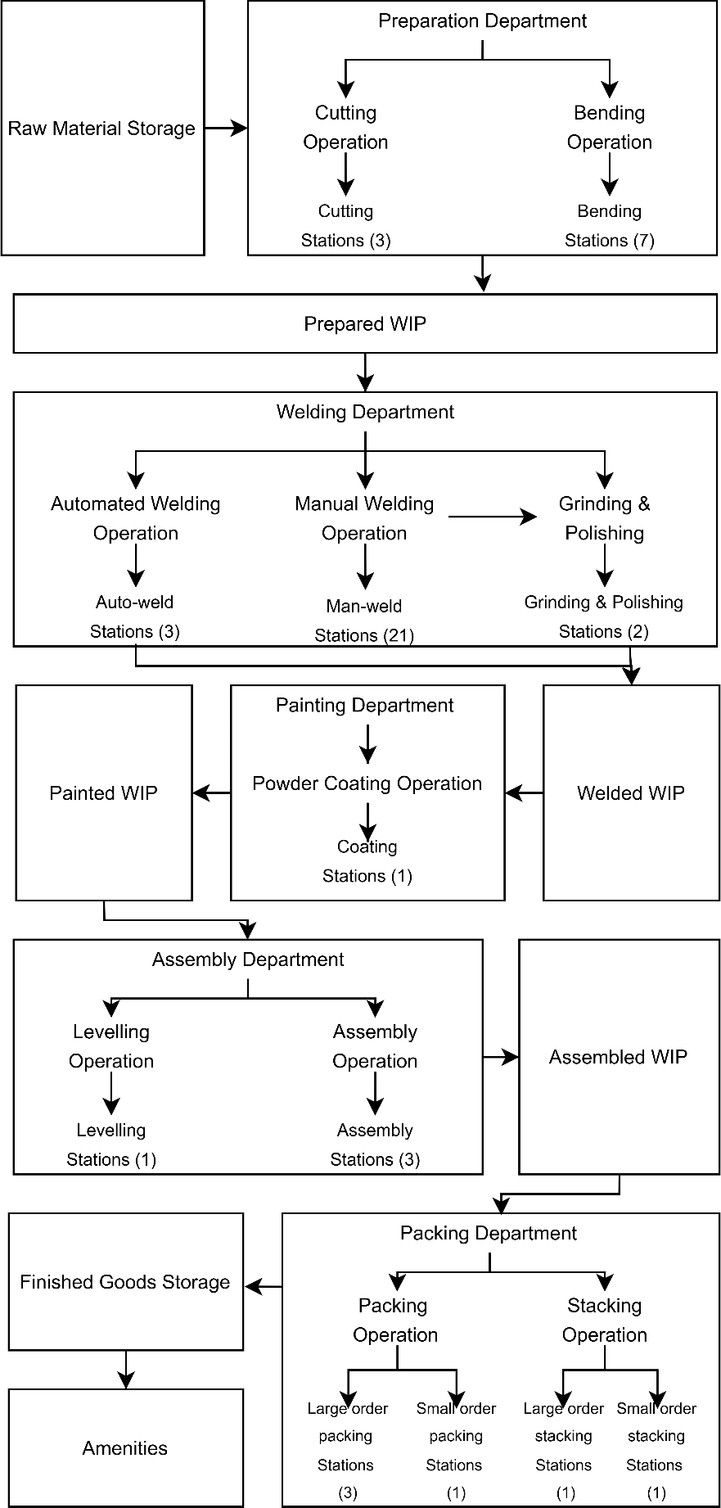
Figure 20: Visual Summary of All Departments


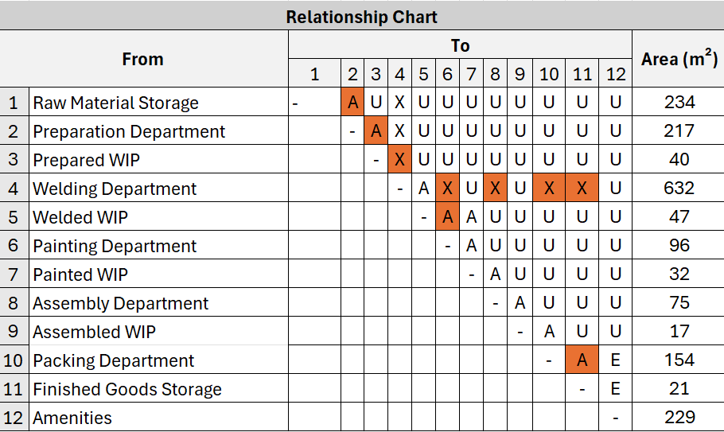
Department Blocks
7.2 Systematic Layout Planning
7.2.1 Alternative 1
Table 28: Final Relationship Chart
Note all the required limitation set in the preliminary activity relationship are highlighted in the chart to the left.

The only thing not shown is that automated welding and manual welding should absolutely be close to each other. However, all the welding processing are places together in the welding department therefore this limitation is met even though it isn’t indicated.
Also note some departments indicated that it shouldn’t be close to other departments, refer to specific operations within the department and it will
be shown that way on the MFP.
40
Below, each department is represented as a block, scaled relative to the others based on their area size.
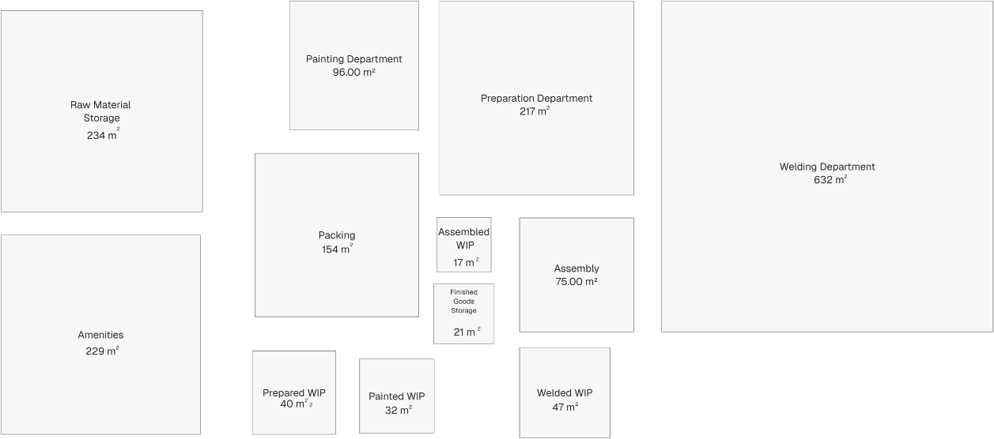
Scale 1:105
Figure 21: Department Blocks

Systematic Layout Planning
Some limitations were provided by TIPTOP TABLES and is shown in the activity relationship diagram in Appendix B1. The activity relationship diagram was a preliminary chart based on limitations given at the beginning of the project. After analysis we decided to structure our departments differently than indicated on the preliminary activity relationship chart, but note the limitation were taken into account and can be seen in the final relationship chart below.

Table 27: Closeness Index
Closeness Index
Value | Closeness | Line Code
A | Absolutely necessary
E | Especially important
I | Important
O | Ordinary closeness
U | Unimportant
X | Not allowed


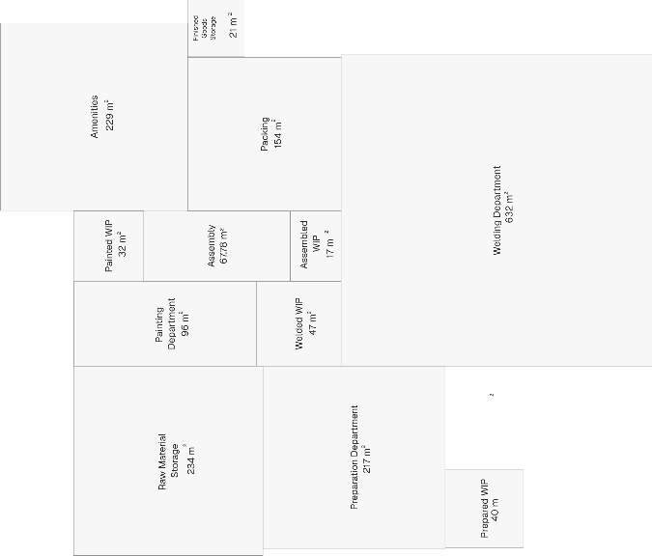
Figure 23: Alternative 1
41
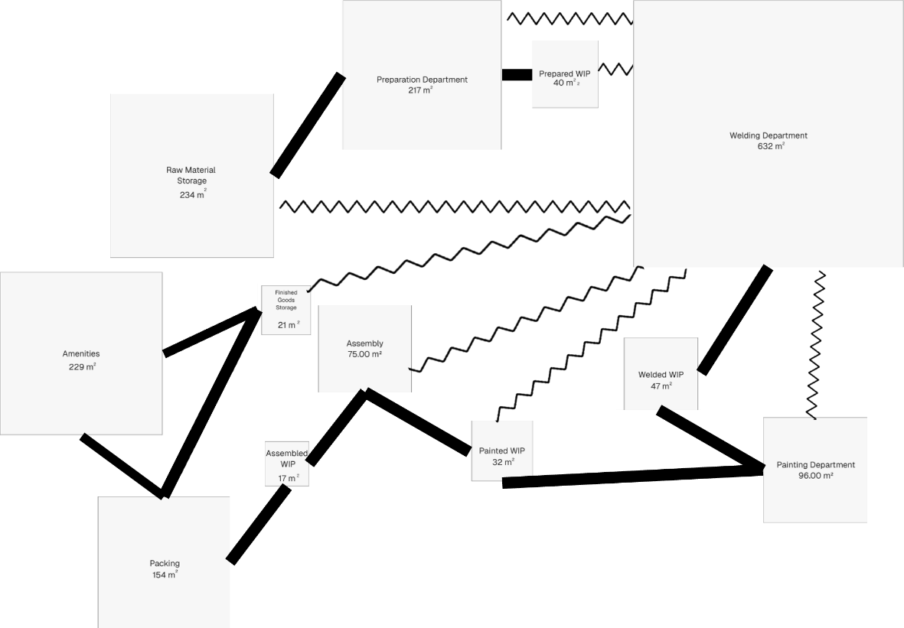
Figure 22: Relationship Diagram

Further three high-level block diagram layouts as the initial step in formulating our Master Facility Layout, were developed using the above relationship diagram.

Alternative 1
Alternative 1 has workflow almost in a zigzag line starting from raw materials. The relationship chart states that the welding process shouldn’t be near the packing station, but it refers specifically the automated welding process. Therefore, it is places on the opposite side. The opening between the Welding Department and Prepared WIP is due to the limitation set by TIPTOP TABLES. Raw materials are received and follows the zigzag flow until finished goods where it is shipped.

the Welding Department is away from all other departments except the Welded WIP which it is required to be absolutely close to. Furthermore, a wall can be built between amenities and finished goods dividing customer parking and truck loadings, as there will be trucks for finished goods storage as well as assembly and welded WIP for the onloading and offloading of chairs.

It is also seen that raw material storage and the preparation department are on the side and therefore will have access to a offloading area for raw materials and a onloading area for scrap removal.
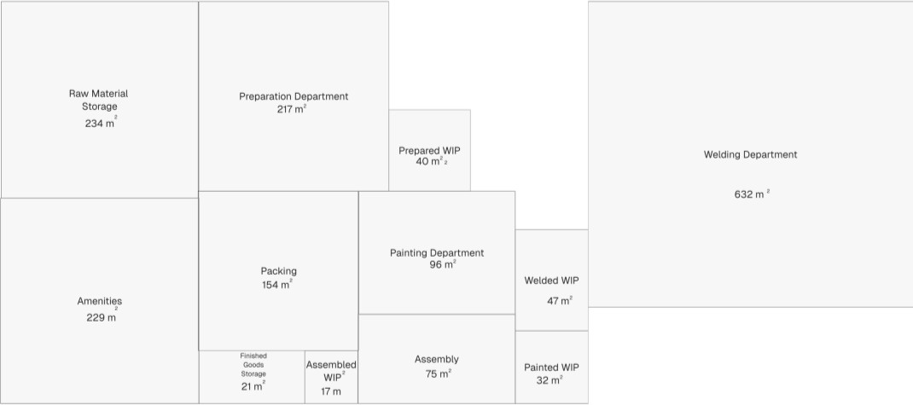
Figure 24: Alternative 2

Alternative 3
Alternative Three features a circular layout, with the welding stations positioned at the centre and all other departments arranged around it in relation to the material flow. This design ensures that welding operations remain completely separate from the rest of the departments, while still being easily accessible. Additionally, each surrounding department is positioned to allow for offloading and onloading of materials as needed.
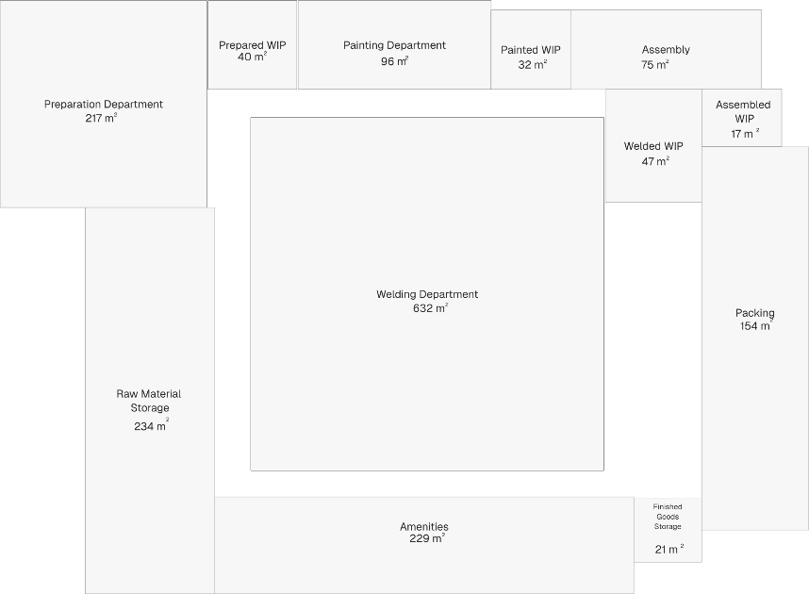
Figure 25: Alternative 3

Evaluating Alternatives
To determine the most suitable facility layout, we employed the Weighted Factor Comparison method. This technique evaluates each alternative based on the four topics stated in the design requirements, each assigned a weight according to its level of importance. Not all factors carry the same significance, so weights were allocated on a priority scale from 1 to 10, where:
  - 1–4: Less critical
  - 5–7: Important
  - 8–10: Highly important
Each alternative was then rated on a performance scale from 1 to 5, where 5 represents the most favourable outcome for that factor. The table below summarises the evaluation:

Table 2S: Weighted Factor Comparison Evaluation
Weighted Factor Comparison Evaluation Table
Design Requirement | Weight  (out of 10) | Alternative 1  (out of 5) | Alternative 2  (out of 5) | Alternative 3  (out of 5)
Production | 9 | 5 | 5 | 5
Site | 6 | 1 | 5 | 4
Layout and Flow | 8 | 2 | 5 | 4
Specific Design  Requirements | 9 | 2 | 5 | 3

Weighted Scores:
  - Alternative 1:
(9×5) + (6×1) + (8×2) + (9×2) = 85

Alternative 2:
(9×5) + (6×5) + (8×5) + (9×5) = 160

Alternative 3:
(9×5) + (6×4) + (8×4) + (9×3) = 128

Alternative 1 lack designated access for the onloading and offloading of chairs, which is a key requirement. Additionally, the welding operation is not separated as specified by TIPTOP TABLES. While Alternative 3 does provide a separate welding area, the overall material flow is inefficient and impractical.

Alternative 2, however, includes a dedicated access point for loading and unloading chairs, a separate welding section, and meets all of the specific design criteria set by TIPTOP TABLES.

Given its stronger performance - particularly in the most critical areas - Alternative 2 is the preferred layout option.


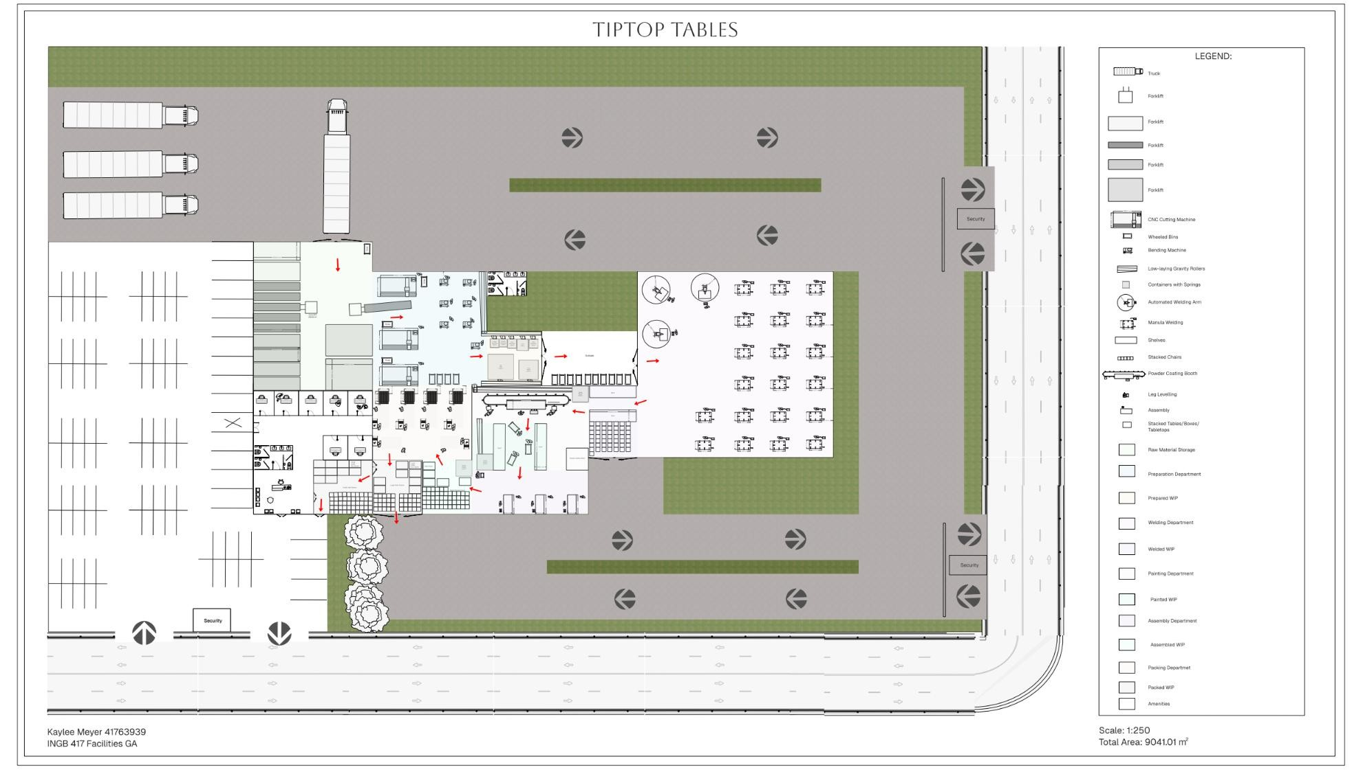
Final Design
44
The figure below shows the master facility plan for TIPTOP TABLES. The entire area utilised is 9041,01 m². The arrows represent the flow of material within the facility.

Figure 2c: MFP

Business Case
The table shows the capital investment required to build the new facility. The capital investment includes:
    - Civil and building works, calculated based on the required area and the average cost per square meter.
    - Machinery and equipment as specified in the facility design (based on prior calculations).
    - Basic utilities and service infrastructure required for full operational readiness.

Table 30: Capital Cost Calculations
Capital Cost Calculations
Component | Area or Qty | Cost per m² or Unit |  | Total  (ZAR) | Estimated Cost
Facility | 9041,01 | R | 5 500.00 | R | 49 725 555.00
CNC Laser Cutting Machine | 3 | R | 306 000.00 | R | 918 000.00
Bending Machine | 7 | R | 17 000.00 | R | 119 000.00
Automated Welding Robot | 3 | R | 650 000.00 | R | 1 950 000.00
Manual Welding Equipment Set | 2 | R | 14 200.00 | R | 28 400.00
Powder Coating Booth | 2 | R | 360 000.00 | R | 720 000.00
Assembly Equipment Set | 4 | R | 2 500.00 | R | 10 000.00
Packing Equipment Set | 6 | R | 1 500.00 | R | 9 000.00
Utility Installation (power, water,  etc) | Lump Sum | R | 3 000 000.00 | R | 3 000 000.00
Total Estimated CAPEX |  |  |  | R | 56 47G G55.00
Estimates are based on recent supplier quotes and local construction benchmarks.
In approaching a project of this scale, it is important to consider relevant risks and ways to mitigate those risks strategically. The table below illustrates some of these potential risks.
Table 31: Risk and Mitigations
Risk and Mitigation Strategies
Risk | Impact | Mitigation Strategy
Construction delays | Project timeline  overruns | Include a buffer in the schedule:  Use experienced contractors
Equipment delivery delays | Commissioning  bottlenecks | Source equipment early;  Staggered installation plans
Cost overruns on civil works | Overspending | Contingency allocation (10–15%);  Fixed-price contracts
Regulatory or environmental approval delays | Legal/compliance impacts | Early engagement with authorities and pre-approvals
Skills shortage for new machinery | Delayed ramp-up | Arrange OEM (Original Equipment Manufacturer) training;  Phased hiring and onboarding

Taking these risks into account, it is important to set a realistic implementation schedule to allow for variance in delivery times and due dates. The table below shows a High-Level Implementation Schedule.
Table 32: High-Level Implementation Schedule
High-Level Implementation Schedule

Phase | Timeline | Duration
Final Design C Procurement | July – September 2025 | 3 months
Site Preparation C Civil Works | October 2025 – February 2026 | 5 months
Equipment Delivery C  Installation | February – April 2026 | 3 months
Commissioning C Handover | May-26 | 1 month
Total Project Duration | July 2025 – May 2026 | 11 months

Final Recommendations and Remarks
I recommend that TIPTOP TABLES consider purchasing a plot of land approximately 1 hectare in size, or just under, as a suitable site for the construction of the new manufacturing facility.

A final remark would be to investigate the reasoning behind the current preference to keep the WIP of cut parts away from the welding area. From a production flow perspective, positioning these processes in closer proximity would create a more logical and streamlined workflow, potentially improving overall efficiency.

Appendix

Appendix A

A1: Raised Staging Area:
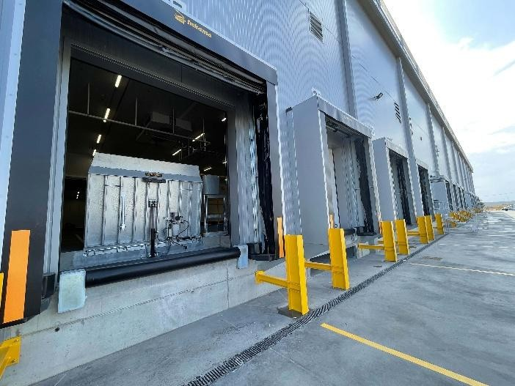
Figure 27: Raised Staging Area

A2: Forklifts utilised:
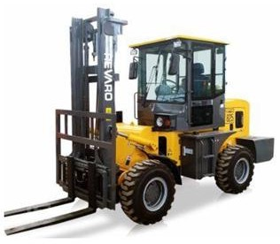
Table 33: Forklift Specs
Forklift Specifications
Name | 2025 REVARO T-REX  830
Load  Capacity | 3000 kg
Lifting Height | 3.5 m
Turning  Radius | 3 m
Drive | 4WD
Safety | Overhead Guard,  Air Brakes
Speed | 35 km/h

Figure 28: Forklift

A3: Low-laying Gravity Roller
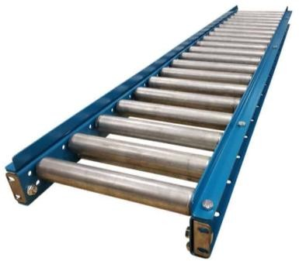
Figure 2S: Low-laying Gravity Roller

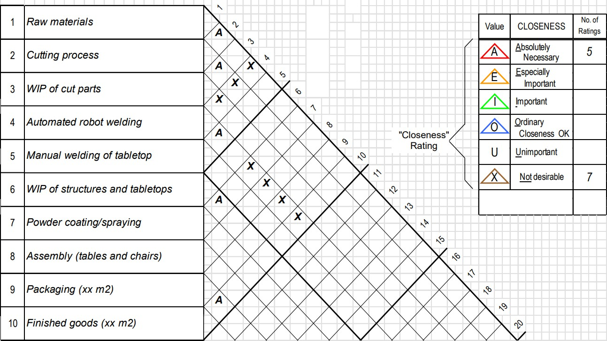
Figure 30: Activity Relationship Diagram

