

GA ASSIGNMENT
INGB417

Submitted to: Mrs W Kruger
Date: 13 June 2025
Author: Karla van Dyk
Student number: 37511459

North-West University: Potchefstroom Campus

Table of Contents
- Academic Integrity 4
- Executive Summary 4
- Background 5
- Design Problem and Objectives 5
- Design Requirements 5
- Design Assumptions and Constraints 6
  - Process Flow 6
  - Assumptions & Constraints 6
- Detail Design Specifications 9
  - Production Volumes 9
  - Departments 10
  - Distribution of large orders 22
- Design Alternatives 23
  - Alternative 1 25
  - Alternative 2 26
  - Alternative 3 27
  - Alternative Evaluation 28
- Final Design 29
- Business Case 31
  - Capital Cost Estimates 31
  - Risks and Mitigations 31
  - Schedule 32

List of Figures
Figure 6.1: High-level Process Flow Chart 6
Figure 6.2: Rectangular Tube 6
Figure 6.3: Flat Bar 6
Figure 6.4: Square Tube 7
Figure 6.5: Round Tube 7
Figure 6.6: Levelling Feet 7
Figure 6.7: Finished Expanded Table 8
Figure 6.8: Small Configuration 8
Figure 6.9: Large Configuration 8
Figure 6.10: Chair 8
Figure 7.1: Cantilever Rack 10
Figure 7.2: Workstation Layout Cantilever Rack 11
Figure 7.3: Storage Racks 11
Figure 7.4: Cutting Machine 13
Figure 7.5: Cutoff bin 13
Figure 7.6: Cutting Workstation Layout 14
Figure 7.7: Bending Machine 14
Figure 7.8: Bending Workstation Layout 14
Figure 7.9: Automated Welding Machine 15
Figure 7.10: Manual Welding Machine 15
Figure 7.11: Automated Welding Workstation Layout 16
Figure 7.12: Manual Welding Workstation Layout 16
Figure 7.13: Handheld Grinder 16
Figure 7.14: Handheld Polisher 16
Figure 7.15: Grinding & Polishing Workstation Layout 17
Figure 7.16: Powder Coating Machine 17
Figure 7.17: Powder Coating Workstation Layout 18
Figure 7.18: Assembly Workbench 18
Figure 7.19: Trolley 19
Figure 7.20: Assembly Workstation Layout 19
Figure 7.21: Dolly with wheels 20
Figure 7.22: Plastic Wrap Dispenser 20
Figure 7.23: Packaging Workstation Layout 21
Figure 8.1: Activity Relationship Chart 23
Figure 8.2: Alternative Block Layout 1 25
Figure 8.3: Alternative Block Layout 2 26
Figure 8.4: Alternative Block Layout 3 27
Figure 9.1: Master Facility Plan 30
Figure 10.1: Schedule 32

List of Tables
Table 6.1: Raw Material Item, Dimensions and Use 6
Table 6.2: Product Description 7
Table 7.1: Machines Calculations 9
Table 7.2: Number of 6m bars and tubes needed for daily production 10
Table 7.3: Cantilever Rack Calculations 11
Table 7.4: Work-in-Progress Space Calculations 12

Table 7.5: Cutting Calculations 12
Table 7.6: Cutting Machine Specifications 13
Table 7.7: Cutoff volume calculations 13
Table 7.8: Bending Machine Specifications 14
Table 7.9: Welding Machines Specifications 15
Table 7.10: Grinding & Polishing Specifications 17
Table 7.11: Powder Coating Machine Specifications 17
Table 7.12: Assembly Workbench Specifications 19
Table 7.13: Plastic Wrap Dispenser Specifications 21
Table 7.14: Supporting Facilities 22
Table 8.1: Department Dimensions 24
Table 8.2: Alternative Evaluation 28
Table 10.1: Equipment Costs 31
Table 10.2: Capital Cost Estimates 31
Table 10.3: Risks & Mitigation Strategies 32

Academic Integrity
I conducted this project with full academic integrity, ensuring that all work is original and completed in accordance with the ethical standards and guidelines of the North-West University and its Faculty of Engineering.

Executive Summary
An industrial engineers has been appointed as facility designers to design a new facility for TIPTOP TABLES. The facility has to be designed from scratch. The facility is required to make lightweight aluminium outdoor tables and accompanying chairs with rattan backing. A 20% expansion must also be considered within the next few years. The facility must meet a demand of 5 000 units monthly.

Background
TIPTOP TABLES is a South African manufacturer that has supplied outdoor tables and chairs for over 25 years. Due to increasing demand, especially for a lightweight, configurable aluminium outdoor table set (1 table + 4 chairs), the company now forecasts monthly sales of up to 5 000 sets. The existing facility cannot meet this demand, prompting the need for a new purpose-built manufacturing facility focused solely on this product line. The company requires a comprehensive facility design that incorporates production processes, storage, shipping, receiving and potential for future expansion (20% spare capacity), developed through a systematic engineering design approach.

Design Problem and Objectives
The core design problem is to develop a fully functional and scalable facility layout that meets the forecasted production demand of 5 000 outdoor table sets per month. This must include:
- Efficient space allocation for all production and non-production functions
- Logical material and product flow throughout the facility
- Compliance with safety and operational constraints (e.g., isolated welding areas, safety zones for robots)
- Integrated support areas including offices, employee facilities and logistics zones
- Alignment with inventory and delivery policies, ensuring adequate storage capacity
- Flexible layout with provision for future capacity expansion

Design Requirements
- Meet monthly demand of 5000 units
- 20% expansion space
- Isolated areas for welding
- Safety space around where robots are working
- Should conform to activity relationship chart
- Optimise facility layout
- Sufficient external interface
- Logical flow of material
- Access to roads
- Should be easy to implement or construct

Design Assumptions and Constraints

Process Flow
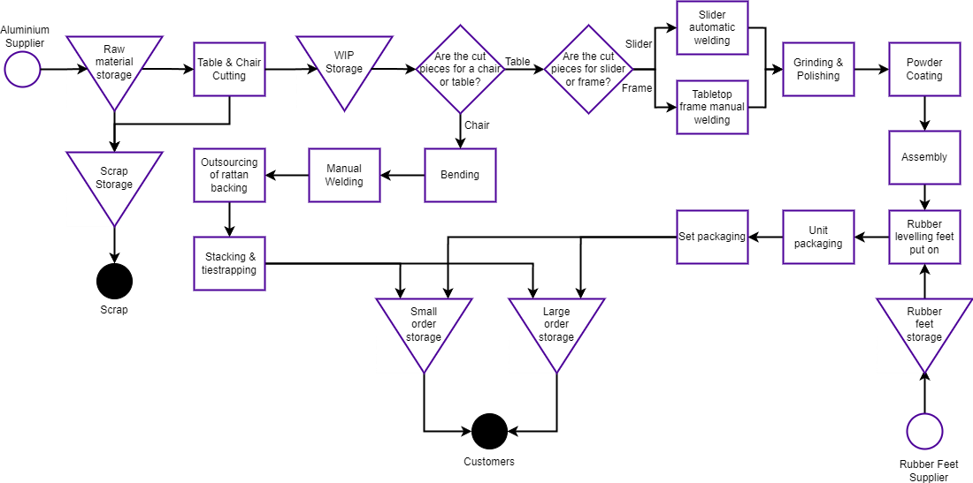
Figure 6.1: High-level Process Flow Chart

Assumptions & Constraints
    - All bars and tubes are assumed to be 6m in length before being cut
    - A unit is one set, including 1 tabletop, four legs and four chairs
    - Small orders are 20% of total orders
    - 20 working days per month
    - Productivity is 7.5hrs daily
    - Setup time and breakdowns take up 0.5hrs daily
    - 5% scrap rate from aluminium delivered by supplier

Table 6.1: Raw Material Item, Dimensions and Use

Item & Dimensions | Image | Use
Rectangular Tubes (40mmx20mmx1,2mm) | 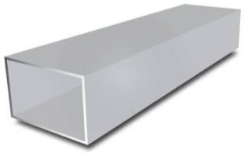  Figure 6.2: Rectangular Tube | Frame for tabletop Sliding structure
Flat Bars (101,6mmx9,52mm) | 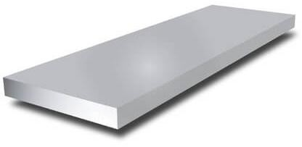  Figure 6.3: Flat Bar | Tabletop

Square Tubes (60mmx60mm) | 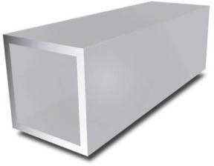  Figure 6.4: Square Tube | Table legs
Round Tubes (25,4mmx1,6mm) | 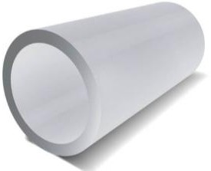  Figure 6.5: Round Tube | Chairs
Rubber Levelling Feet | 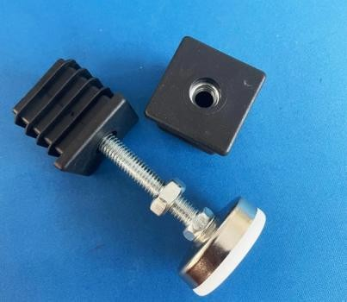  Figure 6.6: Levelling Feet | Levelling Tables

The product dimensions can be seen in table 6.2 below. The length and number of slats used for the second tabletop is calculated by working out the length difference between the large and small configuration of tables and then using that ratio to determine the amount of slats (flat bars) needed. Product images can be seen in figures 6.7 – 6.10.

Table 6.2: Product Description

Item | Dimensions (l*w*h)
Tabletop 1 | 1.52m*1m*0.04m 15 flat bars
Tabletop 2 | 0.96m*1m*0.04m 10 flatbars
Slider insert | 0.94m*1m*0.04m
Legs | 0.06m*0.06m*0.7m
Chair | 0.55m*0.59m*0.76m

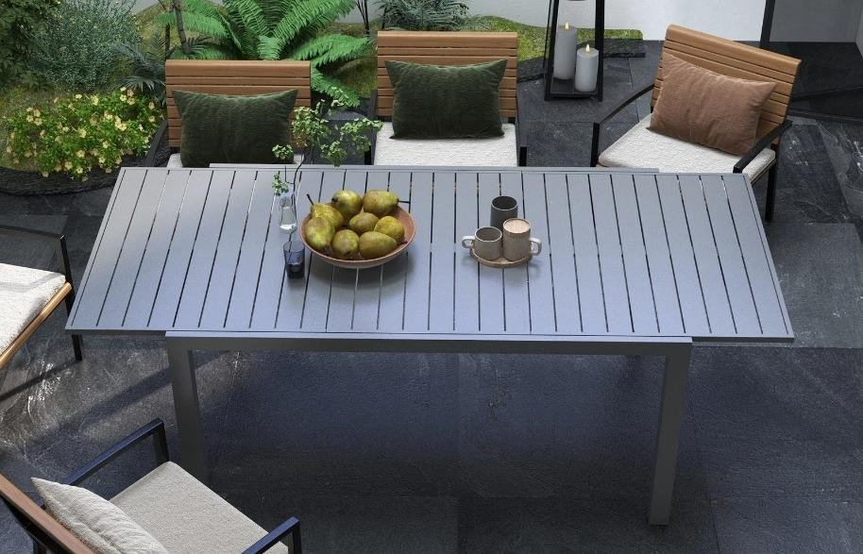
Figure 6.7: Finished Expanded Table

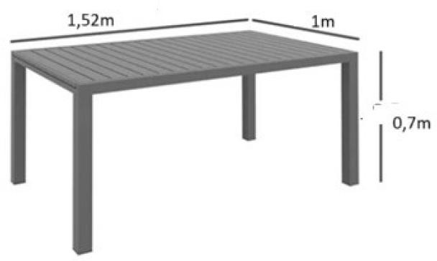 | 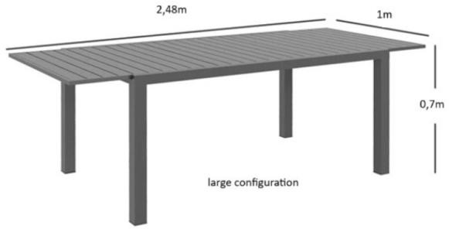
Figure 6.8: Small Configuration | Figure 6.9: Large Configuration

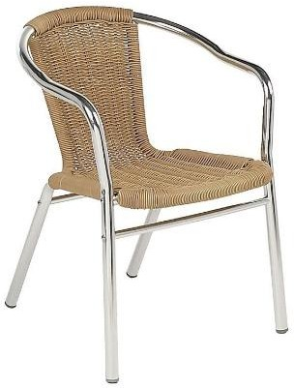
Figure 6.10: Chair

Detail Design Specifications

Production Volumes
The daily production volumes are calculated by taking the monthly demand (5000 units) and dividing it by 12 months and then dividing that value with 20 working days per month. This results in a total of 250 units that have to be produced daily. This is a total of 250 sliders, 500 tabletops, 1000 legs and 1000 chairs.
The amount of machines needed per type is calculated by multiplying the number of units per process by the processing time per item and dividing by the minutes per day (450mins). A summary of the amount of machines needed for each process can be seen in table 7.1 below.

Table 7.1: Machines Calculations

Machine | Units | Processing Time (mins) | Productivity per day (mins) | Machines Needed
Cutting | 250x tables 1000x chairs | 1 | 450 | 3
Bending | 1000 chairs | 3 | 450 | 7
Automated Welding | 250 slider insert | 5 | 450 | 3
Manual Welding | 500 tabletops  1000 chairs | 10 (tabletop)  5 (chair) | 450 | 24
Grinder | 500 tabletops | 0.5 | 450 | 1
Polisher | 500 tabletops | 0.5 | 450 | 1
Powder Coater | 500 tabletops  250 slider inserts 1000 legs | 1.5  (30sec for 1st tabletop + 10sec for each 2nd  tabletop, slider insert, legs) | 450 | 1
Packaging | 50 sets | 5 | 450 | 1

Departments

Raw Material Storage
In order to determine how many 6m bars and tubes of each type have to ordered, the total length of each type for one unit is calculated first. This is done by adding the lengths of all cut pieces up per type of bar or tube and then dividing that by 6m (length of bar/tube). This final value is then rounded up to get the number of bars or tubes needed per type per unit. The final amounts are calculated by multiplying the unit amount by 250 (daily demand). A summary of these calculations can be seen in table 7.2 below.
Raw materials are delivered once daily. Four workers are employed by TIPTOP TABLES to pack the racks and check for defects. Forklifts are used to unload the delivery trucks, after which smaller batches are put in trolleys for easier distribution between the racks.

Table 7.2: Number of 6m bars and tubes needed for daily production

Item | Cut pieces per unit | Bars per unit | Bars per day (250 units) | 2-Weekly raw materials with scrap
Rectangular Bars | 3x1.52m  7x1m 3x0.96m  2x0.94m | 2.836 | 709 | 7464
Flat Bars | 25x1m | 4.168 | 1042 | 10969
Square Tubes | 4x0.7m | 0.5 | 125 | 1316
Round Tubes | 4x6m | 4 | 1000 | 10527
Totals | - | 11.504 | 2876 | 30276
Cantilever racking is used to store the 6m tubes and bars. The racks have a height of 2m, arm length of 0.8m and peg height of 0.3m. It is assumed that each rack has a height of 0.6m and length of 6m. The type of rack that will be used can be seen in figure 7.1 below. The calculations for the number of racks needed can also be seen below in table 7.3. Five of these racks are allocated to the defective tubes and bars received. The workstation layout of one of these racks is depicted below in figure 7.2.
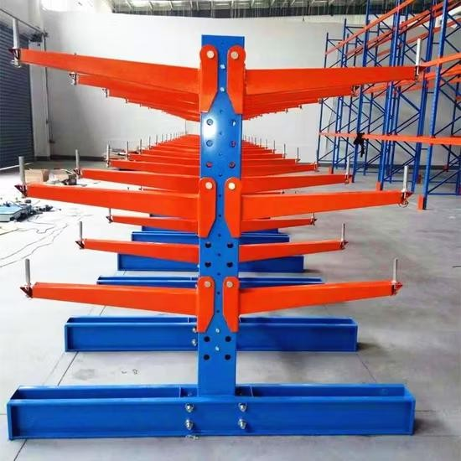
Figure 7.1: Cantilever Rack

Table 7.3: Cantilever Rack Calculations

Item | Bars or  Tubes received | Bars/Tubes in a layer | Layers per rack | Racks
Calculation | - | 𝑅𝑎𝑐𝑘 𝑤𝑖𝑑𝑡ℎ  𝑏𝑎𝑟/𝑡𝑢𝑏𝑒 𝑤𝑖𝑑𝑡ℎ | 𝑅𝑎𝑐𝑘 ℎ𝑒𝑖𝑔ℎ𝑡  𝑏𝑎𝑟/𝑡𝑢𝑏𝑒 ℎ𝑒𝑖𝑔ℎ𝑡 | 𝑟𝑎𝑤 𝑚𝑎𝑡𝑒𝑟𝑖𝑎𝑙 + 5% 𝑠𝑐𝑟𝑎𝑝  6 ∗ 𝑙𝑎𝑦𝑒𝑟𝑠 ∗ 𝑖𝑡𝑒𝑚𝑠 𝑖𝑛 𝑙𝑎𝑦𝑒𝑟
Rectangular Bar | 7464 | 20 | 15 | 5
Flat Bar | 10969 | 7,874016 | 3,151261 | 74
Square Tube | 1316 | 13,33333 | 5 | 4
Round Tube | 10527 | 31,49606 | 11,81102 | 5
Total | 30276 | 72,70341 | 34,96228 | 88
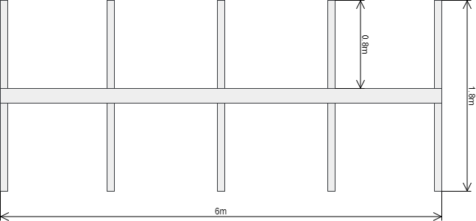
Figure 7.2: Workstation Layout Cantilever Rack

Work-in-Progress
Racks are used to store the bars after they have been cut after which they are then taken to the next work areas. These racks are placed after each workstation to accommodate work-in- progress (WIP) materials. An example of the type of racks used is depicted in figure 7.3 below.
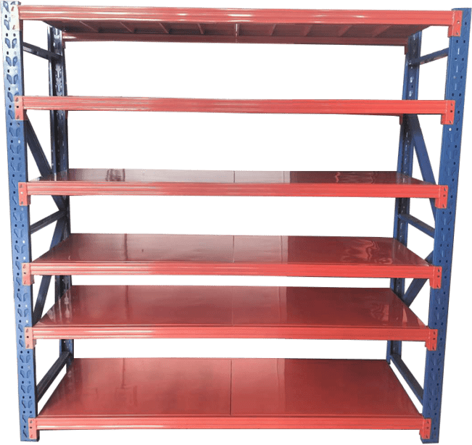

Figure 7.3: Storage Racks

These racks have the dimensions of 2mx0.6mx2m. By calculating the area needed for all the items, the number of racks needed can be found by dividing this area by the shelf space of one rack (area of one shelf multiplied by six shelves). Items are packed in two layers on each rack and thus effectively doubles the area a rack can take. From this it is calculated that a total of 35 racks is needed at each WIP area. 19 of these racks are for the tables and 16 for the chairs. The chair storage is only used at the cutting process and welding process. As pieces are used by the following station as soon as possible, only half of the racks are needed. The calculations can be seen in table 7.4 below.

Table 7.4: Work-in-Progress Space Calculations

Item | Area (m²) | Quantity | Area Needed (m²) | Rack Area | Racks Needed
Tabletop 1 | 1,52 | 250 | 380 | 48 | 8
Tabletop 2 | 0,96 | 250 | 240 | 48 | 5
Legs | 0,042 | 1000 | 42 | 48 | 1
Slider Insert | 0,94 | 250 | 235 | 48 | 5
Chair Cut Pieces | 0,1524 | 5000 | 762 | 48 | 16
Totals |  |  |  |  | 35

Cutting
Pieces are cut in bulk in order to reduce the number of cutoffs from each 6m bar or tube. The following table (table 7.5) indicates how many of which cuts are made as well as the number of bars needed daily when the 5% scrap rate is considered.

Table 7.5: Cutting Calculations

Type of bar/tube | Pieces cut from 6m | 6m bars/tubes needed | 6m bars/tubes with 5% scrap | Length utilised per 6m  tube/bar
Rectangular Bars | 3x1,52m + 1x1m | 250 | 263,1578947 | 5,56
 | 6x1m | 250 | 263,1578947 | 6
 | 6x0,94m | 84 | 88,42105263 | 5,64
 | 6x0,96m | 125 | 131,5789474 | 5,76
Flat Bars | 6x1m | 1042 | 1096,842105 | 6
Square Tubes | 8x0,7m | 125 | 131,5789474 | 5,6
Round Tubes | 1x6m | 1000 | 1052,631579 | 6
Totals | - | 2876 | 3027,368421 | -
From table 7.5 above it is calculated that 3 machines are needed to meet demand. The same machine is used for all bars and tubes and once one type is finished being cut, the next type’s dimensions are put in and cut. The machine is depicted in figure 7.4 and the workstation layout in figure 7.4 below. The specifications of the machine can be seen in table 7.6 below.

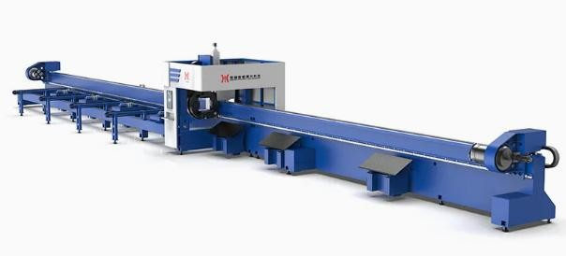
Figure 7.4: Cutting Machine

Table 7.6: Cutting Machine Specifications

Dimensions (l×w×h) | 8.55 × 1.3× 2 (m)
Operators per machine | 2
Machines Needed | 3
The total volume needed for cutoffs is 0.3162m³. The calculations for this is summarised in table 7.7 below. The cutoff length per bar is multiplied with the amount of bars or tubes of that type, the width and height of that type of bar or tube.

Table 7.7: Cutoff volume calculations

Pieces x length (in 6m) | 6m Bars/Tubes | Cutoff length | Cutoff pieces volume (m³)
3x1,52m + 1x1m | 250 | 0,44 | 0,088
6x1m | 250 | 0 | 0
6x0,94m | 84 | 0,36 | 0,024192
6x0,96m | 125 | 0,24 | 0,024
6x1m | 1042 | 0 | 0
8x0,7m | 125 | 0,4 | 0,18
1x6m | 1000 | 0 | 0
Total | - | - | 0,3162
One bin of volume 0.11m³ is placed at each cutting machine for the cutoffs. The bin is depicted in figure 7.5 below. The cutoffs in these bins are collected daily and taken away.
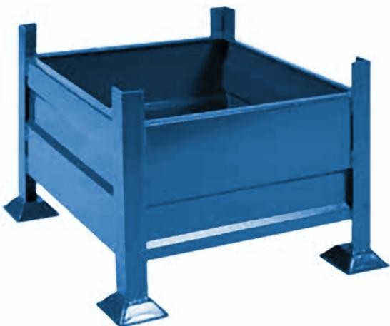
Figure 7.5: Cutoff bin

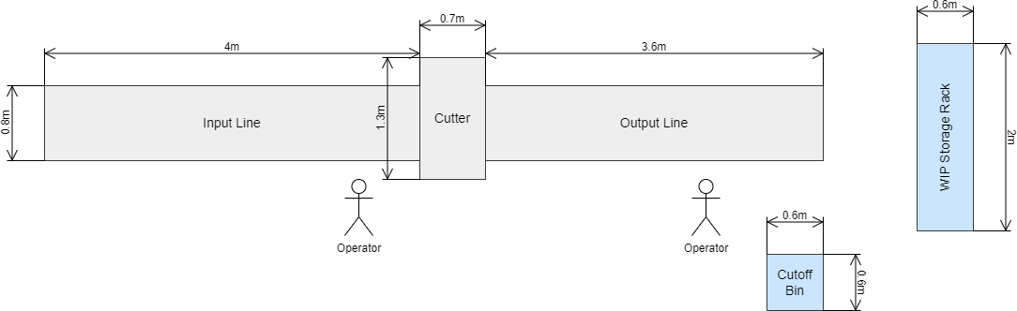
Figure 7.6: Cutting Workstation Layout

Bending
All cut round bar pieces are moved to the bending machines from the cutting area. From table
7.1 above it is calculated that 7 machines are needed. The bending machine is depicted in figure 7.7 and its workstation layout in figure 7.8 below. The specifications of the machine can be seen in table 7.8 below. There are no racks used at the WIP area of the bending as it is easier and more space efficient to stack the chairs in the allocated WIP area. Three stacks of chairs can be put next to each other and moved to the rattan backing area.
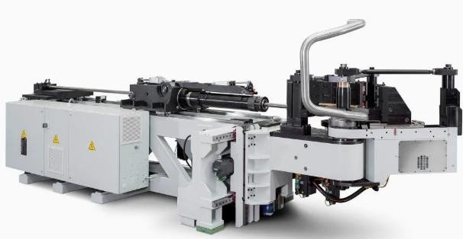
Figure 7.7: Bending Machine

Table 7.8: Bending Machine Specifications

Dimensions (l×w×h) | 2.6 × 0.6 × 1.2 (m)
Operators per machine | 1
Machines Needed | 7
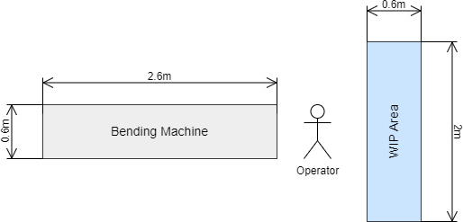
Figure 7.8: Bending Workstation Layout

Welding
After bending, the pieces are taken to the welding area. The rest of the cut pieces to be used for the tables are brought from the cutting area to the welding area. Automated welding machines are used to make the slider insert while manual welding machines are used to make the tabletops and chairs.
From table 7.1 above it is calculated that 3 automated welding machines and 24 manual welding machines are needed. These machines and their specifications are depicted in figures
7.9 & 7.10 and table 7.9 below.
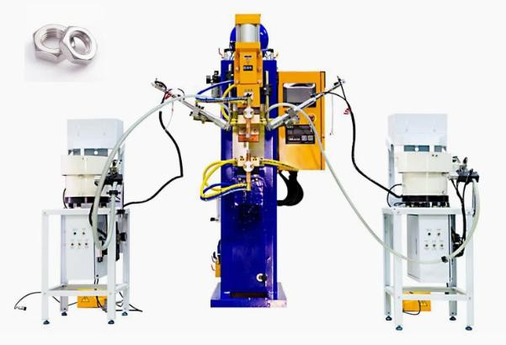
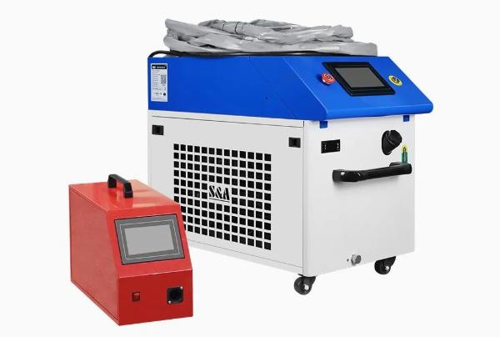
Figure 7.9: Automated Welding Machine Figure 7.10: Manual Welding Machine

Table 7.9: Welding Machines Specifications
 | Automated | Manual
Dimensions (l×w×h) | 1.7 × 0.8 × 1.6 (m) | 0.8 × 1.4 × 1.4 (m)
Operators per machine | 1 | 1
Machines Needed | 3 | 24
Both workstations also have additional tables at which the machines are used. These tables are big enough for one tabletop to be welded at a time. The workstation layouts are depicted in figures 7.11 and 7.12. A 1m safety space is added all around the workstation of the automated welding robots.

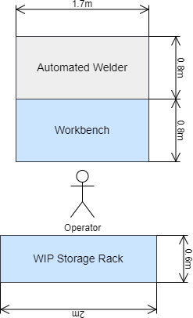 | 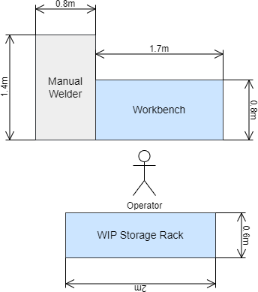
Figure 7.11: Automated Welding  Workstation Layout | Figure 7.12: Manual Welding Workstation  Layout

Grinding & Polishing
The table’s welded pieces are taken to the grinding & polishing area. The welded chairs are taken to the rattan backing storage area. Handheld grinders and polishers are used to grind excess welding away on the tables and to polish the pieces before they are ready for the powder coating.
From table 7.1 above it is calculated that 1 grinder and 1 polisher are needed. These machines and their specifications are depicted in figures 7.13 & 7.14 and table 7.10 below. The amount of grinder discs needed daily is also indicated. This was calculated by taking the average life span of a grinder disc (30min of continuous grinding) and dividing the productivity minutes (450min) by that. This results in 15 discs per grinder per day. The discs needed for the polisher is calculated in the same way. The average polisher disc lifetime is 40mins and this results in 12 disks needed per day per polisher. The polishers and grinders’ dimensions are small, but the workstation must be big enough to accommodate one tabletop at a time. The workstation layouts can also be seen below in figure 7.15.

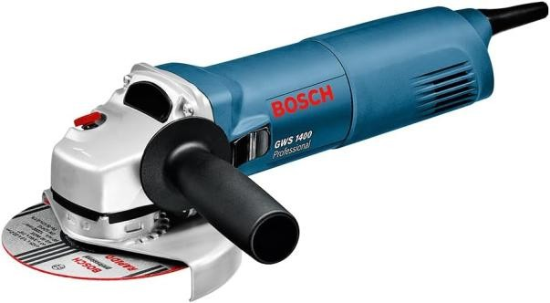  Figure 7.13: Handheld Grinder |   Figure 7.14: Handheld Polisher

Table 7.10: Grinding & Polishing Specifications
 | Grinder | Polisher
Operators per machine | 1 | 1
Machines Needed | 2 | 2
Discs Needed | 15 | 12
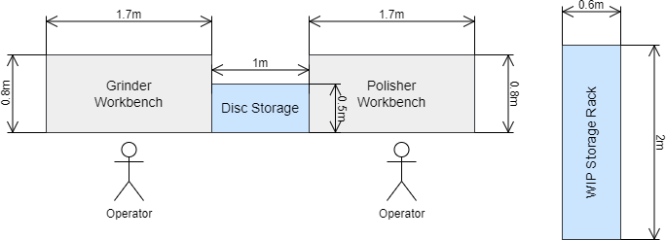
Figure 7.15: Grinding & Polishing Workstation Layout

Powder Coating
From the grinding and polishing areas, the table’s welded pieces are taken to the powder coating machine. Here all seven items used to make a table is sent through the powder coater with 10sec intervals in-between each item. It is thus assumed that it takes 1.5mins for all items to go through the powder coater. This consists of 30secs for the first item plus an additional 10secs for the next items. Only one powder coater is needed to meet demand.
The powder coating machine is depicted in figure 7.16 below. The specifications can be seen in table 7.11 below. The workstation layout is depicted in figure 7.17.
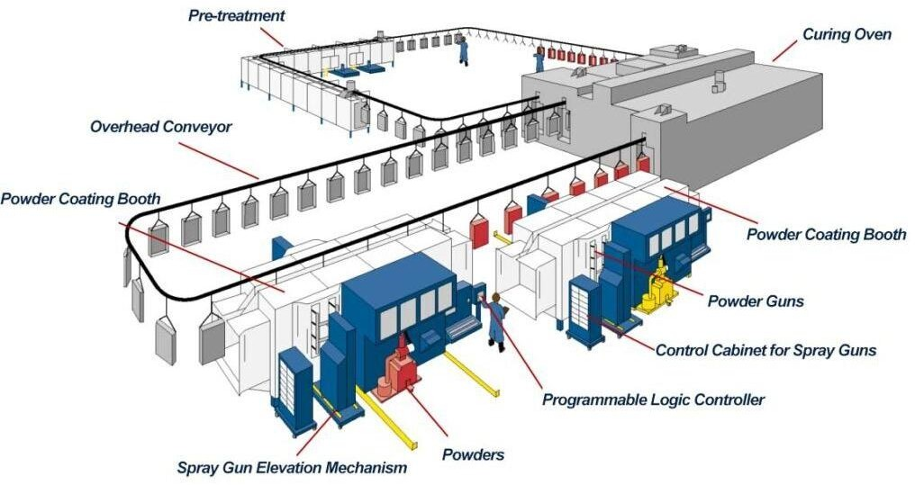
Figure 7.16: Powder Coating Machine

Table 7.11: Powder Coating Machine Specifications

Dimensions (l×w×h) | 30 × 18 × 3 (m)
Operators per machine | 6
Machines Needed | 1

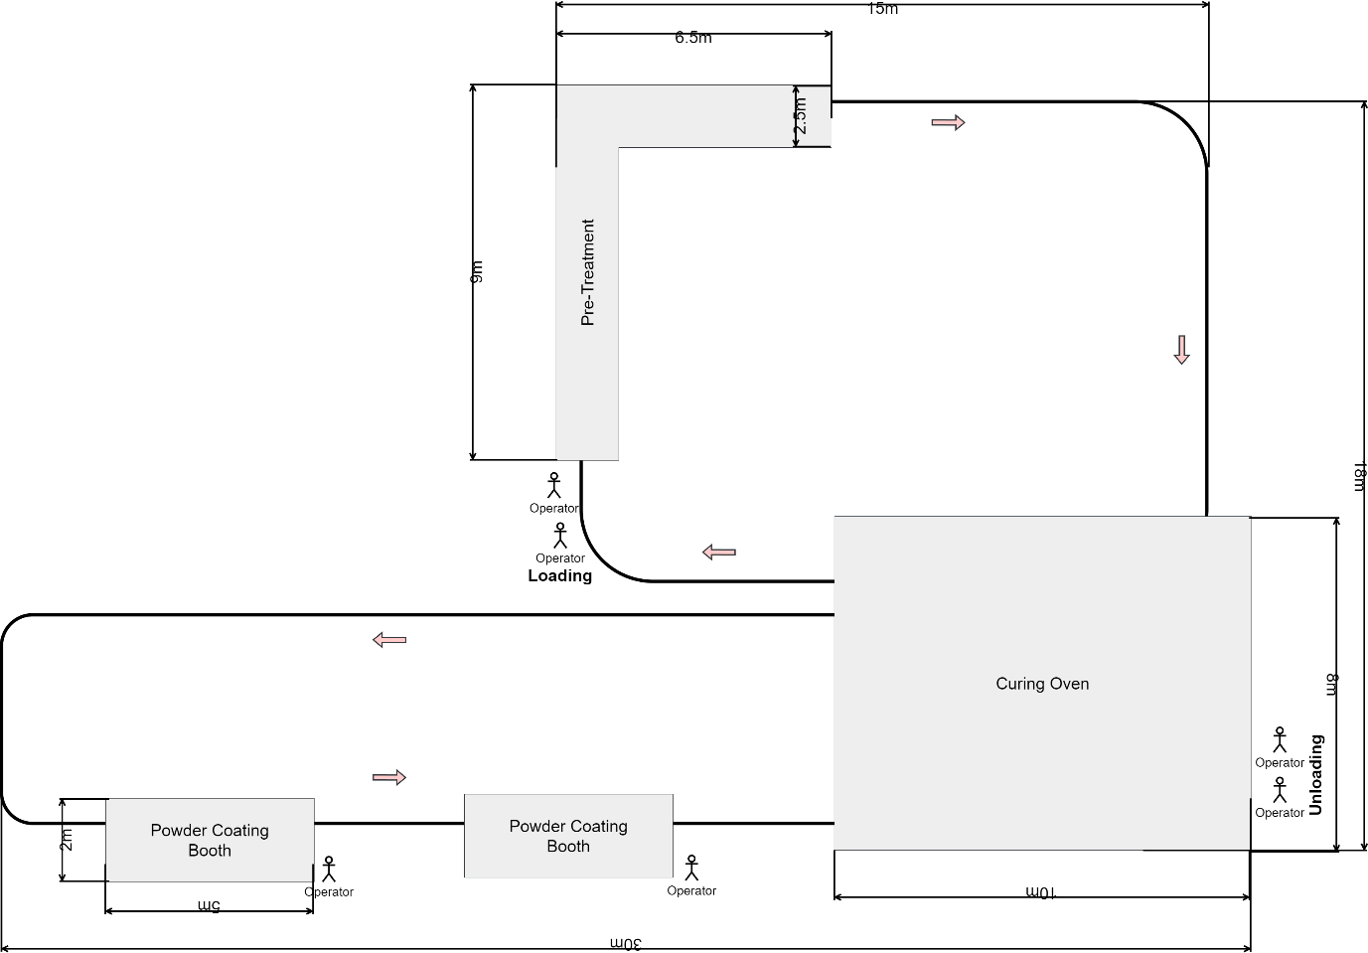
Figure 7.17: Powder Coating Workstation Layout

Assembly
No machinery is used with the assembly of the tables. Workbenches are however required for the tables to be assembled on. From table 7.1 above it can be seen that 3 workbenches are necessary to meet daily demand. An example of the type of workbench to be used can be seen in figure 7.18 below. The specifications are also shown below in table 7.12. WIP storage racks are placed between the powder coater and the workstations to account for bottlenecks that might occur as the powder coater is
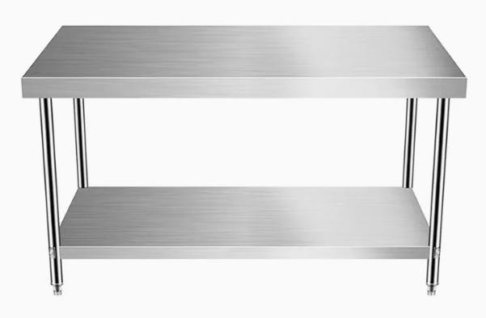
Figure 7.18: Assembly Workbench

Table 7.12: Assembly Workbench Specifications

Dimensions (l×w×h) | 1.7 × 0.8 × 0.7 (m)
Operators per workbench | 3
Workbenches Needed | 3
Rubber levelling feet are placed on the bottom of all the table legs. These feet fit snugly into the square tubing used for the legs. After adding the rubber feet and checking that the legs fit, the legs are removed. This is done to make the packaging process easier. From this area two workers pack five sets of tables on a trolley and move it to the packaging area. An example of the type of trolly used is seen below in Figure 7.19.
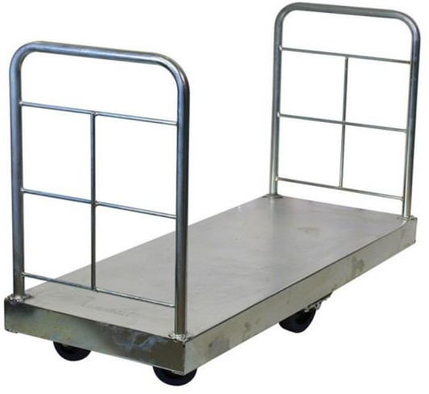
Figure 7.19: Trolley
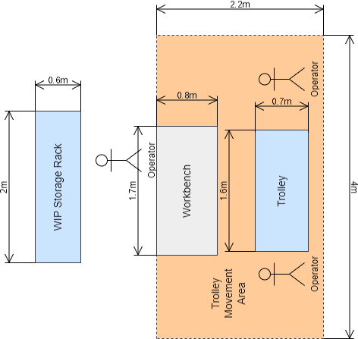
Figure 7.20: Assembly Workstation Layout

Rattan Backing Chair Storage
Enough storage space has to be allotted for one day’s chairs with backing and without backing (2000 chairs). Chairs without rattan backing are swopped with chairs with backing everyday by the outsourced people. The chairs are placed on dollies with wheels to ease their movement, since 20 chairs are stacked on top of one another. This means that 100 dollies are needed to accommodate both backed and unbacked chairs. One stack of 20 chairs takes up a floor area of 0.48m² (0.8m x 0.6m). Multiplying this by 100 dollies, it can be seen that rounded up, 50m² are needed for the storage area. Two employees receive and move the finished and unfinished stacks to and from the trucks. Another two move the finished chairs to the finished goods storage area.
The dolly with wheel being used is depicted in figure 7.21 below. The height of the dolly is 0.2m. Using this, the height of one chair (0.76m) and the added height of each additionally stacked chair (0.1m), it can be calculated that the height of a stack of 20 chairs plus the dolly is 2.86m. The finished chairs are tie strapped when received back, ready for delivery.
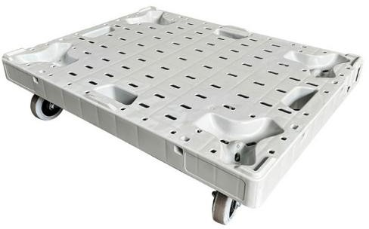
Figure 7.21: Dolly with wheels

Packaging
The de-assembled tables and chairs are taken to the packaging area. A plastic wrap dispenser is used to package a table and legs together after which 5 sets of tables and legs are then placed in a carton box with dimensions 1.55m x 3.25m x 1m. Unfolded boxes (50) boxes are stacked and stores next to the machine for each day 10 pallets are also stored here to stack 5 boxes on each. Two workers stack these boxes on a forklift and forklifts are used to move it from here to the finished goods area. From table 7.1 above it is calculated that 1 machine is needed. The machine and its specifications are depicted below in figure 7.22 and the workstation layout in figure 7.23 and table 7.13.
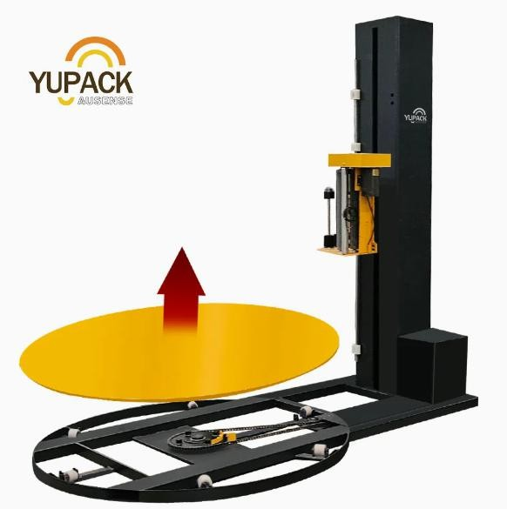
Figure 7.22: Plastic Wrap Dispenser

Table 7.13: Plastic Wrap Dispenser Specifications

Dimensions (l×w×h) | 1.2 × 1.8 × 2.2 (m)
Operators per machine | 4
Machines Needed | 3
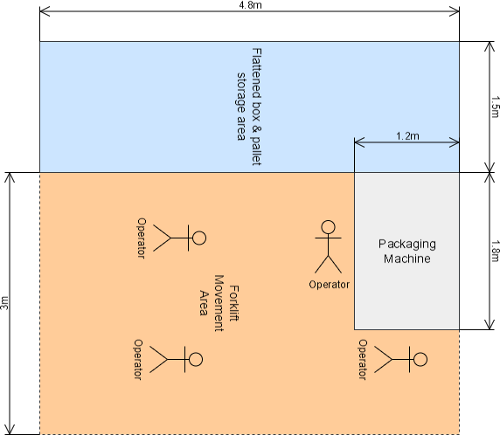
Figure 7.23: Packaging Workstation Layout

Finished Goods Storage
The dimensions of a box with 5 sets of tables are 1.55m x 3.25m x 1m. As there are 5 sets of tables in a box, the total amount of boxes stored for one month is 1000. Two forklifts will be used to move these boxes to the finished goods storage area. Another two will be used to assist on the loading docks. The boxes are stacked 5 on top of one each other. This results in 200 stacks with a floor space of 5.1m² each. Chairs are moved on their dollies by two workers from the rattan backing area to the finished goods storage. 20 000 chairs are stored in this area in a 1000 stacks of 20 chairs each with a floor area of 0.48m² each.
It is assumed that small orders make up 10% of total orders. These orders are removed from the carton boxes and tie strapped stacks as customers come to collect them. Two workers are employed to manage the finished goods storage and dispatching of the items. The final quality inspection is also done at these areas.

Supporting Facilities
Supporting facilities inside the facility include offices, reception, bathrooms, cafeteria and breakroom and locker rooms. Outside of the facility, parking and security gates and checks are considered. The following areas and dimensions as can be seen in table 7.14 below are allocated to these supporting facilities. All of these areas are based on various different national and international standards like SANS 10400.

Table 7.14: Supporting Facilities

Facility | Quantity | Area per item (m²)
Executive Office | 1 | 12–20
Private Office | 2 | 8–12
Open-plan office | 1 | 4-5 per person
Reception | 1 | 8–15
Meeting Room | 1 | 15–25
File storage | 1 | 4–10
Office Bathrooms | 2 | 6–8
Operator Bathroom & Locker Room | 1 | 70-90
Cafeteria | 1 | 95-105
Parking | 100 | 12.5
Security Checks | 3 | 9

Distribution of large orders
To determine the needs in terms of trucks, the total floorspace that the tables and chairs take up (calculated above) is divided by the available floor space in a standard 12m high cube truck. A truck of this side has a useable floorspace of 28 m². Dividing this by the 0.48m² one stack of chairs take up, it is found that one truck can take 58 stacks of chairs. It is decided to only transport 40 stacks in a truck and thus two trucks are needed daily for distribution purposes. For the outsourcing of the rattan backing another two trucks are needed as 1000 chairs are taken to the rattan backers and another 1000 is brought back in the same truck.
For the tables, the floorspace needed is 5m² per box. When packing the boxes in two layers, it is calculated that 10 boxes can be shipped per truck. Four trucks are thus needed to meet the daily 80% large order demand.

Design Alternatives
The following Activity Relationship Chart in figure 8.1 below is setup by using the specifications and limitations by management as well as observing the current manufacturing process.
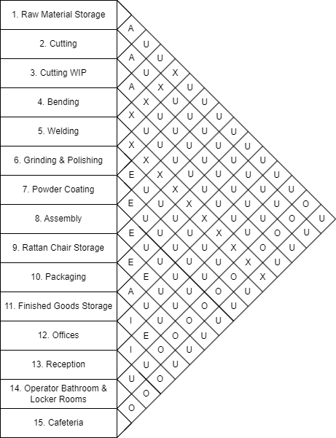
Figure 8.1: Activity Relationship Chart

The following minimum areas are allotted for the different processes and supporting facilities in the block layouts and Master Facility Plan (MFP). A summary of these areas (rounded up) can be seen in table 8.1. These dimensions include aisle space and safety space considerations around machinery and storage areas. The area of one machine is calculated by taking the size of the machine and adding 1.5m walking space around it for operators and 3m where forklifts are used. The total area is calculated multiplying the area of one machine (including aisles and working space) with the number of machines or stations needed. An expansion space of 20% is added to the below areas in the MFP and block layouts can be seen in the last column of the table.

Table 8.1: Department Dimensions

Department | Area of one machine (m²) | Machines | Total Area (m²) | Expanded Area (m²)
Raw Material Storage | 21,87613636 | 88 | 1925,1 | 2310,12
Cutting | 60,75 | 3 | 182,25 | 218,7
Bending | 13,6125 | 7 | 95,2875 | 114,345
Manual Welding | 14 | 24 | 336 | 403,2
Automated Welding | 20.8 | 3 | 62.4 | 74,88
Grinding & Polishing | 32 | 2 | 64 | 76,8
Powder Coating | 693 | 1 | 693 | 831,6
Assembly | 16,8625 | 3 | 50,5875 | 60,705
Rattan Backing | 0,48 | 100 | 75 | 90
Loading Area for Rattan Chairs | 24 | 1 | 24 | 28,8
Packaging | 27,4725 | 3 | 82,4175 | 98,901
Finished Tables | 11,27 | 200 | 2254 | 2704,8
Finished Chairs | 1,056 | 1000 | 1056 | 1267,2
Forklifts | 30,8 | 1 | 30.8 | 36,96
Offices | 62 | 1 | 62 | 74,4
Office Bathrooms | 16 | 2 | 32 | 38,4
Operator Bathroom & Locker Room | 96 | 1 | 96 | 115,2
Cafeteria | 206 | 1 | 206 | 247,2
Parking | 12,5 | 100 | 1250 | 1500
Totals | - | - | 8577 | 10 293

Alternative 1
For this alternative, the focus was to keep to the areas and dimensions discussed above in table 8.1. Only a few of the departments’ dimensions were adjusted to allow for a more U- shaped design of the building. The flow starts at the raw material loading bays and storage. From there it moves to the various departments as manufacturing process goes until it reaches the finished goods areas. The supporting facilities are placed towards the middle of the facility to allow for easy access.
One of the main issues with this design is the use of corridors for the movement of chairs from the bending department to the rattan backing storage area, where it is then transported through another corridor to reach the loading bay. It is also difficult to reach the finished table storage area from reception. When people come to pick up their small orders they will have to drive from reception to the storage area to collect the items. An employee from reception will have to either drive with them or walk to that area. This design takes up 14 415m² without expansion and with 20% expansion 17 298m².

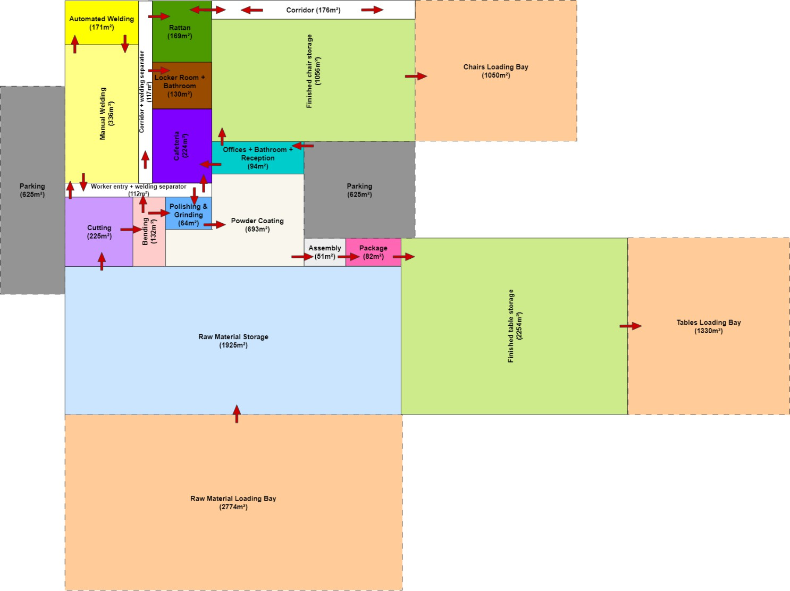
Figure 8.2: Alternative Block Layout 1

Alternative 2
This design is a bit more compact than alternative 1 in the sense that there is less unused space outside. On the inside however, most of the departments’ size is increased a bit to accommodate for better flow. Especially at the bending department where welded materials for the tables are moved through the are to the polishing & grinding area. The finished goods areas are also put together here, making it easier for both small and large order dispatching, The reception area can also directly go into the finished goods storage area. The rattan backing storage area also has its own loading bay, contrasting alternative 1. Workers also have easier access from the parking area to the locker room and offices.
The shape of the building itself is a bit less modular than alternative 1, but better than that of alternative 3. It would still allow for relatively easy construction. One of the small disadvantages of this layout is that a corridor is used again to move chairs from the rattan backing area to the finished goods storage. This corridor is shorter than the one in alternative 1 and is only used for half the amount of chairs (finished chairs). This design takes up 15 224m² without expansion and with 20% expansion 18 293m².
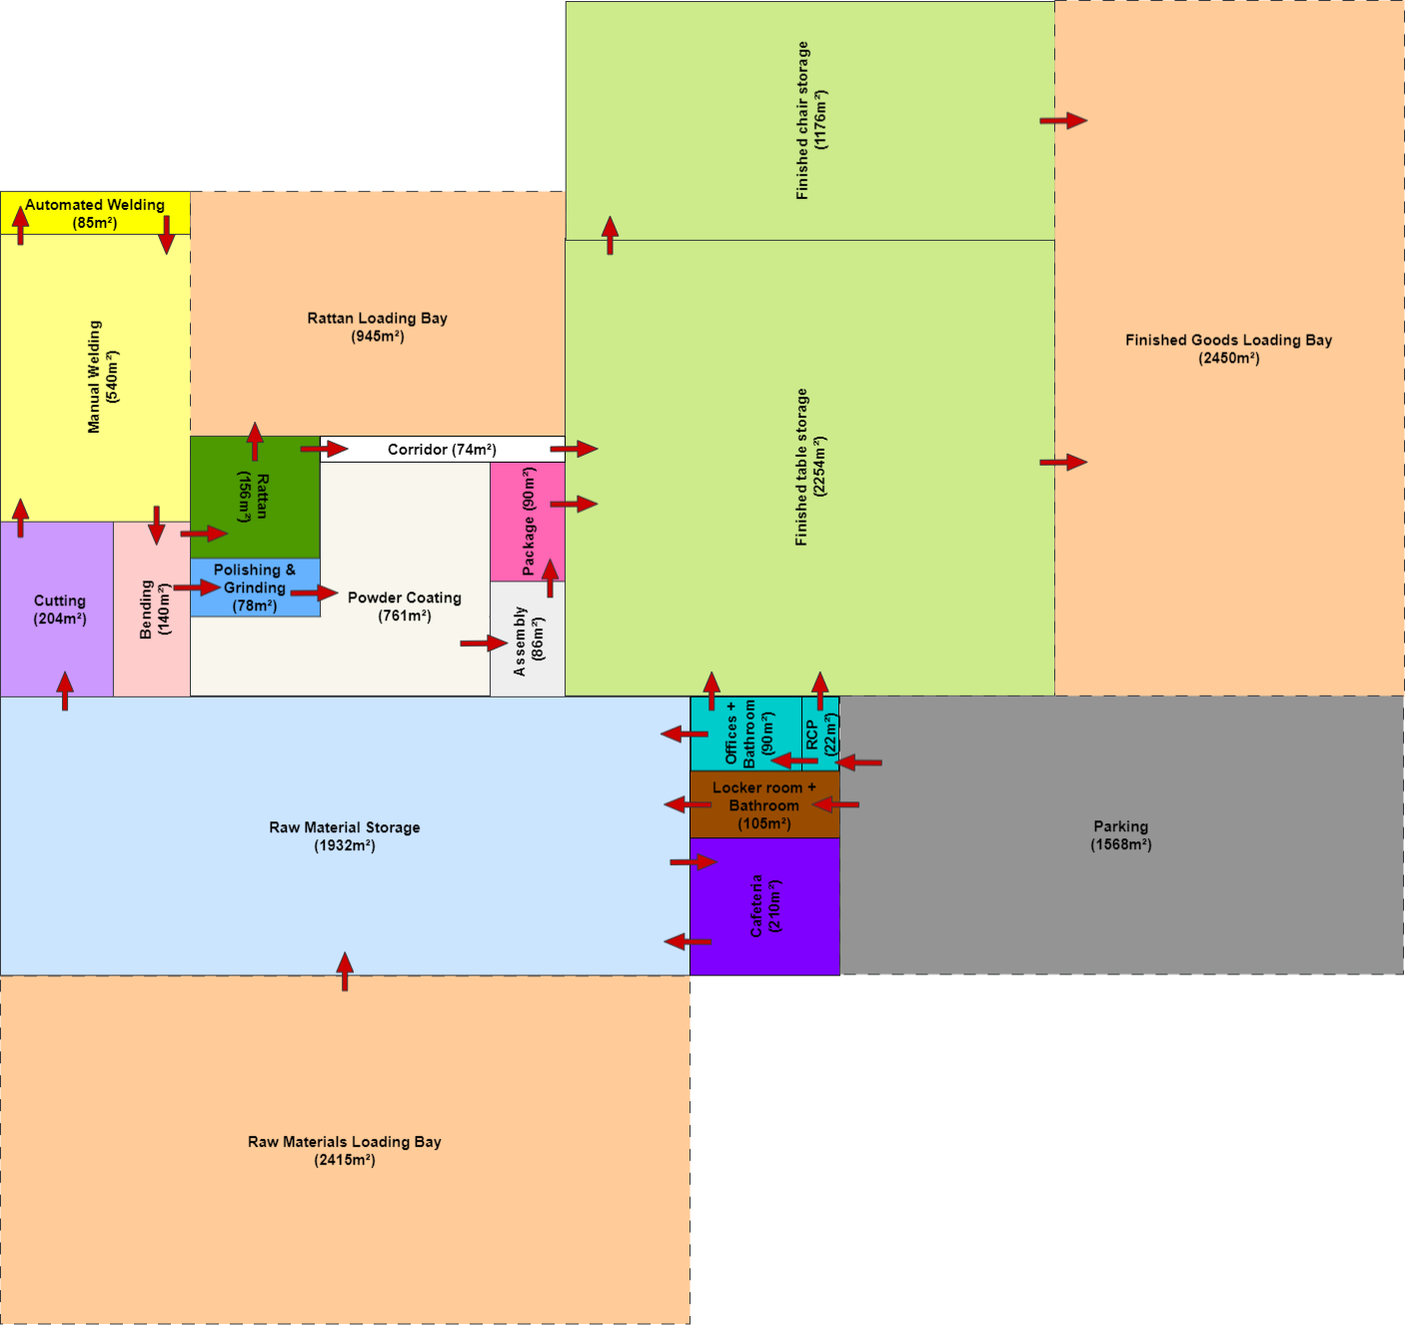
Figure 8.3: Alternative Block Layout 2

Alternative 3
This layout has by far the most complex shape. This was done in order to try and split the operations between chair and table as far as possible and by putting the common departments in the middle of the design. The flow of this design is a bit simpler due to this design choice, but the odd shape outweighs the small improvement the flow has compared to other alternatives above.
Similarly to alternative 1, in this design there is no direct path for employees in reception (who manages the small orders) to get to the finished chair storage area. Another issue is that the rattan backed and unbacked chairs have to move through the finished goods storage to be loaded and unloaded from trucks. The welding area is also in the middle of the layout, which although it is shut off with walls from the rest of the areas, is not ideal. This design takes up 15 829m² without expansion and with 20% expansion 18 995m².
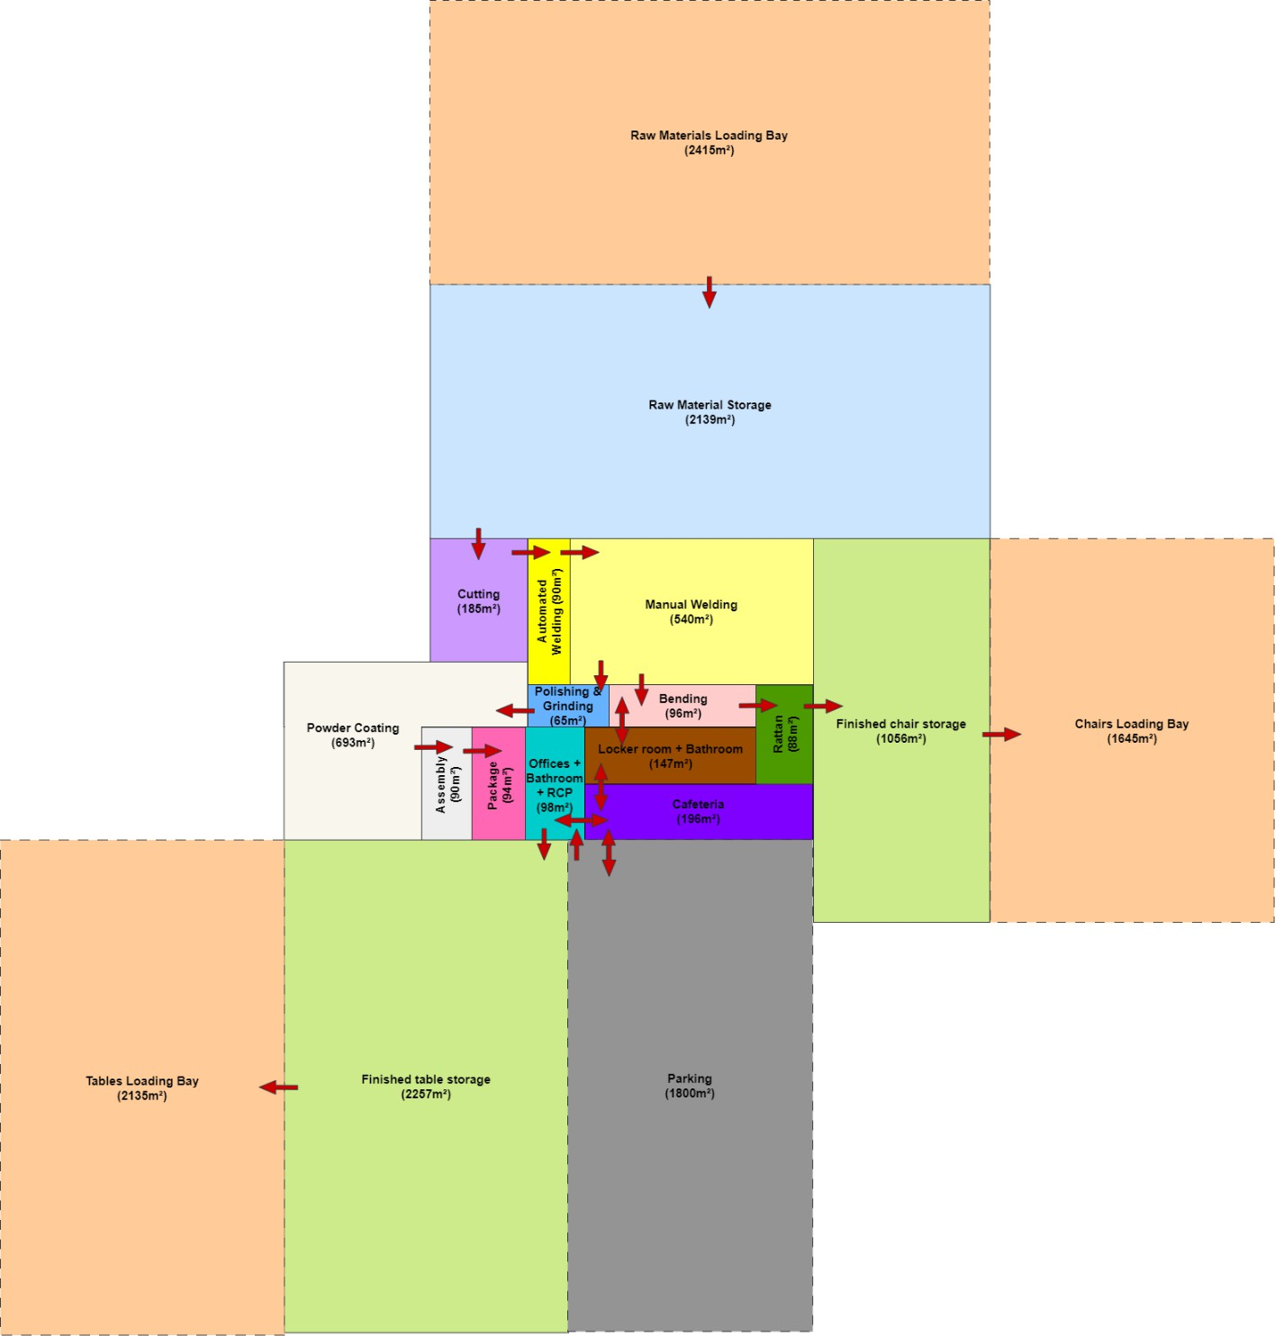
Figure 8.4: Alternative Block Layout 3

Alternative Evaluation
A weighted decision matrix is set up in table 8.2 below to score and evaluate the different alternatives explained and shown above. The matrix is setup with the design requirements as criteria. Each alternative is then scored out of ten based on the criteria. This score is then multiplied by the weights. The weights add up to one. The alternative design with the highest score is selected to base the MFP on.

Table 8.2: Alternative Evaluation

 |  | Alternative 1 |  | Alternative 2 |  | Alternative 2
Criteria | Weight | Score | Weighted Score | Score | Weighted Score | Score | Weighted Score
Meet monthly demand of  5000 units | 0,15 | 10 | 1,5 | 10 | 1,5 | 10 | 1,5
20% expansion space | 0,15 | 10 | 1,5 | 10 | 1,5 | 10 | 1,5
Isolated areas for welding | 0,15 | 9 | 1,35 | 8 | 1,2 | 6 | 0,9
Should conform to activity relationship  chart | 0,1 | 9 | 0,9 | 8 | 0,8 | 6 | 0,6
Optimise facility layout | 0,05 | 6 | 0,3 | 7 | 0,35 | 8 | 0,4
Sufficient  external interface | 0,1 | 8 | 0,8 | 10 | 1 | 8 | 0,8
Logical flow of material | 0,1 | 6 | 0,6 | 8 | 0,8 | 8 | 0,8
Access to roads | 0,1 | 7 | 0,7 | 8 | 0,8 | 9 | 0,9
Ease of  implementation or construction | 0,1 | 9 | 0,9 | 8 | 0,8 | 7 | 0,7
Totals | 1 | 74 | 8,55 | 77 | 8,75 | 72 | 8,1
From the evaluation above it is evident that alternative layout 2 has the highest score (77/100) and is the best one to utilise as base for the MFP. Some small changes might be made to the layout based on the evaluation and discussions above and will be discussed in the next section.

Final Design
Although the basic layout of alternative 2 was used for the design, many adjustments and necessary additions were made. In terms of the general layout was the finished chair storage and finished table storage combines. Similarly, the offices & reception and manual & automated welding were also combined to allow for better flow. The powder coating area was also increased in size to allow for better ventilation around the machine. The parking area was reduced in size to allow for better flow of traffic.
Some additions that were made were that more space was allocated to WIP racks and loading docks were added to the loading bays to make it easier for trucks to park and items to be loaded. Forklift parkings were also added at raw material storage and finished goods storage. The parking in the finished goods areas are to be used by both packaging and finished goods and distribution. Motor gates and security check points were also added to the internal roads before trucks and commercial vehicles enter the grounds, which are surrounded with a fence. An outdoor area next to the cafeteria was added to increase the amount of people that can take a break at once. This is especially beneficial when 20% increase in personnel is also considered.
Clear roofing panels made from polycarbonate sheets are installed on the roof in strategic places. This is done as there is little to no windows in the facility, due a focus on security and theft prevention as well as cost savings on construction and maintenance. Small orders are collected at the same warehouse as large orders, but at the overhead door closest to reception. In this way employees handling the deliveries can easily move between these two areas.
Another important note is that at the intersection next to the parking area, trucks and small order collection vehicles will have right of way and other vehicles must yield when approaching the intersection. This should however not be a major issue as very few people will enter and exit the grounds during operating hours when the trucks come.
The facility (excluding roads & undeveloped areas) has a total area of 20 444m². The building itself has an area of 13 036m² and a height 7m, resulting in a building volume of 91 252m³. The total facility surrounded by a fence has an area of 43 462m². The roads (excluding parking) takes up an additional 8638m², resulting in a total developed area of 29 082m². The MFP can be seen in figure 9.1 on the next page.

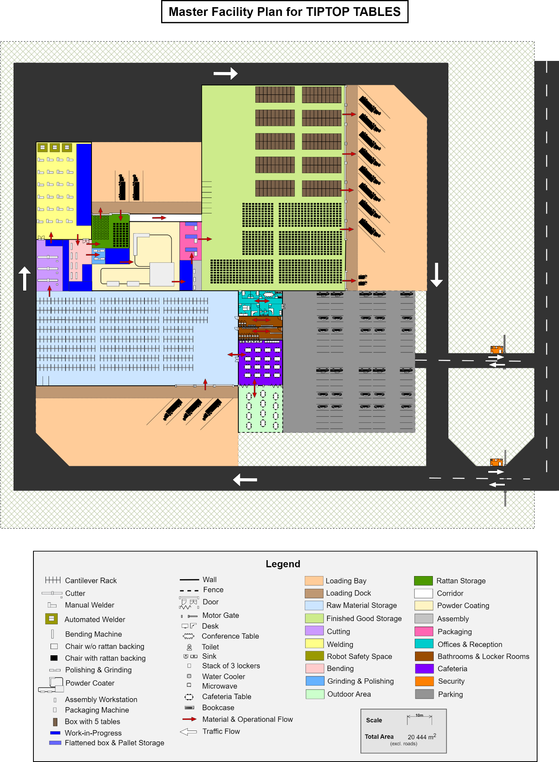
Figure 9.1: Master Facility Plan

Business Case

Capital Cost Estimates
The total capital cost estimates (including the equipment costs calculated above) is calculated and can be seen in table 10.2 below. A breakdown of the equipment costs can be seen in table 10.1 below. Operational and procurement costs are not taken into account as it does not form part of the facility costs.

Table 10.1: Equipment Costs

Equipment | Rate (R/equipment) | No. of equipment | Cost (R)
Cantilever Racks | 15 000 | 88 | R1 320 000
WIP Storage Racks | 4 000 | 175 | R700 000
Cutting Machine | 250 000 | 3 | R750 000
Cutoff Bins | 4 000 | 3 | R12 000
Bending Machine | 60 000 | 7 | R420 000
Manual Welder | 45 000 | 24 | R1 080 000
Automated Welder | 200 000 | 3 | R600 000
Grinder | 600 | 2 | R1 200
Polisher | 350 | 2 | R700
Powder Coater | 1 200 000 | 1 | R1 200 000
Workbenches | 2 000 | 3 | R6 000
Trolley | 4 000 | 3 | R12 000
Electric Forklifts | 400 000 | 8 | R3 200 000
Dolly with Wheels | 1 500 | 850 | R1 275 000
Packaging Machine | 40 000 | 3 | R120 000
Total |  |  | R10 696 900

Table 10.2: Capital Cost Estimates

Component | Rate (R/ m²) | Total m² | Cost (R)
Building | 7 000 | 13 036 | R91 252 000
Offices | 10 000 | 112 | R1 120 000
Cafeteria | 10 000 | 210 | R2 100 000
Parking & Roads | 1000 | 10 206 | R10 206 000
Restrooms | 7 500 | 105 | R787 500
Electrical | 1 500 | 13 500 | R20 250 000
Lighting | 1000 | 13 500 | R13 500 000
Ventilation | 1 000 | 13 036 | R13 036 000
Fire Safety | 300 | 13 500 | R4 050 000
Equipment |  |  | R10 696 900
Total Cost |  |  | R166 998 400

Risks and Mitigations
Table 10.3 below outlines the potential risks identified for the project along with their impacts and proposed mitigation strategies.

Table 10.3: Risks & Mitigation Strategies

Risk | Impact | Mitigation Strategy
Construction delays – Late site preparation or permitting | Project timeline slip; increased labour/equipment costs | Early engagement with local authorities for fast- track permitting; Include 10% time contingency in  schedule
Cost overruns – Material price volatility (aluminium) | Budget exceedance; reduced profit margins | Lock-in key material prices via forward contracts; Maintain 10% budget  contingency reserve
Equipment selection risk – Delivery or selection times longer than planned | Delayed commissioning; lost production days | Pre-qualify multiple suppliers; negotiate penalty clauses for late delivery and include  delivery buffers
Labour shortages or delays in hiring skilled  workers | Production can’t start; lost production days and profit | Start recruitment and training early

Schedule
A high-level depiction of the project schedule can be seen below in figure 10.1.
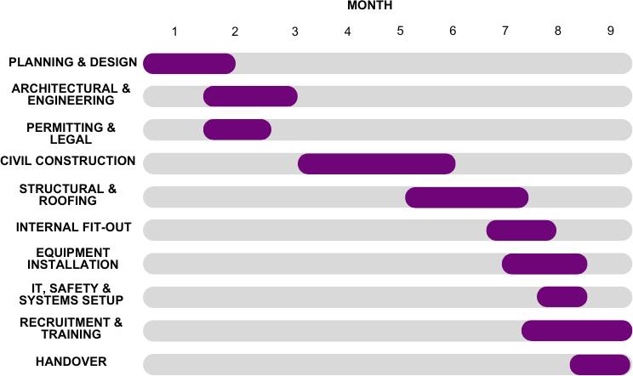

Figure 10.1: Schedule

