FACILITIES DESIGN REPORT
DigMore Folding Mini Shovel Facility
INGB417 Facilities Design GA3 (2026)

Student Name: [Placeholder]
Student Number: [Placeholder]
Date: 11 June 2026

Academic Integrity and AI Declaration
I hereby declare that this report is my own original work. Where external sources, literature, or artificial intelligence tools have been consulted, they have been properly acknowledged and referenced in accordance with academic integrity guidelines. The facility design, calculations, and engineering logic presented herein are derived from rigorous industrial engineering principles.

Executive Summary
This report details the comprehensive facility design for the DigMore folding mini shovel production plant. Through rigorous industrial engineering analysis, the facility has been structured to meet a defined takt time of 3.0 minutes per unit. The macro layout follows a systematic flow from receiving to dispatch, optimising material handling through the strategic placement of 10 distinct workstations. Capacity planning identified Station 4 (Grinding & Sharpening) as the system bottleneck with a cycle time of 4.8 minutes per unit. To mitigate this constraint, 8 parallel machines have been deployed, achieving 97% utilisation while maintaining throughput. Material handling systems, including selective pallet racking and electric pallet jacks, have been specified to minimise non-value-added transport. The final design integrates ergonomic workstation layouts, robust capacity alignment, and lean manufacturing principles to deliver an efficient, scalable, and safe production environment.

List of Abbreviations
- BOM: Bill of Materials
- CT: Cycle Time
- FGS: Finished Goods Store
- FIFO: First In, First Out
- GRN: Goods Received Note
- MFP: Master Facility Plan
- QC: Quality Control
- SPR: Selective Pallet Rack
- TT: Takt Time
- WIP: Work In Progress
- WS: Workstation

Table of Contents

1. Introduction and Background
The DigMore folding mini shovel is a compact, durable, and highly versatile tool designed for outdoor enthusiasts, military applications, and emergency preparedness. As market demand for portable, high-strength tools increases, establishing an efficient, dedicated manufacturing facility becomes imperative. This report outlines the industrial engineering approach taken to design a world-class production facility for the DigMore shovel.
Facility layout design is the process of planning the optimal arrangement of physical facilities to increase resource utilisation in production activities. A well-optimised layout reduces wasted movement, streamlines workflows, lowers operating costs, and supports business growth. The design presented in this document follows Systematic Layout Planning (SLP) principles, ensuring that material flow, personnel movement, and equipment placement are logically structured to eliminate bottlenecks and maximise throughput.

2. Problem Statement, Aim and Objectives

2.1 Problem Statement
The primary challenge is to design a greenfield manufacturing facility for the DigMore folding mini shovel that seamlessly integrates raw material processing, component fabrication, assembly, and dispatch. The facility must accommodate complex metal stamping, grinding, and assembly processes while managing a known bottleneck at the sharpening station. Inefficient layouts lead to excessive material handling, high WIP inventory, and unmet production targets. Therefore, a systematic design is required to ensure continuous flow and high resource utilisation.

2.2 Aim
To develop a comprehensive Master Facility Plan (MFP) for the DigMore shovel that optimises space utilisation, minimises material handling costs, and achieves the required production capacity safely and efficiently.

2.3 Objectives
- Establish a clear Design Basis aligned with production demand and takt time.
- Define the product structure (BOM) and process routing for all components.
- Calculate precise machine, labour, and space requirements based on cycle times.
- Design ergonomic, safe, and efficient individual workstations.
- Select appropriate material handling and storage systems.

3. Design Requirements and Design Basis
The facility design is anchored on a robust production basis. Takt time—the maximum allowable time to produce one unit to meet customer demand—serves as the heartbeat of the factory.
Parameter | Value / Basis
Operating Shifts | 1 Shift / Day (8 hours)
Effective Production Time | 420 minutes / shift (excluding breaks)
Target Daily Demand | 140 units / day
Takt Time (TT) | 3.0 minutes / unit
Table 1: Production Design Basis

4. Product Structure and Process Flow

4.1 Bill of Materials (BOM)
The DigMore shovel comprises three major sub-assemblies: the shovel head, the handle, and the folding mechanism. Figure 1 illustrates the hierarchical BOM tree.
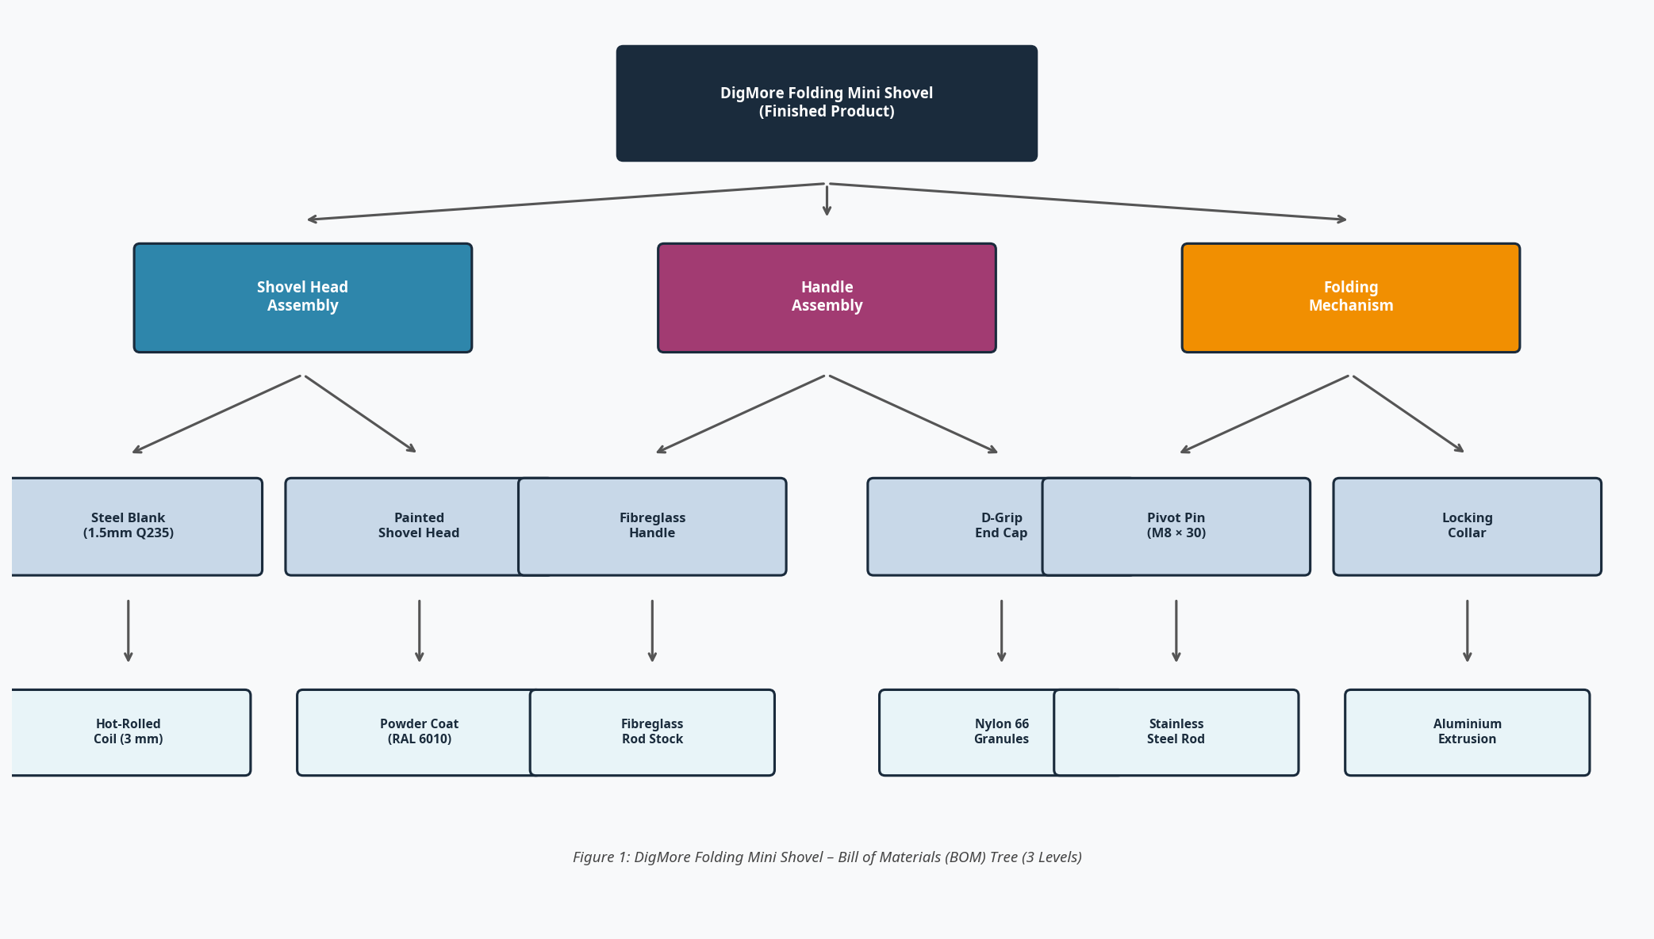

4.2 Process Routing
The manufacturing process follows a 10-station routing. Raw steel coil is blanked, formed, and socketed before moving to the critical grinding and sharpening phase. Post-surface treatment, components converge at assembly. Figure 2 maps this sequential flow.
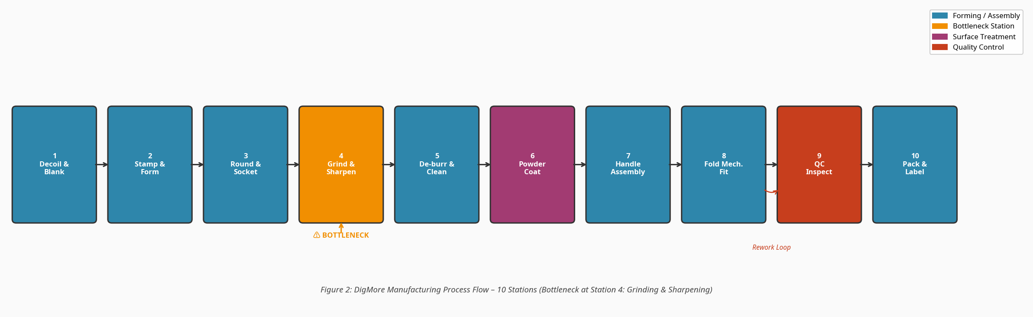

5. Design Approach and Evaluation Preparation
The layout methodology adheres to the Chaku-Chaku principle (continuous flow) and lean manufacturing tenets. The design sequence progressed from Macro-level block planning (zonal relationships) to Micro-level workstation detailing. Bottleneck analysis was central to this approach; by identifying the constraint early, the entire facility layout was subordinated to ensure the bottleneck is never starved of material, reflecting the Theory of Constraints.

6. Detail Design Specifications
This section constitutes the core engineering output, detailing the exact specifications for capacity, workstations, storage, and material handling required to generate the Master Facility Plan.

6.1 Demand and Production Design Basis
Engineering Logic: The facility must balance line flow against the required takt time of 3.0 min/unit. Cycle times exceeding takt dictate the necessity for parallel workstations.
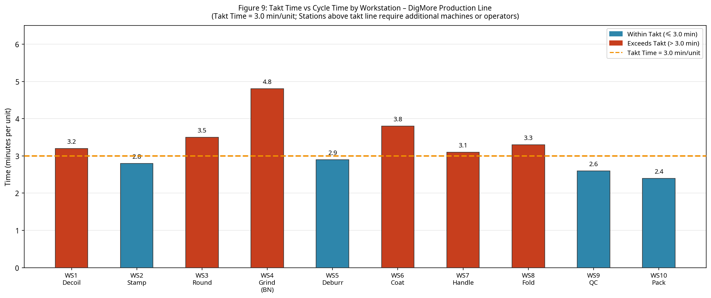
Design implication for layout (MFP): Workstations exceeding the 3.0 min/unit takt line (e.g., WS4) require a parallel layout configuration to prevent system-wide starvation.

6.2 Raw Material Requirements and Storage Basis
Engineering Logic: Raw materials (Q235 steel coils, nylon granules, fibreglass rods) are stored based on a 14-day safety stock policy. Storage systems must utilise vertical space to minimise the facility footprint.
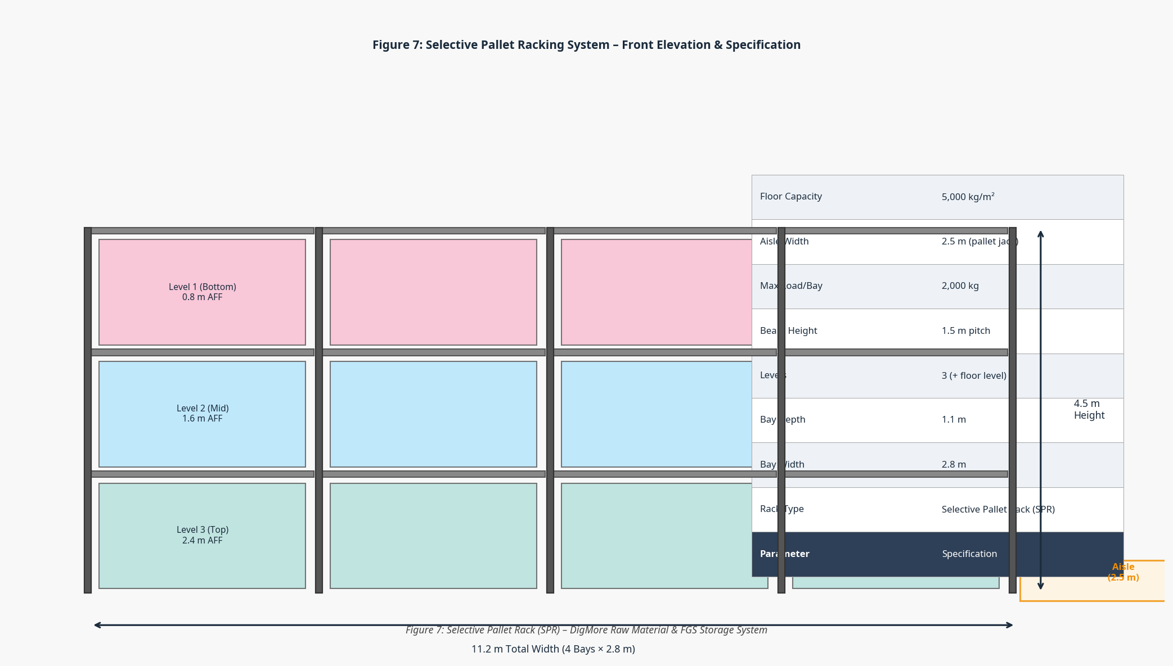
Design implication for layout (MFP): The 2.8m wide Selective Pallet Racks (SPR) dictate a minimum aisle width of 2.5m to accommodate electric pallet jacks. The raw material zone must be positioned immediately adjacent to the receiving dock.

6.3 Manufacturing Processes and Workstation Design
Engineering Logic: Workstations are designed ergonomically (Level V design). The most critical zone is WS4 (Grinding & Sharpening), which requires extensive manual intervention and presents significant safety hazards (sparks, dust, noise).
• Process purpose: Precision sharpening of the shovel blade edge.
• Equipment selected: Industrial bench grinders with dust extraction.
• Workstation logic: 2×4 parallel arrangement facing inwards to allow a single central aisle for material supply.
• WIP before/after: Dedicated trolley parking zones at the head and tail of the cell.
• Operator movement: Minimal pivot (90 degrees) from WIP trolley to grinder.
• Safety considerations: Centralised PPE station; 1.5m clearance from main aisle.
• Material handling: Roller conveyors cannot be used due to part orientation; WIP trolleys selected.
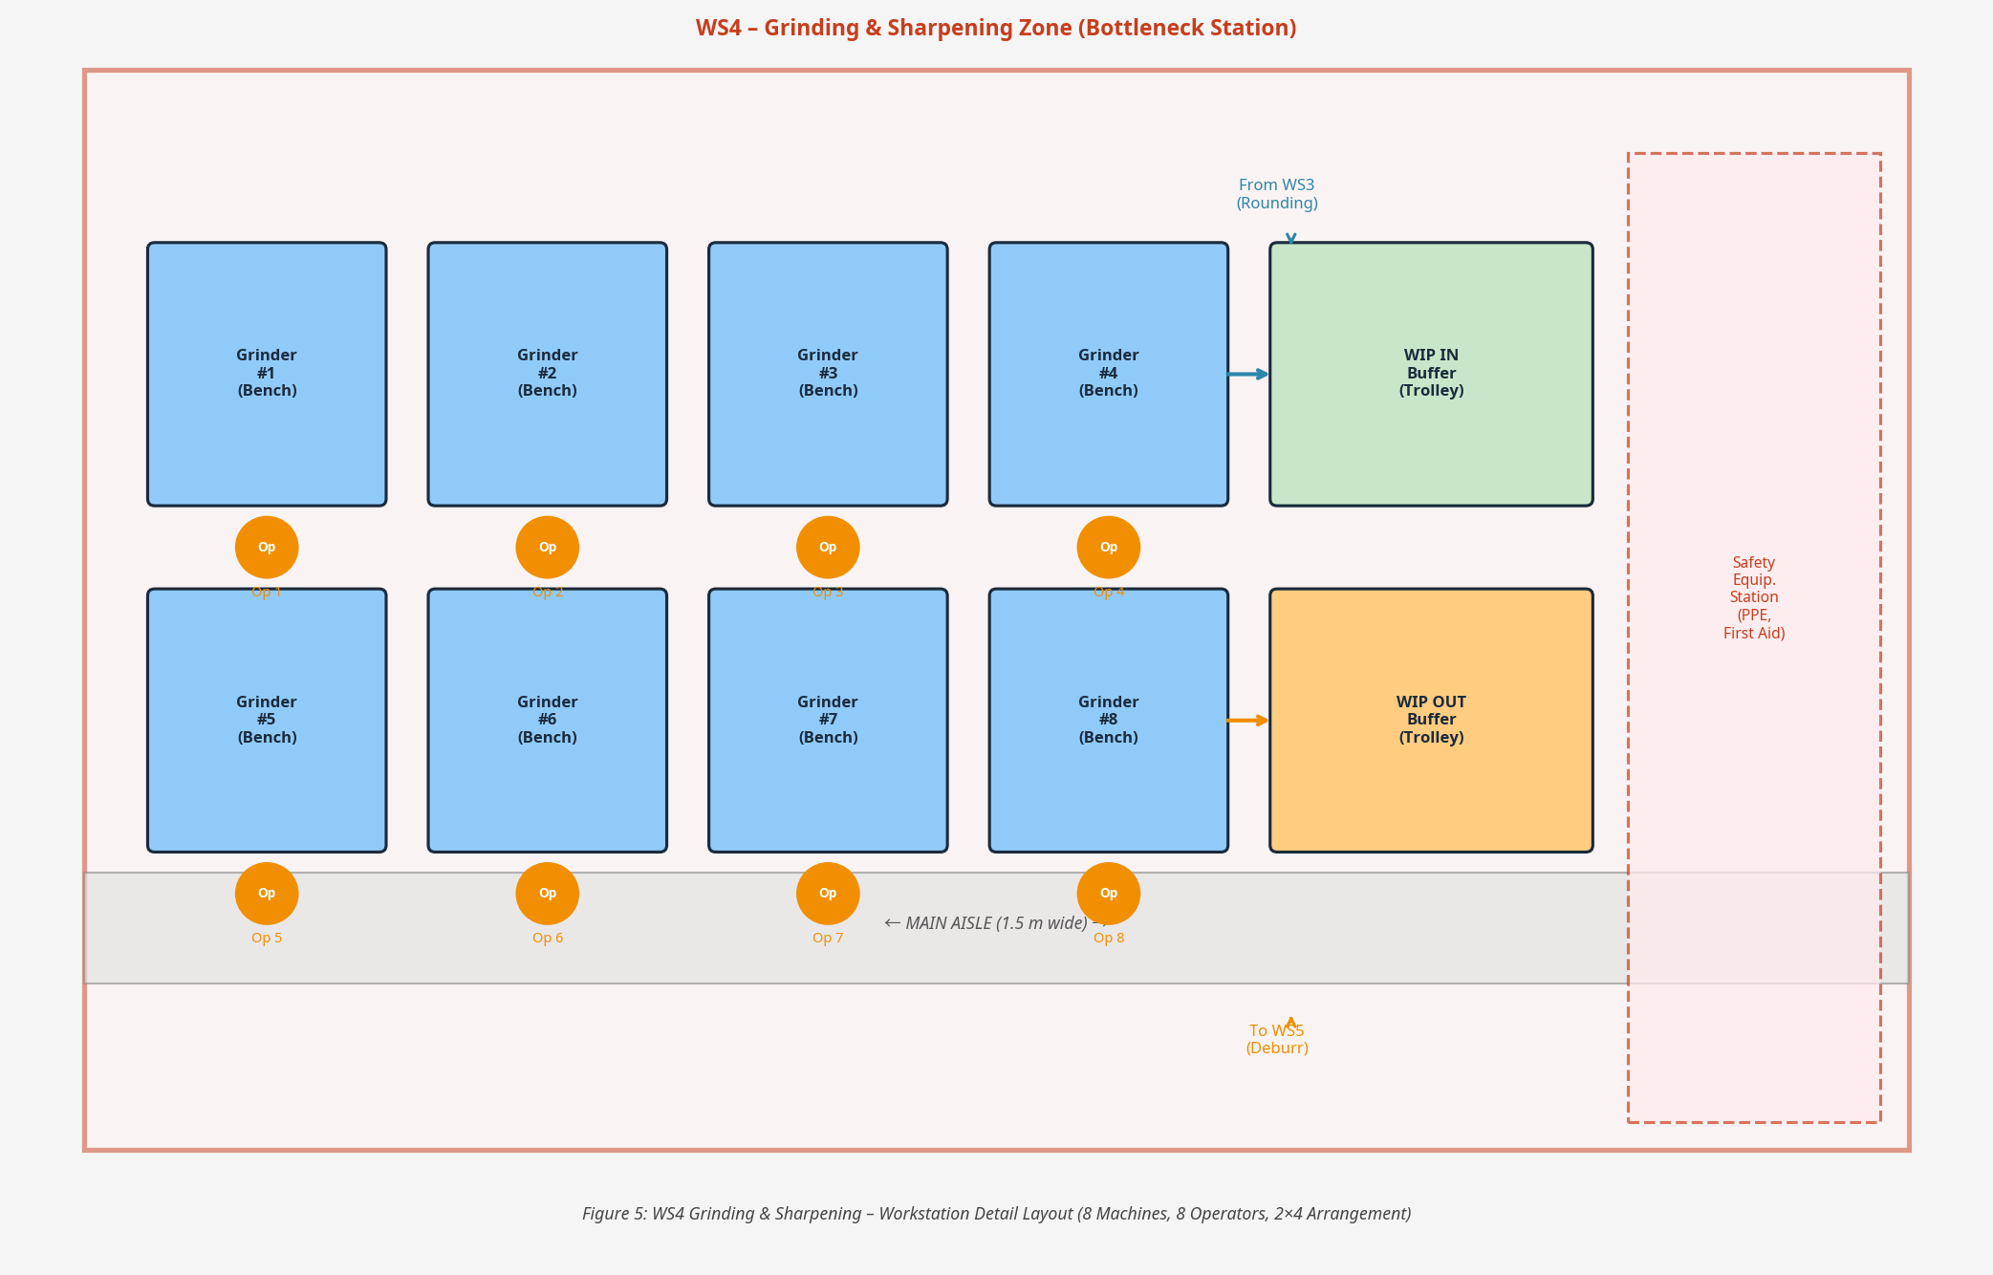
Design implication for layout (MFP): The high machine count (8 units) creates a large, localised footprint. It must be centrally located but acoustically and physically separated from clean zones like Powder Coating.

6.4 Manufacturing Time, Capacity and Labour
Engineering Logic: Capacity is calculated using the formula: Number of Machines = (Demand Rate × Cycle Time) / (Available Time × Efficiency). To meet demand, 34 machines and 34 operators are required across the 10 stations.
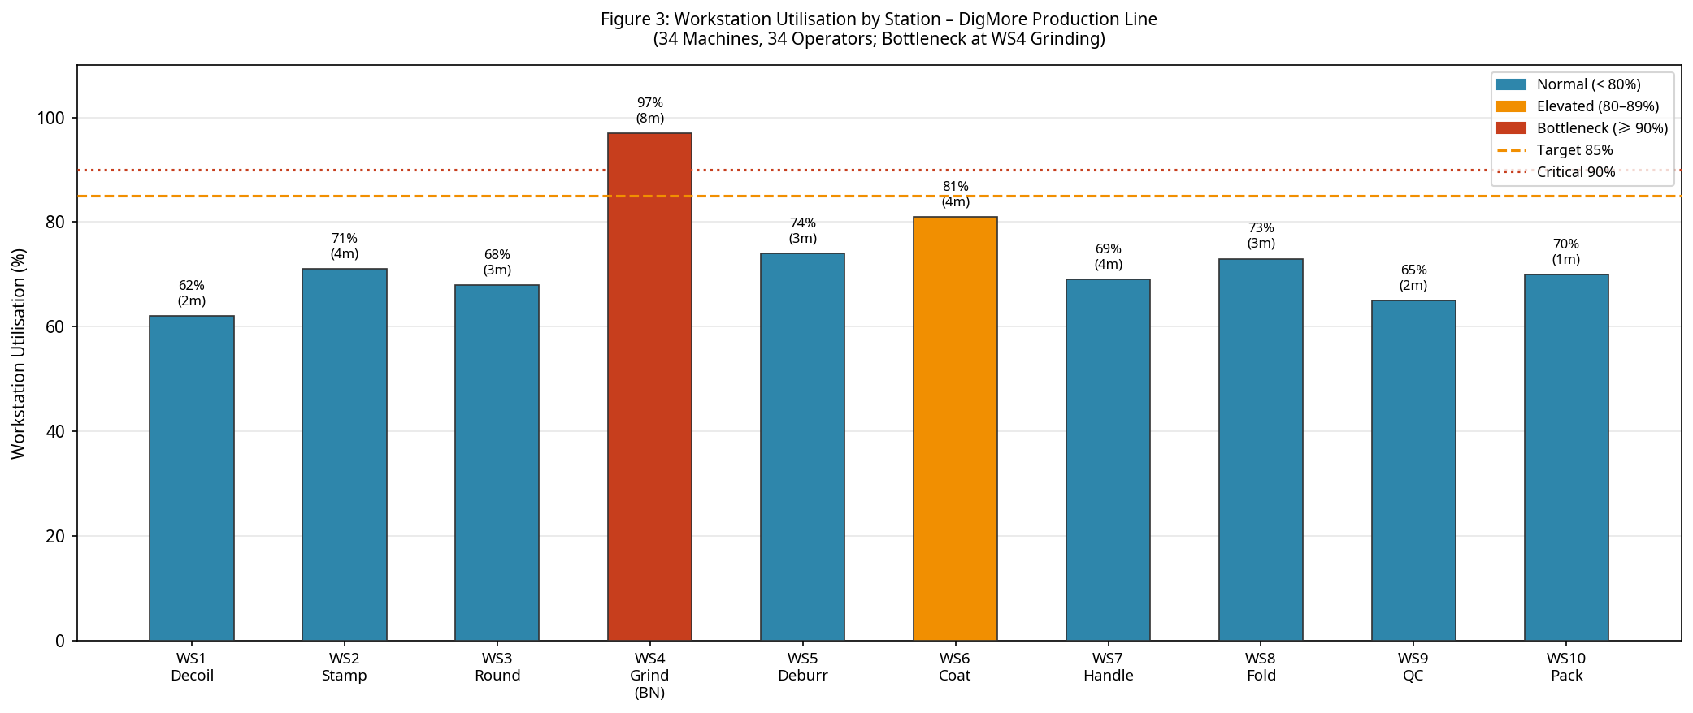
Design implication for layout (MFP): WS4 operates at 97% utilisation, confirming its status as the bottleneck. Buffer zones for WIP must be oversized immediately preceding WS4 to absorb upstream variances.

6.5 Receiving and Dispatch
Engineering Logic: A U-shaped or straight-through flow dictates dock placement. To separate dirty inbound materials from clean finished goods, distinct receiving and dispatch docks are established.
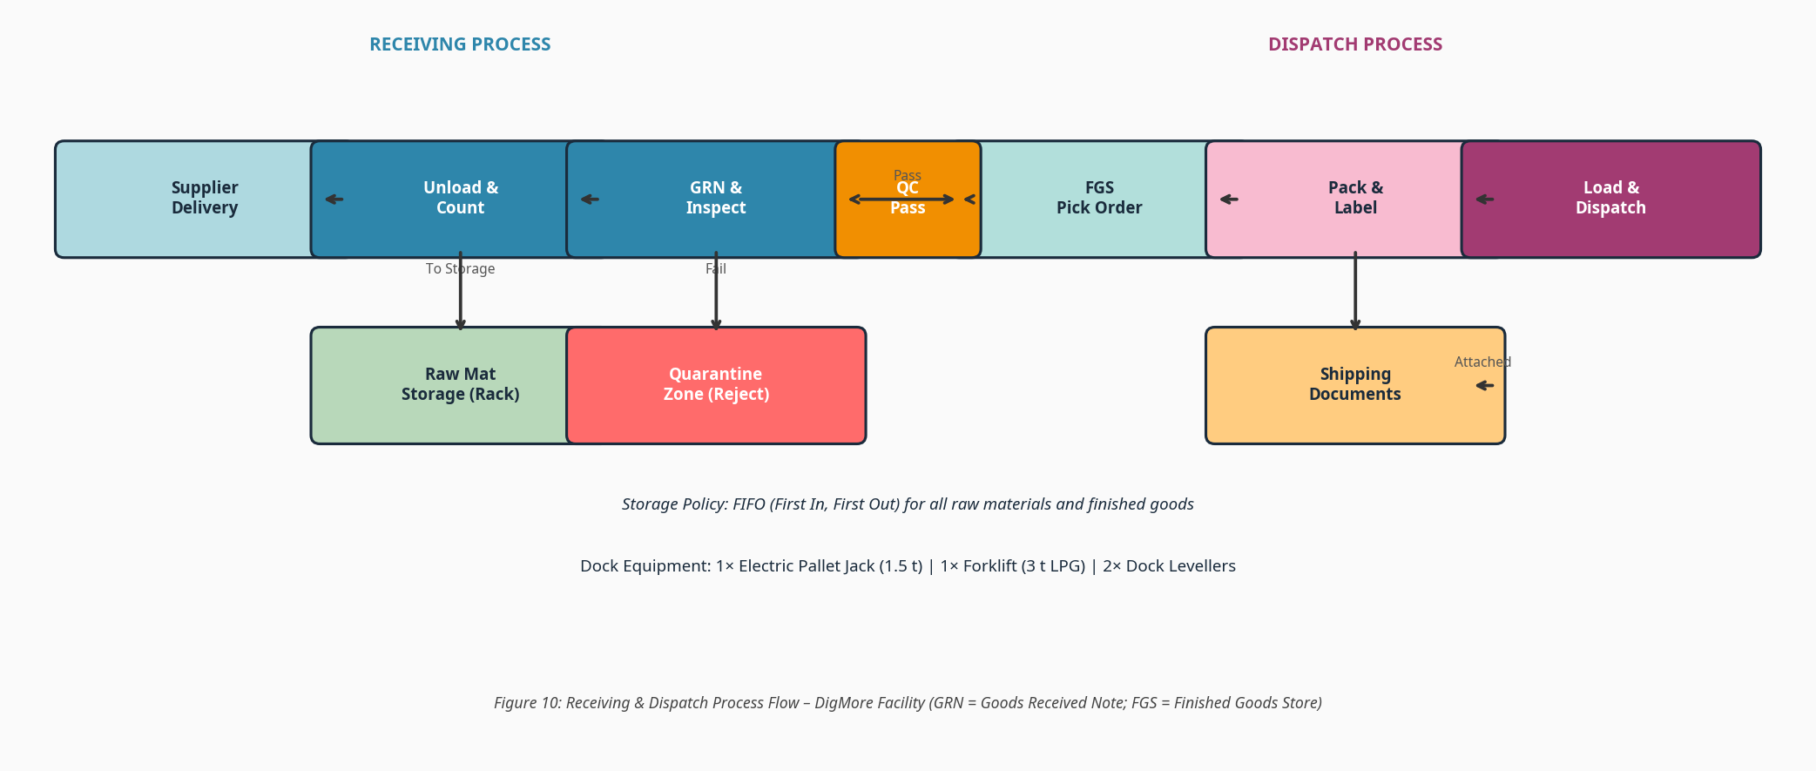
Design implication for layout (MFP): Docks are placed at opposite ends of the facility (straight-through flow) to prevent cross-contamination and forklift traffic congestion.

6.6 Storage and Material Handling
Engineering Logic: Following the Material Handling Institute (MHI) principles, equipment is matched to load, distance, and frequency. Heavy coils require hoists, while inter-station movement utilises gravity roller conveyors where possible.
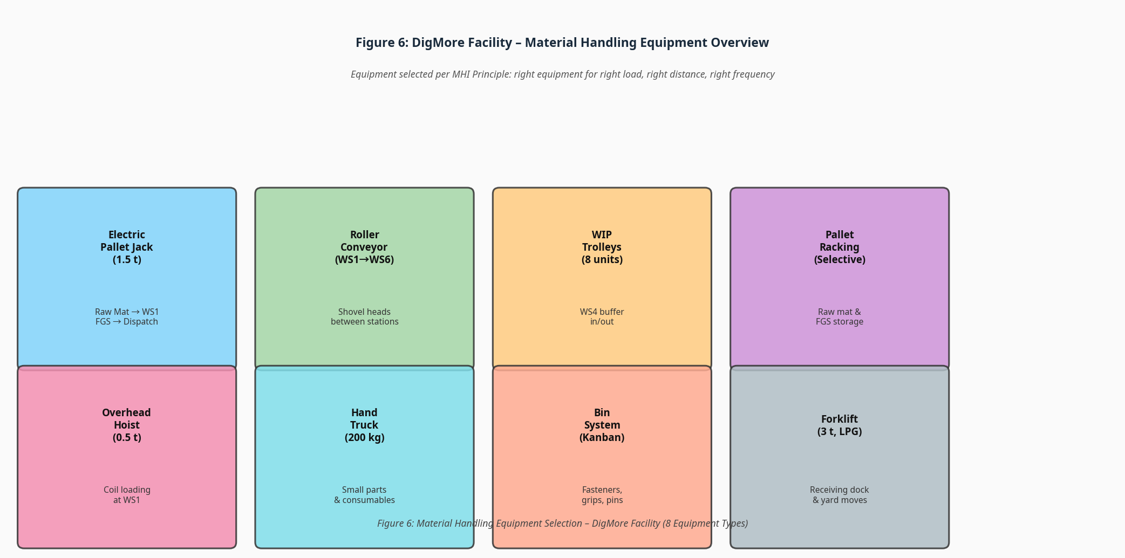
Design implication for layout (MFP): The layout must feature a continuous 1.5m minimum clearance along the main assembly line to accommodate WIP trolleys and pallet jacks without obstructing operators.

6.7 Supporting Facilities, Utilities and Waste
Engineering Logic: Human welfare and technical infrastructure must not interfere with production flow. Utilities (compressed air, power drops) drop from overhead grids to maintain floor flexibility.
Design implication for layout (MFP): Offices, restrooms, and the maintenance workshop are consolidated into a single strip along the non-expansion wall of the building.

6.8 Space Requirement Summary and Expansion
Engineering Logic: Aggregating the footprints of workstations, storage, aisles, and support zones yields the total Gross Floor Area (GFA).
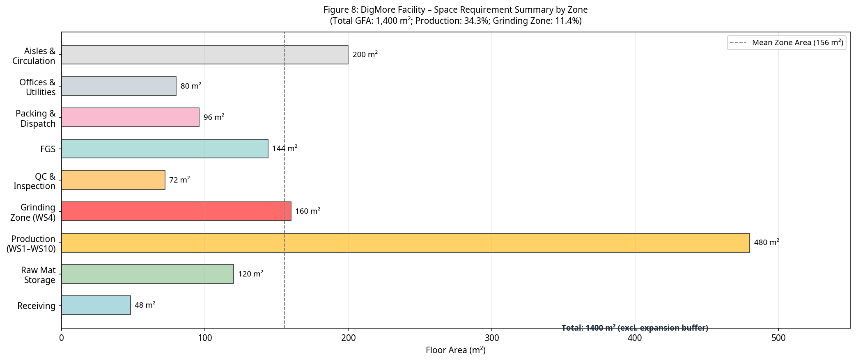
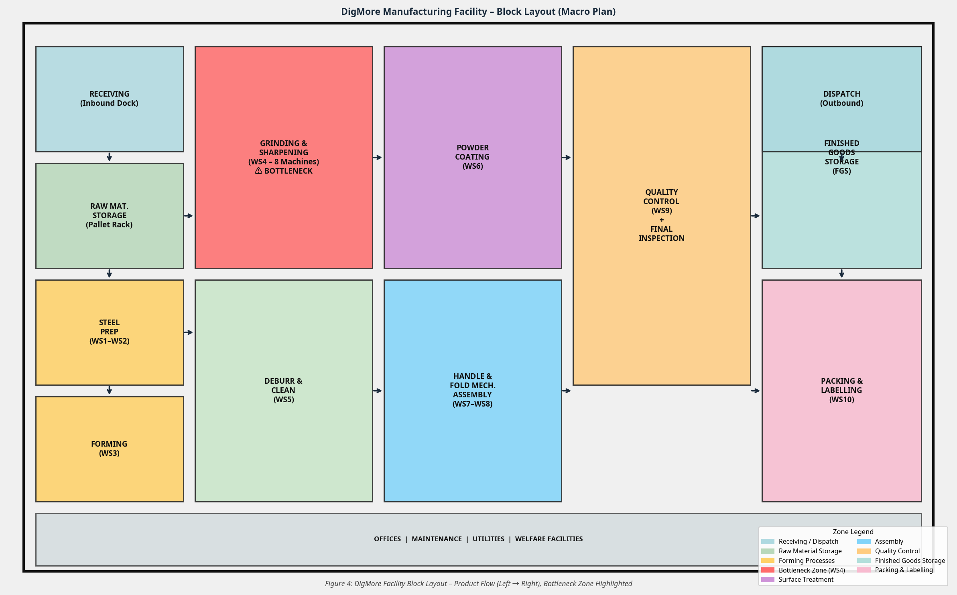
Design implication for layout (MFP): The total calculated footprint is 1,400 m². The macro block layout (Figure 4) arranges these zones logically. The eastern wall is designated as a non-load-bearing curtain wall to facilitate future expansion.

References
[1] Wrennall, W. & Zandin, K. B. (n.d.). Maynard's Industrial Engineering Handbook. McGraw-Hill Education.
[2] Muther, R. (n.d.). Systematic Layout Planning (SLP). Richard Muther Associates.
[3] Maveneer. (2025). Facility Layout for Success. Retrieved from https://maveneer.com/blog/facility-layout
[4] BESCO Machine Tool Limited. (2026). Shovel Production Line: Complete Manufacturing Equipment & Cost Guide.
[5] Six Sigma DSI. (n.d.). Manufacturing Facility Layout Overview. Retrieved from https://sixsigmadsi.com/manufacturing-facility-layout/
[6] Kardex. (n.d.). Material Handling in Warehouses: How It Works and 22 Ways to Improve It. Retrieved from https://www.kardex.com/en-us/blog/material-handling

