INGB417 – Assignment 3 18/02/2025 Group 7
Karla van Dyk 37511459 Henrico Joubert 38114100

Initial Workstation Layout:
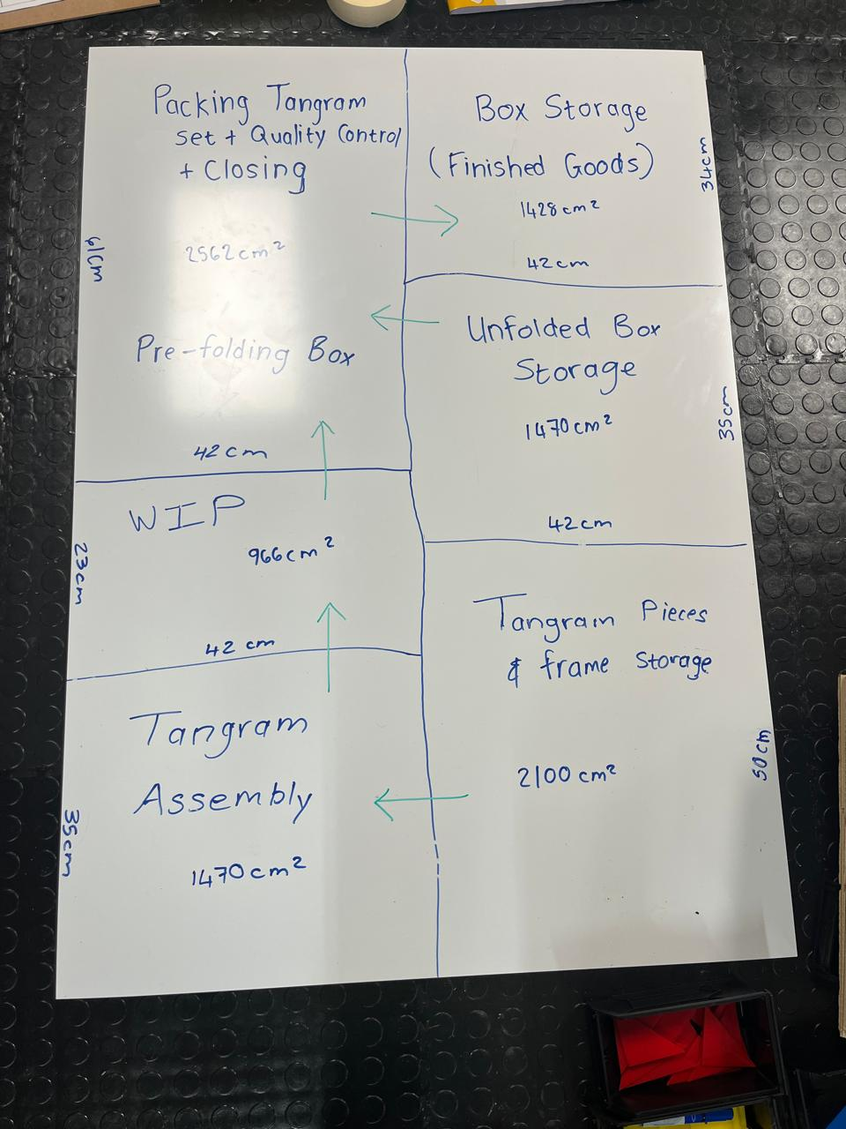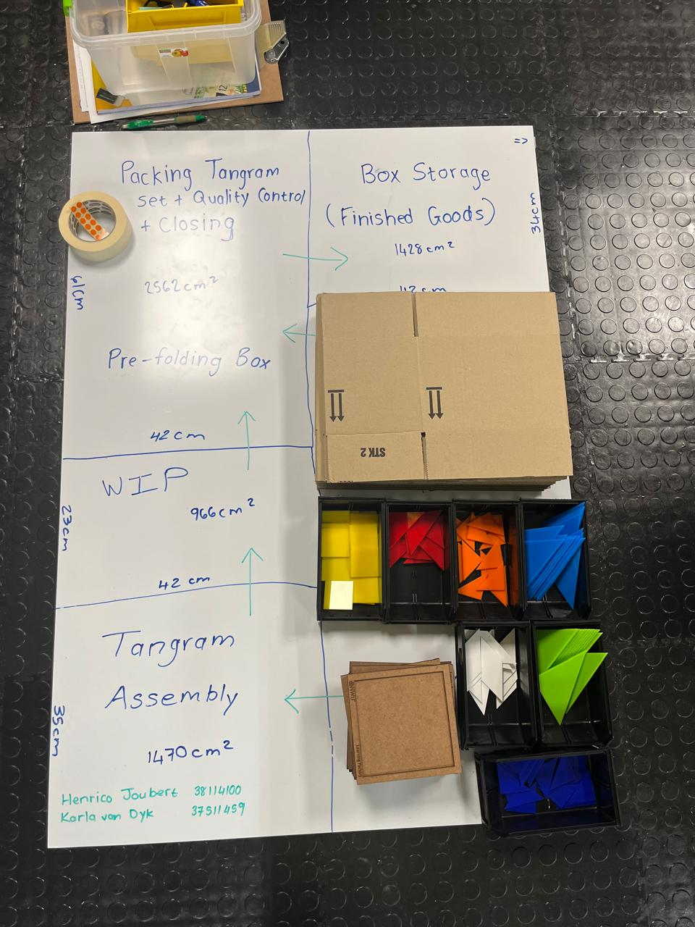
The height of the workstation is 4*15.5 = 62cm
The whole workstation has the same max height. The total cubic cm of the station is thus 619.75 cubic cm.

Calculations:
1) Estimate cycle time per product = 65 seconds
2) Calculated output in 30 minutes = 1800/65 = 27 products
3) Actual cycle time of assembly = 9 min 24 secs for 15 products = 37.6 seconds per product
4) Scaling calculations = 37.6*60*60*8 = 765 products in 8hr day
OR 60*60*8/1000 = 28.8 seconds per product
1800/37.6 = 47 products in 30 min

Improved workstation layout:
Minimal changes were made from the initial. The unpacked box storage is made smaller as boxes are stored upright. This gave us more space in the finished goods storage ang other work areas. The workers are also able to work faster as they get used to the tangram pattern and box folding, eventually boosting the output.
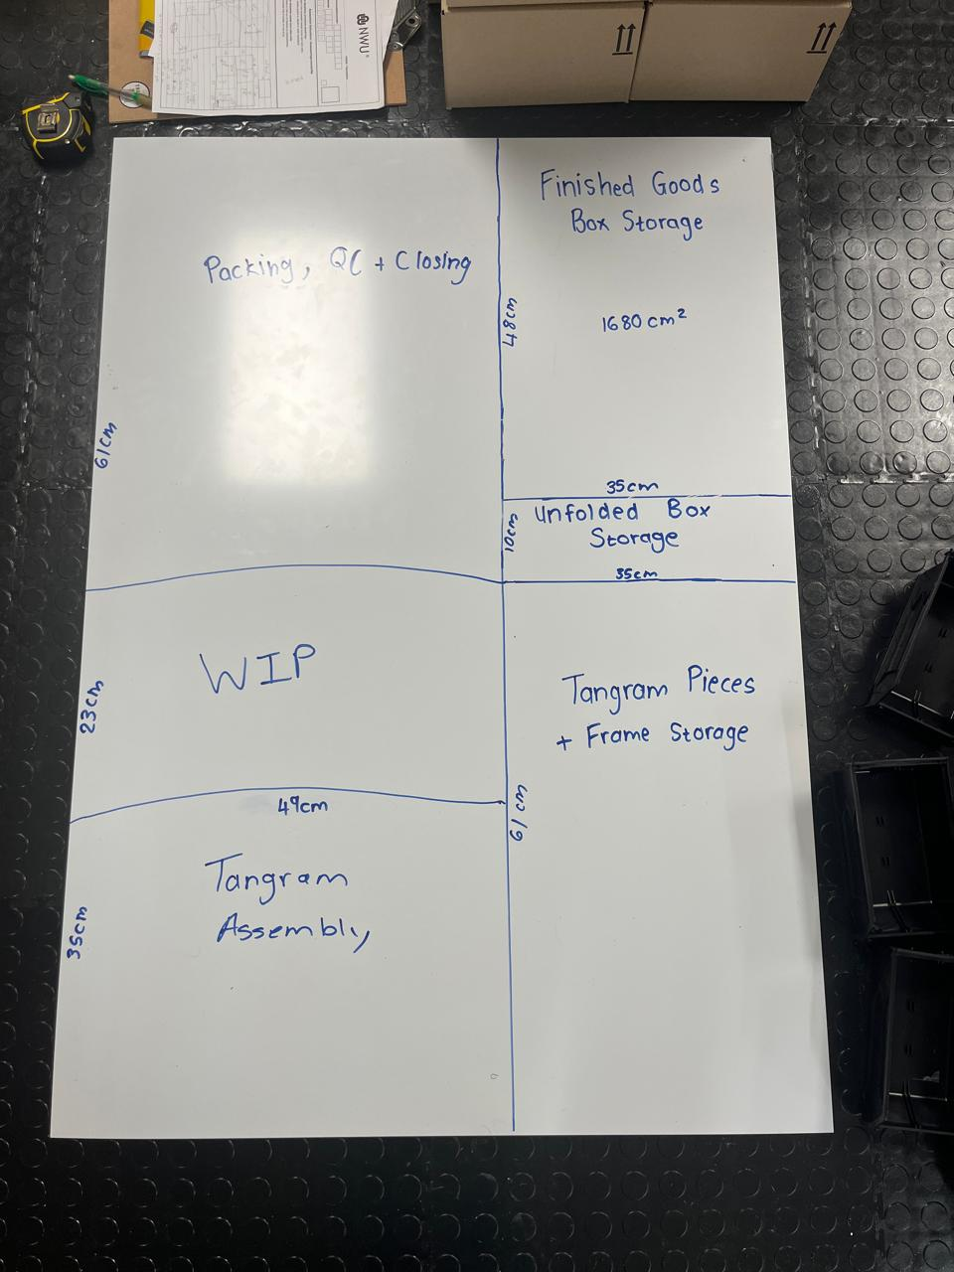

Total Facility Block Layout:
For this layout, a total of 20 workstations need to be placed at each of the three main work areas (Tangram Assembly, Fold & Tape Bottom of Box + tangram packaging and Quality Control + Close Box + Tape Top). The whole process almost works as an assembly line with 20 different “lines”.
