
INBG 417
Exam Assignment 1
12 June 2026

Nthabiseng Maoka
30224926

Submitted in pursuit of the degree
BACHELOR OF ENGINEERING

In

INDUSTRIAL ENGINEERING

North-West University
Potchefstroom Campus

North-West University: Potchefstroom Campus

Table of Contents
List of Tables 0
List of Figures 0
List of Equations 0
1. Project Background 0
2. Design Problem, Aim and Objectives 0
2.1. Aim 0
2.2. Objectives 0
2.3. Scope, exclusions and limitations 1
3. Design Requirements, Assumptions and Constraints 1
3.1. Design requirements summary 1
3.2. Key assumptions 1
3.3. Design Constraints and Implications 2
4. Product and process understanding 0

List of Tables

List of Figures
Figure 1:DigMore folding mini shovel process flow diagram 0

List of Equation

Project Background
DIGMORE is an established shovel manufacturer with a broad customer base and a strategic intention to expand its product offering through the introduction of an all-purpose folding mini shovel designed primarily for camping and outdoor use. The 2026 design brief indicates that market demand for this product has increased to the point where the existing facility no longer has sufficient capacity to manufacture the shovel at the required scale. Management has therefore requested the design of a new dedicated manufacturing facility that will support the complete operational sequence, from the receipt of raw materials to production, packaging, storage and final dispatch. In addition, the proposed facility must reserve approximately 10% of its space for future expansion and must provide for safe and efficient access by both suppliers and customers.
The brief also imposes several operational and spatial conditions that materially influence the design. These include the requirement that all materials be stored indoors, that powder coating be located within a separate enclosed area due to safety and fume-control considerations, and that the facility provide for both incoming supplier deliveries and outgoing customer collections. As demonstrated by the 2025 benchmark submissions, high-quality facility design reports are characterised by a clear articulation of the business context, a structured formulation of the design problem, and a rigorous connection between demand, process requirements, spatial planning and alternative evaluation. In keeping with this standard, the present report approaches the DIGMORE facility as a complex engineering design problem rather than merely a building layout exercise.

Design Problem, Aim and Objectives
The design problem is to develop a new manufacturing facility for the DIGMORE folding mini shovel that can satisfy forecast demand while ensuring logical process flow, safe operation, adequate storage, effective receiving and dispatch, and provision for future growth. The problem is inherently complex because the facility must integrate multiple manufacturing and finishing processes, distinct material types, defined inventory policies, internal and external logistics, and specific safety-driven layout requirements, such as the segregation of powder coating within an enclosed area.

Aim
The aim of this project is to design a practical, scalable and analytically justified facility layout for DIGMORE that can meet the required production demand for folding mini shovels, support efficient movement of materials and personnel, and provide management with a sound basis for strategic decision-making regarding the proposed new facility.

Objectives
To achieve the stated aim, the project is guided by the following objectives:
- Determine the production output required to satisfy the stated demand of 400000 folding mini shovels per year and translate this into daily and workstation-level requirements.
- Identify the manufacturing processes, workstations, machinery and labour implications necessary to achieve the required throughput.
- Quantify raw material, work-in-progress and finished goods storage requirements in line with the inventory policies provided in the brief.
- Develop facility departments and space requirements that accommodate receiving, storage, manufacturing, assembly, packaging, dispatch and supporting services.
- Generate and compare alternative block layouts using defendable criteria aligned to process flow, safety, logistics and future expansion.
- Select and justify a preferred Master Facility Plan that satisfies the client’s stated needs and demonstrates a structured engineering design approach.

Scope, exclusions and limitations

Design Requirements, Assumptions and Constraints

Design requirements summary
The design requirements are derived directly from the examination brief and define the minimum conditions that the proposed facility must satisfy. These requirements establish the basis against which design alternatives and the final layout will later be evaluated.
- The facility shall be capable of supporting production of 400000 folding mini shovels per year under the stated operating conditions.
- The design shall include receiving capacity for supplier vehicles and dispatch arrangements for both customer collections and larger outgoing deliveries.
- All raw materials and finished goods shall be stored indoors, with storage capacity reflecting two weeks of raw material stock and four weeks of finished goods stock.
- The powder-coating function shall be placed in a separate enclosed area within the building because of safety and fume-control requirements.
- The facility shall provide logical and efficient material flow from receiving through manufacturing, finishing, assembly, packaging and dispatch.
- The design shall include adequate space for support functions such as offices, employee amenities, security, parking, fleet accommodation, waste handling and utilities.
- Approximately 10% spare capacity or expansion allowance shall be reserved for future growth over the next five years.

Key assumptions
Consistent with the brief and with the benchmarked style of making explicit, defendable assumptions, the following assumptions are adopted for the front-end design stage:
- The facility operates one 9-hour shift per day, five days per week, with 30 minutes for lunch and two 15-minute tea breaks, resulting in 8 productive hours per day.
- A total of 220 working days per year is assumed, in accordance with the brief.
- One finished product is defined as one complete folding mini shovel consisting of the grip section, middle handle section and shovel-head subassembly.
- Public road access, basic site services and external circulation space are assumed to be available or achievable for the selected site concept.
- Where detailed equipment dimensions, cycle times or operator requirements are not explicitly stated in the brief, reasonable engineering assumptions and supplier-based estimates will be used later in the report and clearly justified.
- Small and large orders will be defined by the designer during the dispatch design stage, as required by the brief.
- Powder coating and sandblasting are assumed to have negligible effect on final product mass, as stated in the brief.

Design Constraints and Implications
The following constraints materially influence the design:
- A 5% scrap rate applies to tube cutting and sheet stamping processes, and this must be incorporated into material and capacity calculations.
- All deliveries and collections must occur during working hours on weekdays.
- The final design must accommodate future growth through a dedicated expansion allowance rather than relying only on overtime.
- Packaging is performed manually, which means labour, ergonomic space and inspection requirements must be reflected in the final layout.
- The body of the report is limited to 40 pages, requiring a concise but sufficiently rigorous presentation of evidence.
- The final design must be defendable in an oral exit interview, meaning assumptions, calculations and layout choices must remain coherent, original and practically justifiable.
Store | Items | Racks/positions | Floor area (m2) | Basis
Raw tube | 960 | 4 | 38,4 | cantilever racks
Raw sheet | 240 | 2 | 10 | sheet stacks
Finished goods | 91 | 31 | 59,52 | palletised, racked
WIP staging | 5 | 2 | 3,84 | decoupling buffers
Scrap / waste | - | - | 40 | assumption
Total storage area |  |  | 151,76

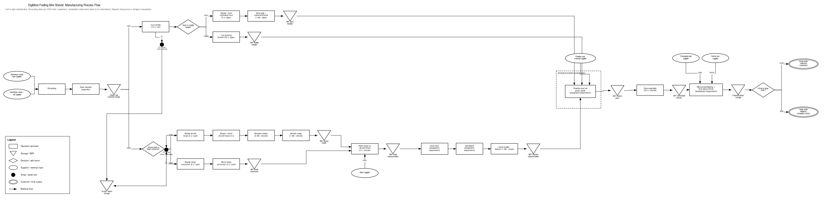
Figure 1:DigMore folding mini shovel process flow diagram

Product and process understanding
Nn

Product structure
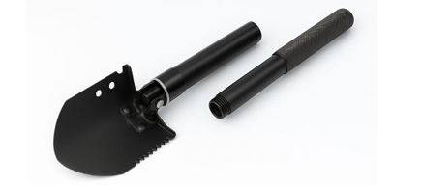
Figure 2: Folding shovel

