Data Visualization Project report

INTRODUCTION
Over the past few decades, South Africa has experienced substantial economic transformation. The lack of political constraints on policy and access to global markets during the apartheid era suppressed economic expansion and raised inflationary pressure. After apartheid, it reformed to address inequality and promote growth. However, challenges such as volatile inflation and uneven GDP continued to influence the economic growth performance. As Collen (2008, 48-49) states, when GDP is growing, especially if inflation is not a problem, workers and businesses are generally better off than when it is not.

GDP is the measure of the monetary value of final goods and services bought by the final user produced in a country in a given period, whereas Inflation is the rate at which prices rise over a certain period, showing how much the relevant sets of goods and services have increased in price over a given time frame in a year. Understanding the relationship between GDP growth and inflation during apartheid and after apartheid provides valuable insights into how South Africa’s economy has evolved. A favorable correlation between inflation and GDP is seen in conflict studies focused on emerging countries. The price increase has led to inflation (e.g., Oil shocks), and increasing inflation lowers GDP, consumption, and reduces the buying capacity of cash.

To do this, we examined South Africa's GDP and inflation from 1960 to 2024. Trends, patterns, and correlations between the two indicators over decades were investigated using the GDP and inflation indicators. This report aims to shed light on the South African economy during and after apartheid and identify which period performed better during those years by connecting the quantitative research with the historical context.

DATASET DETAILS
GDP:
- GDP annual % growth
- The dataset was obtained from the World Bank Group
- The dataset contains records of GDP growth rate across different countries
- Year - period (1960-2023)
- GDP growth (observation value) – The annual percentage of GDP
- Shape - The dataset has 262 rows and 86 columns
- Format – The dataset was downloaded in wide csv format for analysis
- Data types: Year (Integer), Country (String) and GDP (Float)
- Missing Values: There are no missing values found in the dataset
Inflation:
- Inflation consumed prices (annual %)
- The dataset was obtained from the World Bank Group
- The dataset contains records of the Inflation rate across different countries
- Year - period (1960-2023)
- Inflation rate (observation value) – The annual rate of inflation
- Shape - The dataset has 240 rows and 87 columns
- Format – The dataset was downloaded in wide csv format for analysis
- Data types: Year (Integer), Country (String), and Inflation (Float)
- Missing Values: There are no missing values found in the dataset
Methods of analysis
Descriptive analysis
- Evaluated the mean, maximum, minimum, and standard deviation for GDP growth and inflation rate to describe the characteristics of the datasets
- Created a summary table to give an overview of the dataset before performing the analysis
Analytical approach
- Used a Quantitative analysis approach to look over the historical trends, patterns, and relationships between GDP and inflation in South Africa from 1960 to 2024
- This method facilitated numerical assessments, which led to valuable insights into economic performance
Trends/time-series analysis
- Plotted a line chart of GDP growth and inflation rate for the period of years to visualize the patterns over time
- Identified economic volatility of periods such as high inflation or high GDP, and periods of relative stability
Correlation/ Relationship analysis
- Used a scatter plot to visually verify the relationship and trend between GDP and inflation
Comparative analysis
- Divided the dataset into the pre-apartheid and post-apartheid segments
- Used pie charts to show a proportional contribution of GDP and the inflation mean
- used Bar Charts to highlight the worst and best years for GDP and inflation during apartheid and post-apartheid
Data checking and preparation
- Checked for missing values to ensure consistency and filled with the mean if found
- Converted the relevant column to the correct data type
- Dropped the irrelevant column
- Filtered the dataset to only work with the country “South Africa”

Correlation between Inflation and GDP
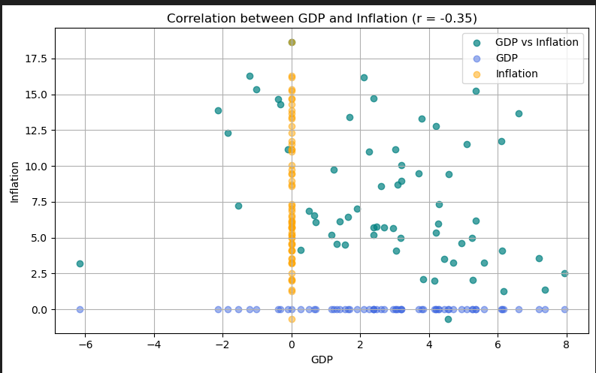

This plot shows then negative correlation which is -0.35 of South Africa’s GDP and inflation. This indicates that slower growth was caused by inflation, but higher growth was usually caused by lower inflation. Inflation increased when there was a rapid GDP growth in the 1960s during the apartheid era. In the post-apartheid era, GDP growth decreased, and the inflation rate increased in the 2000s. Although, the graph indicates that after apartheid the prices improved stability but could not maintain a stable economic growth.
YEAR-OVER-YEAR CHANGES OVER THE YEARS FOR GDP AND INFLATION
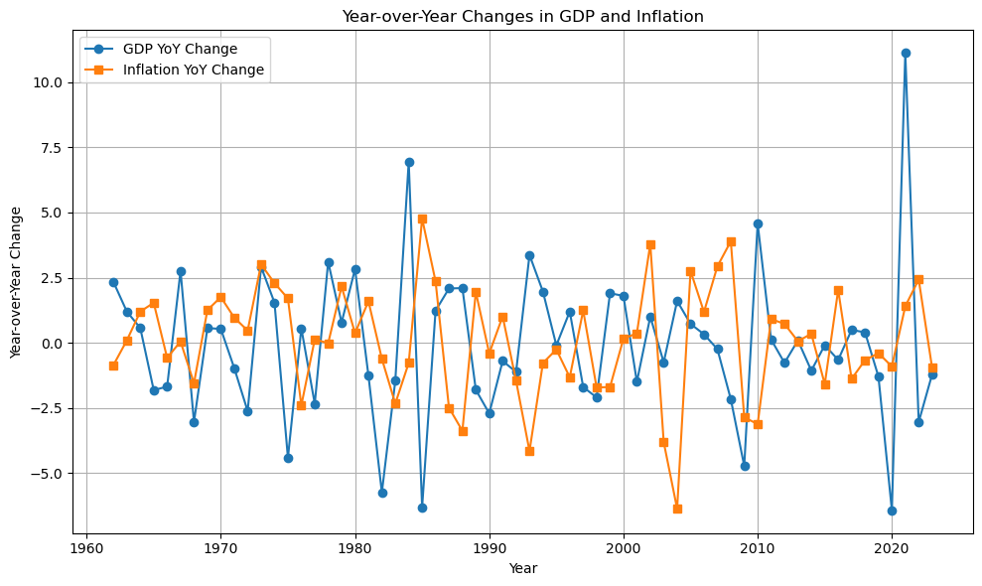
Variations in GDP and inflation from year to year
The plot displays how inflation and GDP have changed over time. During apartheid growth was rough between 1960s and 1994 where inflation was stable but showed notable peaks in the 1970s and 1980s because of Oil shocks and policy restrictions. This graph highlights that GDP tends to be uneven while inflation is volatile. Growth was robust in the late 1990s and early 2000s, but COVID-19 caused serious setbacks in 2020 and in 2010 both inflation and GDP increased due to south Africa joining Bricks. Inflation was better controlled and less severe than it had been during the apartheid era, but still erratic.

Volatility of GDP and Inflation: Pre VS Post-apartheid
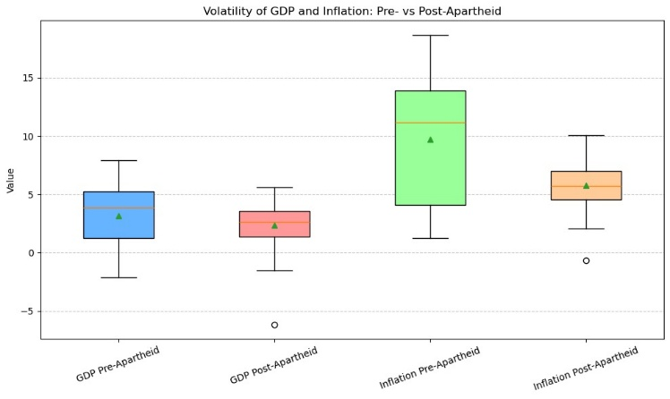
The chart shows the volatility of inflation and GDP in pre- and post-apartheid South Africa. The pre-apartheid GDP volatility was higher, with wider ranges between negative and growth, but in the post-apartheid period it became stable, but it was on the lower ranges. Inflation remained volatile before apartheid, with extremely high levels and extreme change, but was far more stable and predictable in the post-apartheid period. This overall suggests that while South Africa experienced stable and less economic expansion after apartheid, it also experienced greater stability in inflation than it did in the highly volatile pre-apartheid years.
GDP and Inflation mean during and after apartheid
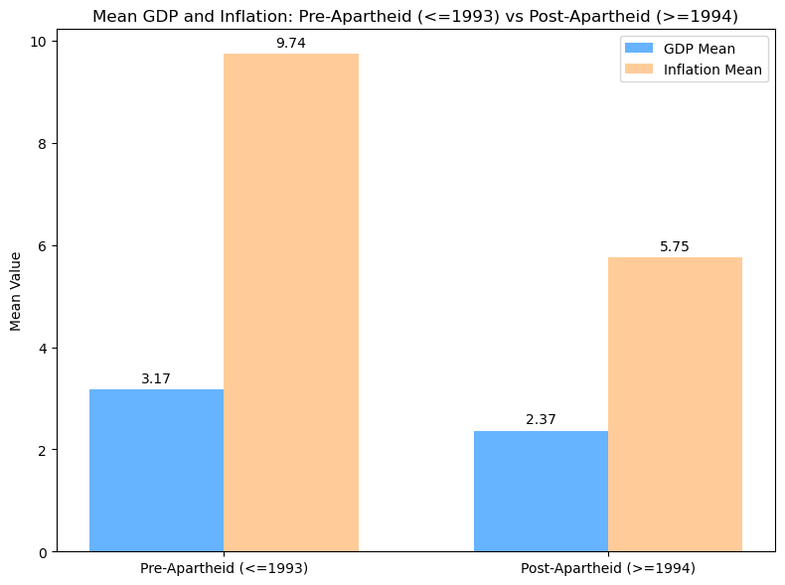
This implies that before to the end of apartheid, both GDP and inflation were greater, whereas average GDP and inflation have been lower and more moderate in the post-apartheid era. The economic shifts that took place in South Africa during these two historical eras are depicted in the chart.

Best and Worst Years for GDP AND Inflation (Pre and Post-apartheid)
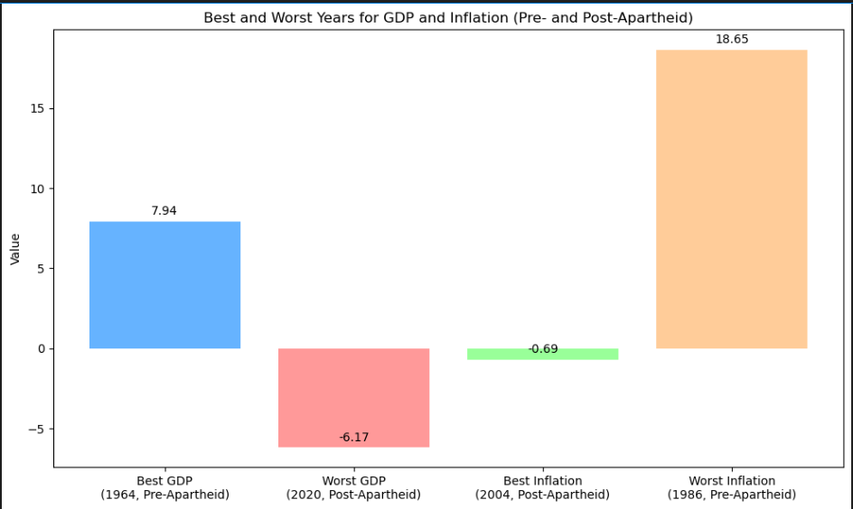
Years Before and After Apartheid That Had the Best and Worst GDP and Inflation
With a high positive score, the best GDP was recorded in 1964 (before to apartheid), suggesting robust economic expansion in that year. After the apartheid year, the year 2020 had the worst GDP with significant peaks that revealed a drastic economic downturn, which was brought by COVID-19 and the year 2004 had the best inflation, indicating a period of stable prices. Pre-apartheid 1986 had the worst inflation (highest rate), signifying a year with sharp price increases.

Conclusion
The investigation of South Africa’s GDP growth and inflation between 1960 and 2023 reveals that different economic forces shaped both the apartheid and post-apartheid periods. During apartheid, economic development was stronger but highly unstable and ,inflation was influenced to rise significantly due to external shocks and restrictive policies. However, greater price stability was obtained in the post-apartheid era at the expense of slower and more unequal GDP growth. The outcomes process that after apartheid, the organization changes apartheid inflation, it expanded South Africa’s integration in the worldwide market but persisted to maintain solid and dependable economic growth. The relationship between inflation and GDP shows general demographic shifts in the country. Altogether, this proves that the South African economy was better performing post-apartheid than during apartheid.
Environment Configuration
Hardware configuration | Software Configuration
Device name: Desktop-42ukv3k | Jupyter Notebook
Processor: AMD Ryzen 5 5625U with Radeon Graphics 2.30Ghz | Vscode IDE
Ram: 8.00GB (7.31GB usable) | Python 3.11.4
system type: 64-bit operating system, x64-based processor | Django frameWork
Pen and touch: No pen or touch input is available for this display
Device name: Martin P
Processor: 11th Gen Intel®core™i5-1135G7@2.40GHz 2.42GHz
Installed Ram: 8.00GB (7.79GB usable)
system type: 64-bit operating system, x64-based processor
Pen and touch: No pen or touch input is available for this display

Reference
Oner, C, 2010. “What is inflation?”. Finance & development, 77(1) p44
Boskin, M.J, 2019: The economy in the 1980s: A program for growth stability.
Callen, T., 2008. What is gross domestic product? Finance & Development, 45(4), pp.48-49.
Salamai, A.A., Faisal, S.M., and Khan, A.K., 2022. The relationship between inflation and GDP with reference to oil oil-based economy. International Journal of Multidisciplinary Research and Growth Evaluation, 3(1), pp.375-380.
Nowak, M.M. and Ricci, M.L.A., 2006. Post-apartheid South Africa: The first ten years.

GitHub Link
https://github.com/Tumelo-Jane/Data_analysis_and_visualisation_assignment.git
One Drive Link(Excel)
NDTA Assingment.xlsx

