Nicholas Thomas

CST-235

September 18, 2018

Dr. Toure

Short Assignment 5

When creating this application, I ran into some difficulty and confusion when creating this assignment. I believe the issue lies within my Parameters.java file and I got confused searching through articles and PDFs when trying to figure out the best approach to take but I have made more progress with it being able to execute through NetBeans instead of Eclipse.

Classes consist of:

-Index.html

-web.xml

-Parameters.java

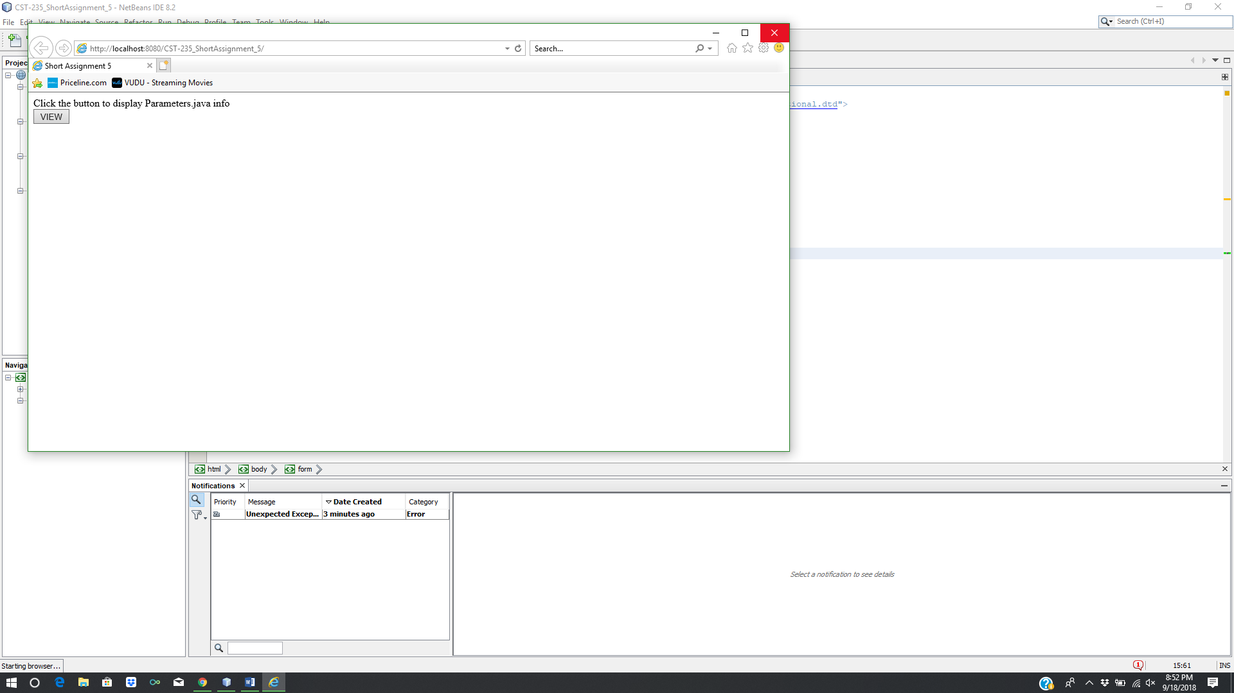

Here is the first screen when running the program and created a button to take you to the Parameters page display.

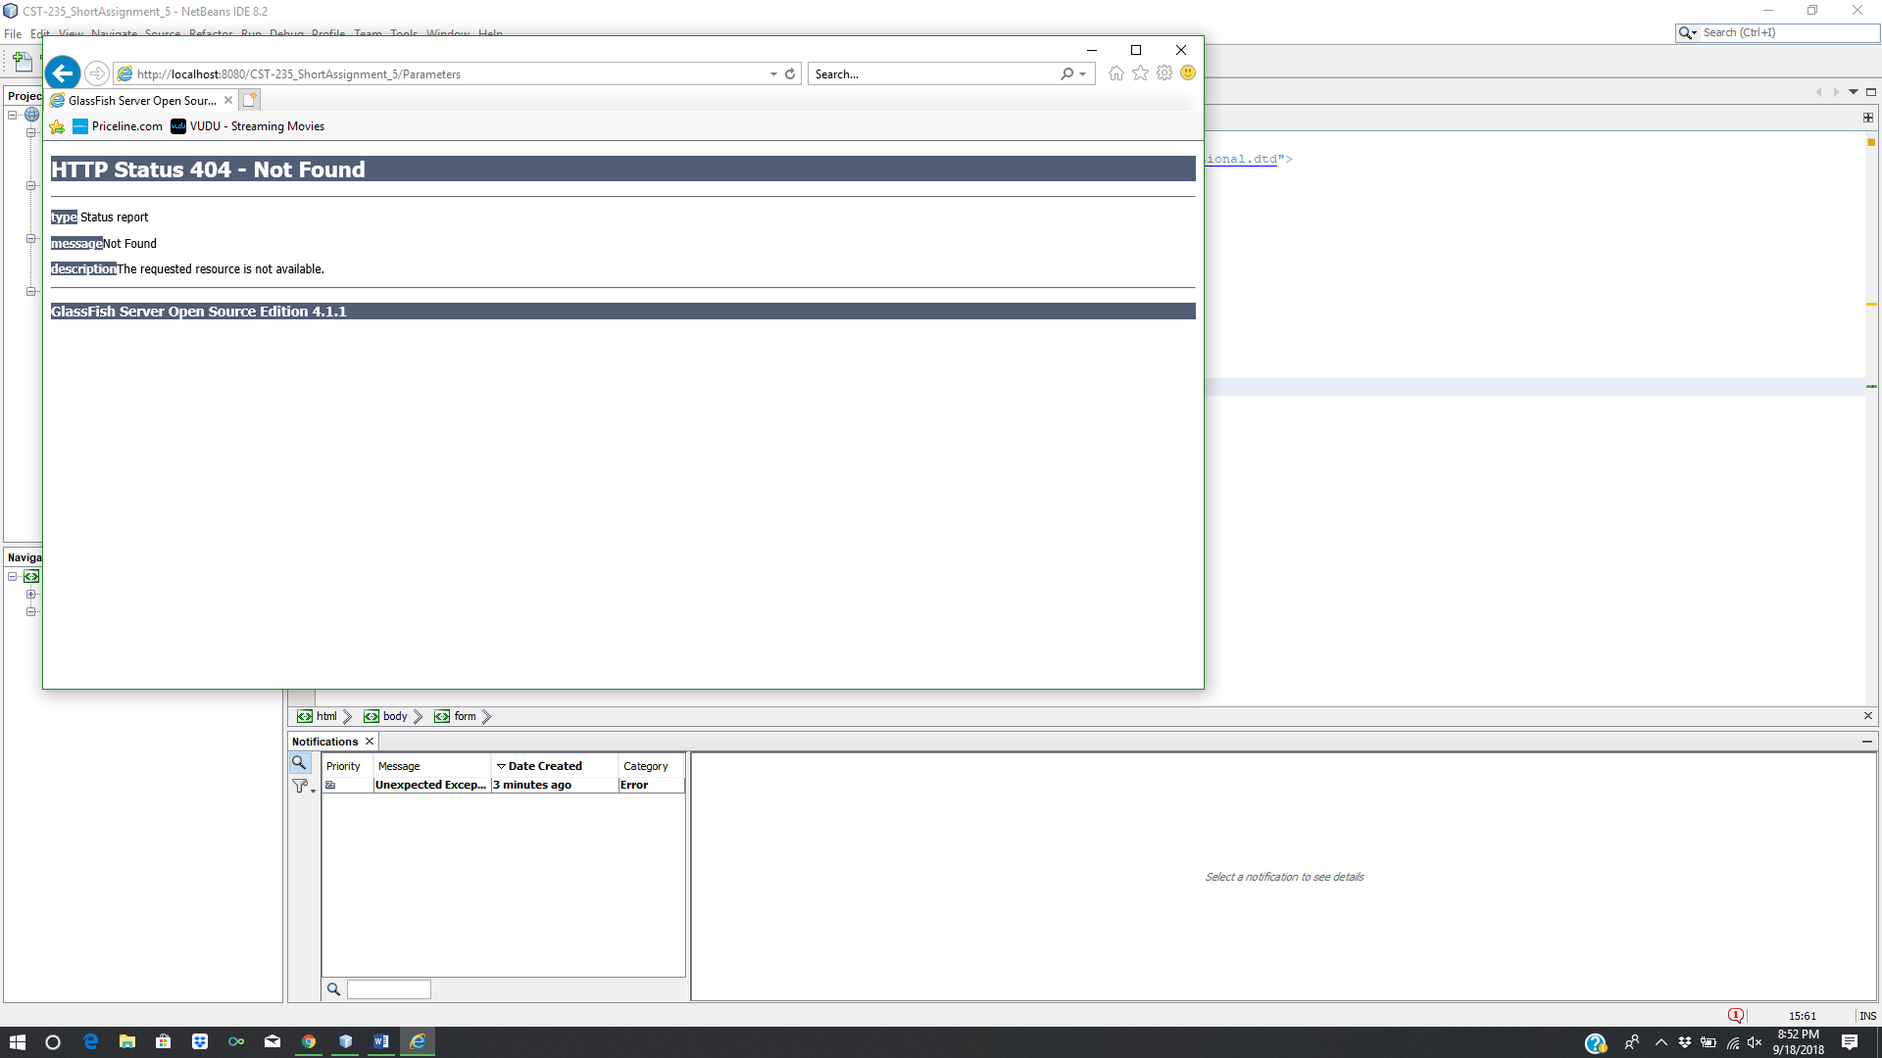

Here is the output of the click button and showing that there is an error in the program.