**Veterinary Management System**

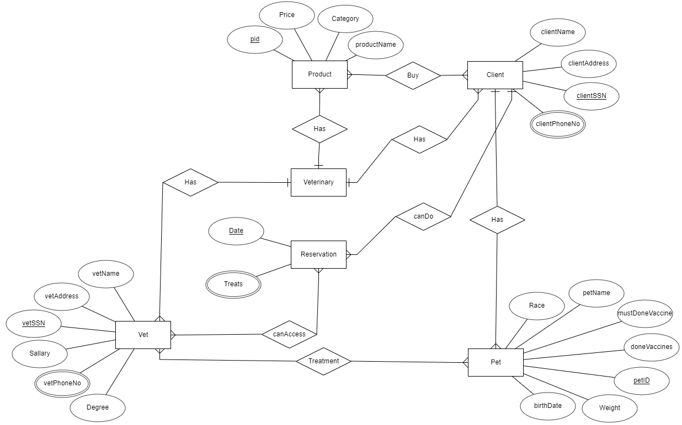

**Queries used in the app**:

* What treatment is most used? (we will choose vet according to this)
* Which medicine is sold most? (We will stock more than other medicine)
* What is the average price of Products?
* Which breed of animals comes most? (for pollster)
* Who is the most operating doctor? (raise on salary)

**E/R Diagram:**

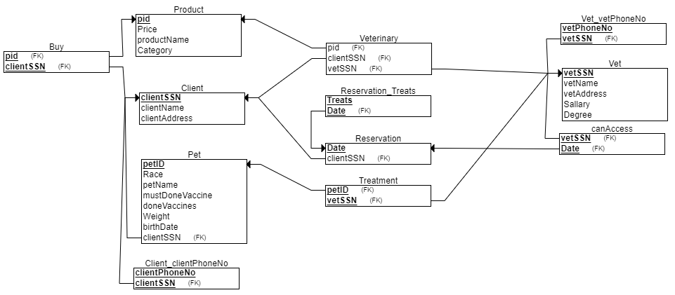

**Relational Schema of phpMyAdmin:**

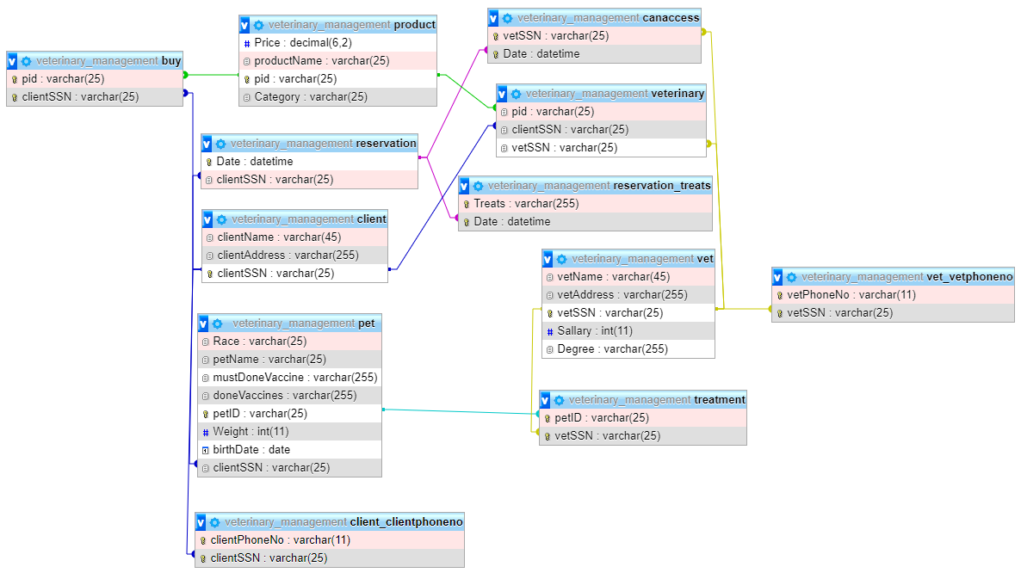

**\*THIS APP IS NOT CLIENT BASED, IT’S FOR MANAGERS \***

**Main Page of App**

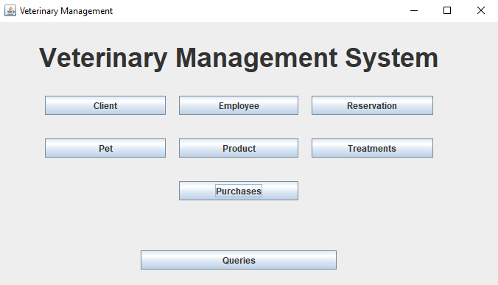

There are names of tables that we can do operations in them.

**Client Page of App**

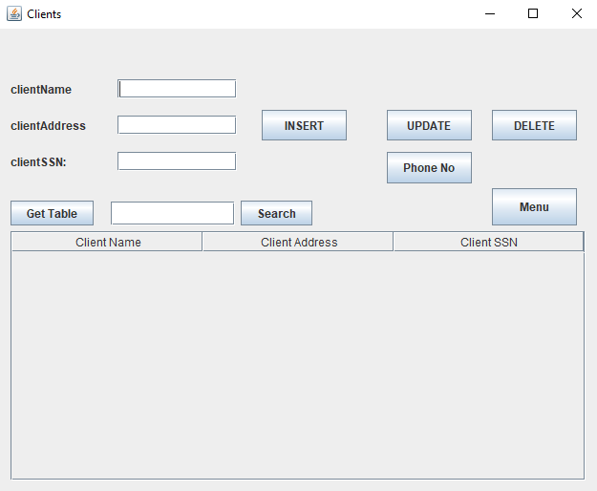

There are **INSERT, UPDATE** and **DELETE** operations inalmost every tab. But in **Client Page and Employee Page** there’s an extra button to go to the PhoneNo form and do operations (Adding, updating and deleting **Phone Numbers**)

In Client there’s a bar to search by clientSSN.

Most of Pages have **Menu** button to get back to Main Page.

Every Page has a **Get Table** button to show table indexes.

Also, foreign keys are showed by combo boxes that we can select.

There are buttons to get Tables that are in relationship with current Table. For instance, in this table there are **Show Pet ID** and **Show Vets** button to see the tables of Pet and Vet that will help user.

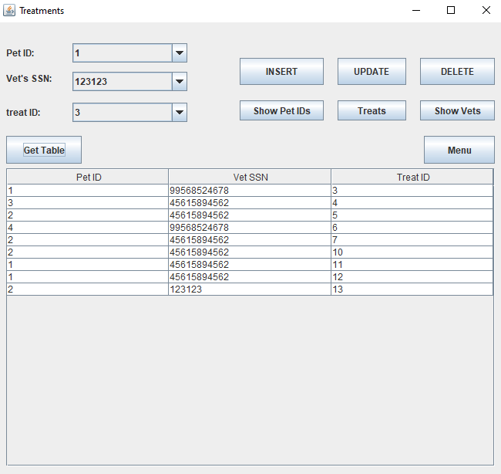

In this (Treatments) page there is treat ID attribute that is AUTO INCREMENT which means it gets values randomly by order.

**The Three Operation (INSERT, UPDATE, DELETE)**

**INSERT:**

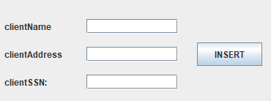

To Insert, first you have to fill the blank text fields. Then after you press **INSERT** button the data will be inserted to related table. If the data already exist, the app will pop up an error message.

**UPDATE:**

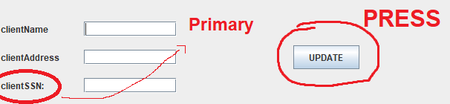

First you should enter the primary key to get the row you want to change.

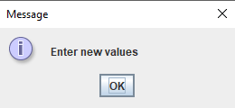

After this message, you have to enter the new values.

Finally, on your 2nd press of **UPDATE** you will get this message that means you have successfully updated the data.

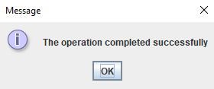

Also, if you press the **UPDATE** button 3rd time, the text fields will get blank again.

**DELETE:**

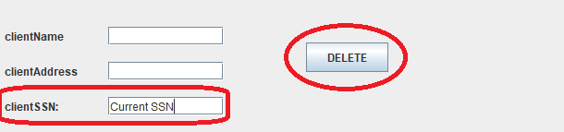

First you have to enter current Primary value. After you press **DELETE** button, if you get this message the data must have been deleted.

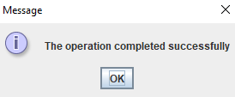

**Advanced Queries**

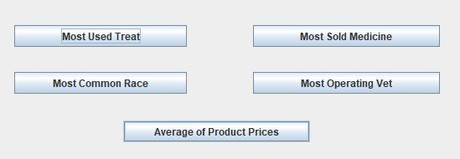

In Queries page there are our advanced queries on buttons. To get the result of advanced queries all we have to do is click the button. The messages are like “answer of query: the number of data”

**Most Used Treat Query Most Sold Medicine Query**

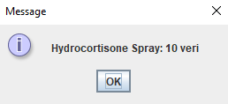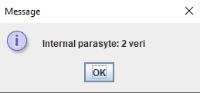

**Most Common Race Query Most Operating Vet Query**

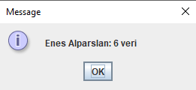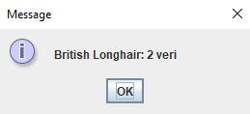

**Average of Product Prices Query**

