

AI/ML Internship
Week 1 Technical Report
Exploratory Data Analysis (EDA)
of the Online Retail II Dataset
Prepared by:
Lerato Nkolokoane
Date: 04/July/2026
Tools Used:
Python | Jupyter Notebook | VS Code | Pandas | NumPy | Matplotlib | Seaborn

1. Introduction
Exploratory Data Analysis (EDA) is a critical first step in any data science or machine learning project. Before building predictive models, it is essential to understand the structure, quality, and characteristics of the dataset. This project analyzes the Online Retail II dataset using Python. The aim is to identify trends, understand customer purchasing behavior, detect anomalies, and generate business insights while leaving the original data unchanged.
The work was completed in Jupyter Notebook using Visual Studio Code.

2. Project Objectives
The objectives of this task were to:
- Load the Online Retail II dataset into Python.
- Explore the dataset structure.
- Understand the variables contained in the dataset.
- Identify missing values.
- Identify duplicate records.
- Analyze the top-selling products by quantity.
- Analyze the highest revenue-generating products.
- Analyze sales performance by country.
- Visualize monthly revenue trends.
- Create a correlation heatmap.
- Detect outliers using box plots.
- Generate business insights from the analysis.
- Produce reproducible code that runs from top to bottom without errors

3. Development Environment
Component | Description
IDE | Visual Studio Code
Notebook | Jupyter Notebook
Language | Python 3
Libraries | Pandas, NumPy, Matplotlib, Seaborn
Version Control | GitHub

4. Dataset Description
Dataset Name:
Online Retail II
The dataset contains historical online retail transactions.
Each transaction includes:

Column Description
Invoice | Invoice number
Stock Code | Product identifier
Description | Product name
Quantity | Number of products purchased
Invoice Date | Date and time of purchase
Price | Unit price
Customer ID | Customer identifier
Country | Customer country

The dataset is suitable for exploratory data analysis because it contains transactional information that allows patterns in sales, products, customers, and revenue to be investigated.

5. Project Structure
ONLINE_RETAIL/
├── Data/
│ online_retail_II.xlsx
│
├── Notebook/
│ Retail_EDA.ipynb
│
├── Screenshots/
│
├── README.md
├── requirements.txt
├── .gitignore
6. Implementation
Step 1 : Importing Libraries; Before analyzing the dataset, the required Python libraries were imported.
Code
Import pandas as pd
Import numpy as np
Import matplotlib.pyplot as plt
Import seaborn as sns
%matplotlib inline
Explanation
- Pandas was used for loading and manipulating tabular data.
- NumPy was used for numerical computations.
- Matplotlib was used to create graphs.
- Seaborn was used to generate advanced statistical visualizations.
- `%matplotlib inline` ensures plots are displayed directly inside the notebook

Step 2 — Loading the Dataset
The dataset was loaded from the Excel file stored in the Data folder.
Code
df = pd.read_excel("../Data/online_retail_II.xlsx")
df.head()
Explanation
The `read_excel()` function reads the Excel file into a Pandas DataFrame.
The `head()` function displays the first five rows to verify that the dataset has loaded correctly.
Output:
Invoice StockCode Description Quantity InvoiceDate Price Customer ID Country
0 489434 85048 15CM CHRISTMAS GLASS BALL 20 LIGHTS 12 2009-12-01 07:45:00 6.95 13085.0 United Kingdom
1 489434 79323P PINK CHERRY LIGHTS 12 2009-12-01 07:45:00 6.75 13085.0 United Kingdom
2 489434 79323W WHITE CHERRY LIGHTS 12 2009-12-01 07:45:00 6.75 13085.0 United Kingdom
3 489434 22041 RECORD FRAME 7" SINGLE SIZE 48 2009-12-01 07:45:00 2.10 13085.0 United Kingdom
4 489434 21232 STRAWBERRY CERAMIC TRINKET BOX 24 2009-12-01 07:45:00 1.25 13085.0 United Kingdom

Step 3 — Exploring the Dataset
The structure of the dataset was explored.
Code
df.shape
df.columns
df.dtypes
df.info()
Explanation
These functions provide:
- Number of rows and columns.
- Variable names.
- Data types.
- Missing values
- Memory usage
Understanding the dataset structure helps determine the appropriate preprocessing techniques for future machine learning tasks.
Output of df.info():
<class 'pandas.DataFrame'>
RangeIndex: 525461 entries, 0 to 525460
Data columns (total 8 columns):
# Column Non-Null Count Dtype
--- ------ -------------- -----
0 Invoice 525461 non-null object
1 StockCode 525461 non-null object
2 Description 522533 non-null object
3 Quantity 525461 non-null int64
4 InvoiceDate 525461 non-null datetime64[us]
5 Price 525461 non-null float64
6 Customer ID 417534 non-null float64
7 Country 525461 non-null str
dtypes: datetime64[us](1), float64(2), int64(1), object(3), str(1)
memory usage: 32.1+ MB

Step 4 — Data Quality Assessment
The dataset was checked for missing values and duplicate records.
Code
df.isnull().sum()
df.duplicated().sum()
Explanation
Missing values can affect model performance, while duplicate records may bias analysis results.
As required by the internship instructions, no records were removed during Week 1. The task focused solely on observation.
Step 5 — Top 10 Best-Selling Products
The products with the highest quantities sold were identified.
Code
top_quantity = (
df.groupby("Description")["Quantity"]
.sum()
.sort_values(ascending=False)
.head(10)
)
top_quantity
Explanation
The dataset was grouped by product description, quantities were summed, and the top ten products were visualized using a horizontal bar chart.
The visualization helps identify the products with the highest customer demand.
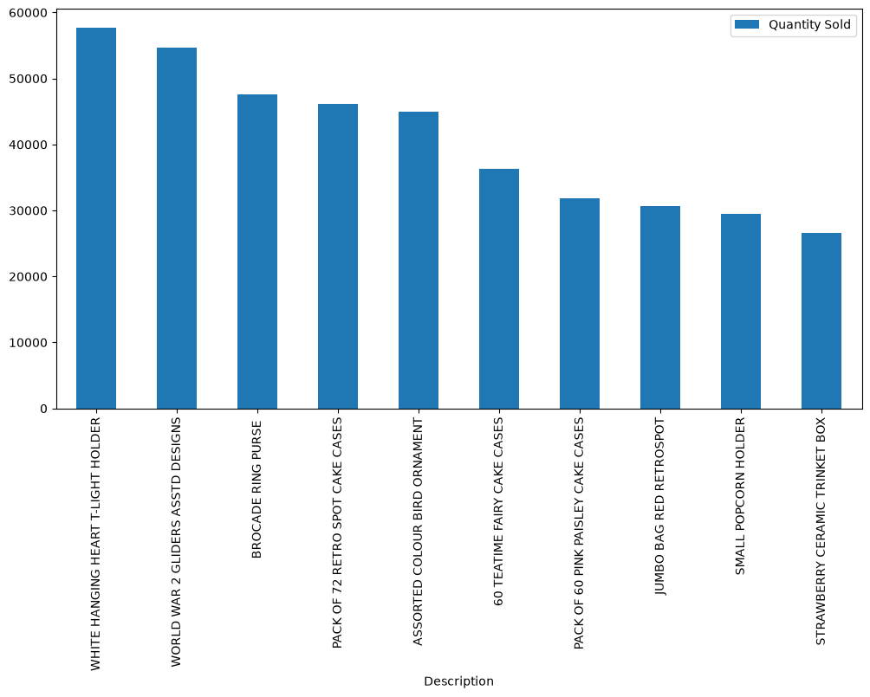
Step 6 — Top 10 Products by Revenue
Revenue was calculated using:
Revenue = Quantity × Price
Code
# Create Revenue Column
df["Revenue"] = df["Quantity"] + df["Price"]
# Display first five rows
df.head()
Explanation
A new Revenue column was created before grouping the data by product description.
The products generating the highest revenue were visualized using a bar chart.
This identifies products that contribute most to total business income.
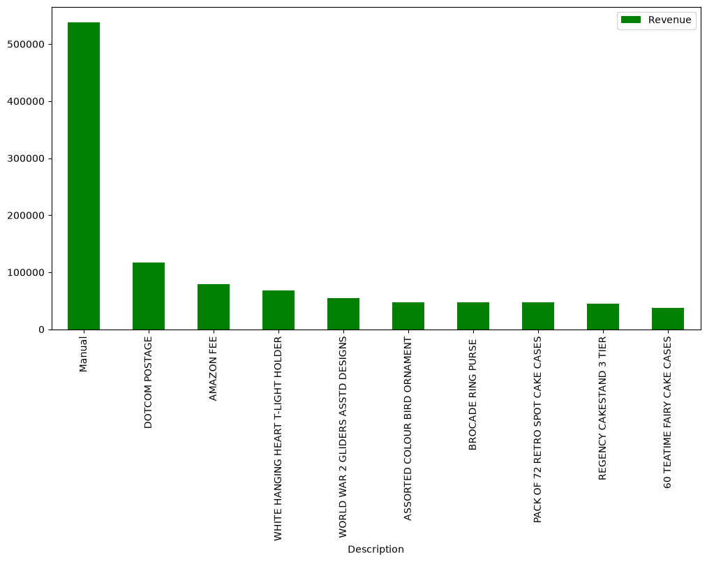

Step 7 — Sales Performance by Country
Code
Country_sales = (
df.groupby("Country")["Revenue"]
.sum()
.sort_values(ascending=False)

)
Country_sales.head(10)
Explanation
Sales were grouped by customer country.
The results were visualized using a bar chart to compare market performance across countries.
This helps identify important international markets.
Step 8 — Monthly Revenue Trend
Code
df["InvoiceDate"].head()
df["Month"] = df["InvoiceDate"].dt.to_period("M")
monthly_revenue = (
df.groupby("Month")["Revenue"]
.sum()
)
monthly_revenu
Explanation
Invoice dates were converted into monthly periods.
Monthly revenue totals were calculated and displayed using a line graph.
Trend analysis helps identify seasonal sales patterns and business growth over time.
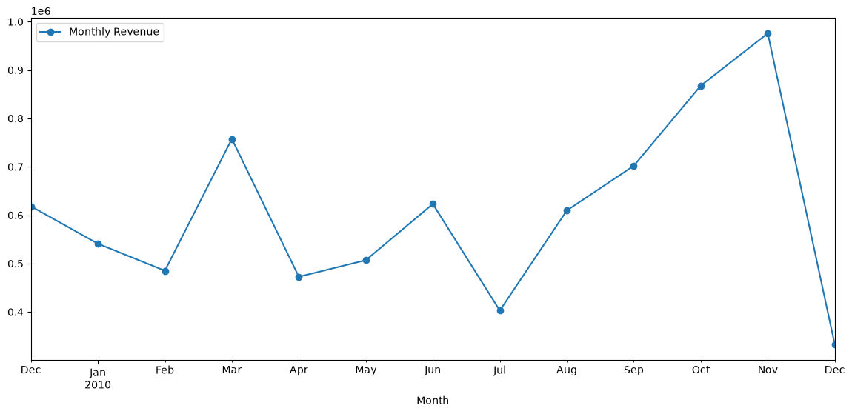
Step 9 — Correlation Heatmap
Code
#Select only numerical columns
Numeric_df=df.select_dtypes(include=["number"])
Numeric_df.head()
#Crreating Correlation matrix
Correlation =Numeric_df.corr()
Correlation
##Heatmap Plot
plt.figure(figsize=(8,6))
sns.heatmap(
Correlation,
annot=True,
cmap="coolwarm",
linewidths=0.5
)
plt.title("Correlation Heatmap")
plt.show()
Explanation
A correlation matrix was computed using numerical variables.
The heatmap visually illustrates relationships between variables. Strong positive or negative correlations help identify variables that may influence each other.
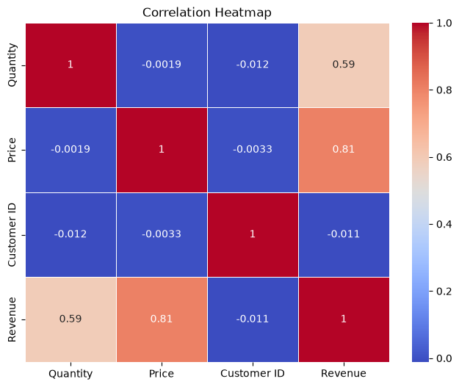

Step 10 — Outlier Detection
Code
## Box plot for Quantity
plt.figure(figsize=(8,5))
sns.boxplot(x=df["Quantity"])
plt.title("Box plot of Quantity")
plt.xlabel("Quantity")
plt.show()

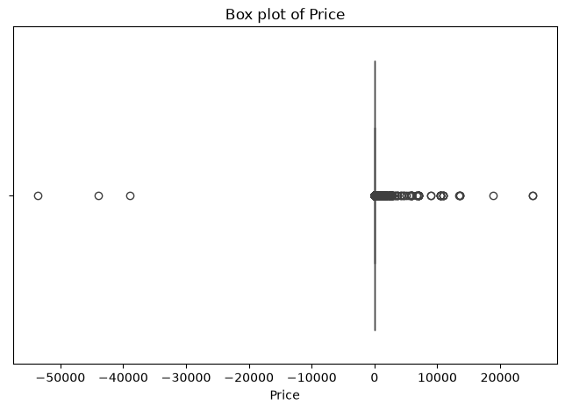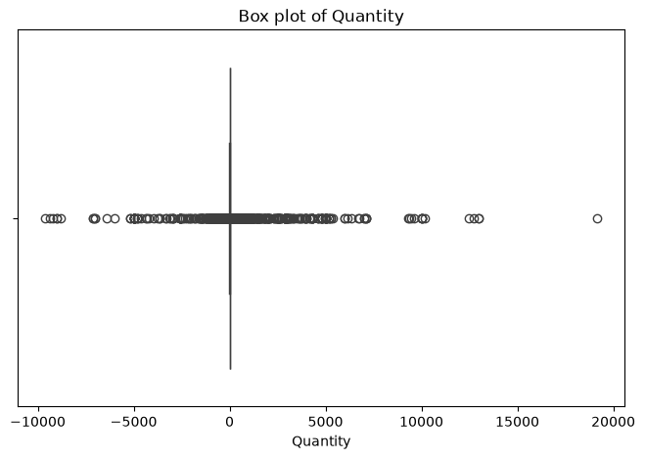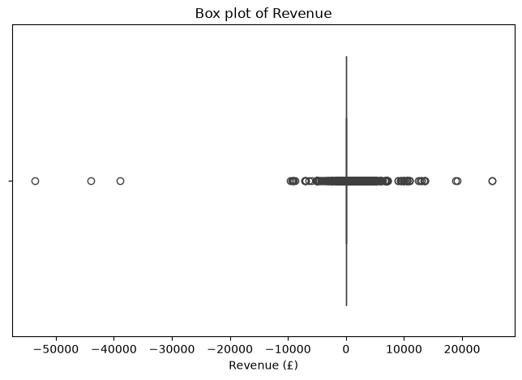

7. Business Insights
The exploratory analysis produced the following insights:
- A relatively small number of products accounted for a large proportion of total sales volume.
- Products with moderate quantities but higher prices contributed significantly to revenue.
- Sales were concentrated in a limited number of countries, indicating strong geographic markets.
- Monthly revenue fluctuated, suggesting seasonal purchasing behaviour.
- Outliers were present in Quantity, Price, and Revenue, indicating unusually large purchases or exceptional transactions that should be examined during preprocessing.

8. Challenges Encountered
During the implementation of this project, several technical challenges were encountered and resolved.
Challenge 1: Jupyter Kernel Failure
Problem:
The notebook could not execute because the required `ipykernel` package was missing.
Solution:
A Python virtual environment was created and the necessary packages were installed using `pip`.
9. Skills Acquired
This project strengthened practical skills in:
- Python programming
- Pandas
- NumPy
- Data visualization
- Jupyter Notebook
- Git
- GitHub
- Exploratory Data Analysis
- Problem solving
- Debugging
- Data interpretation

10. Conclusion
The objectives of Week 1 were successfully achieved. The Online Retail II dataset was explored using Python, and key sales patterns, product performance, geographic trends, and potential data quality issues were identified. The project established a strong foundation for subsequent stages of the AI/ML workflow, including data preprocessing, feature engineering, and predictive modeling.
11. GitHub Repository

