Task1-API Testing

Tools-PostMan

Collection url: <https://documenter.getpostman.com/view/5833161/RzfZMrrQ>

GetBreedList

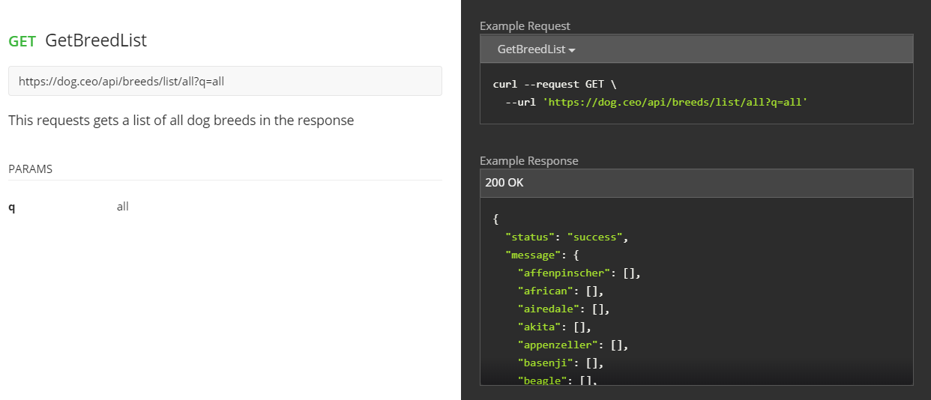

**GET** RetrieverVerification

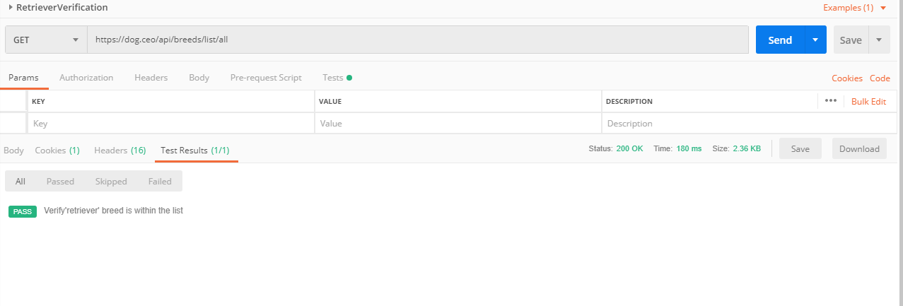

**GET** BySubBreed

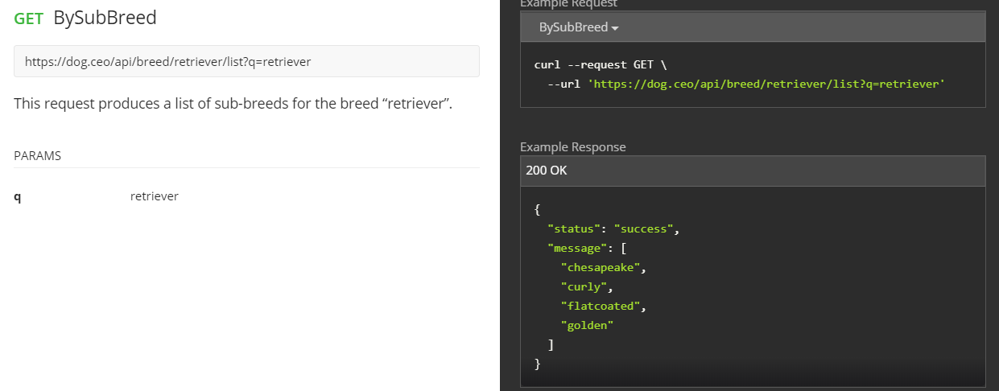

**GET** RandomImage

