VERIFICATION & QUALITY ASSURANCE PACK
Mzansi Solar Excel + DOCX and Imbizo Fin PowerPoint
Important limitation: the pack does not claim any external AI-detection or plagiarism percentage because no authenticated third-party detector result was available. The final screenshot records that limitation rather than manufacturing a score.

Assignment Coverage
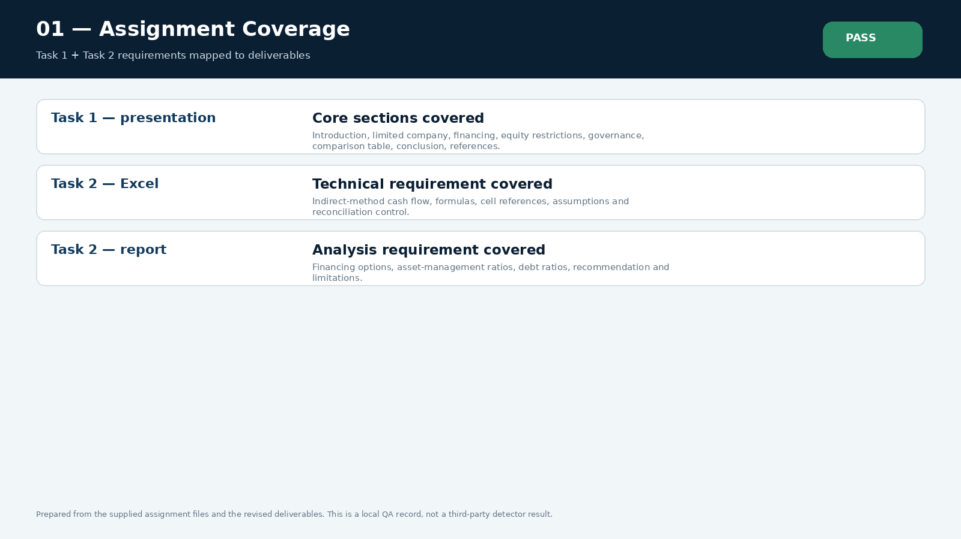
Verification item 1. The screenshot records the specific check and the current result for the final deliverables.

Excel Formula Audit
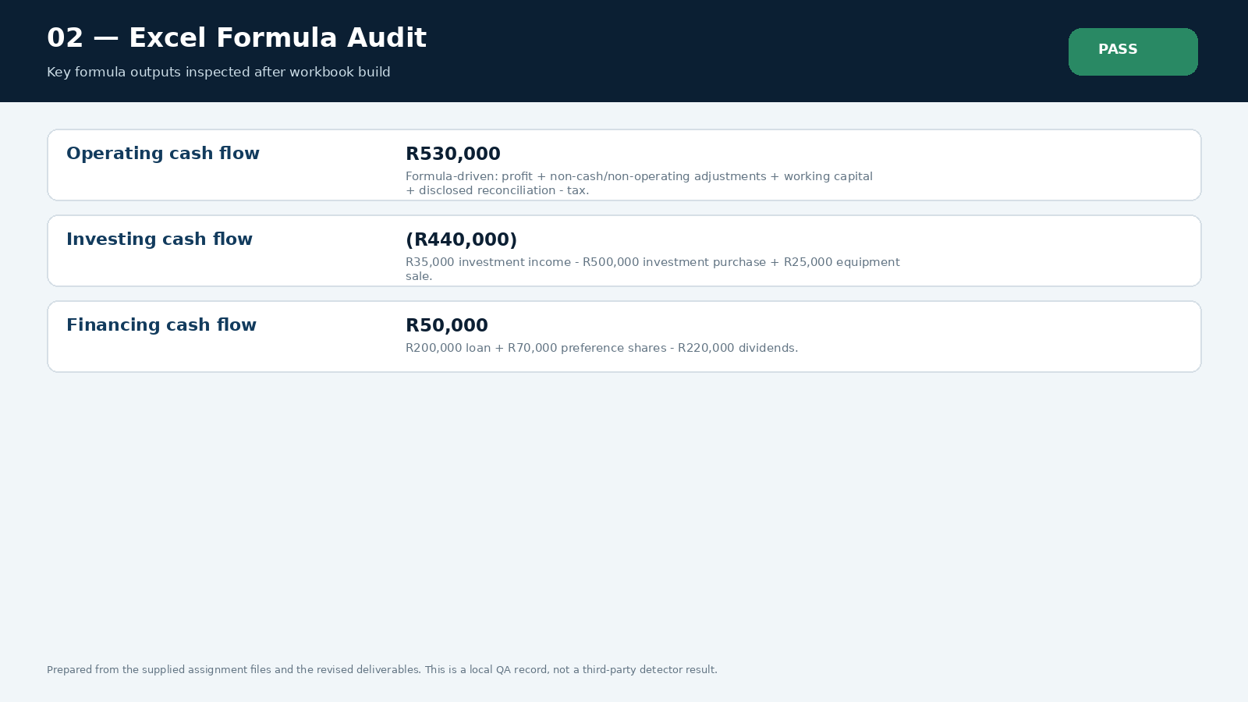
Verification item 2. The screenshot records the specific check and the current result for the final deliverables.

Cash Tieout
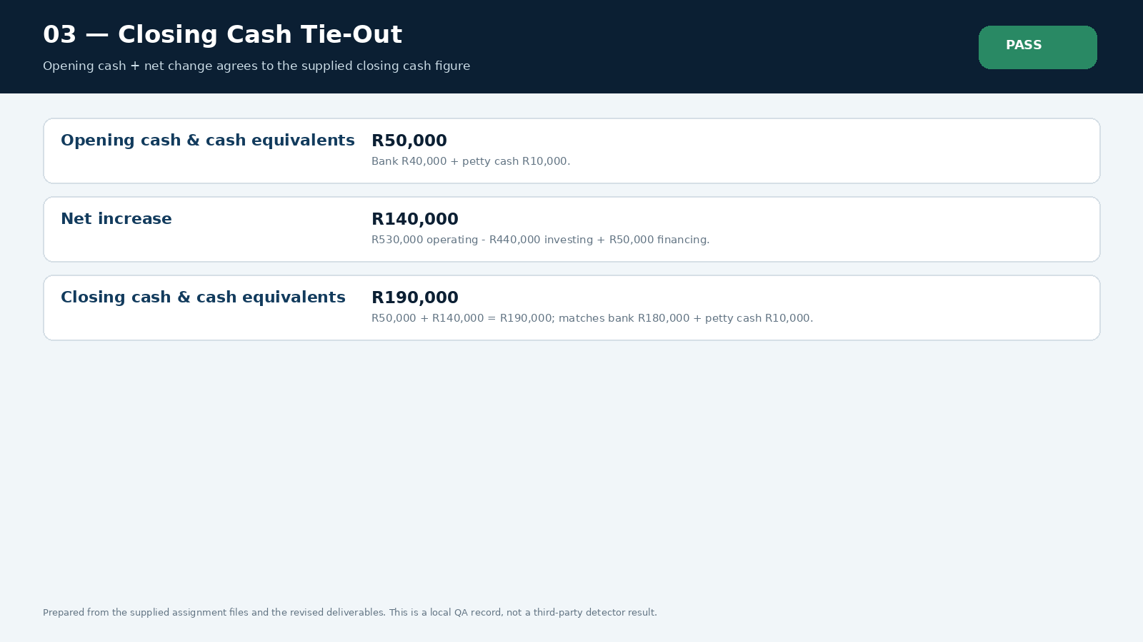
Verification item 3. The screenshot records the specific check and the current result for the final deliverables.

Ratio Verification
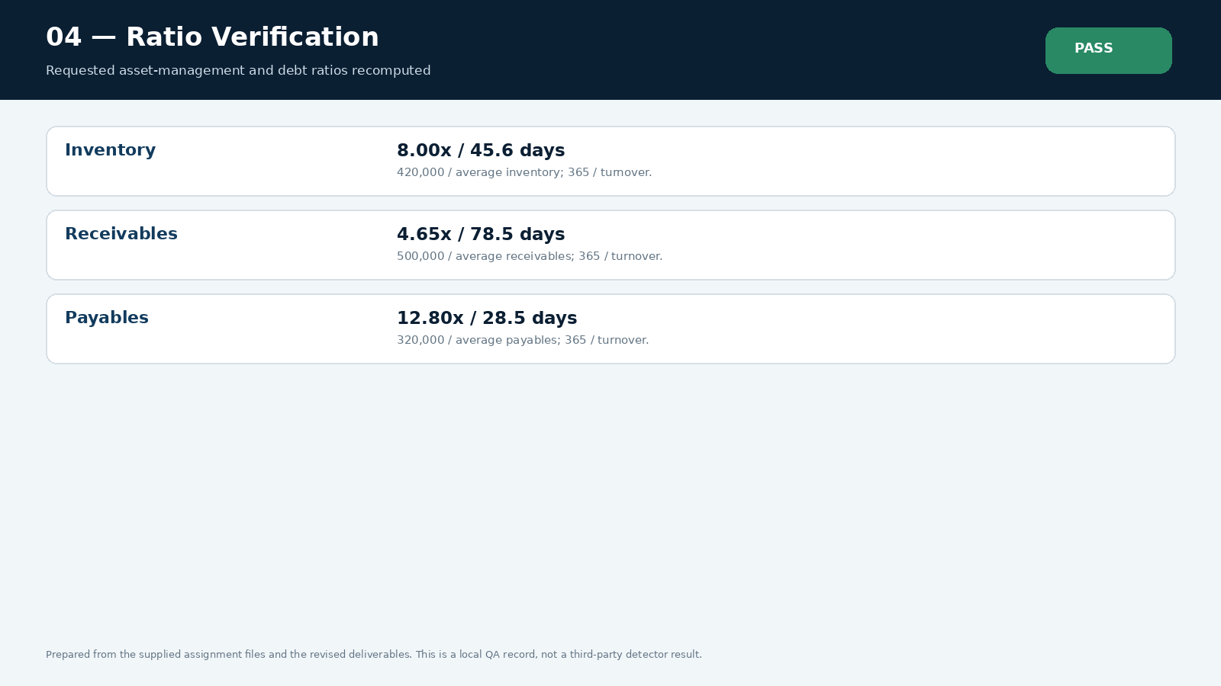
Verification item 4. The screenshot records the specific check and the current result for the final deliverables.

Funding Mix
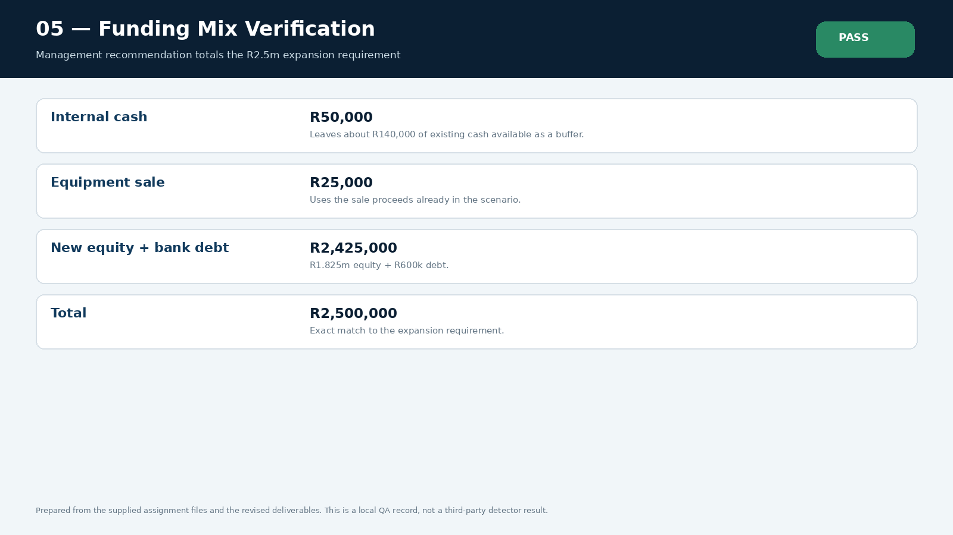
Verification item 5. The screenshot records the specific check and the current result for the final deliverables.

Ppt Rubric
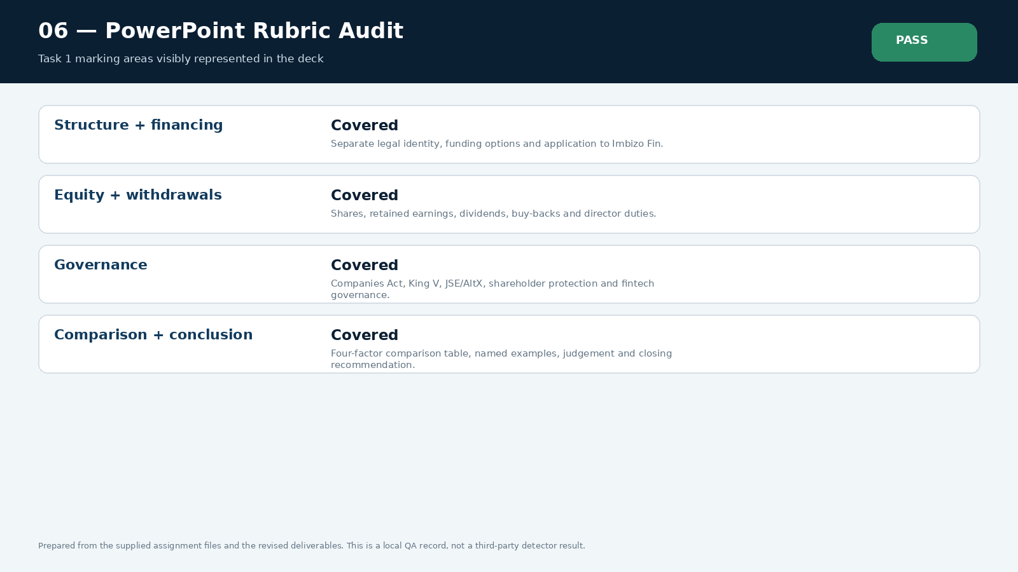
Verification item 6. The screenshot records the specific check and the current result for the final deliverables.

Harvard Audit
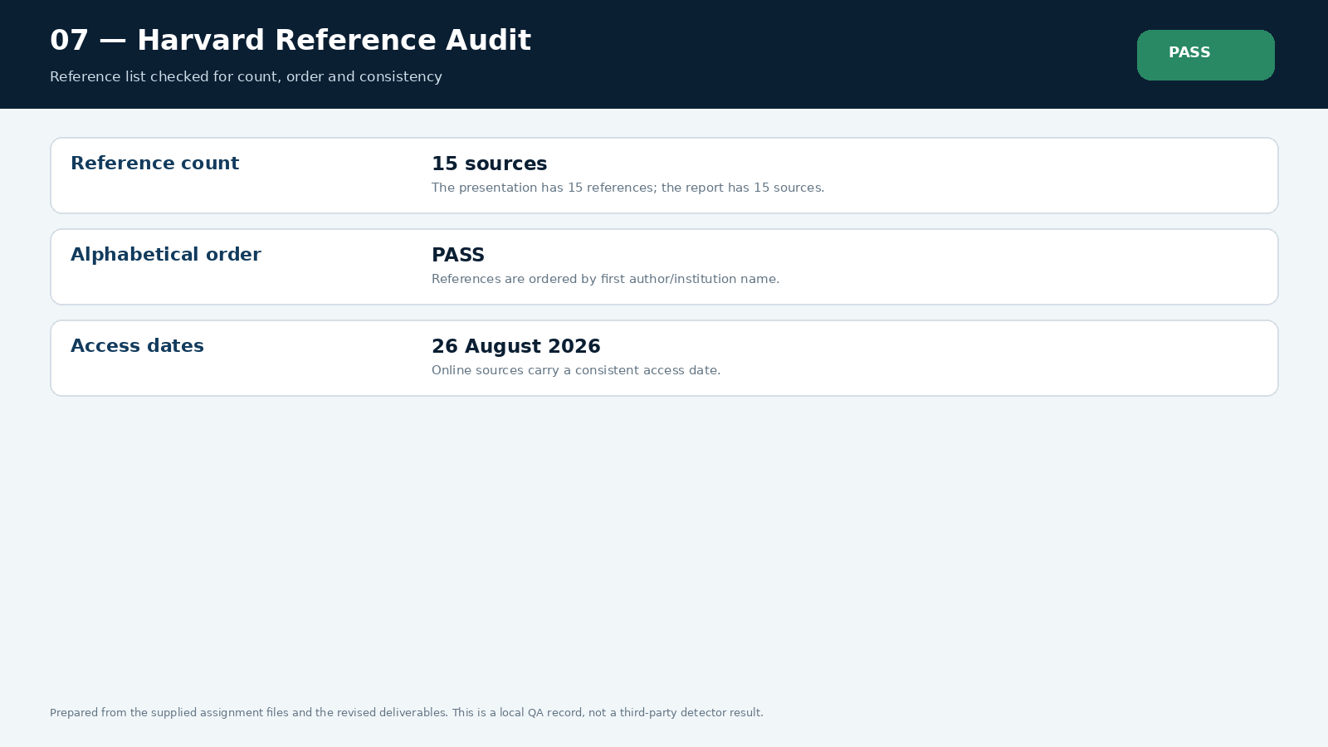
Verification item 7. The screenshot records the specific check and the current result for the final deliverables.

Source Audit
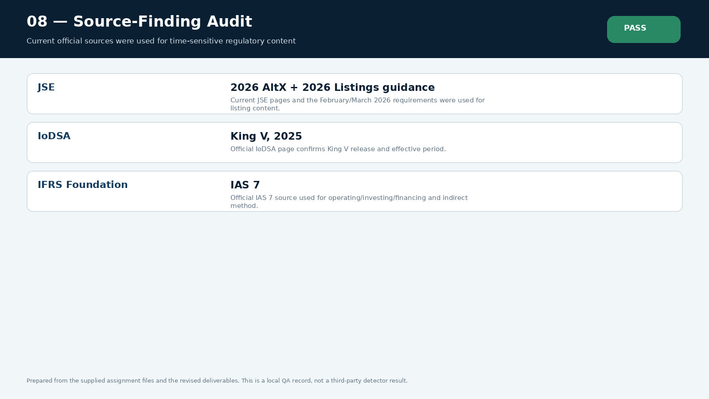
Verification item 8. The screenshot records the specific check and the current result for the final deliverables.

Cross Document
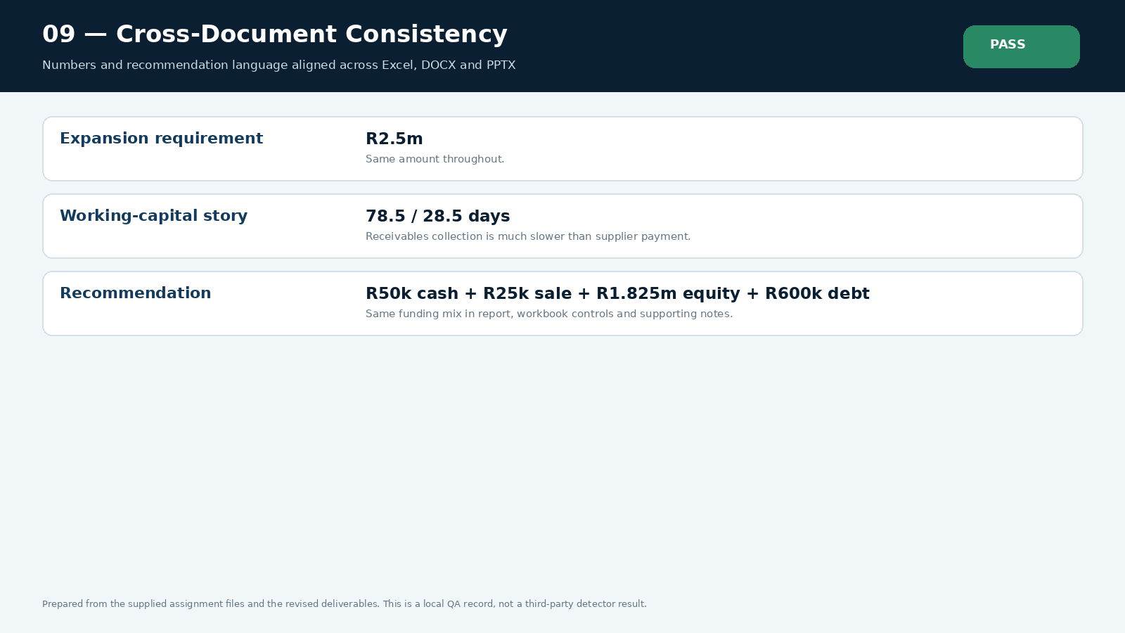
Verification item 9. The screenshot records the specific check and the current result for the final deliverables.

Ai Plagiarism Status
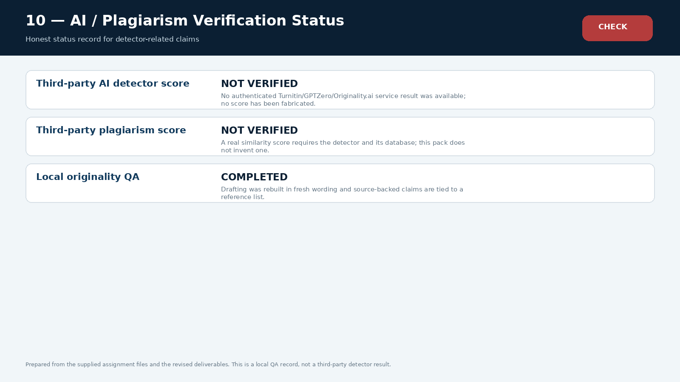
Verification item 10. External detector scores are not claimed. The deliverables were instead checked for consistency, source traceability, formula integrity and visible coverage of the assignment brief.

