Misinformation, Political Hostility and Defamation on Social Media:
A Taxonomy-Driven Social Media Mining Study
[Student Name] | [Index Number]
Social Media Mining (Level 300) — Semester Project
October 2026
Code, data and executed notebook: https://github.com/[your-username]/[repository-name]
Abstract
Social media platforms, moderators and researchers often treat misinformation, political threats and defamation as interchangeable forms of “harmful content”, although they differ in what makes them harmful, how they spread and how they can be detected. This project studies the three categories side by side using open data. For misinformation we analyse 1,056 PolitiFact stories (432 fake, 624 real) from FakeNewsNet; for political hostility we analyse 3,000 tweets about the 2020 US election annotated for stance and hateful speech (Grimminger & Klinger, 2021). No open English defamation dataset exists, a gap we document rather than paper over. Fake stories were far more likely to have any recorded tweets (91% vs 66%; odds ratio = 5.15), but among stories that were tweeted at all, reach did not differ significantly (median 102 vs 58 tweets; Mann–Whitney p = .500), and an apparent correlation between classifier confidence and reach disappeared once untweeted stories were excluded (ρ = 0.05). Title-only TF-IDF classifiers separated fake from real stories (5-fold accuracy ≈ 0.83) but relied on headline style rather than falsity. Tweets opposing a candidate were more often hostile than tweets supporting the same candidate (Trump: 18.5% vs 12.9%, OR = 1.53; Biden: 26.7% vs 11.4%, OR = 2.83), although the annotation scheme partly builds this association in. A hostility classifier reached F1 = 0.40 on the hateful class, and its accuracy (88.8%) did not exceed the majority-class baseline (90.2%). We discuss what these results imply for treating the three categories as distinct detection problems, and we provide a fully reproducible repository.
Keywords: misinformation, fake news, political hostility, defamation, social media mining, text classification, information diffusion

1. Introduction
Online platforms moderate “harmful political content” as if it were a single phenomenon. In practice at least three different problems are bundled together. Misinformation concerns the truth of a claim; political threats and hostility concern the tone and target of a message; defamation concerns a false factual statement that damages the reputation of an identifiable person. Each calls for different evidence: judging misinformation needs a reference for what is true, judging hostility needs a target and a tone, and judging defamation needs all of these plus a showing of harm. Treating them as one category risks both over-removal (a harsh but true statement is not defamation) and under-removal (a false claim about policy is not necessarily a threat, yet a threat need not be false).
The research literature reflects this blur. A recent systematic review of 192 health-misinformation studies found that more than half never defined “misinformation” at all, and that related terms were used inconsistently (Karami et al., 2025). Detection research is also uneven across categories: misinformation and hate speech have many benchmark datasets, while defamation, a legal rather than linguistic category, has almost none.
This project asks whether the three categories behave differently when examined with the same toolkit, and how far open data allows each to be modelled. Table 1 summarises how we operationalise them.
Table 1. Working definitions and the evidence each category requires.
Category | Core criterion | Typical target | Signal needed | Open English data
Misinformation | False or misleading factual claim, regardless of intent | A topic, event or public | Content plus an external truth reference (fact-check) | FakeNewsNet, PolitiFact-derived sets
Political hostility / threat | Language that threatens or demeans a person or group (Gao & Huang, 2017) | A named person or group | Lexical tone plus target mention | Grimminger & Klinger (2021); UK MP set (access-gated, IDs only)
Defamation | False statement of fact that harms the reputation of an identifiable person (legal test) | An identifiable individual or entity | Named target, factual (not opinion) assertion, falsity and harm | None found; Japanese set (IDs only)

Research questions and hypotheses. RQ1: Do false political stories reach more people than true ones? (H1: yes; H0: no difference.) RQ2: Does a text classifier’s confidence that a story is fake relate to how far it spread? RQ3: Is hostile language concentrated in tweets that oppose a candidate rather than support one? (H1: hostility rate is higher among opposing tweets; H0: no difference.) RQ4: Can each category be modelled with openly available data?
Contributions. (i) A side-by-side treatment of three often-conflated categories with explicit working definitions; (ii) a robustness-checked analysis showing that a headline “fake spreads further” result in FakeNewsNet is driven by whether a story was tweeted at all, not by how much; (iii) evidence that opposition and hostility co-occur strongly in 2020 US election tweets, with an explicit discussion of the annotation circularity behind it; (iv) documentation of the open-data gap for defamation; and (v) a reproducible repository with an executed notebook.

2. Related Work

2.1 Misinformation: diffusion and detection
The foundational diffusion study analysed roughly 126,000 rumour cascades on Twitter and found that false news travelled farther, faster and more broadly than true news, with political falsehoods spreading most (Vosoughi et al., 2018). Our misinformation sub-study asks a deliberately narrower version of the same question on a different dataset. FakeNewsNet pairs fact-checked stories with the tweets that shared them (Shu et al., 2020), and UPFD later released propagation graphs built from it (Dou et al., 2021). A bibliometric analysis of fake-news research on social media identifies limited labelled data and evolving concealment tactics as persistent obstacles for detection (Sahid et al., 2025). Work on the fact-checking ecosystem itself shows that the organisations producing ground-truth labels differ in political leaning, so “ground truth” is not neutral (Altuncu et al., 2025). A case study of the “scamdemic” conspiracy theory found that only about one fifth of the most influential accounts were bots and that few rule-violating accounts were suspended within two months, suggesting that misinformation spread is often organic and that enforcement lags policy (Rossi, 2024).

2.2 Hostility toward political figures
Large-scale work on UK public figures labelled 45.5 million tweets directed at 4,602 MPs, footballers and journalists, finding that abuse is highly concentrated on a small share of targets and that journalists were most likely to receive it once other factors were controlled (Burke-Moore et al., 2025). Grimminger and Klinger (2021) built a corpus of 2020 US election tweets annotated for stance toward Trump, Biden and Kanye West and for hateful or offensive speech, and report that hostility is directed at political opponents. Their guidelines follow Gao and Huang’s (2017) definition of hate speech but explicitly extend it to name-calling and “down talking” of the political opponent, a design choice that matters for interpreting stance–hostility associations (Section 6). Davidson et al. (2017) provide a general hate-speech and offensive-language corpus that we use only as a supplementary comparison.

2.3 Defamation
Computational work on defamation is sparse. A recent systematic review of 50 Scopus-indexed studies on authorship attribution for anonymous defamatory texts reports a shift to transformer models (BERT, mBERT, XLM-RoBERTa) and flags the opacity of these models as a concern where outputs may carry legal weight (Rayhan et al., 2025). The one labelled social-media resource we located is a Japanese Twitter dataset whose annotation separates physical threats, insults to appearance or character, and factual accusations that damage reputation from non-defamatory content (Kubota, 2023). That scheme was designed independently of ours yet separates nearly the same three kinds of harm, which supports treating them as distinct categories.

3. Data
Misinformation — FakeNewsNet/PolitiFact. 432 stories labelled fake and 624 labelled real by PolitiFact, each with a title, source URL and the identifiers of tweets that shared it. Full tweet text and user networks require paid API access, which is no longer available free of charge, so we use the story title for text and the number of recorded tweet IDs per story (cascade size) as a diffusion-reach proxy. Cascade size measures breadth of pickup only; it says nothing about speed, depth or community structure.
Political hostility — Grimminger & Klinger (2021). 3,000 tweets (2,400 train / 600 test as released) with full text, stance toward Trump, Biden and West (Favor, Against, Neither, Mixed, Neutral mentions) and a binary hateful/offensive label (HOF). Overall 11.7% of tweets are labelled hateful. West is mentioned too rarely (n = 6 with a stance) to analyse. We also considered the UK MPs hostility dataset, but it ships tweet IDs only and requires paid hydration, so it was not used.
Supplementary — Davidson et al. (2017). 24,783 tweets labelled hate, offensive or neither. A keyword filter yields 332 political-context tweets; this weak proxy is reported for comparison only.
Defamation. We found no open, English, social-media dataset labelled for defamation; a check against a 2025 survey of English hate-speech and abuse datasets found none targeting it. Defamation therefore enters this study through the literature and the discussion, not through a trained model.

4. Methods
Text classification. Titles or tweets were vectorised with TF-IDF (unigrams and bigrams, 5,000 features, English stop-words removed) and classified with L2 logistic regression and a linear SVM, both with balanced class weights (scikit-learn; Pedregosa et al., 2011). For the misinformation task we report the fixed stratified 80/20 hold-out used throughout the project and 5-fold stratified cross-validation, because a single split on about 1,000 stories is noisy. For the hostility task we use the released split and report a bootstrap 95% confidence interval (2,000 resamples) for the F1 score of the hateful class, together with the majority-class accuracy baseline, because the classes are imbalanced.
Reach analysis. Because many stories have no recorded tweets, reach was analysed in two parts: whether a story had any tweets (chi-square test, odds ratio with Woolf 95% CI) and, among stories with at least one tweet, cascade size (Mann–Whitney U test, rank-biserial effect size, bootstrap CI for the difference in medians, 5,000 resamples). The all-stories Mann–Whitney test is reported for continuity with the project’s earlier analysis.
Joint analysis. Every story received an out-of-fold probability of being fake from a calibrated linear SVM, so no story was scored by a model trained on it. Spearman correlations between this probability and cascade size were computed for all stories and, as a robustness check, only for stories with at least one tweet.
Stance–hostility analysis. For Trump and Biden separately we compared the hateful-tweet rate among tweets labelled Against versus Favor (2×2 chi-square with Yates correction, odds ratio with Woolf CI, Wilson intervals for rates). Two tests were run, so Bonferroni-adjusted p-values are reported (α = .025). We also compared hostility among Against-Trump and Against-Biden tweets.
Reproducibility. All results in this paper come from one executed notebook (notebooks/01_full_analysis.ipynb) with a fixed random seed (42); the numbers in the text are read from results/full_analysis_results.json. Section 9 maps every analysis to its file.

5. Results

5.1 Reach of fake and real stories (RQ1)
Fake stories were much more likely to have been tweeted at all: 90.7% of fake stories had at least one recorded tweet against 65.5% of real stories (40 fake and 215 real stories had none; χ² = 87.1, p < .001; odds ratio 5.15, 95% CI 3.58–7.42). Across all stories, fake stories had a far higher median cascade (79 vs 8 tweets; Mann–Whitney p < .001; rank-biserial r = 0.27). That headline difference does not survive conditioning on being tweeted: among the 392 fake and 409 real stories with at least one tweet, medians were 102 and 58 but the rank test found no difference (p = .500; r = 0.028), although the bootstrap interval for the difference in medians (7 to 74 tweets) excludes zero. We read this as at most a small, unreliable difference in magnitude.
Table 2. Reach of fake and real PolitiFact stories (cascade size = recorded tweet IDs).
Measure | Fake | Real | Test
Stories (n) | 432 | 624 | —
Stories with ≥ 1 tweet | 90.7% | 65.5% | χ² test, p < .001; OR = 5.15
Median cascade, all stories | 79 | 8 | Mann–Whitney p < .001; r = 0.27
Median cascade, stories with tweets | 102 (n=392) | 58 (n=409) | Mann–Whitney p = .500; r = 0.028
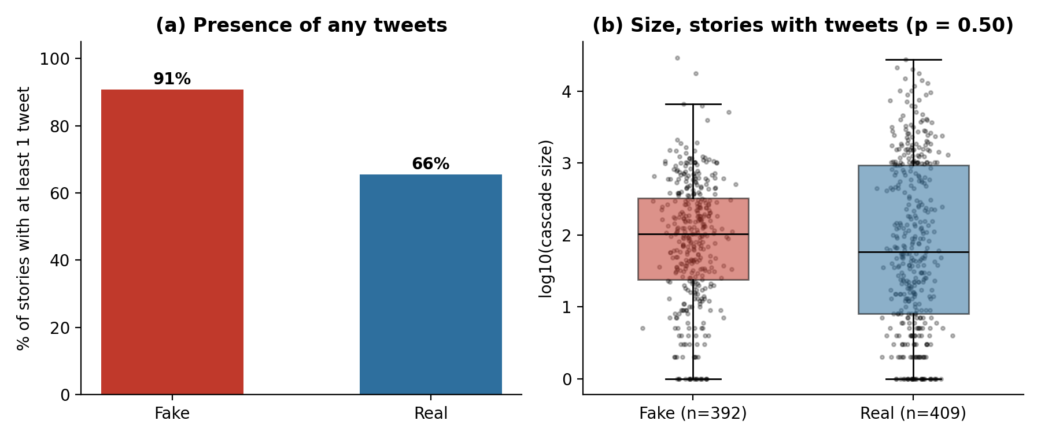
Figure 1. (a) Share of stories with at least one recorded tweet. (b) Cascade size (log scale) among stories with at least one tweet; boxes show the interquartile range and median.

5.2 Classifying fake and real stories from titles
Both models clearly beat the majority-class baseline (59%). On the fixed hold-out the linear SVM reached accuracy 0.877 and F1 0.854, but 5-fold cross-validation gave lower and more reliable estimates (accuracy 0.833 ± 0.014, F1 0.793 ± 0.021), so the single hold-out figure is somewhat optimistic. The strongest fake-indicating terms were trump, breaking, arrested, killed, dead and million; the strongest real-indicating terms were transcript, remarks, debate, interview and senate. The model therefore appears to learn headline style and topic (sensational events versus formal records of speech) rather than falsity as such.
Table 3. Fake-vs-real classification from story titles (positive class = fake).
Model | Hold-out accuracy | Hold-out F1 | 5-fold accuracy | 5-fold F1
Logistic Regression | 0.863 | 0.842 | 0.831 ± 0.025 | 0.795 ± 0.036
Linear SVM | 0.877 | 0.854 | 0.833 ± 0.014 | 0.793 ± 0.021

5.3 Does classifier confidence relate to reach? (RQ2)
Across all 1,056 stories, out-of-fold P(fake) correlated weakly but significantly with cascade size (ρ = 0.20, p < .001). The pattern is an artefact of the zero-tweet stories: restricted to the 801 stories with at least one tweet, the correlation vanishes (ρ = 0.05, p = .157), and it is likewise null within fake stories (ρ = 0.07) and within real stories (ρ = 0.03). Classifier confidence therefore tells us whether a story is likely to be fake, which in this data is associated with being tweeted at all, but not how far it will spread. Figure 2 shows the band of untweeted stories at the bottom of the plot that produces the apparent trend. (An earlier hold-out-only version of this analysis, ρ = 0.21, was subject to the same artefact.)
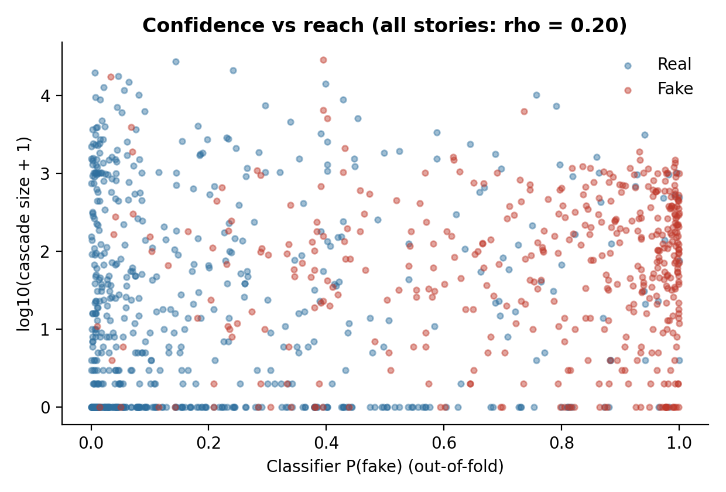
Figure 2. Out-of-fold classifier probability of “fake” against cascade size. The horizontal band at zero is the set of stories with no recorded tweets.

5.4 Hostility and opposition (RQ3)
Hostility was concentrated among tweets that opposed a candidate (Figure 3, Table 4). For Trump, 18.5% of Against tweets were hateful or offensive versus 12.9% of Favor tweets (odds ratio 1.53, 95% CI 1.16–2.01; Bonferroni p = 0.005). For Biden the gap was larger: 26.7% vs 11.4% (odds ratio 2.83, 95% CI 2.14–3.76; Bonferroni p < .001). H0 is rejected for both candidates. Hostility was also higher among Against-Biden than Against-Trump tweets (26.7% vs 18.5%; χ² = 10.5, p = 0.001), although the Against-Biden group is smaller (n = 404 vs 842).
Table 4. Hateful/offensive rate by stance (Grimminger & Klinger, 2021).
Candidate | Against (hateful / n) | Favor (hateful / n) | Odds ratio [95% CI] | p (Bonferroni)
Trump | 18.5% (n=842) | 12.9% (n=780) | 1.53 [1.16, 2.01] | ..005
Biden | 26.7% (n=404) | 11.4% (n=1236) | 2.83 [2.14, 3.76] | < .001
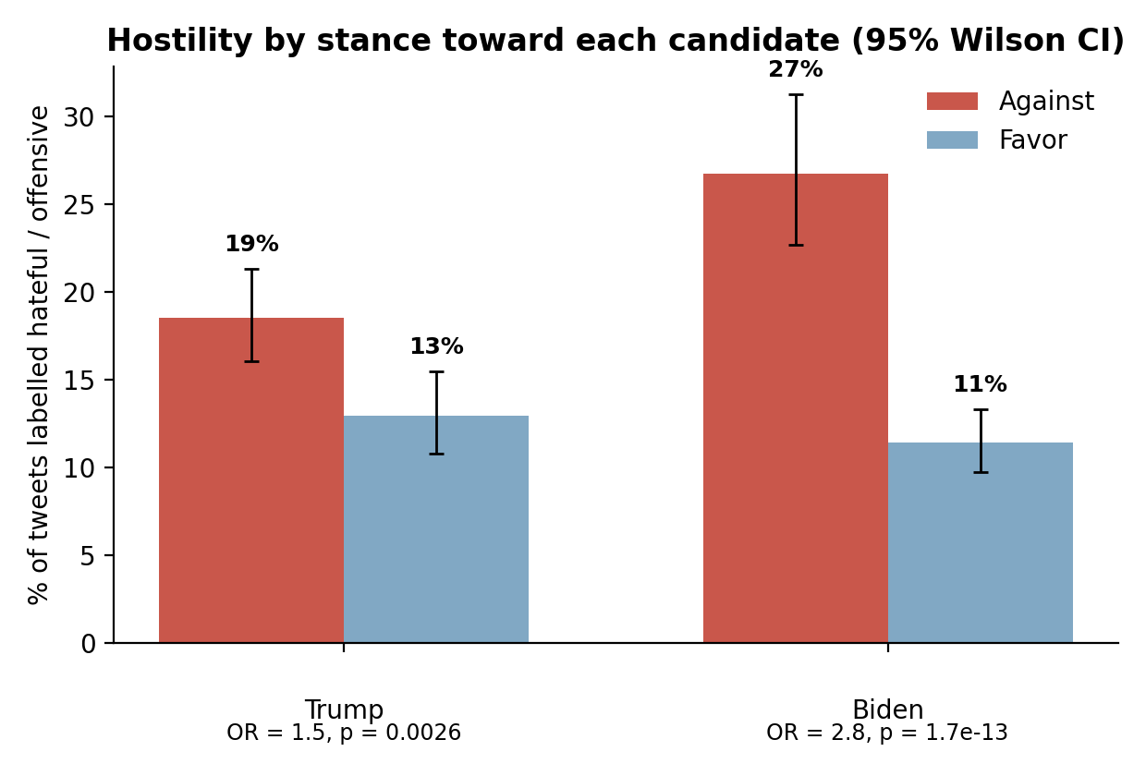
Figure 3. Share of tweets labelled hateful/offensive among tweets Against vs Favor each candidate, with 95% Wilson intervals.
The hostility classifier was modest (Table 5). The linear SVM reached F1 = 0.40 on the hateful class (95% CI 0.28–0.51), with precision 0.42 and recall 0.37. Its accuracy of 88.8% is below the 90.2% obtained by always predicting “not hateful”, so accuracy is not an informative metric here and we report F1. The strongest hateful-indicating terms were profanity, insults (moron, idiot) and name-calling labels (sleepy joe, trumpcrimefamily, creepy joe), exactly the categories the annotation guidelines define as hateful.
Table 5. Hateful-speech classification on the released test split (n = 600; 9.8% hateful).
Model | Accuracy | Precision | Recall | F1 [95% CI] | Macro-F1
Logistic Regression | 0.865 | 0.32 | 0.32 | 0.32 [0.20, 0.42] | 0.62
Linear SVM | 0.888 | 0.42 | 0.37 | 0.40 [0.28, 0.51] | 0.67

Supplementary comparison. In the Davidson corpus, tweets matching political keywords had a hateful rate of 7.83% versus 5.74% elsewhere, a difference in the same direction that was not significant (p = 0.133; only 332 political tweets). We treat this as inconclusive, not as evidence for or against the main result.

6. Discussion
Presence is not magnitude. The strongest and most robust reach result is that fake stories are far more likely to have been tweeted at all. Whether this reflects genuine differences in pickup or differences in how tweets were collected for each class cannot be determined from these data, and we do not claim it replicates the faster, farther spread reported by Vosoughi et al. (2018): once stories with no tweets are set aside, the evidence for larger cascades is weak. The practical lesson is that cascade statistics from FakeNewsNet are zero-inflated and should be analysed in two parts; a single all-stories test, as we initially ran, overstates the difference.
Classifiers read style, not truth. A bag-of-words model separated fake from real titles well above chance, but its most informative features (breaking, arrested versus transcript, remarks) are properties of headline genre. Such a model would probably flag any sensational headline, true or false, and it has no representation of target or harm. This is precisely why content-only classifiers cannot by themselves distinguish misinformation from a threat or a defamatory claim.
Opposition and hostility co-occur, partly by construction. The stance–hostility association is large, significant after correction, and larger for Biden than Trump. It must nevertheless be read carefully. The corpus guidelines label name-calling and “down talking” of the political opponent as hateful, so an opposing tweet that uses a pejorative nickname is hateful by definition. The finding is therefore best stated as: in this annotated corpus, expressing opposition and using abusive or name-calling language co-occur at substantially elevated rates. It should not be read as showing that opponents are more threatening, and it is not evidence about threats of violence specifically, which the binary label does not isolate.
Three categories, three evidence requirements. The two categories we could model need only text and a label: hostility can be approximated from tone and a named target, and misinformation from content plus a fact-check label. Defamation needs more: a named target, a factual rather than opinion assertion, falsity, and harm, the last two of which cannot be read off the text. This may explain why open defamation data are absent and why the one resource we found annotates the harm categories (threat, insult, reputation-damaging claim) rather than legal defamation as such (Kubota, 2023). A realistic next step for the field is a small English corpus annotated for exactly these components.
Implications for moderation. Our results suggest that a single “harmful content” classifier would conflate behaviours that differ in evidence needs and in how they spread: misinformation correlates with being picked up at all, while hostility concentrates on opposition. They also illustrate why reporting only accuracy can mislead on imbalanced hostility data.

7. Limitations and Threats to Validity
- Proxy for diffusion. Cascade size is a count of recorded tweet IDs, not a propagation network; it ignores speed, depth, community structure and who spreads content. The zero-tweet stories may reflect collection coverage or deleted tweets, which we cannot separate.
- Title-only text. Classifiers use headlines, not article bodies, and the observed style cues may partly reflect how PolitiFact stories were sourced.
- Classifier simplicity. We evaluate TF-IDF models only. A pre-trained transformer (DistilBERT) and a graph-based analysis of UPFD propagation trees were prepared as notebooks but could not be executed in the available environment, so no results from them are reported.
- Annotation circularity. The stance–hostility association is inflated by guidelines that treat name-calling of opponents as hateful; the HOF label does not separate threats of violence from insults.
- Small and unbalanced hostility data. Only about 12% of tweets are hateful, the test split contains 59 hateful tweets, and the F1 interval is wide (about 0.28–0.51). Against-Biden tweets are fewer than Against-Trump tweets.
- Single event and platform. The hostility corpus covers one election on one platform; results may not generalise to other contexts, languages or periods.
- Keyword proxy. The Davidson political subset is selected by keywords and is small; it is supplementary only.
- Defamation not modelled. No model or hypothesis test is offered for defamation; claims about it rest on the literature.
- Multiple comparisons. Two stance tests were Bonferroni-corrected; the many descriptive robustness checks were not, and should be read as exploratory.

8. Conclusion and Future Work
Examined with one toolkit, misinformation and political hostility show different patterns. Fake political stories were much more likely than real ones to be tweeted at all, but not demonstrably more widely tweeted once they were, and classifier confidence did not predict reach. Hostile language was strongly associated with opposing a candidate, although partly because of how hostility was defined. Defamation could not be modelled for lack of open data, which is itself a finding. The main methodological lessons are to analyse zero-inflated reach in two parts, to benchmark imbalanced classifiers against the majority class, and to inspect what classifiers actually learn.
Future work includes (i) running the prepared DistilBERT notebook and comparing it with the TF-IDF baselines; (ii) analysing UPFD propagation graphs for depth, breadth and community structure; (iii) hydrating the UK MPs dataset to test the opposition–hostility finding outside the US; and (iv) building a small English corpus annotated for defamation components (named target, factual claim, falsity, harm) and a joint multi-label model across the three categories.

9. Reproducibility and GitHub Evidence
All analyses were run on public datasets with fixed seeds. Table 6 maps each reported analysis to the file that contains it in the repository. Notebooks marked “not executed” are included for transparency and contain no reported results.
Table 6. Mapping of analyses to repository artefacts.
Analysis | Artefact | Location
All results in Sections 5–6 (executed) | Executed notebook with outputs | notebooks/01_full_analysis.ipynb
Numbers quoted in this paper | Machine-readable results | results/full_analysis_results.json
Figures 1–3 | PNG files | figures/
Misinformation baseline, reach, joint analysis (scripts) | Standalone scripts and JSON | scripts/, results/
Hostility classifier and stance tests (scripts) | Standalone scripts and JSON | scripts/train_gk_classifier.py, results/
Datasets used | Raw/processed data and licences notes | data/
Literature notes | Annotated bibliography | docs/bibliography.md
DistilBERT fine-tuning (not executed) | Colab notebook | notebooks/BERT_finetuning.ipynb
UPFD graph analysis (not executed) | Colab notebook | notebooks/UPFD_network_analysis.ipynb

Environment. Python 3 with pandas, NumPy, SciPy, scikit-learn and matplotlib (requirements.txt); no API keys, network access or GPU needed for the executed analyses.
Ethics and data use. All data are previously published research datasets. The hostility corpus contains offensive language; only aggregate statistics and short lexical features are reported, and no attempt was made to identify users.

References
Altuncu, E., Başkent, C., Bhattacherjee, S., Li, S., & Roy, D. (2025). FACTors: A new dataset for studying the fact-checking ecosystem. In Proceedings of the 48th International ACM SIGIR Conference on Research and Development in Information Retrieval (pp. 3530–3539).
Burke-Moore, L., Williams, A. R., & Bright, J. (2025). Journalists are most likely to receive abuse: Analysing online abuse of UK public figures across sport, politics, and journalism on Twitter. EPJ Data Science, 14, 32.
Davidson, T., Warmsley, D., Macy, M., & Weber, I. (2017). Automated hate speech detection and the problem of offensive language. In Proceedings of the 11th International AAAI Conference on Web and Social Media.
Dou, Y., Shu, K., Xia, C., Yu, P. S., & Sun, L. (2021). User preference-aware fake news detection. In Proceedings of the 44th International ACM SIGIR Conference on Research and Development in Information Retrieval.
Gao, L., & Huang, R. (2017). Detecting online hate speech using context aware models. In Proceedings of the International Conference Recent Advances in Natural Language Processing (pp. 260–266). INCOMA.
Grimminger, L., & Klinger, R. (2021). Hate towards the political opponent: A Twitter corpus study of the 2020 US elections on the basis of offensive speech and stance detection. In Proceedings of the 11th Workshop on Computational Approaches to Subjectivity, Sentiment and Social Media Analysis (WASSA @ EACL 2021).
Karami, A., Zain, A., & Jamal, A. (2025). Unveiling the information mirage: A systematic literature review of health misinformation on social media. Journal of Public Health. https://doi.org/10.1007/s10389-025-02639-2
Kubota, I. (2023). Twitter Japanese defamation detection dataset [Data set]. Hugging Face. https://huggingface.co/datasets/kubota/defamation-japanese-twitter
Pedregosa, F., et al. (2011). Scikit-learn: Machine learning in Python. Journal of Machine Learning Research, 12, 2825–2830.
Rayhan, M., Boeriswati, E., & Iskandar, I. (2025). Authorship attribution on anonymous defamatory texts in social media: A systematic review. Universitas Negeri Jakarta.
Rossi, S. (2024). Bots on social media (PhD dissertation, PhD Series 19.2024). Copenhagen Business School. [Paper II: The scamdemic conspiracy theory and Twitter’s failure to moderate COVID-19 misinformation.]
Sahid, A., Maleh, Y., & Ouazzane, K. (2025). Changing landscape of fake news research on social media: A bibliometric analysis. Quality & Quantity, 59(Suppl 2), 901–954.
Shu, K., Mahudeswaran, D., Wang, S., Lee, D., & Liu, H. (2020). FakeNewsNet: A data repository with news content, social context, and spatiotemporal information for studying fake news on social media. Big Data, 8(3), 171–188.
Vosoughi, S., Roy, D., & Aral, S. (2018). The spread of true and false news online. Science, 359(6380), 1146–1151.

