**[CORPORATE TRAINING](https://www.ispringsolutions.com/blog/corporate)**

**LMS Pricing Guide: Find the Pricing Model That’s Right for You**

*In this blog post, we’ll look into different LMS pricing models and their cost structure, and give you step-by-step instructions on how to pick the best choice for your training goals.*

 13 minutes

 5862 views



*“People spend 59% more than they expect to on their Learning Management System,”* according to [Capterra](https://www.capterra.com/learning-management-system-software/user-research). Whether you’re just getting started with eLearning in your company, or planning to change your LMS vendor, estimating the final cost of a [learning management system](https://www.ispringsolutions.com/blog/what-is-lms) may seem like a full-scale investigation.

**Popular LMS Pricing Models**

There are several basic types of pricing plan. To make things easier for you, we’ve put together a comparison table of the most common pricing models and how much you would pay monthly, based on the number of learners in your organization. Click on each pricing model to get a detailed analysis.

| **Learning Management System Pricing Models Comparison** | | |
| --- | --- | --- |
| 1. Pay-per-learner | | |
| **How it works** | **This plan is for you if…** | **Price Range for this Model** |
| You’ll pay a fixed price for a fixed number of learners. | * the number of learners is stable; * the training in your company is obligatory. | * TalentLMS (also has per-active-user pricing) — from $39/month * JoomlaLMS — from $37/month |
| 2. Pay-per-active-user | | |
| **How it works** | **This plan is for you if…** | **Price Range for this Model** |
| You’ll be charged for users who used the LMS during a billing cycle. | * you need to add temporary users or conduct one-time training; * you’d like to spread training for different batches of learners evenly throughout the year. | * [iSpring Learn LMS](https://www.ispringsolutions.com/ispring-learn/pricing.html) — from $366/month * Litmos — from $900/month * LearnUpon — from $399/month |
| 3. Pay-as-you-go | | |
| **How it works** | **This plan is for you if…** | **Price Range for this Model** |
| You’ll pay only for what you use. | * you aren’t sure there will be a stable demand for learning. | * Upskill — no monthly fees, about $2 per learner per course if you buy a large credit package in advance. Otherwise, the price is higher. |
| 4. License fee/subscription | | |
| **How it works** | **This plan is for you if…** | **Price Range for this Model** |
| You’ll pay a set price for a periodic license. The price is usually tiered depending on the included features. | * you know for sure which features you need; * you’re a large enterprise and need a large capacity of users. | * Teachable — from $399/month * Easy LMS — from $199/year * LearnDash — from $159/year |
| 5. (Free) open source | | |
| **How it works** | **This plan is for you if…** | **Price Range for this Model** |
| You’ll pay nothing for access. However, you’ll need setup, customization, and maintenance, which can be rather expensive. | * you want to stay independent of vendors; * you need highly tailored features; * you need high user capacity * you have IT professionals to customize and maintain the system. | * Moodle — free * Forma LMS — free * Totara Cloud — from $4,500/year |

**1. Pay-per-learner**

The pay-per-learner model is also often called pay-per-seat. The principle is simple: you pay a fixed price for a certain number of learners added to the system. The benefit of this pricing model is that you can easily predict your monthly and yearly expenses for the learning management system.

Pay-per-learner prices are tiered: as the number of users goes up, the rate goes down. The amount of learners is usually calculated per month or year.

**Pay-per-learner pricing example**

As an LMS is a service you will stick with for a while, most providers encourage you to pre-pay yearly at an additional discount. Say you have 150 learners in your Talent LMS account. Paying for a year would reduce your cost from $3,108 a year to $2,388, saving you $720.

Here’s a typical example of this pricing model:

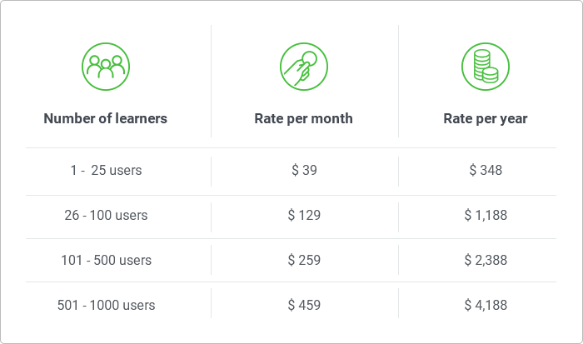

**Takeaway**

This model is very popular largely because of its simplicity, but in some cases this simplicity may cost you a lot. By paying per learner, you pay for hundreds of people added to the LMS upfront. However, that doesn’t give you any guarantee that those employees will actually log into the system and study. So, pay-per-learner makes sense when the amount of learners remains more or less the same for long periods of time, and eLearning is obligatory at your company.

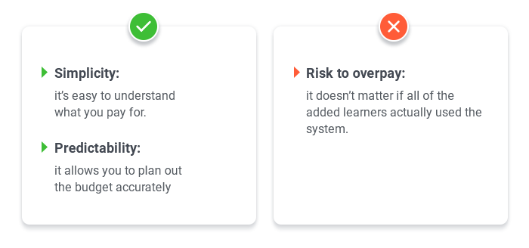

**2. Pay-per-active-users**

Pay-per-active-users pricing is the second most popular model; it addresses the problem of the previous pricing model. As opposed to per-learner plans, which are charged irrespective of usage, it allows you to add an unlimited number of users to the LMS; you’ll only be charged for the ones who logged into the system during the pay period.

The one thing you should know before committing to this model is that the price is usually bundled. For example, let’s say you expect to have 250 active users each month, so you choose the corresponding plan. Even if you don’t hit 250 but have, say, 200 users, you’ll still have to pay for 250.

[iSpring Learn LMS](https://www.ispringsolutions.com/ispring-learn?ref=blog-insert)

Automate corporate training and improve employee performance.

[Get Free Trial](https://www.ispringsolutions.com/ispring-learn/get-free-trial.html?ref=blog-insert)[Learn more](https://www.ispringsolutions.com/ispring-learn?ref=blog-insert)

**Pay-per-active-users pricing example**

Let’s suppose you are going to train 120 employees in iSpring Learn LMS. 37 of them are salespeople; they’ll be the most active learners, who need to maintain their knowledge of products and sales techniques, as well as have instant access to presentations and promo materials uploaded to the LMS. The remaining 83 employees will be divided into groups; their training will be spread evenly over a year. So, each month you expect about 80-90 active users, including up to 5 new team members who will have to take onboarding courses.

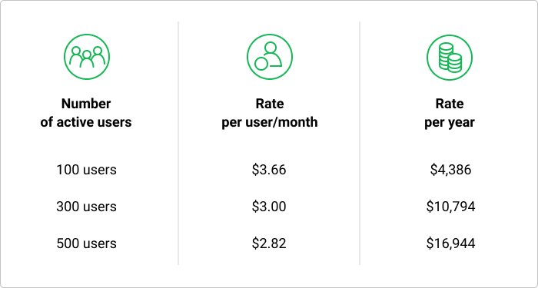

The iSpring Learn pricing plan that fits that number costs $3.66 per user per month and $4,386 per year. This price also includes a 1-user subscription to an authoring toolkit, iSpring Suite, and technical support.

**Takeaway**

The per-active-users pricing model is convenient when you need to train different groups of learners each month, for instance, if you’re a large enterprise and need to train your customers or partners. Plus, you don’t need to worry about inactive accounts, as you won’t be charged for them anyway.

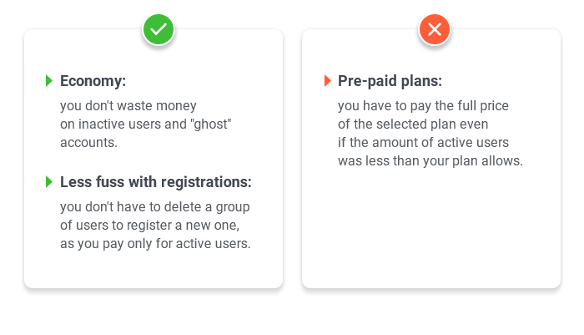

**3. Pay-as-you-go**

The cost of an LMS with this pricing model is directly linked to its usage. You pay little in off-peak times, but may have to pay a fortune when there is a rush of users.

In practice, pure pay-as-you-go isn’t a very popular pricing model among LMSs despite the fact that it lets you stay footloose and fancy free. eLearning isn’t typical SaaS, as launching it takes too many resources (in personal effort if not just money) to conduct it only occasionally.

**Pay-as-you-go pricing example**

Upskill LMS is among the few that stick to this model. It charges no license, no setup, and no hosting fees. Instead, they offer you to pay for learners to take training courses with “credits”. For example, you will need 3 course credits to sell a course to one learner. For each SCORM course, they charge one additional credit. One credit amounts to $3, so you’ll pay up to $10 for each user who buys your content. You can also buy credits in advance and in volume to get a discount.

**Takeaway**

This model can benefit those who sell their e-courses, as this model guarantees that costs go up only during periods of increased revenue. This way you can be sure that you’ll always be able to afford the change in price.

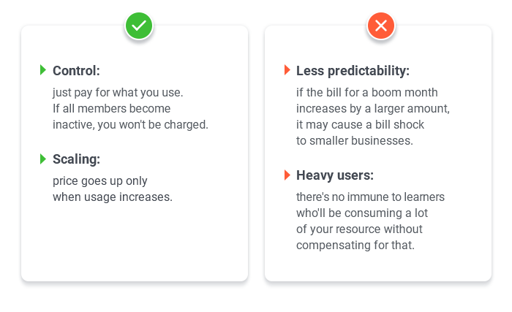

**4. License Fee/Subscription**

This is probably the easiest pricing model: you buy a periodic license for an LMS, pay a set (often annual) fee, and add as many users and courses as you want.

However, flat rate pricing (single price, single set of features) is relatively uncommon, and most vendors offer two or three flat-fee plan types to choose from. The price depends on the number of features included in the package. With each upgrade, new functionality is unlocked. Plus, when dealing with this pricing model, you need to keep in mind that the variation in the prices of different LMSs at first sight can be really significant (if not terrifying).

**Licensing fee example**

Teachable’s Business plan with an unlimited number of users and maximum feature set costs $4,788 per year. As a comparison, Topyx’s Essentials plan costs $19,500 per year. For that price, they offer you 3,000 user accounts, 100 GB of storage, and tech support. Topyx’s Expanded plan for $29,500 per year grants access to all the features of the company’s product: unlimited number of users, eCommerce, webinars, dedicated support team, and so on.

**Takeaway**

As you can see, it’s absolutely necessary to do your homework and estimate the value of each feature included and not included in the offered packages. The prospect of not worrying about the number of users and other things might be tempting enough when buying an all-inclusive package, but if your company is new to eLearning or simply doesn’t need many extra features, this kind of pricing plan can be a waste of money. On the other hand, if you choose a plan with too few features, it may be really expensive to upgrade.

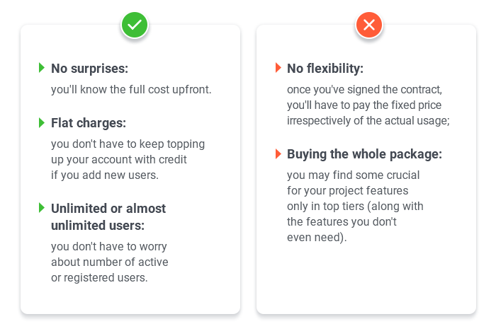

**5. (Free) Open source LMSs**

Actually, “open source” isn’t a pricing model. The term means that the original source code of the LMS is open and can be freely distributed and modified. We’ve added it to the list, because open source LMSs are often contrasted with those that have closed code. The main benefits are flexibility, meaning you can make any customization you want, and cheaper price. Just keep in mind that it’s not an out-of-the-box solution.

If software is open source, it doesn’t necessarily mean that it is free. Open source vendors declare: “Pay for service, not for code.” In fact, that means that the real cost of an open source LMS involves customization, integrations, and maintenance, as such LMSs require extensive configuration to suit a given organization. Craig Weiss described [the main costly challenges of open source](https://elearninfo247.com/2010/11/16/encore-moodle-pros-challenges/) you’ll have to face, and the largest of them is that you need to have strong technical skills to work with such LMSs. Otherwise, you’ll have to hire someone who knows programming languages.

**Open source LMS example**

The best known specimen of open source LMSs is Moodle, which is designed for educators and is distributed free of charge. Its corporate offshoot Totara is also an open source LMS, but offers customers annual subscription plans with prices based on the number of active users (starts from $4,950/year).

**Takeaway**

As it’s rather hard to provide you with even an approximate price, since it strongly differs depending on a particular project, here’s a formula that will help you to get the lay of the land:

*LMS price (may be free) + Hosting + Setup fee + Customization (or buying plugins) + dedicated IT specialist salary*

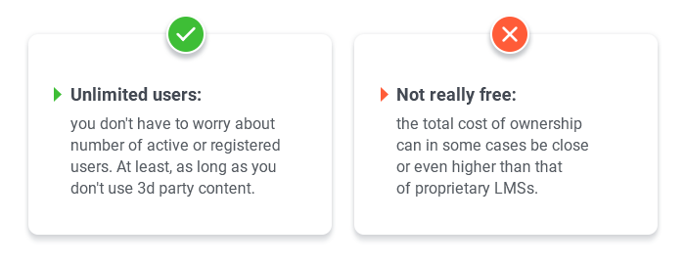

**How to Choose the Best LMS Pricing Model?**

The variety of LMS pricing plans may look like a confusing minefield of number of users, courses, and features. Before committing to an LMS purchase, follow our instructions to work out the right plan that meets your needs.

**Step 1: Tally up the users you plan to train**

Before opting for a certain LMS, figure out how many learners will use the system during a billing cycle, say, a month. Will this amount be stable throughout the year?

**Step 2: Determine how long the LMS will be used by each user**

Will all your users be the same people, or will they come and go? If you plan to use an LMS for onboarding courses only, the total amount of active users may be stable, more or less, but the users will be different.

**Step 3: Estimate how many courses you’re going to upload**

In many cases, LMS cost is based on the number of uploaded courses and space needed for data storage. If you conduct training regularly throughout the day, then look for a provider and a plan with a high or unlimited data storage allowance.

**Step 4: Define essential features and integrations**

Do some preliminary research to make a list of features you need. Thanks to this homework, you’ll save time on negotiations with providers who don’t offer the necessary features. Also, this list will help you to better estimate the real value provided with each pricing plan.

Let’s look at how this works in a real-life example.

***Situation****: Oticon is a hearing healthcare company. It needs to maintain a high level of knowledge and skills among all 250+ employees across the country. It is crucial that all employees hear the same consistent messages related to the products sold by Oticon.*

*There is a 10-week onboarding training program for new account managers who join the company and a wide range of product training, totaling more than 300 e-courses.*

*The most essential features they need:*

* *offline capabilities for account managers and field trainers*
* *reporting feature to measure and monitor completions*
* *learning paths feature in order to create individualized plans*

***Estimating options****: Billing for the number of users in the system isn’t cost effective for the case, as with that number of users they’d like to pay only for what they use and save some money.*

*The reason why Oticon didn’t go for LMSs with a license fee model is that the features they need weren’t present in the basic plans, and all plans like “Business” or “Professional” also include excessive features and integrations. There wasn’t any point paying a monthly/yearly fee and missing out on some of their functionality.*

*The reason why Oticon refused an open source solution is the lack of user-friendliness and the time- and resource-consuming processes.*

***Solution****:*[*LMS with pay-per-active-users pricing model*](https://www.ispringsolutions.com/ispring-learn)*with unlimited space for data storage, mobile app for offline use, and learning path feature.*

**4 More Questions to Estimate LMS Cost**

We’ve collected a list of the most commonly asked questions. Getting the answers to them will provide you with a better understanding of learning management system pricing, and help you find out how much your LMS really costs.

**1. What features are included in each pricing plan?**

As we already discussed, some LMSs are sold in packages that include different features: the higher the price, the more robust the system. If you’ve done your homework and defined the features that are crucial for your project, you’ll be able to estimate the value of each plan offered by a vendor.

**2. Are there any extra fees I’ll have to pay after purchasing the LMS?**

In other words, find out if there are any hidden payments. Sometimes vendors additionally charge for the LMS setup, training, technical support, hosting, upgrades, and add-ons.

**3. How can I upgrade or downgrade my pricing plan? Are there any special conditions?**

As for upgrading per-user plans, it often happens when you exceed the number of users included in your current plan. What will happen to users who register after the limit has been reached? Will they be able to log in to the system, and if not, will it save their contact details?

As for downgrading, you’ll need to know how often it’s possible, and if there are penalties for doing so.

**4. What is your cancellation and refund policy?**

Don’t hesitate to ask if there are any exit costs just to make sure that you won’t fall into a trap of an LMS that may no longer meet your demands in the future.

**To sum up**

Finding the right balance between price and value can make or break your digital learning project. In this article, we’ve tried to explain the most popular LMS pricing models, though you may find that offers from LMSs with the same pricing model can differ greatly. So, whatever pricing model you’d prefer in the future, you want it to be [totally transparent](https://www.ispringsolutions.com/ispring-learn/pricing.html).