AegisOps
Enterprise Infrastructure & DevOps Management Platform
Version 1.0
Stakeholder Review

Executive Summary
AegisOps is a centralized infrastructure and DevOps management platform that hosts, deploys, monitors, and manages all of the organization's digital products from a single dashboard. Built on DigitalOcean infrastructure, it integrates Cloudflare, GitHub, Docker, PostgreSQL, Redis, Prometheus, Grafana, and Loki into one unified operational experience.

Vision
To create an enterprise-grade internal platform that enables reliable deployment, monitoring, security, and lifecycle management of websites, web applications, management systems, APIs, and future AI services.

Strategic Objectives
- Centralize infrastructure management
- Automate deployments through CI/CD
- Improve system reliability and observability
- Strengthen security and governance
- Support multiple products on shared cloud infrastructure

Infrastructure Architecture
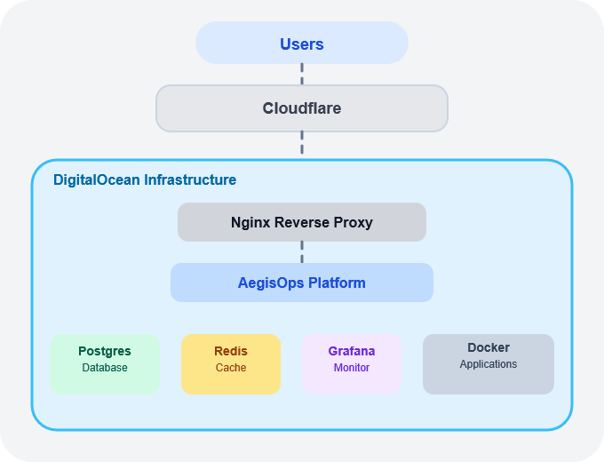
Figure 1. AegisOps Infrastructure Layers

Infrastructure Layers
Layer | Technology | Purpose
Edge Network | Cloudflare | DNS, SSL, CDN, WAF and DDoS protection
Cloud Infrastructure | DigitalOcean | Virtual servers and networking
Reverse Proxy | Nginx | Routes HTTPS traffic to applications
Platform | AegisOps | Deployment and infrastructure management
Containers | Docker | Isolated application hosting
Database | PostgreSQL | Persistent application and platform data
Cache | Redis | Caching, sessions and queues
Monitoring | Prometheus & Grafana | Metrics and dashboards
Logging | Loki | Centralized log aggregation

Core Platform Modules
- Identity & Access: Login, RBAC, MFA, API keys and audit logs.
- Executive Dashboard: Servers, applications, CPU, RAM, storage and alerts.
- Project Management: Manage repositories, domains and environments.
- Deployment Engine: GitHub Actions, Docker deployments and rollbacks.
- Infrastructure Management: Multi-server administration and container control.
- Database Management: PostgreSQL provisioning, backups and restores.
- Monitoring & Logs: Prometheus, Grafana, Loki and Alertmanager integration.
- Backup & Recovery: Automated backups and disaster recovery policies.

Third-Party Services
Service | Purpose | Cost
DigitalOcean | Cloud infrastructure | ~$24/month
Cloudflare | DNS & Security | Free
GitHub | Source control & CI/CD | Free
Domain | Public access | $10–20/year

Open-Source Stack
Docker, Nginx, PostgreSQL, Redis, Prometheus, Grafana, Loki and Alertmanager are all self-hosted and incur no software licensing costs.

Implementation Roadmap
- Phase 1: Infrastructure Foundation
- Phase 2: Core Platform Development
- Phase 3: Deployment Automation
- Phase 4: Monitoring & Observability
- Phase 5: Enterprise Scaling

Financial Summary
Estimated operational cost: $25–30/month, driven primarily by DigitalOcean infrastructure, with all core DevOps tooling running open source and self-hosted at no additional licensing cost.

