CTF Write-Up: Dragon Ball Z

Author: Alexander Shudrya
Date: October 30, 2025
CTF: Dragon Ball Z — Privilege Escalation Challenge

Overview
This report documents the process of identifying, exploiting, and escalating privileges on a target Linux system during the Dragon Ball Z CTF challenge.

Target machine set-up
I wanted to make sure that the victim machine was set up properly.
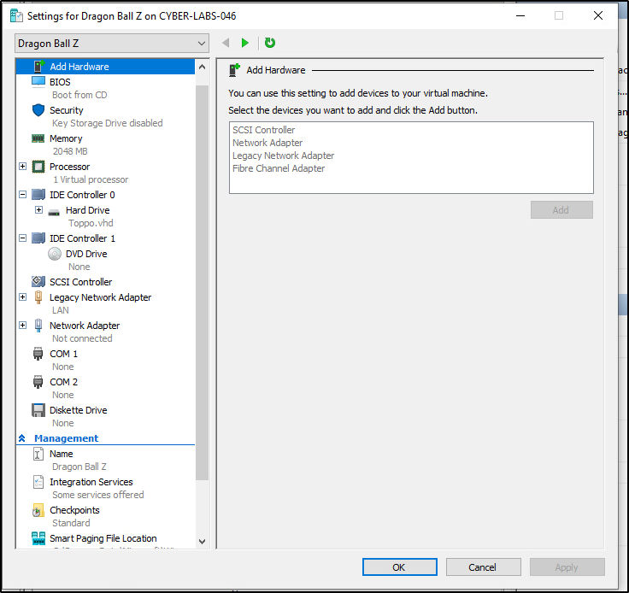
Figure 1 Configuration of the unknown machine.

Tools overview
I also had to make sure that all of my tools are up to date, so that everything works error-less.
- Dirbuster: 1.0-1
- Nmap: 7.95
- SSH: 10.2p1
- Netdiscover: 0.21-1
- Kali Linux: 2025.3 (Rolling)

Reconnaissance
Initial network discovery was performed using Netdiscover to locate live hosts within the subnet.
netdiscover -r 192.168.2.0/24
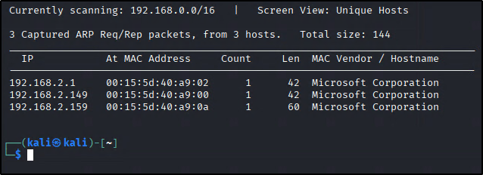

Enumeration
Nmap was used to scan for open ports and services to determine attack surface.
nmap -T4 -A 192.168.2.159
Option -A is needed to receive as much information from my scan as possible, and option -T4 usually gives me fastest results while still being reliable.
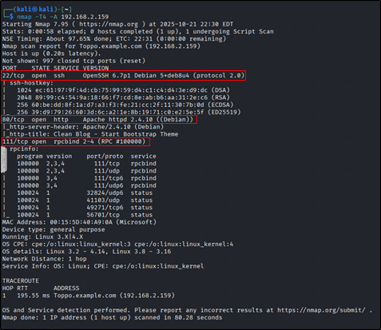
Figure 2. Several ports were found open on the target machine.

From what I can tell, this is a regular Linux machine that could be running a web server. I will leave SSH 22 port for the last because I know there is nothing much that I can do with it. Same story for rpcbind. Yes, I can try to find to look for exploits on those, since I already have their versions, but I’m looking for an easier way in. That we leave me with http on port 80.

Web Enumeration
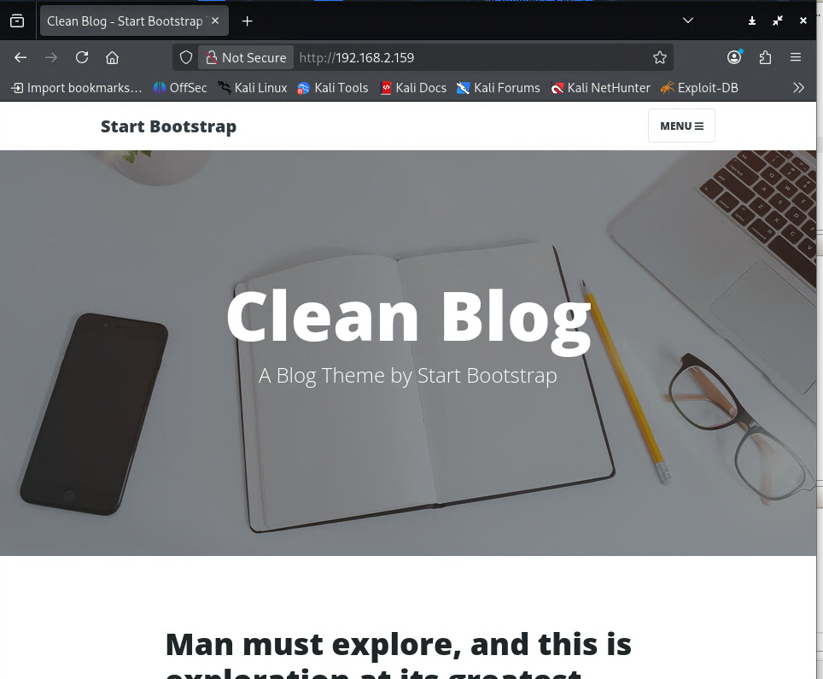

Figure 3. Apache website of the webserver.

Dirbuster was used to identify hidden directories and files on the web server, but while it loads I want to see if I can find anything useful on the front end.
dirbuster -u http://192.168.2.159 -w /usr/share/wordlists/dirbuster/common.txt

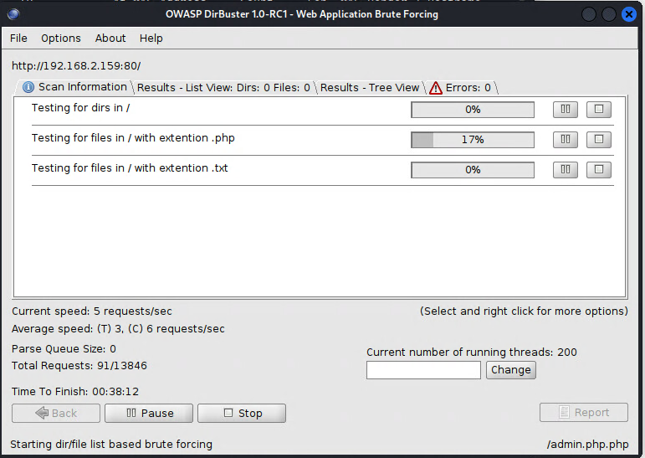
Figure 4. I used the default common.txt file that already came with my version of Kali.

My dirbuster ran into error issues twice.
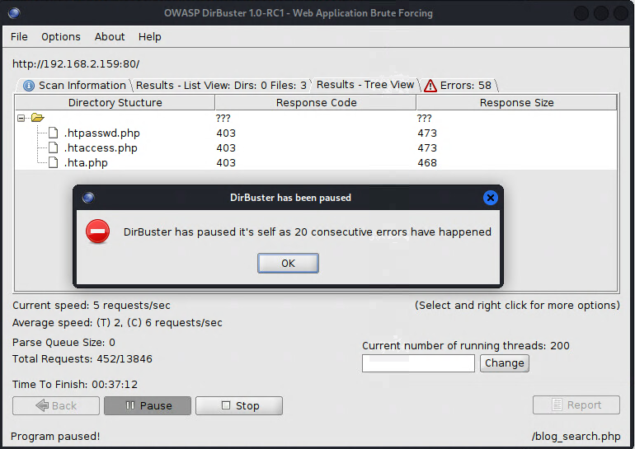
Figure 5. Dirbuster Error

But I continued to scan more and more, until I hit some prize pools.
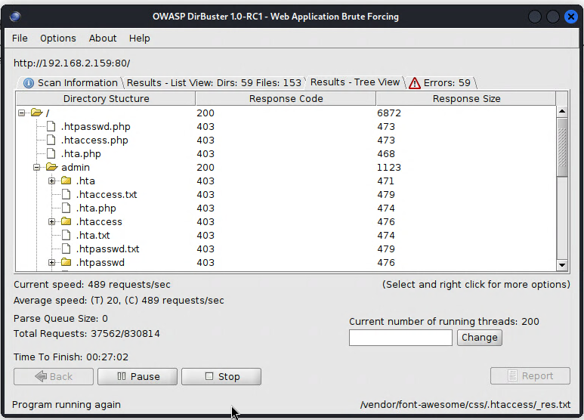
Figure 6. Dirbuster tool displaying subdirectories of our website.

I came across notes.txt file, which gave me a password, but unfortunately this was the only valuable recon I will get from this.
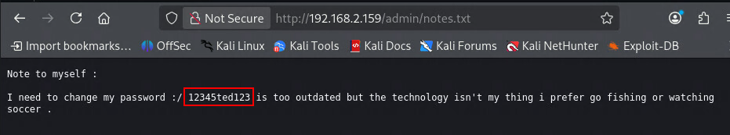
Figure 7. Password found by a improper use of webserver

Initial Access
The first thought that came to mind was “go try to ssh login.” And I did try it with username of “admin” and it didn’t work out.
ssh admin@192.168.2.159
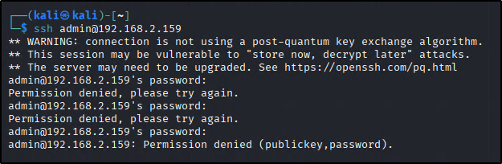
Figure 8. Trying loging in as admin.

I completely missed the hint from password itself. Beside the letters, name “ted” was sitting quitly, so I gave it a try and it was successful.
ssh ted@192.168.2.15
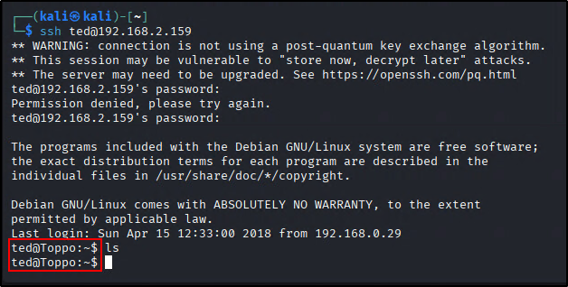
Figure 9. Successful entrance using the username "ted."
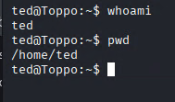

Privilege Escalation
Upon that, I tried to look through the /etc/passwd and /etc/shadow files, and as expected I was denied permission on one of them, while the other didn’t reveal anything enticing.
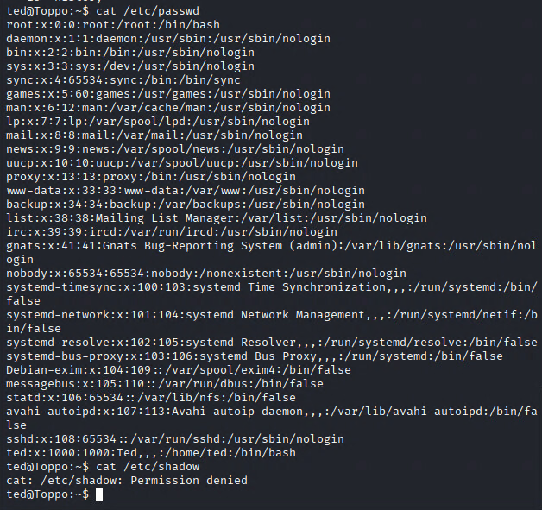
Figure 10. /etc/passwd file contents.
After that I understood that I have to find some other way for privilege escalation. I had to see what the server version was, but that didn’t help me out much.

I’ve given a go for sudo -l, but this machine doesn’t have it available, so then I looked for an escalation via SUID permissions. Using a command:
find / -perm -4000 -type f 2>/dev/null

And here is the list of things ted can access here:
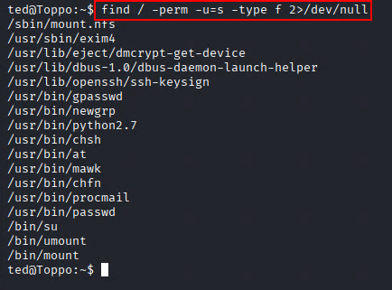
Figure 11. Figuring out my possible SUID binaries.

After digging a bit through GTFO bins, I found out that I can gain privileged access with mawk.
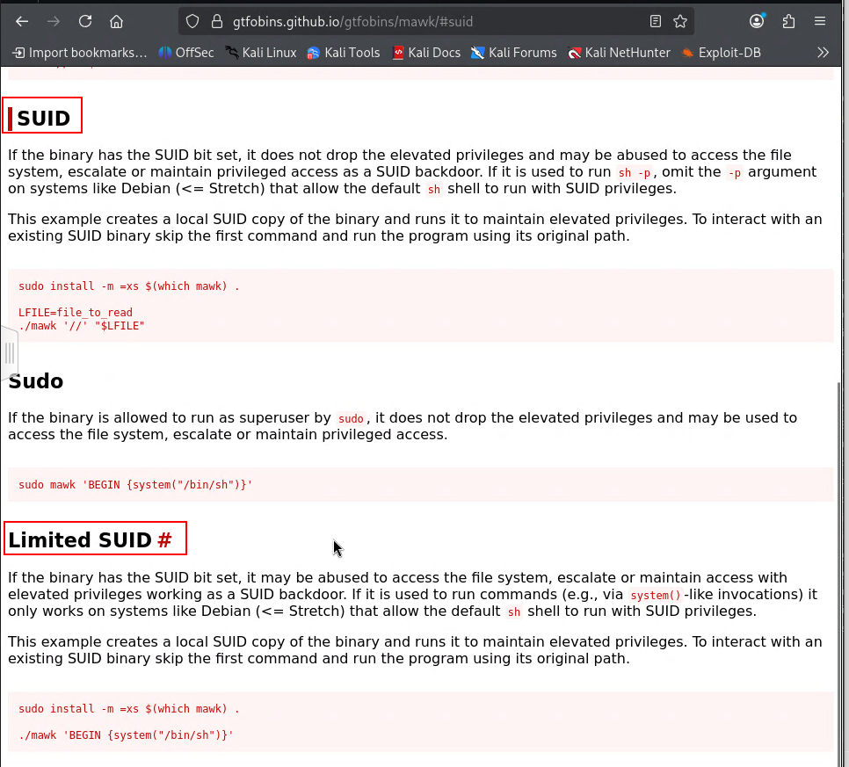
Figure 12. Vulnerable SUID binary found.

I was able to get a shell with Limited SUID only this time, which gained me privileged access, and allowed me to completely own the machine.
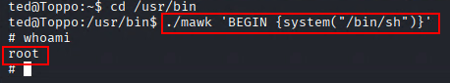
Figure 13. Vulnerable code execution to gain escalated privileges.

Flag Capture
After obtaining root privileges, the flag was retrieved from the root directory.
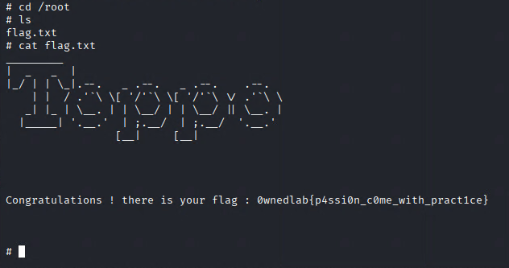
Figure 14. Flag.txt message.
Here is the confirmation of our user “ted” having elevated privileges.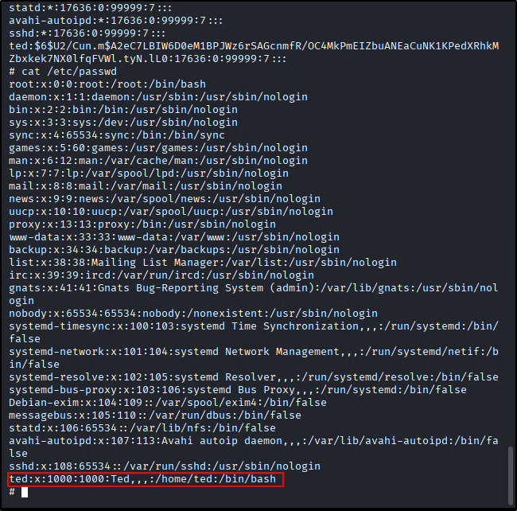
Figure 15. Confirmation of the user "ted" having root abilities

Lessons Learned & Recommendations
If someone had a machine with similar vulnerabilities, then I would discourage them from displaying sensitive information like a password online, since this would be the weak link between him and a cyber criminal. SSH hardening would also put up a brick wall.

