MARKETING STRATEGY REPORT
Repositioning Magnum for Gen Z
Through Nostalgia-Driven Emotional Marketing
― Pakistan Market · 2025 ―

Gen Z Focus | Nostalgia Strategy | Digital-First
About This Report
This report makes the case for one of the most exciting brand opportunities in Pakistan right now: getting Gen Z to genuinely fall in love with Magnum — not because it’s expensive, but because it feels like home.
We’ve looked at the emotional data, the cultural context, and what Gen Z actually responds to — and built a campaign concept that could shift the needle significantly. Read on.
Prepared for Magnum Brand Team | Confidential | 2025

1. Executive Summary
Here’s the short version: Magnum is a great product sitting on a missed emotional opportunity. Gen Z in Pakistan is stressed, nostalgic, and craving content that feels real — but Magnum’s current luxury messaging speaks past them entirely.

This report proposes flipping that. Instead of selling indulgence, we sell a feeling. Instead of aspirational, we go emotional. The campaign we’re recommending — “Magnum Moments: Kuch Yaad Aya?” — uses nostalgia-driven storytelling to build the kind of brand connection money can’t buy.

“Magnum can become the ice cream brand Gen Z actually feels something about — not just the one they occasionally splurge on.”

55%  of Gen Z report high anxiety daily | 2x  more distressed than Millennials | 40%  feel stressed most of the time | 73%  engage more with nostalgic content

Sources: McKinsey Consumer Health Survey · Deloitte Gen Z Report 2024

2. Where Magnum Stands Today

The Brand Right Now
Magnum is globally known for premium, luxurious ice cream. That positioning works brilliantly in mature markets — but in Pakistan, with a young, emotionally-driven consumer base, it can feel a bit cold and out of reach.

Brand | How They Position | Who They’re Talking To | Price Feel
Magnum | Premium luxury & indulgence | Urban, affluent adults | Expensive treat
Walls | Fun for everyone, accessible | Broad, family-oriented | Everyday affordable
Omore | Local pride, affordable joy | Mass market, all ages | Very accessible

The gap Magnum can own: no ice cream brand in Pakistan is speaking to Gen Z’s emotions. That space is wide open.

3. Understanding Gen Z in Pakistan

Who They Are
Born between 1997 and 2012, Pakistan’s Gen Z is the largest, most digitally connected generation in the country’s history. They’re also one of the most emotionally self-aware — and one of the most stressed.

Trait | What It Means for Magnum
Emotionally expressive & self-aware | They reward brands that feel genuine, not performative
Heavy social media users | Content needs to be scroll-stopping and shareable
Nostalgic by nature | They romanticise childhood even in their early 20s
Skeptical of traditional ads | They’ll skip a luxury ad but share a relatable memory reel
Seek emotional comfort | Magnum can be their emotional escape, not just a snack

4. The Emotional Data — Why This Works
This isn’t just a gut feeling. The data on Gen Z’s emotional state is striking — and it directly explains why nostalgia-based marketing outperforms luxury messaging with this audience.

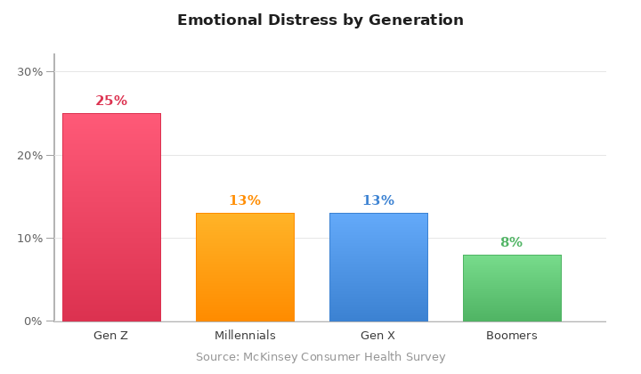
Figure 1: Emotional Distress by Generation (%) — McKinsey Data
Gen Z is dealing with roughly twice the emotional distress of Millennials. This isn’t a weakness to exploit — it’s a human truth to empathise with. Nostalgia provides emotional safety. It reminds people of “better times.” It reduces stress and anxiety. When Magnum becomes associated with that feeling, it stops being just an ice cream.

Nostalgia doesn’t just make people feel good — psychologically, it reduces loneliness, increases optimism, and creates a sense of continuity. That’s the emotional real estate Magnum should occupy.

5. The Problem to Solve
Before we get to the solution, let’s be honest about what’s not working:

The Challenge | Why It Hurts
Magnum feels expensive & out of reach | Low purchase frequency among students and young earners
Global luxury imagery feels foreign | Pakistani Gen Z can’t see themselves in it
No emotional hook | Weak brand recall when it matters most — at the point of decision
Missing from nostalgia conversations | Walls and local brands own that warm, familiar feeling

6. The Campaign: Kuch Yaad Aya?

The Big Idea
“Kuch Yaad Aya?” — Did something come to mind?
Position Magnum as the taste that takes you back. One bite = one memory. Not luxury. Not indulgence. Remembrance.

Why This Tagline Works
- It’s in Urdu — instantly warm, local, and personal
- It’s a question — it invites Gen Z to think, share, and participate
- It’s emotionally open-ended — every person has a different memory, making it universally relatable
- It’s unexpected from a ‘luxury’ brand — that contrast creates attention

Brand Shift at a Glance

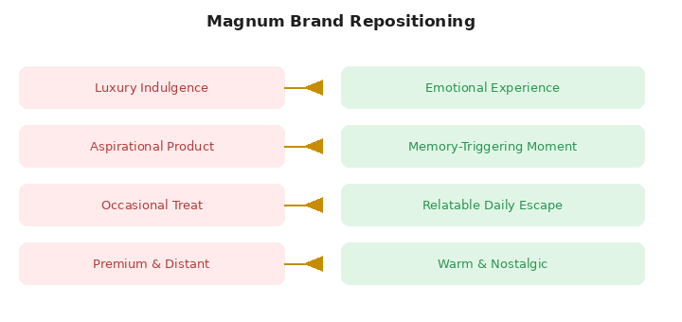
Figure 2: Magnum Repositioning — Current vs. Proposed

The Ad: Scene by Scene
Here’s how the hero TVC / Reel plays out:

Scene | What You See | What You Feel
Opening | Kids sharing ice cream on a summer afternoon, laughing in a gully | Joy, warmth, innocence
Reality Cut | Same person, now 22 — office screen, phone notifications, tired eyes | Tension, longing
The Moment | They unwrap a Magnum. First bite. Eyes close. | Relief, pleasure
The Flood | A warm overlay of childhood flashes back in golden tones | Nostalgia, safety
Close | Screen goes simple. Logo. “Kuch Yaad Aya?” | Brand love

7. Digital Strategy
Gen Z doesn’t watch TV ads — they’re on their phones. Here’s where we meet them:

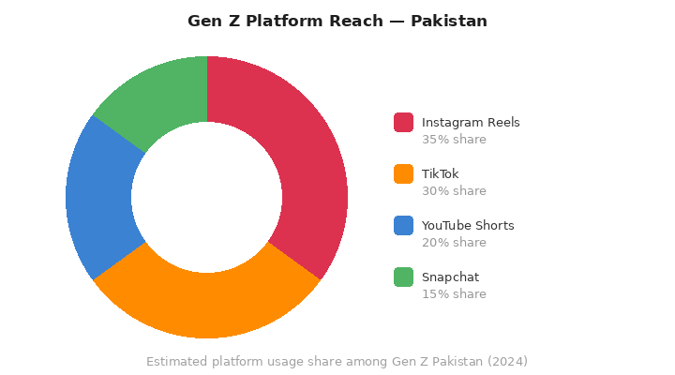
Figure 3: Gen Z Platform Reach — Pakistan Estimate 2024

Platform | Content Approach | Format
Instagram Reels (35%) | POV nostalgia storytelling — 30–60 sec, emotional | Short video
TikTok (30%) | Trending memory sounds, before/after comparisons | Sound-on, lo-fi
YouTube Shorts (20%) | Extended emotional stories — 1–2 min | Mini-film style
Snapchat (15%) | Ephemeral nostalgia prompts, AR filters | Stories + lens

Hashtag Ecosystem
- #MagnumMoments — the main campaign tag
- #KuchYaadAya — the emotional trigger
- #MagnumPakistan — for local discovery
- UGC Challenge: “Share your Magnum memory” — rewarded with features & prizes

8. What We Expect to See

+20%  brand recall among Gen Z in 6 months | 5M+  target reel views per campaign wave | +15%  trial purchase intent among 16–25s | 10K+  UGC posts with #MagnumMoments

KPI | How We Measure It | 6-Month Target
Brand Awareness | Aided recall survey (Gen Z) | +20% vs. baseline
Emotional Sentiment | Social listening score | >75% positive
Digital Reach | Reel views + saves across platforms | 5M+ per campaign
Purchase Intent | Trial rate among 16–25 segment | +15% vs. baseline
Community | UGC submissions & hashtag usage | 10,000+ posts

9. Why This Actually Works

The Psychology Is Real
- Nostalgia is scientifically proven to reduce anxiety and increase a sense of social connectedness
- Memory-linked brand associations produce stronger long-term recall than feature-based ads
- Emotional campaigns generate 2x more word-of-mouth than rational ones (Nielsen Emotional Engagement Study)

The Culture Is Ready
- Pakistan has one of the strongest nostalgia cultures in the region — just look at how viral ‘old Karachi’ content gets
- Urdu emotional storytelling already dominates the most-shared ad content on Pakistani social media
- No other ice cream brand is owning this emotional space — it’s uncontested territory

The Business Case Is Clear
- Emotional repositioning is harder for competitors to copy than a product feature or price promotion
- It expands Magnum’s addressable market beyond affluent consumers to a broader nostalgic Gen Z audience
- UGC and community-driven campaigns dramatically reduce paid media costs over time

10. The Bottom Line
Magnum doesn’t need to change what it is. It just needs to change how it makes people feel. Right now it’s “the expensive ice cream.” The opportunity is to make it “the one that reminds me of being a kid.”

That’s not a small shift. That’s the difference between a brand people buy occasionally and one they’re genuinely loyal to.

“By meeting Gen Z at the intersection of emotional need and cultural memory, Magnum can build the kind of brand loyalty that no promotional discount or celebrity endorsement can manufacture. This campaign isn’t just smart marketing — it’s the right thing to do for a brand that wants to matter.”

MAGNUM ICE CREAM · Confidential · Pakistan Marketing Strategy · 2025 ❤

