**Exercise : k-NN**

**From Rapidminer**

* Perform a k-NN classification with all predictors except ID and ZIP using k = 1. How would this customer be classified?



Ans new_customer would classify in false.

* Partition the data into training (60%) and validation (40%) sets. Show the classification matrix for the validation data that results by varying k.
  + k = 1

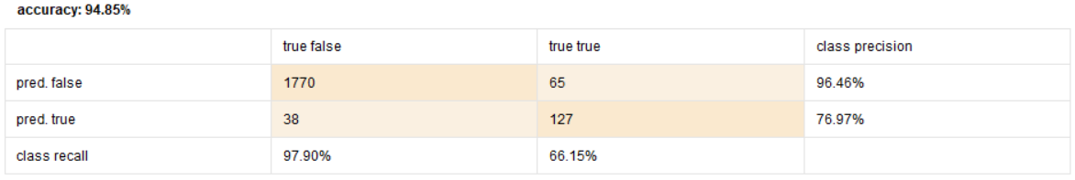

* k = 2



* k = 3

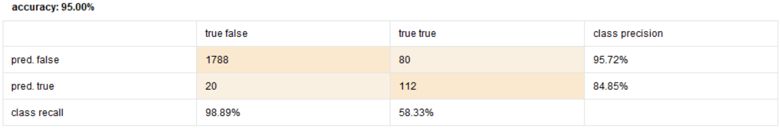

* k = 4

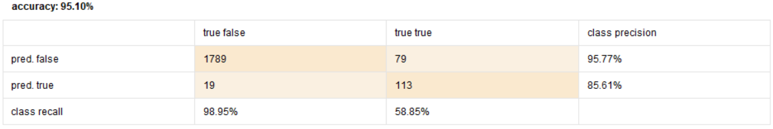

* k = 5

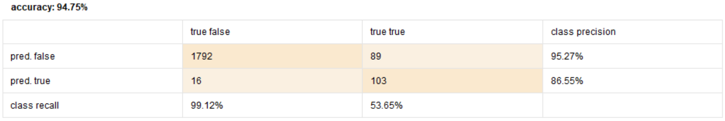

* k = 6

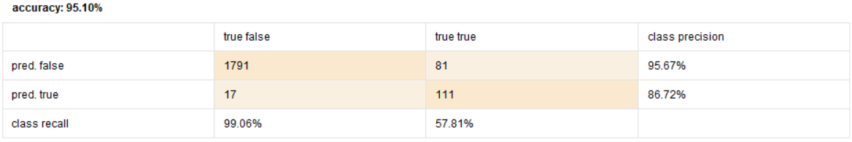

* k = 7

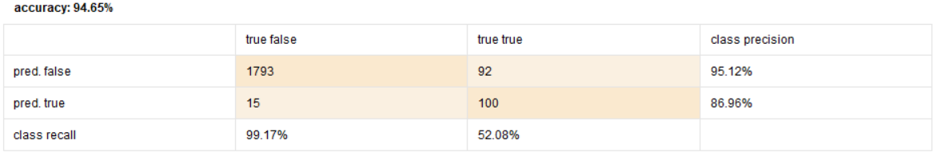

* k = 8

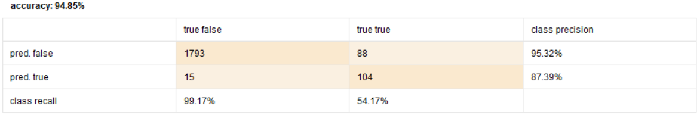

* k = 9

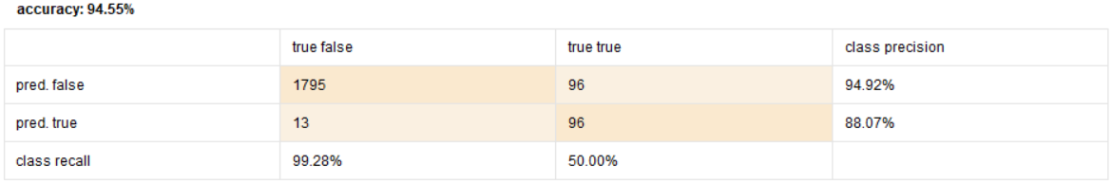

* k = 10

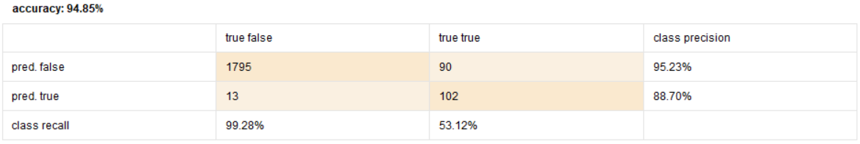

* Using the best k, how would this customer be classified?



Ans new_customer would classify in false. ( k = 4 )

**From Python**

* Perform a k-NN classification with all predictors except ID and ZIP using k = 1. How would this customer be classified?

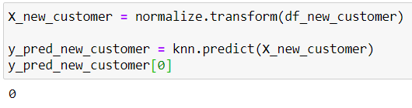

Ans new_customer would classify in false.

* Partition the data into training (60%) and validation (40%) sets. Show the classification matrix for the validation data that results by varying k.
  + k = 1

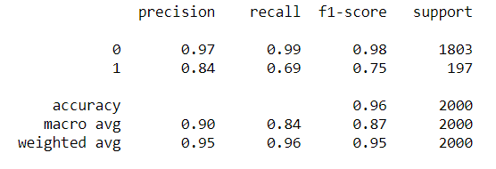

* + k = 2

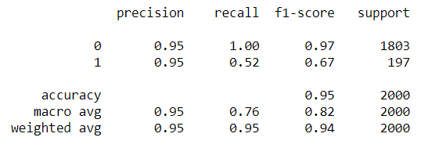

* + k = 3

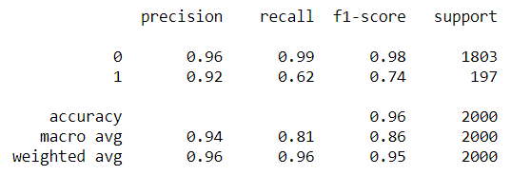

* + k = 4

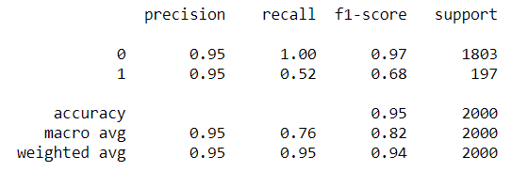

* + k = 5

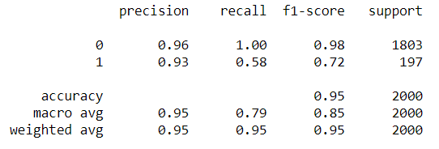

* + k = 6

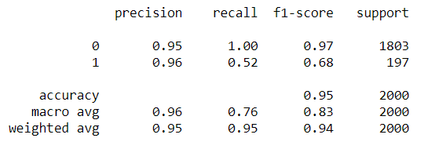

* + k = 7

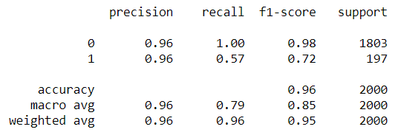

* + k = 8

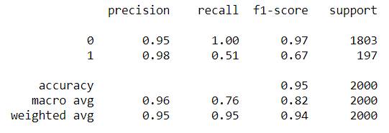

* + k = 9

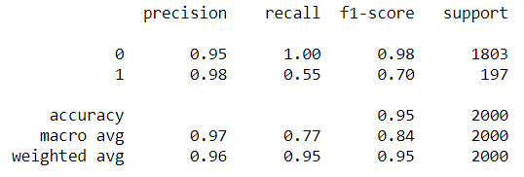

* + k = 10

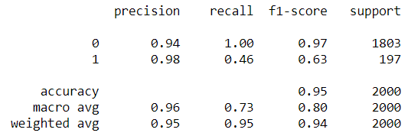

* Using the best k, how would this customer be classified?

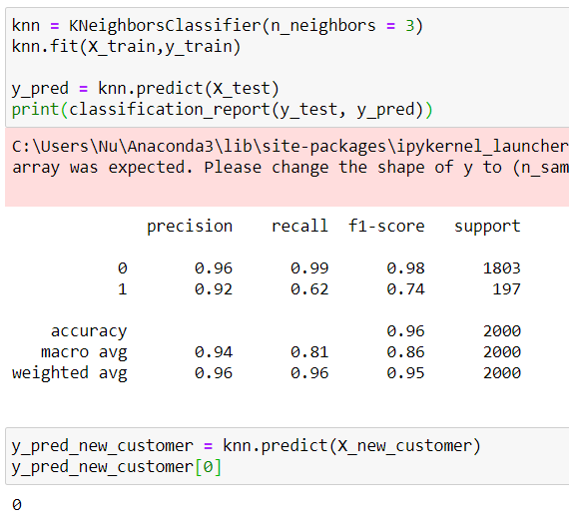

Ans new_customer would classify in false. ( k = 3 )